Application for tree works
T1 is a medium, over mature Sycamore. The crown condition is very poor with significant decay as shown in Figure 1. There is additionallyvn a young fruiting body of possibly Perreniporia fraxinea in the stem base as shown in Figure 2. The application is to pollard the tree at approximately 4 m as shown in Figure 3.
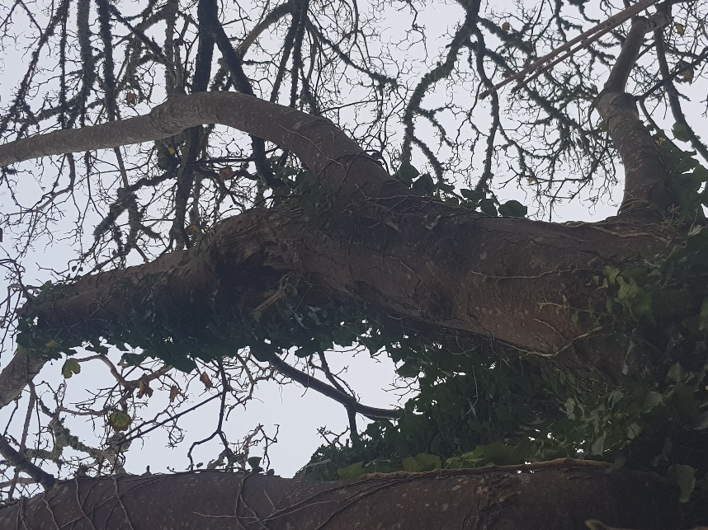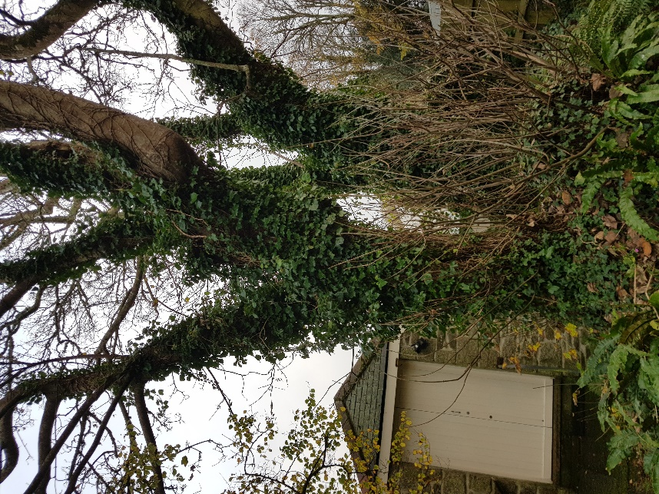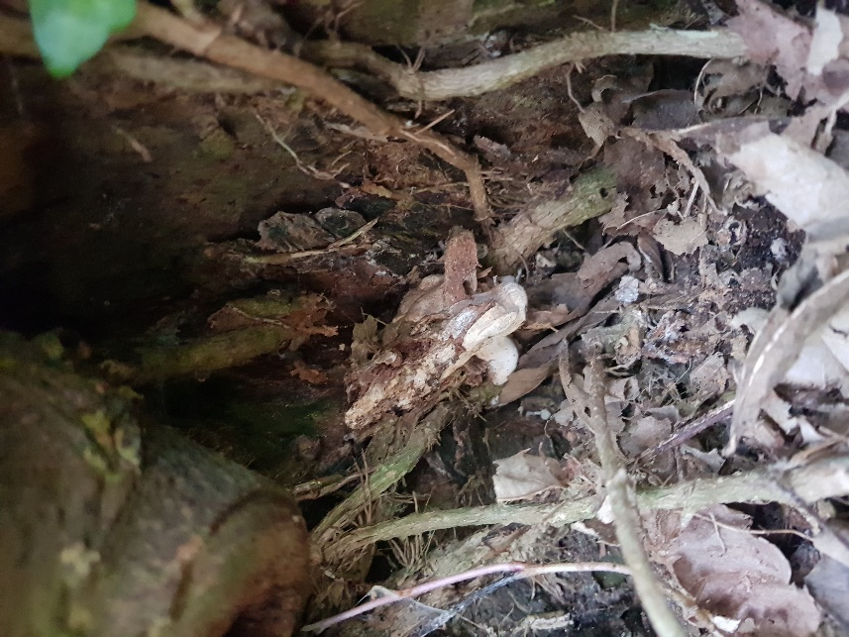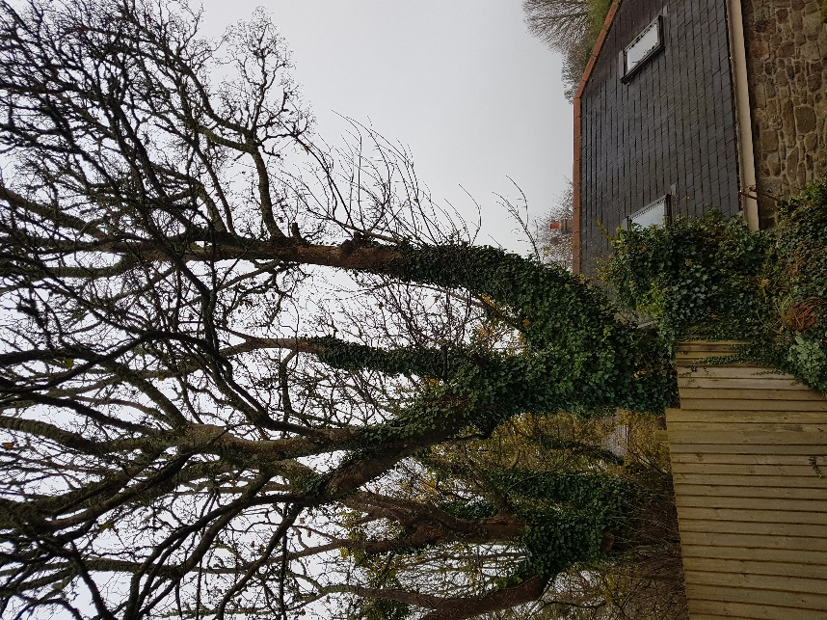
Figure 4. T2, proximity of tree to dwelling.
Figure 3. T1, red line shows level of reduction.
Figure 2. T1, young fungal fruiting body.
Figure 1. T1, decay in crown
T2 is a large mature Sycamore. The tree is very close to the dwelling with a very large lateral limb growing right over the dwelling as shown in Figure 4. The tree is unsuitably placed and the application is to fell this tree.
T3 is a semi-mature Sycamore. As shown in Figure 5 the tree has basal decay. The application is to fell the tree.
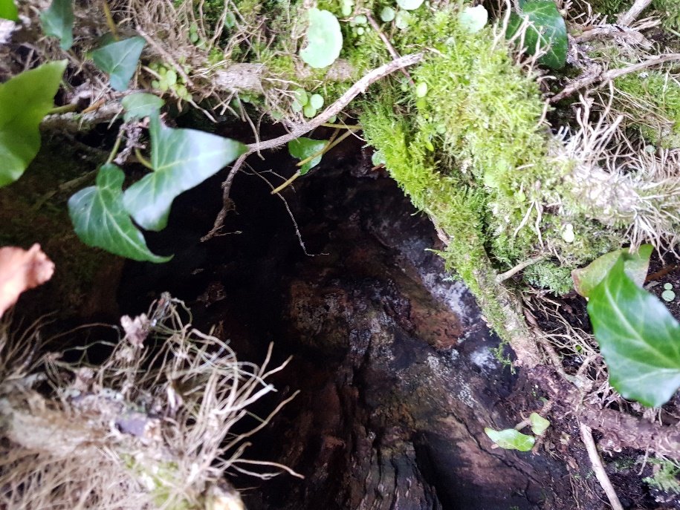
Figure 5. T3. Basal decay.
G1 is a group of 2 Elms and 1 Holly. The application is to reduce these trees in height to approximately 9 m as shown in Figure 6. I do not believe these trees to be old enough to be covered by the TPO however I am including them for the avoidance of doubt.
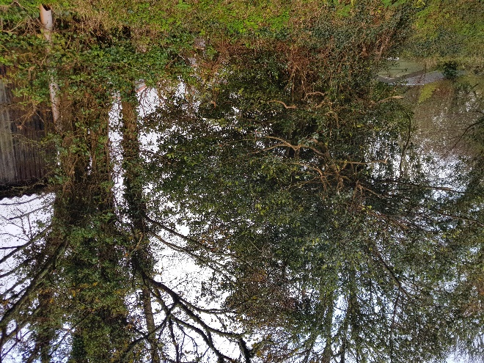
Figure 6. G1, red line indicates level of proposed reduction.
The lane is private with very low footfall, so the trees in question do not provide visual amenity to a significant number of people.
The applicant is able to plant 4 trees to compensate for the loss of the two trees being removed on adjacent land.

TR11 5TA

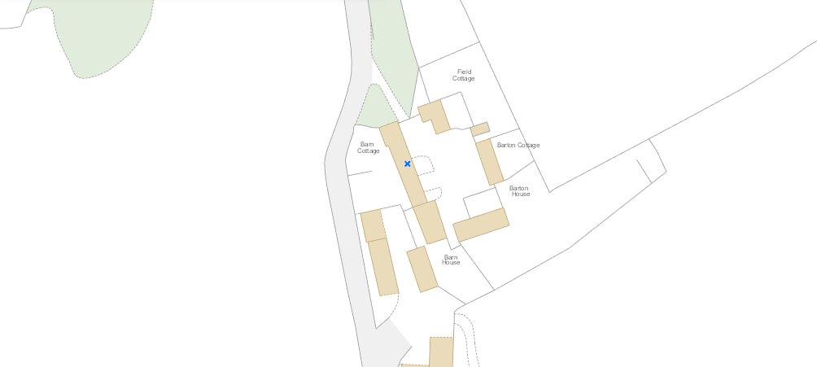
G1
T3
T2
T1

