41 Loom Lane

T3 beech T4 goat willow   
  
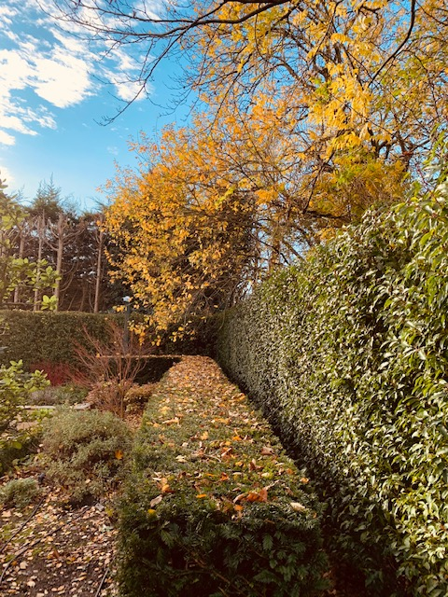

T3 beech  


T3 beech  
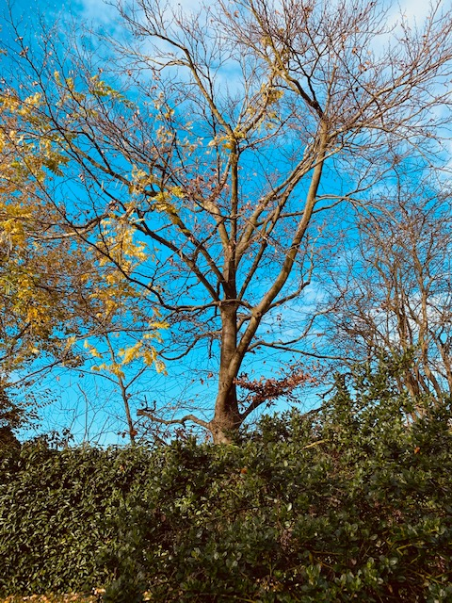

T4 goat willow   
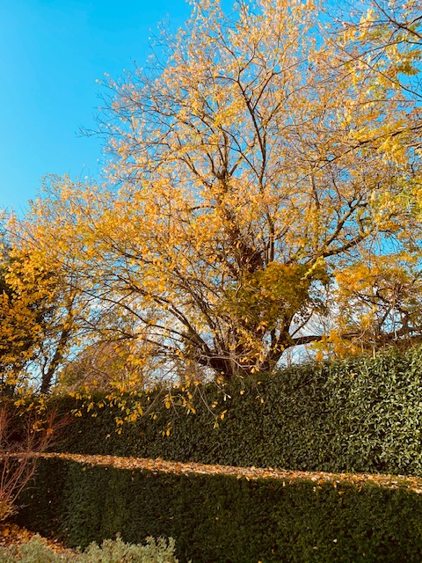

All over hanging 41 Loom Lane

Rear right hand side garden from neighbours 43 loom Lane

Reduce back to boundary back to suitable growth points within the trees