Christopher Fearn Limited.

Architectural Consultant.
61 Victoria Grove

Bridport

Dorset
Telephone. 01308 456077. email.chrisfearn42@hotmail.com DT6 3AE

17th of November 2020

STATEMENT OF HERITAGE SIGNIFICANCE

FOR THE PROPOSED DROPPED KERB, DRIVE AND

PARKING / TURNING AREA

AT

No 1 CHURCHILL CLOSE, WYKE REGIS, WEYMOUTH,

DORSET. DT4 PLZ.

No 1 Churchill Close is a semi-detached two storey house, which is part of a development built in the 1960s. The 3 bedroom dwelling is on an elevated site at the beginning of the cul-de-sac. The property is constructed with cavity walls finished externally in render with a shallow pitched gable ended roof, which is covered with inter-locking concrete tiles. The doors and windows are PVCu units in white. The property has a single garage within a block to the south-east with vehicular access off the cul-de-sac. Parking is problematic for this property due to its elevated location and also the cul-de-sac arrangement. The applicant’s wife is disabled and has had primary progressive MS for over 10 years, and the only manageable level access to the house involves a minimum 45 metre walk from the parking area to the south-east.

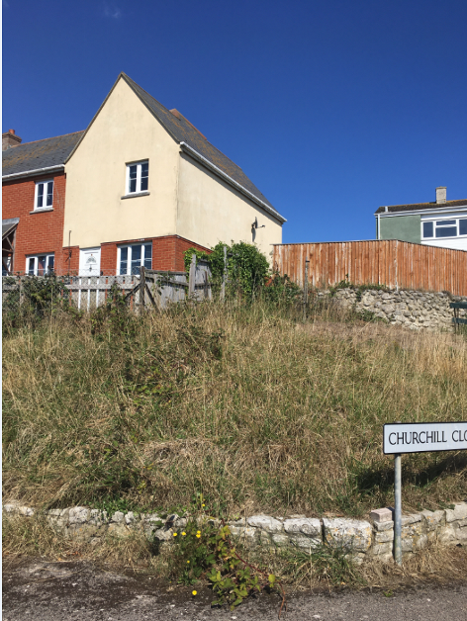
The proposed scheme will involve the formation of a dropped kerb arrangement and a new opening within the dwarf natural stone wall to the sites north-west boundary providing vehicular access up to the new drive leading up to the existing gravel area to the house frontage which will be paved and will be used for parking and turning. By providing off road parking for the applicant the existing restrictive parking arrangement will be somewhat eased and the access for Mrs Chapman will be transformed so that she can effectively get of the car and walk straight into the house. The scale of this scheme is sympathetic to this setting. The two shoulders and dropped kerbs will create an access that will be wide enough for a car to comfortably cross. The new drive will be in the region of 3 metres wide so that a car can comfortably and safely drive up and down.
The new paved area will be large enough for a car to easily turn around so that it can drive on and off the site. The scheme has some scope for landscaping where the existing ground level will be graded back as required to accommodate the new drive. A section of the existing grassed area to the road frontage will be removed and the levels reduced and then topped off with geotextile matting and gravel to provide a low maintenance area. This will all be free draining and no surface water will run off into the road. An Aco drainage channel will be installed at the bottom of the new drive and will be piped to a soak away within the site so no surface water will run off onto the pavement and into the road. The proposed dropped kerb will provide access to the new drive and up to the existing gravel area, which will be paved to match the existing. The drive will be finished in tarmac to provide a simple and honest appearance. Vertical paving slabs will be used to either side of the new drive where it is required to retain the ground and this has a simpler and softer appearance than a masonry retaining wall. The scheme will fit in well with its surroundings and have little or no visual impact on the surrounding area. The new vehicular access up to the new parking and turning area will help to reduce the impact on the current parking arrangements. The turning and parking area will allow cars to drive on and off the site and due to the elevated quality of the site, the good visibility will allow a safe exit from the site.

The proposed scheme works well with the surrounding buildings and will enhance the area without impacting this part of the settlement and will not detract from the Conservation Area.

