Installation Manual Operation Manual
(Original Instruction)

Reciprocating condensing unit Scroll condensing unit for medium temperature application for medium temperature application
Series 1 Series 2
JEHCCU0040CM1 JEHSCU0200CM1
JEHCCU0050CM1 JEHSCU0200CM3
JEHCCU0051CM1 JEHSCU0250CM1
JEHCCU0063CM1 JEHSCU0250CM3
JEHCCU0067CM1 JEHSCU0300CM1
JEHCCU0077CM1 JEHSCU0300CM3
JEHCCU0095CM1 JEHSCU0350CM3
JEHCCU0100CM1
JEHCCU0113CM1 Series 3
JEHSCU0400CM3
Series 2 JEHSCU0500CM3 JEHCCU0140CM1 JEHSCU0600CM3
JEHCCU0140CM3 JEHSCU0680CM3

Reciprocating condensing unit Series 4 for low temperature application JEHSCU0800CM3
JEHSCU1000CM3
Series 1
JEHCCU0115CL1 Scroll condensing unit
for low temperature application

Series 2
JEHSCU0200CL3
JEHSCU0300CL3

Series 3
JEHSCU0400CL3
JEHSCU0500CL3
JEHSCU0600CL3

Series 4
JEHSCU0750CL3

Contents

- Nomenclature 2
- Safety and Health 2
- Installation & commissioning 3
- Decommissioning & Disposal 6
- Checklist 6
- Service and Maintenance 7
- F gas Regulations 7
- Trouble Shooting 8
- Specifications 9
- Outline Drawings 11 11. Electrical Data 14
12. Appendix 20

1. Nomenclature
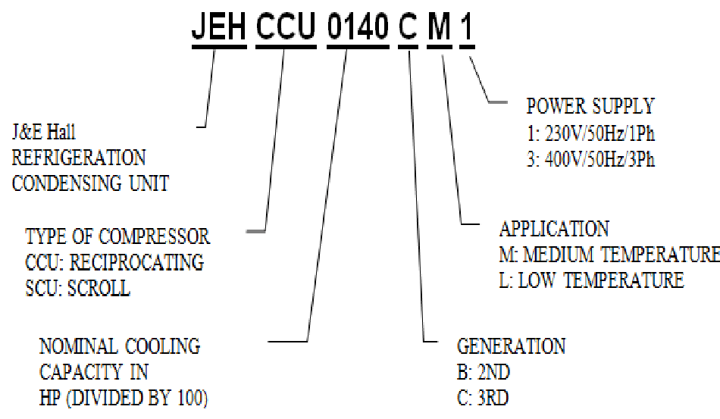
J&E Hall
REFRIGIRATION

CONDENSING UNIT

TYPE
OF COMPRESSOR

CCU: RECIPROCATING

SCU:
SCROLL
NOMINAL COOLING

CAPACITY IN

HP (DEVIDED BY 100)

POWER SUPPLY

1:

230
V/50Hz/1PH
3:
400V/50Hz/3PH

APPLICATION

M: MEDIUM TEMPERATURE

L: LOW TEMPERATURE

GENERATION

B: 2ND

C: 3RD

- Ensure the unit received is the correct model for the intended application.
- Ensure refrigerant, voltage, are suitable for the proposed application and environment.
- Installation and maintenance are to be performed only by qualified personnel who are familiar with local codes and regulations, and experienced with this type of equipment.
- The condensing unit is delivered with a nitrogen holding charge.
- The condensing unit contains moving machinery and electrical power hazards. May cause severe injury or death. Disconnect and shut off power before installation or service of the equipment.
- Refrigerant release into the atmosphere is illegal. Proper evacuation, handling and leak testing procedures must be observed at all times.
- Condensing unit must be earthed. Improper earthing may result in electric shocks or fire.
- Be sure to switch off the unit before touching any electrical parts. Touching a live part may result in electric shocks or fire.
- The electrical covers and condenser fan guard must remain fitted at all times.
- The condensing units are not designed to withstand loads or stresses from other equipment or personnel. Such extraneous loads or stress may cause failure/leak/injury.
- In some circumstances, a suction accumulator (not supplied) component may be required, it offers protection against refrigerant flood back during operation. It helps protect against off-cycle migration by adding internal free volume to the low side of the system.
- Test must be conducted to ensure the amount of offcycle migration to the compressor does not exceed the compressor’s charge limit.
- Wherever possible the system should be installed to
- Use of the condensing unit outside of design conditions and application for which units were intended may be unsafe and be detrimental to the unit, regardless short or long term operation.

2. Safety and Health

General Information

Important Note
Only a qualified refrigeration engineer who is familiar with refrigeration systems and components, including all controls should perform the installation and start-up of the system. To avoid potential injury, use care when working around coil surfaces or sharp edges of metal cabinets. All piping and electrical wiring should be installed in accordance with all applicable codes, ordinances and local by-laws.
This appliances is not intended for use by persons (including children) with reduced physical, sensory or mental capabilities, or lack of experience and knowledge, unless they have been given supervision or instruction concerning use of the appliance by a person responsible for their safety. Children should be supervised to ensure that they do not play with the
O-CU06-DEC14-1 appliance.
utilize a pump down configuration. For unit Series 1 JEHCCU040CM1 and JEHCCU0050CM1, it is advisable to connect with thermostat cut off configuration using the reserved terminal in control box.
• After installation, the system should be allowed to run for 3 – 4 hours. The oil level should be checked after 3 – 4 hours run time and topped up as necessary. The oil level should not be lower than quarter of the compressor oil sight glass.

3. Installation & Commissioning

3.1 Unit site location
- In order to achieve maximum cooling capacity, the installation location for condensing unit should be carefully selected.
- Install the condensing unit in such a way so that hot air distributed by the condensing unit cannot be drawn in again (as in the case of short circuit of hot discharge air). Allow sufficient space for maintenance around the unit.

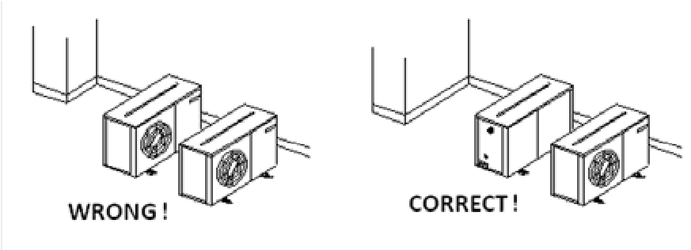
Wrong !

Correct !

- Ensure that there is no obstruction of air flow into or out of the unit. Remove obstacles which block air intake or discharge.
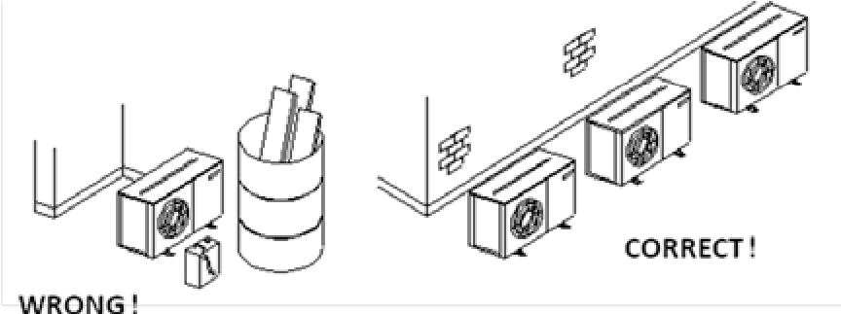
Wrong !

Correct !

- The location must be well ventilated, so the unit can draw in and distribute plenty of air thus lowering the condensing temperature.
- To optimize the unit running conditions, the condenser coil must be cleaned at regular intervals.

3.2 Installation Clearance
- The installation location should allow sufficient space for air flow and maintenance around the unit.
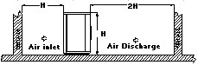

Air inlet
Air Discharge

- To allow sufficient space for doing service or installation.
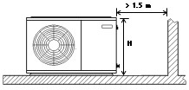

  - Compressor handling
To ensure compressor reliability, the condensing unit and the compressor must not be tilt greater than an angle of 45°.
Otherwise, the compressor can fall from its 3 compressor housing spring, which results in noisy vibrations during operation and possible to breakdown.

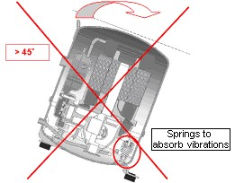
Springs to absorb vibrations

Important Note
Line sizing should only be determined by qualified personnel. All local codes of practice must be observed in the installation of refrigerant piping
  - Field Piping

To ensure satisfactory operation and performance, the following points should be noted for field piping arrangements,

- Couples one indoor unit with one outdoor condensing unit only.
- Release all the pre-charged nitrogen before pipework connection.
- Connecting pipe size for suction and liquid line must same as attaches to the condensing unit. Correct line sizing will minimize the pressure drop and maintain sufficient gas velocity for proper oil return.
- Pipework routes must be as simple and as short as possible. Avoid low points on pipework where oil can accumulate.
- Use only clean, dehydrated refrigeration grade copper tube with large radius elbows. The piping shall be kept with enough bending radius.
- Braze without over filling to ensure there is no excess solder into the tube.
- To prevent oxidation, blow nitrogen through pipework when brazing.
- Install insulation on all suction lines after pressure test.
- Adequately support all pipe work at a maximum of 2 meter intervals.
- For the condition where the outdoor condensing unit is above the indoor unit, the height difference between units shall be less than 25 m and install oil trap on suction pipe every 4 m height. The suction pipe must always be fitted with U-trap at the bottom.
- For the condition where the outdoor condensing unit is below the indoor unit, the height difference between units shall be less than 4 m. Pipe trap shall be installed upward on outlet of indoor unit (suction pipe).
- The recommended piping length is 25 m or less.
- Additional oil might be required in case field piping is long or with many oil traps. Check the oil level of the

Important Note
Ensure that a good quality vacuum pump is used to pull a minimum vacuum of -0.1 barg (250 microns) or less. Ensure that no pressure increase during 1 hour or more after stop vacuuming. If pressure increase, there is moisture or leakage along the pipeline.
compressor to decide to add the oil after minimum 2 hours operation.

- It is recommended as well to install the MOP (Maximum Operation Pressure), expansion valve for medium
evaporating temperature units, if the working suction pressure during start procedure especially after defrost cycle, is out of the limit, as refer to the table provided.

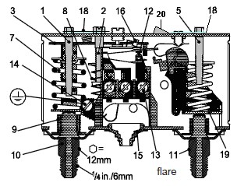
CoRempressor Model frigerantCompresRecommend compressor working pressure range sor ModelR404A/AE/CAJ/TAJ R407A/Med TempAE/Med Temp CAJ/TAJ R134a R404A MeMed TempR134aMTZ dMTZ Temp R407C R404AMed TempZB*KQE/R407A/MeZB*KQE d Temp R134a3.8The pressure switch fitted to condensing units with auto reset for low pressure and manual reset for high pressure Safety pressure switch settings
Refrigerant R407F R404A R134a R404A R134a R407C R404AR407F R134a are NOT factory preset.
Working Working Pressure
Pressure Range High Side,
_{Range High (barg)} 13.2 – 27.7 13.2 - 27.7 6.7_{15.8}6.7 - 15. – 8 13.2 - 27.713.2_{27.7} – 7.9 - 22.67.9_{22.6} – 12.5 - 29.412.5_{29.4} – 7.14 - 27.67.14 – 27.6 6.6 - 22.6 6.6_{22.6} –
Side (barg)
_{Working} Working Pressure
SidRaPrnge Low e,essure (Range barg)( bLow Side, arg) _{1.5 – 8.3} 1.5 - 8.3 0.1_{3.9}0.1 - – 3.9 1.01.0 -7.2_{7.2} – 0.6 - 4.70.6_{4.7} – 1.4 - 6.61.4_{6.6} – 1.98 - 7.14_{1.98 – 7.14} 0.6 - 3.8 0.6_{3.8} –

3.5 Pressure testing
- Make sure that both service valves are closed when running a pressure test on field piping, always use an inert, dry gas such as Nitrogen
- The pressure differential between the high and low side shall not higher than below.
Compressor | Pressure differential
AE/AJ | 19 barg  (275 psig)
MTZ/ZB*KQE | 30 barg  (435 psig)

Test pressure
High side | Low side
28 barg  (405 psig) | 19 barg  (275 psig)
- Test pressures shall be as shown follows.
- If there is pressure drop, check the leakage portion.

3.6 Leak detection
- Make sure that all manual valves are open
- Perform a leak test of the system using nitrogen mixed with the refrigerant to be used
- Do not use CFC for leak testing the condensing unit which will be used with HFC refrigerants
- The use of leak testing fluids is not recommended as this may interact with the lubricants own additives

3.7 Vacuum - moisture removal

Important Note
Moisture prevents proper functioning of the compressor and the refrigeration system

Air and moisture reduce service life and increase condensing pressure causing abnormally high discharge temperatures likely to destroy the oil’s lubricating properties. The risk of acid formation is also increased by air and moisture and copper plating can be generated in this way. All these phenomena can cause mechanical and electrical failure.
flare

- Low pressure (LP) setting spindle  - Differential setting spindle, LP  - Main arm  5. High pressure (HP) setting spindle 7. Main spring  - Differential spring  - Bellows  - LP connection  - HP connection | - Switch  - Terminals  - Earth terminal  - Cable entry  - Tumbler  - Locking plate  - Arm  - Manual reset button

High pressure safety (Manual reset) The high pressure safety switch is required to protect the compressor from working out of its envelope. The high pressure switch shall set equal or lower than below values depending on the type of refrigerant, application and the ambient condition.

Model | AE/CAJ/TAJ |  | MTZ/ZB
Refrigerant | R404A/  R407A/  R407F | R134a | R404A/  R407A/  R407F | R134a
Cut Out (barg) | 27.7 | 18 | 27.7 | 18
Cut Out (psig) | 402 | 261 | 402 | 261

Model | AE/CAJ/TAJ |  |  | MTZ |  | ZB*KQE
Refrigerant | R404A/  R407A/  R407F | R134a | R404A | R134a | R407C | R404A/  R407A/  R407F | R134a
Application | M* | M* | M* | M* | M* | M* | M*
Cut out (barg) | 1.5 | 0.5 | 1 | 0.6 | 1.4 | 2 | 0.6
Cut out (psig) | 21.8 | 7.3 | 14.5 | 8.7 | 20.3 | 29 | 8.7

Low pressure safety (Auto reset)

The low pressure safety switch is recommended to avoid compressor operation at too lower suction pressure and vacuum condition. The low pressure safety cut should never be set below value as shown in the following table.
* M: Medium temperature; L: Low temperature

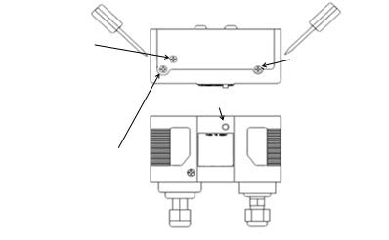
Anticlockwise: Decrease cut off
Low Pressure side range

a
djusting screw

Clockwise: Decrease cut in
pressure setting

Anticloc
kwise: Increase cut in
pressure sett
i
ng

Differential adjusting screw

Clockwise: Increase
differential pressure setting

Anticlockwise:Decrease
differential pressure setting

High Pressure side range
adjusting screw

Clockwise: Increase cut off
pressure setting

pressure setting

Manual reset switch

Low pressure High pressure side connector side connector

The low pressure cut off pressure is the setting of cut in minus the differential.

Important Note There must be no more than 10 compressor starts per hour. A higher number reduces the service life of the compressor. If necessary, use an anti-short-cycle timer in
the control circuit. Minimum a 2recommended. Only minute idle time after each minute runtime run for much during the pump after each shorter start of compressor and a 3 stop & start are
down cycle may the compressor intervals.
3.9 Fan speed controller setting

The fan speed controller regulates the speed of the condenser’s fan.
It keeps the condensing pressure at a steady level by changing the speed of the fan according to the required condensing pressure.

For model in Series 2 and 4 : Recommended setting for range setting pointer/ range adjusting screw as table below:

Medium Temp
Refrigerant | R404A/R407C/R407F/R407A | R134a
Setting (bar) | 19 | Series 2- 13  Series 4 -10

Low Temp
Refrigerant | R404A/R407A/R407C/R407F
Setting (bar) | JEHR model -19 JEHS model - 13

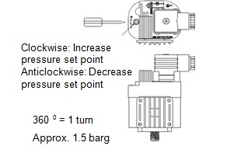
Clockwise:
Increase pressure
set point

Anticlockwise: Decrease
pressure set point

360
° =
1

turn

Approx. 1.5 barg

Cut off: Fan motor stops when the pressure decreases below the value P_{min}.

Note:
F.V.S. = Full Voltage Set Point (pressure setting for maximum speed)
E.P.B. = Effective Proportional Band (6 bar)
P_{min} = (F.V.S. – 6)

For Series 1 model: Recommended setting for Series 1 model which using pressure switch to on/off fan:

Refrigerant | R404A/ R407A/  R407F | R134a
Setting  (bar)  Cut in | 16 | 10
Setting  (bar)  Differential | 7 | 7

The low pressure cut off pressure is the setting of cut in minus the differential.

For model in Series 3, the fan speed controller setting as shown below.

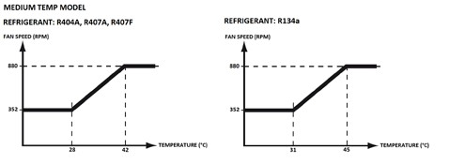
MEDIUM TEMP MODEL

REFRIG
ERANT: R404A, R407A, R407F

FAN SPEED (RPM)

REFRIGERANT : R134a

FAN SPEED (RPM)

TEMPERATURE (C°)

TEMPERATURE (C°)

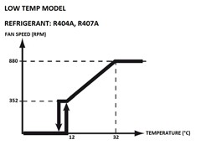
LOW

TEMP MODEL

REFRIGERANT: R404A, R407A

FAN SPEED (RPM)

TEMPERATURE (C°)

3.10 Commissioning of the Condensing Unit

Please make sure that all manual service valves are fully open when starting the system for the first time. This includes external and internal shut off valves as well as liquid receiver valve in the unit. The ball valve open position is shown as below:

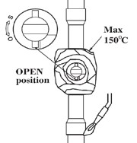  OPEN  position | MAX 150°C

3.11 Compressor electrical wiring

Verification of proper rotation direction is made by observing that suction pressure drops and discharge pressure rises when the compressor is energized. Reverse rotation of a scroll compressor also results in substantially reduced current draw. Suction temperature will be high, discharge temperature will be low and the compressor may generate abnormal noise.

3.12 Earthing of Condensing Unit

Installation of earth wire must be made to earthing screw
(labelled with earth label) before connecting the live wires.
The earth wire shall be slack as shown in below diagram.

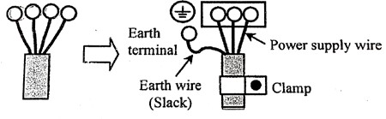
Eart wire

(
Slack)
Power supply wire

Clamp

Earth
terminal

4. Decommissioning & Disposal

At the end of the unit’s useful life, a suitably qualified engineer should decommission it. The refrigerant and compressor oil are classed as hazardous waste and as such must be reclaimed and disposed of in the correct manner, including completion of waste transfer paperwork. The unit components must be disposed of or recycled as appropriate in the correct manner.

5. Checklist

- Ensure the high low pressure controls are configured properly.
- Ensure crankcase heater is energized minimum 12 hours prior to start up and permanently energized.
- Check the refrigerant is correct for intended use.
- Check all electrical connections.
- Check all electrical termination and circuits are correct.
- Check compressor oil level via compressor sight glass, the oil level should not be lower than quarter of sight glass.
- Check the TXV capacity sizing based on indoor unit capacity. Check TXV applicable refrigerant. Check position and condition of the sensing bulb fixing
- Observed the system pressures during the charging and initial operation process.
- Ensure that suction pressure will decrease, discharge pressure will increase. No abnormal noise from the compressor.
- Continue to charge the system until sight glass is clear. Make sure that high pressure is > 14 barg for R404A and > 8 barg for R134a when doing this charge adjustment operation. Continuous flow of clear refrigerant through the sight glass, with perhaps an occasional bubble at very high temperature indicates the refrigerant is at optimum.
- Check the compressor’s discharge and suction pressure, to ensure it is within operating range. Discharge temperature should be within 50 to 90 °C and pressure should be around 15 to 26 barg (for system charged with R404A) and 8 to 16 barg (for system charged with R134a).
- Check the current of condensing unit and ensure it is below the motor circuit breaker setting value.
- Check condenser fan, ensure warm air blowing off the condenser coil.
- Check evaporator blower, ensure it’s discharging cool air.
- Check suction superheat and adjust expansion valve to prevent liquid flood back to the compressor. Recommended 5 to 20 K of suction superheat.
- Do not leave the system unattended until the system has reached its normal operating condition and the oil charge has properly adjusted itself to maintain the proper level in the sight glass.
- Check periodically the compressor performance and all the moving components during the first day of operation.
- Check the liquid line sight glass and expansion valve operation. If there is an indication that the system is low on refrigerant, thoroughly check the system for leaks before adding refrigerant.

6. Service and Maintenance
Important Note
Warning! – Disconnect the mains electrical supply before servicing or opening the unit
Warning! – Ensure there is no refrigerant in refrigerant circuit before dismantle it
Warning! – If the supply cord is damaged, it must be replaced by the qualified service agent in order to avoid a hazard.

The condensing units are designed to give long life operation with minimum maintenance. However, they should be routinely checked and the following service schedule is
recommended under normal circumstances: Important Note
For scroll compressor: wiring for 3 phases must be controlled. Supply phase sequence L1, L2 and L3 will affect the rotating direction of scroll compressor and damage the compressor.

Service technician should be present at initial start- up to verify that the supply power is properly phased and that compressor is rotating in the correct direction.

The removal of the top, side and front panels ensures that all parts are accessible.
- Compressor – Inspect at regular intervals • Check for refrigerant leaks on all joints and fittings.
  - Ensure that no abnormal noise or vibration is detected during test run.
  - Check the compressor oil levels and top up if required. The oil level should not be lower than quarter of the compressor oil sight glass. Not applicable to AE/AJ compressor.
- Condenser Coil – Clean and inspect at regular intervals
  - Remove surface dirt, leaves, fibers, etc. with a vacuum cleaner (preferably with a brush or other soft attachment rather than a metal tube), compressed air blown from the inside out, and/or a soft bristle (not wire!) brush. Do not impact or scrape the coil with the vacuum tube, air nozzle, etc. It may be beneficial to blow or vacuum out the rinse water from MCHE to speed drying and prevent pooling.
- Power Supply – Inspect at regular intervals
  - Check the running current and voltage for the condensing unit.
  - Check the electrical wiring and tighten the wires onto the terminal blocks if necessary.
Under normal circumstances:
  - Clean condenser coil every three months
  - To assure no leakage
  - Check and verify operation of all safety devices every three months, ensure crankcase heater is operational
  - Check sight glass and operating conditions
  - Check security of compressor mountings and the bolts that hold down the unit each year

7. F-Gas Information

- From 1/1/2015, a new F-Gas Regulation (EU) No
517/2014 comes into force repealing Regulation (EC) No 842/2006. This will affect system labelling, information supplied within documentation and also the way in which thresholds for frequency of leak testing.
- For systems with a charge below 3kg, the changes to the leak checking regime will not apply until 2017. Currently, there is no requirement for regular leak testing of systems with a total charge below 3kg.
- Changes to leak testing requirements are as follows:

OLD LEGISLATION | NEW LEGISLATION | LEAK CHECKING FREQUENCY
3-30 kgs | 5-50 TCO₂Eq | Every 12 months but can be increased to 24 months if fitted with a fixed leak detection system.
30-300 kgs | 50-500 TCO₂Eq | Every 6 months but can be increased to 12 months if fitted with a fixed leak detection system.
300+ kgs | 500+ TCO₂Eq | Every 6 months - however automatic leak detection system is mandatory which requires servicing every 12 months.

Important information regarding the refrigerant used

Its functioning relies on fluorinated greenhouse gases

- This product is factory charged with N2.
- The refrigerant system will be charged with fluorinated greenhouse gases. Do not vent gases into the atmosphere.

The GWP (Global Warming Potential) values of refrigerants which are specified for use in this equipment along with the three new thresholds for leak testing requirements based on TCO₂Eq (Tonnes CO₂ Equivalent) are as follows:

Refrigerant | GWP  (1) | Refrigerant Charge - kg
 |  | 5T | 50T | 500T
 |  | CO₂Eq | CO₂Eq | CO₂Eq
R404A | 3921.6 | 1.3 | 12.7 | 127
R407A | 2107 | 2.4 | 23.7 | 237
R407F | 1824.5 | 2.7 | 27.4 | 274
R134a | 1430 | 3.5 | 35.0 | 350

Please fill in with indelible ink, on the refrigerant charge label supplied with the product.

The total refrigerant charge & the TCO₂ equivalent for charged refrigerant.

The filled out label must be adhered in the proximity of the product charging port.
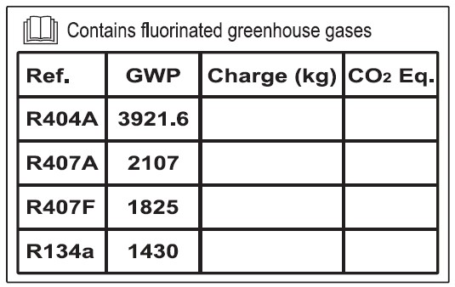

Contains fluorinated greenhouse gases

Ref.

GWP

Charge

)
(
kg

CO

₂
E
q
.

R404A

3921.6

R407A

2107

R407F

1825

R134a

1430

8. Trouble Shooting

This troubleshooting guide describes some common condensing unit failure. Consult qualified personnel before any corrective actions are taken.

Failure |  | Possible Causes
Fan does not work | • | Improper wiring
Compressor  does not start | •  • | Improper wiring  System stopped because of tripped of safety device.
Insufficient cooling | • | Incorrect TXV size and SH setting
 | • | Miss matching of indoor unit
 | • | Low refrigerant charge
 | • | Condenser coil dirty
 | • | Obstacle blocking air inlet/outlet
 | • | Improper thermostat setting
 | • | Compressor rotating direction is incorrect
Important Note
Warning! – Immediately shut off power of the unit if there is any event of accident or breakdown.

9. Specifications

 | Model | Series | COP/SEPR |  |  |  | Compressor |  |  | Oil type |  | Electrical Data |  |  |  |  |  | Airflow (m³/h) | Receiver | Connection |  | Dimensions |  |  | Weight (kg) | Sound pressure  dB(A)^{c} at  10 meter
 |  |  | R404A | R407A | R407F | R134a | Type | Displaceme nt (m³/h) | Oil Charge (Liter) |  | Power Input | Nominal  Currentª (A) R404A | Nominal  Currentª (A) R407A | Nominal  Currentª (A)  R407F | Nominal  Currentª (A)  R134a | Lock Rotor current (A) | MFA^{b} (A) |  | Volume  (Liter) | Suction (inch) | Liquid (inch) | Width (mm) | Depth (mm) | Height  (mm)
Medium temperature | JEHCCU0050CM1 | 1 | 1,45 | 1,33 | 1,47 | N/A | AE4460Z-FZ1C | 1,80 | 0,28 | Oil A^{f} | 230V/1~/50Hz | 3,79 | 3,74 | 3,78 | N/A | 19,4 | 10 | 1300 | 1,2 | 3/8" | 1/4" | 876 | 420 | 607 | 45 | 29
 | JEHCCU0067CM1 | 1 | 1,61 | 1,37 | 1,49 | N/A | CAJ9480Z | 2,64 | 0,887 |  | 230V/1~/50Hz | 3,53 | 3,32 | 3,53 | N/A | 22,6 | 10 | 1300 | 1,2 | 1/2" | 3/8" | 876 | 420 | 607 | 54 | 28
 | JEHCCU0100CM1 | 1 | 1,61 | 1,43 | 1,51 | N/A | CAJ9510Z | 3,18 | 0,887 |  | 230V/1~/50Hz | 4,26 | 4,00 | 4,21 | N/A | 30 | 10 | 1300 | 1,2 | 1/2" | 3/8" | 876 | 420 | 607 | 54 | 28
 | JEHCCU0113CM1 | 1 | 1,60 | 1,52 | 1,58 | N/A | CAJ9513Z | 4,21 | 0,887 |  | 230V/1~/50Hz | 5,27 | 4,88 | 5,11 | N/A | 33,5 | 12 | 1300 | 1,2 | 1/2" | 3/8" | 876 | 420 | 607 | 55 | 28
 | JEHCCU0040CM1 | 1 | N/A | N/A | N/A | 1,28 | AE4440Y-FZ1A | 1,80 | 0,28 |  | 230V/1~/50Hz | N/A | N/A | N/A | 2,55 | 13,2 | 10 | 1300 | 1,2 | 3/8" | 1/4" | 876 | 420 | 607 | 45 | 29
 | JEHCCU0051CM1 | 1 | N/A | N/A | N/A | 1,53 | CAJ4461Y | 3,18 | 0,887 |  | 230V/1~/50Hz | N/A | N/A | N/A | 3,65 | 19 | 10 | 1300 | 1,2 | 3/8" | 1/4" | 876 | 420 | 607 | 53 | 29
 | JEHCCU0063CM1 | 1 | N/A | N/A | N/A | 1,55 | CAJ4476Y | 3,79 | 0,887 |  | 230V/1~/50Hz | N/A | N/A | N/A | 4,65 | 24 | 10 | 1300 | 1,2 | 3/8" | 1/4" | 876 | 420 | 607 | 53 | 29
 | JEHCCU0077CM1 | 1 | N/A | N/A | N/A | 1,63 | CAJ4492Y | 4,51 | 0,887 |  | 230V/1~/50Hz | N/A | N/A | N/A | 5,25 | 27 | 10 | 1300 | 1,2 | 1/2" | 3/8" | 876 | 420 | 607 | 54 | 29
 | JEHCCU0095CM1 | 1 | N/A | N/A | N/A | 1,65 | CAJ4511Y | 5,69 | 0,887 |  | 230V/1~/50Hz | N/A | N/A | N/A | 4,17 | 30 | 10 | 1300 | 1,2 | 1/2" | 3/8" | 876 | 420 | 607 | 54 | 29
 | JEHCCU0140CM1 | 2 | 1,68 | 1,57 | 1,75 | N/A | CAJ4517Z | 4,52 | 0,887 |  | 230V/1~/50Hz | 5,90 | 5,19 | 6,07 | N/A | 38,5 | 16 | 2700 | 4,5 | 5/8" | 3/8" | 1101 | 444 | 662 | 68 | 34
 | JEHCCU0140CM3 | 2 | 1,80 | 1,50 | 1,67 | N/A | TAJ4517Z | 4,52 | 0,887 |  | 400V/3~/50Hz | 2,94 | 2,37 | 2,96 | N/A | 18 | 10 | 2700 | 4,5 | 5/8" | 3/8" | 1101 | 444 | 662 | 68 | 34
 | JEHSCU0200CM1 | 2 | 2,25 | 2,13 | 1,88 | 1,85 | ZB15KQE-PFJ | 5,90 | 1,24 | Oil C^{f} | 230V/1~/50Hz | 7,88 | 8,10 | 8,68 | 5,45 | 58 | 16 | 2700 | 4,5 | 3/4" | 3/8" | 1101 | 444 | 662 | 70 | 33
 | JEHSCU0200CM3 | 2 | 2,06 | 2,07 | 1,81 | 2,12 | ZB15KQE-TFD | 5,90 | 1,24 |  | 400V/3~/50Hz | 3,51 | 3,43 | 3,65 | 2,94 | 26 | 10 | 2700 | 4,5 | 3/4" | 3/8" | 1101 | 444 | 662 | 70 | 33
 | JEHSCU0250CM1 | 2 | 2,00 | 2,01 | 1,79 | 2,14 | ZB19KQE-PFJ | 6,80 | 1,30 |  | 230V/1~/50Hz | 9,87 | 9,70 | 10,35 | 6,24 | 61 | 16 | 2700 | 4,5 | 3/4" | 3/8" | 1101 | 444 | 662 | 72 | 34
 | JEHSCU0250CM3 | 2 | 2,07 | 1,95 | 1,79 | 2,13 | ZB19KQE-TFD | 6,80 | 1,36 |  | 400V/3~/50Hz | 4,75 | 4,41 | 4,71 | 3,36 | 32 | 10 | 2700 | 4,5 | 3/4" | 3/8" | 1101 | 444 | 662 | 72 | 34
 | JEHSCU0300CM1 | 2 | 1,88 | 1,89 | 1,69 | 2,13 | ZB21KQE-PFJ | 8,60 | 1,45 |  | 230V/1~/50Hz | 12,83 | 12,32 | 13,13 | 7,44 | 82 | 20 | 2700 | 4,5 | 3/4" | 3/8" | 1101 | 444 | 662 | 74 | 36
 | JEHSCU0300CM3 | 2 | 1,94 | 1,86 | 1,65 | 2,10 | ZB21KQE-TFD | 8,60 | 1,45 |  | 400V/3~/50Hz | 4,97 | 4,80 | 5,66 | 3,75 | 40 | 10 | 2700 | 4,5 | 3/4" | 3/8" | 1101 | 444 | 662 | 74 | 36
 | JEHSCU0350CM3 | 2 | 2,61 | N/A | N/A | 2,08 | ZB26KQE-TFD | 9,90 | 1,5 |  | 400V/3~/50Hz | 6,43 | N/A | N/A | 4,28 | 46 | 10 | 2700 | 4,5 | 3/4" | 3/8" | 1101 | 444 | 662 | 74 | 39
 | JEHSCU0400CM3 | 3 | 2,77 | 3,09 | 2,83 | 2,29 | ZB29KQE-TFD | 11,40 | 1,36 |  | 400V/3~/50Hz | 8,20 | 6,20 | 6,31 | 5,20 | 50 | 16 | 4250 | 7,6 | 7/8" | 1/2" | 1353 | 575 | 872 | 119 | 37
 | JEHSCU0500CM3 | 3 | 2,64 | 2,81 | 2,60 | 2,69 | ZB38KQE-TFD | 14,40 | 2,07 |  | 400V/3~/50Hz | 9,11 | 8,30 | 8,40 | 6,57 | 65,5 | 16 | 4250 | 7,6 | 7/8" | 1/2" | 1353 | 575 | 872 | 123 | 38
 | JEHSCU0600CM3 | 3 | 2,72 | 2,75 | 2,69 | 2,63 | ZB45KQE-TFD | 17,10 | 1,89 |  | 400V/3~/50Hz | 9,56 | 8,62 | 9,21 | 6,87 | 74 | 16 | 4100 | 7,6 | 1-1/8" | 1/2" | 1353 | 575 | 872 | 125 | 40
 | JEHSCU0680CM3 | 3 | 2,65 | 2,64 | 2,59 | 2,57 | ZB48KQE-TFD | 18,80 | 1,8 |  | 400V/3~/50Hz | 12,33 | 11,50 | 11,80 | 8,67 | 101 | 20 | 4100 | 7,6 | 1-1/8" | 1/2" | 1353 | 575 | 872 | 126 | 40
 | JEHSCU0800CM3 | 4 | 2,90 | 2,88 | 2,83 | 2,92 | ZB58KCE-TFD | 22,10 | 2,5 |  | 400V/3~/50Hz | 13,00 | 12,57 | 12,33 | 12,41 | 95 | 20 | 8500 | 13,6 | 1-1/8" | 3/4" | 1348 | 641 | 1727 | 218 | 43
 | JEHSCU1000CM3 | 4 | 2,57 | 2,35 | 2,53 | 2,88 | ZB76KCE-TFD | 29,10 | 3,2 |  | 400V/3~/50Hz | 16,20 | 15,67 | 15,76 | 12,60 | 118 | 25 | 8500 | 13,6 | 1-3/8" | 3/4" | 1348 | 641 | 1727 | 218 | 43

- Refer to condition: Outside ambient temperature= 32°C, Evaporation temperature = -10°C (medium temperature application)
- MFA = Maximum Fuse Amps (R404A) ^{c} Sound pressure level measured in anechoic room ^{f} Oil A = Uniqema Emkarate RL32CF
Copeland Ultra 32-3MAF, Mobil EALf Oil C = Polyester oil (Copeland Ultra 22 CC, Copeland Ultra 32 CC, TM Arctic 22 CC, Uniqema
Emkarate RL32CF)
Note: condensing units are pre-charged with oil as stated in table

O-CU06-DEC14-1 10
All specifications are subjected to change by the manufacturer without prior notice.
The English text is the original instruction. Other languages are the translations of the original instructions.

M | odel | Series | COP/SEPR |  | Compressor |  |  | Oil type |  | Electrical Data |  |  |  | Airflo w  (m³/h) | Receiver | Connection |  |  | Dimensions |  | Weight (kg) | Sound pressure dB(A) ^{c} at 10 meter
 |  |  | R404A | R407A | Type | Displaceme nt (m³/h) | Oil Charge (Liter) |  | Power Input | Nominal  Current ª (A)  R404A | Nominal  Current ª (A)  R407A | Lock Rotor current (A) | MFA^{b} (A) |  | Volume  (Liter) | Suction (inch) | Liquid (inch) | Width (mm) | Depth (mm) | Height (mm)
Low temperature | JEHCCU0115CL1 | 1 | 0,96 | N/A | CAJ2446Z | 4,55 | 0,887 | Oil A^{f} | 230V/1~/50Hz | 4,00 | N/A | 29 | 10 | 1300 | 1,2 | 3/8" | 1/4" | 876 | 420 | 607 | 55 | 31
 | JEHSCU0200CL3 | 2 | 0,97 | N/A | ZF06K4E-TFD | 5,9 | 1,3 | Oil C^{f} | 400V/3~/50Hz | 3,30 | N/A | 26 | 10 | 2700 | 4,5 | 1/2" | 3/8" | 1101 | 444 | 662 | 70 | 32
 | JEHSCU0300CL3 | 2 | 1,09 | N/A | ZF09K4E-TFD | 8 | 1,5 |  | 400V/3~/50Hz | 4,40 | N/A | 40 | 10 | 2700 | 4,5 | 5/8" | 3/8" | 1101 | 444 | 662 | 70 | 33
 | JEHSCU0400CL3 | 3 | 1,88 | 1,67 | ZF13K4E-TFD | 11,8 | 1,9 |  | 400V/3~/50Hz | 5,79 | 5,39 | 51,5 | 10 | 4250 | 7,6 | 1-1/8" | 1/2" | 1353 | 575 | 872 | 132 | 37
 | JEHSCU0500CL3 | 3 | 1,79 | 1,67 | ZF15K4E-TFD | 14,5 | 1,9 |  | 400V/3~/50Hz | 7,59 | 6,58 | 64 | 16 | 4250 | 7,6 | 1-1/8" | 1/2" | 1353 | 575 | 872 | 132 | 39
 | JEHSCU0600CL3 | 3 | 1,80 | 1,52 | ZF18K4E-TFD | 17,1 | 1,9 |  | 400V/3~/50Hz | 8,51 | 7,00 | 74 | 16 | 4250 | 7,6 | 1-1/8" | 1/2" | 1353 | 575 | 872 | 133 | 41
 | JEHSCU0750CL3 | 4 | 1,82 | 1,51 | ZF25K4E-TFD | 21,40 | 1,9 |  | 400V/3~/50Hz | 9,15 | 8,75 | 102 | 16 | 5750 | 13,6 | 1-1/8" | 1/2" | 1348 | 605 | 1727 | 203 | 41

ª Refer to condition: Outside ambient temperature= 32°C, Evaporation temperature = -35°C , Suction Return Gas Temperature = 20°C , Subcooling 0K (low temperature application)
^{b} MFA = Maximum Fuse Amps (R404A) ^{c} Sound pressure level measured in anechoic room ^{f} Oil A = Uniqema Emkarate RL32CF ^{f} Oil C = Polyester oil (Copeland Ultra 22 CC, Copeland Ultra 32 CC, Copeland Ultra 32-3MAF, Mobil EALTM Arctic 22 CC, Uniqema Emkarate RL32CF)

Note: condensing units are pre-charged with oil as stated in table

O-CU06-DEC14-1 11
All specifications are subjected to change by the manufacturer without prior notice. The English text is the original instruction. Other languages are the translations of the original instructions.

10. Outline drawings
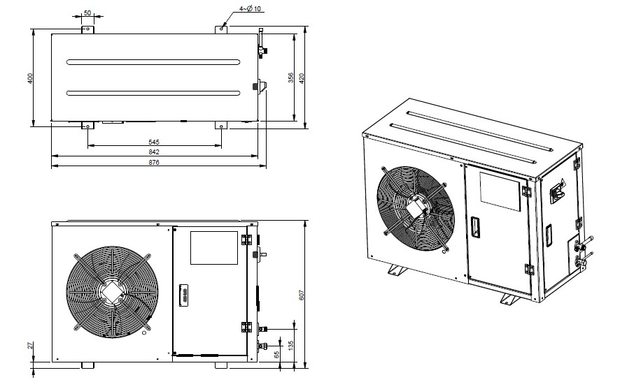

Series 1

Series 2

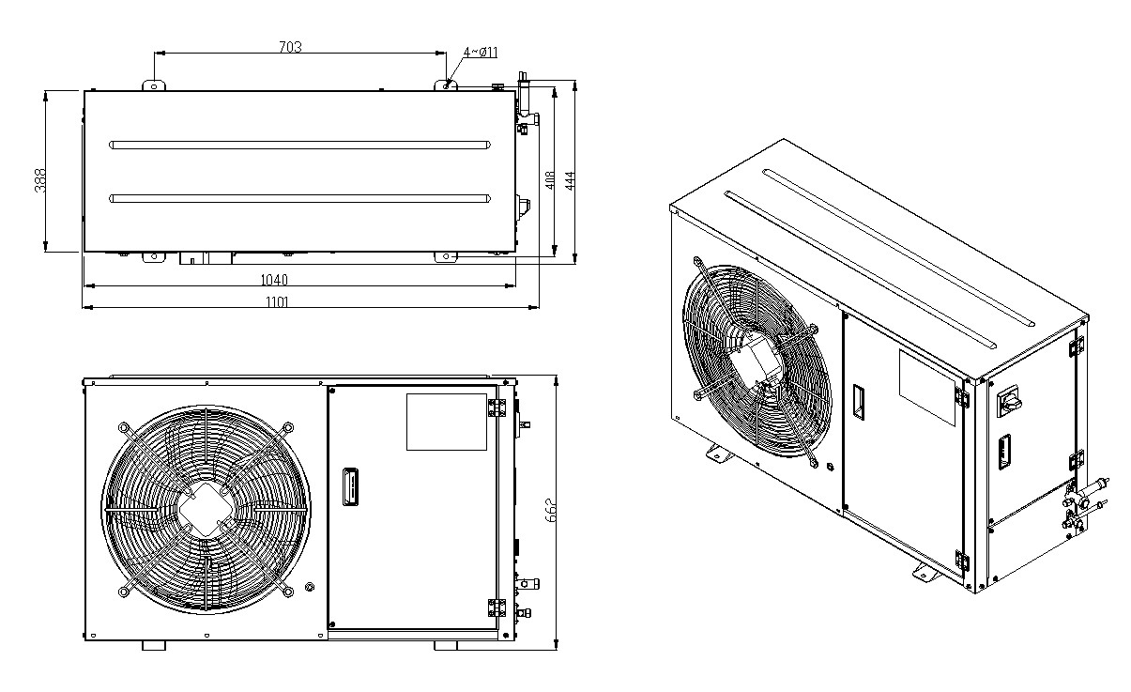

Series 3

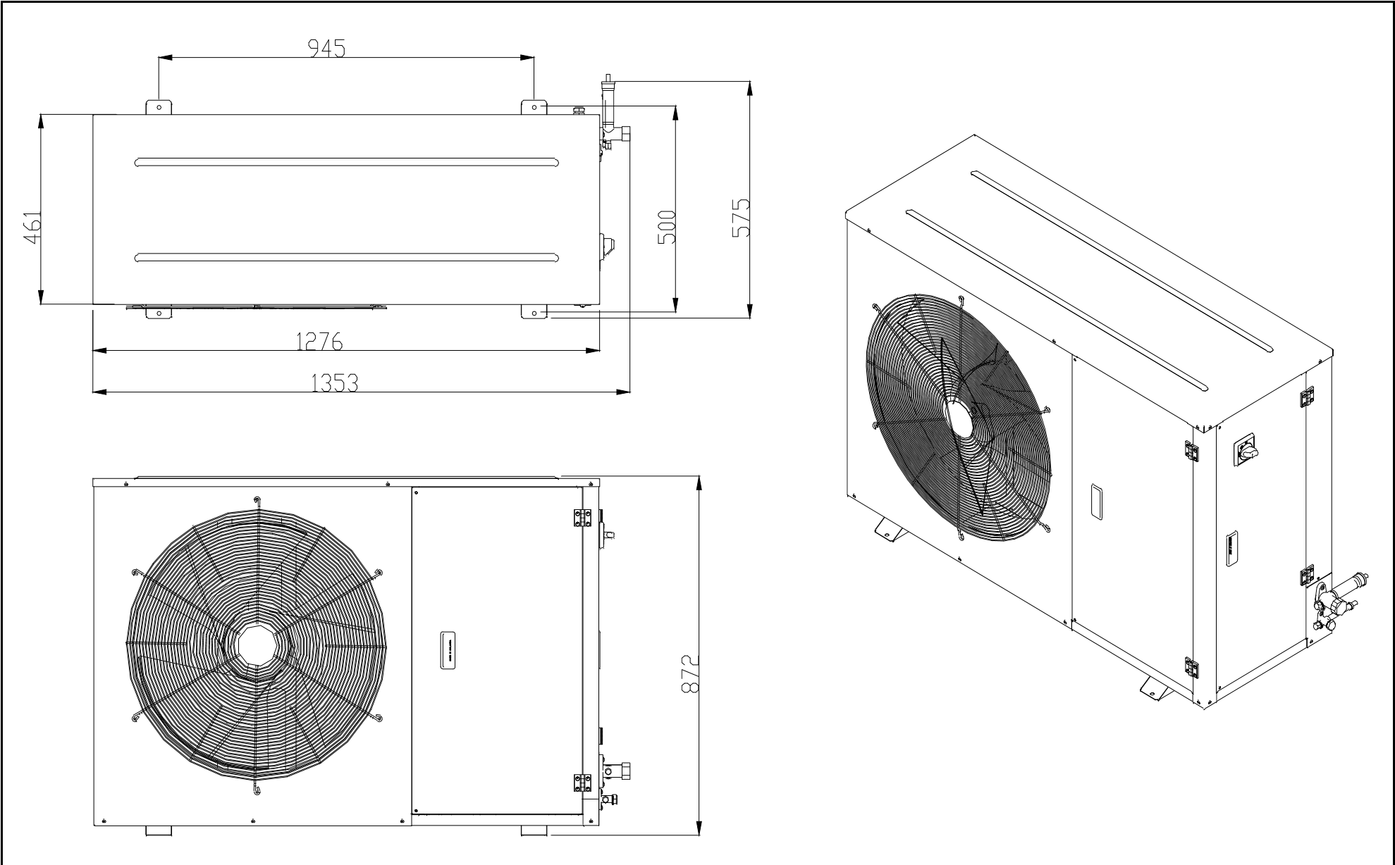

Series 4

Medium Temperature

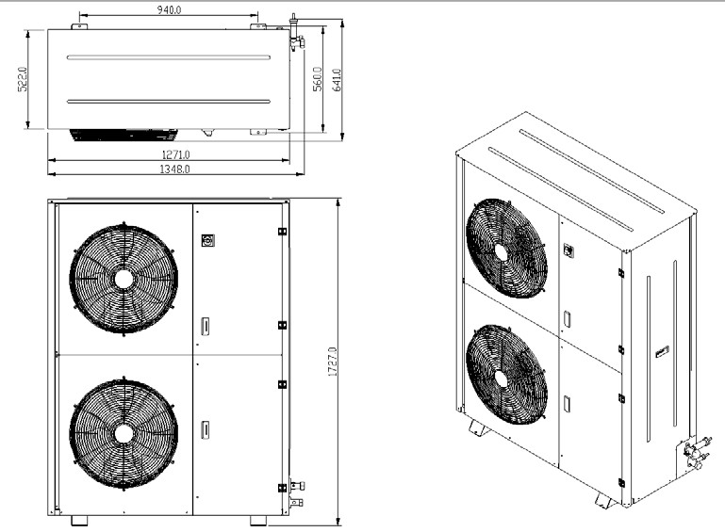

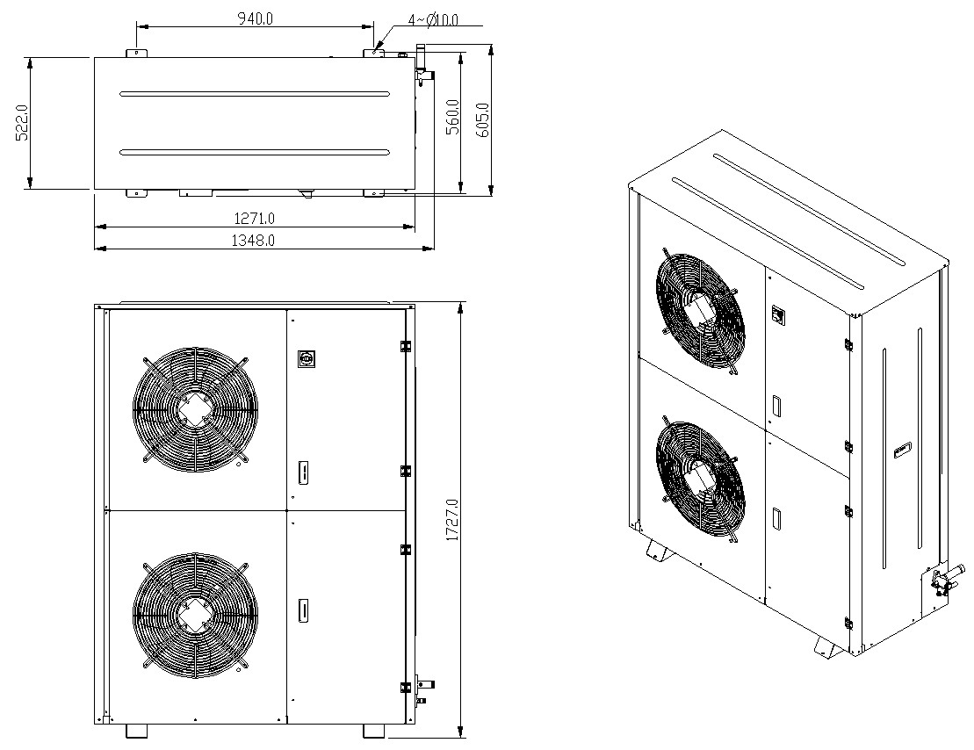
Low Temperature

10. Electrical Data

Important Note: All wiring and connections to the condensing unit must be made in accordance to the local codes.
Single Phase
JEHCCU0040CM1; JEHCCU0050CM1

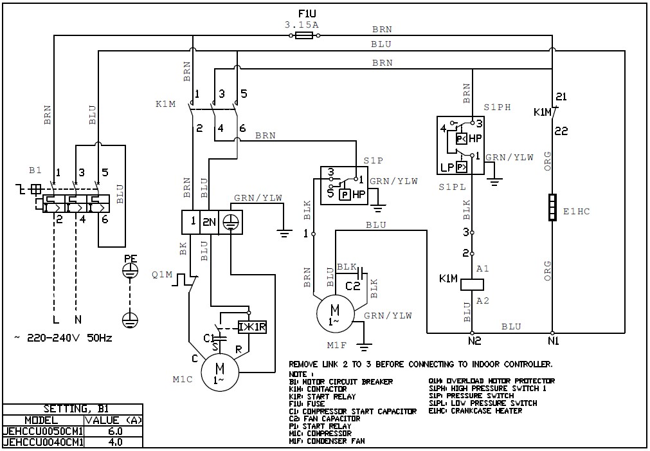

REMOVE LINK 2 TO 3 BEFORE CONNECTING TO INDOOR CONTROLLER

NOTE:

B1: MOTOR CIRCUIT BREAKER

Q1M: OVERLOAD MOTOR PROTECTOR
K1M: CONT
ACTOR

S1PH: HIGH PRESSURE SWITCH 1
K1
R: START RELAY

S1P: PRESSURE SWITCH
F1U: FUSE

S1PL: LOW PRESSURE SWITCH
C1 COMPRESSOR START CAPACITOR

E1HC: CRANKCASE HEATER
C2: FAN CAPACITOR

P1: START RELAY

M1C: COMPRESSOR

M1F CONDENSER FAN

SETTING
, B1

MODEL

VALUE <A>

JEHCCU0050CM1

6.0

JEHCCU0040CM1

4.0

JEHCCU0051CM1; JEHCCU0063CM1; JEHCCU0077CM1
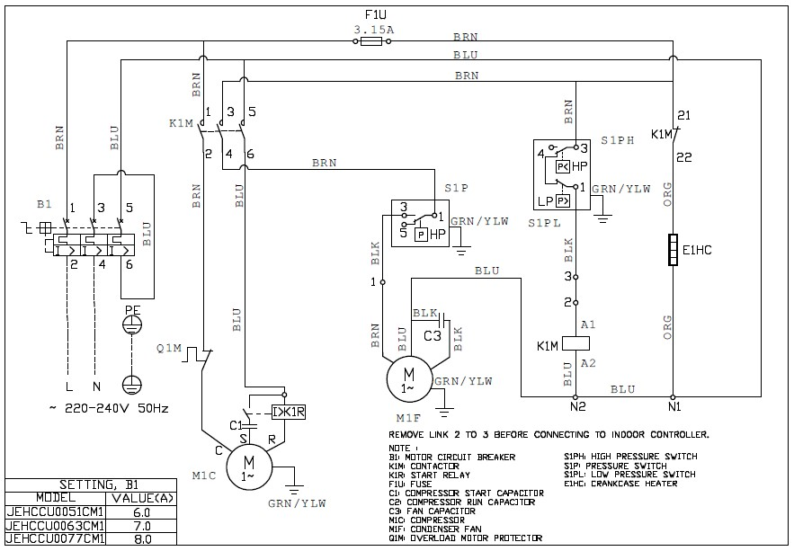

REMOVE
LINK 2 TO 3 BEFORE CONNECTING TO INDOOR CONTROLLER

NOTE:

B1: MOTOR CIRCUIT BREAKER

S1PH: HIGH PRESSURE SWITCH
K1M: CONT
ACTOR

S1P: PRESSURE SWITCH
K1R: START RELAY

S1PL: LOW PRESSURE SWITCH
F1U: FUSE

E1HC: CRANKCASE HEATER
C1
:
COMPRESSOR START CAPACITOR
C2: COMPRESSOR RUN CAPACITOR

C3: FAN CAPACITOR

M1C: COMPRESSOR

M1F CONDENSER FAN

Q
1
M: OVERLOAD MOTOR PROTECTOR
SETTING
, B1

MODEL

VALUE <A>

JEHCCU0051
CM1

6.0

JEHCCU0063CM1

7.0

JEHCCU0077CM1

8.0

JEHCCU0067CM1; JEHCCU0095CM1; JEHCCU0100CM1; JEHCCU0113CM1; JEHCCU0115CL1
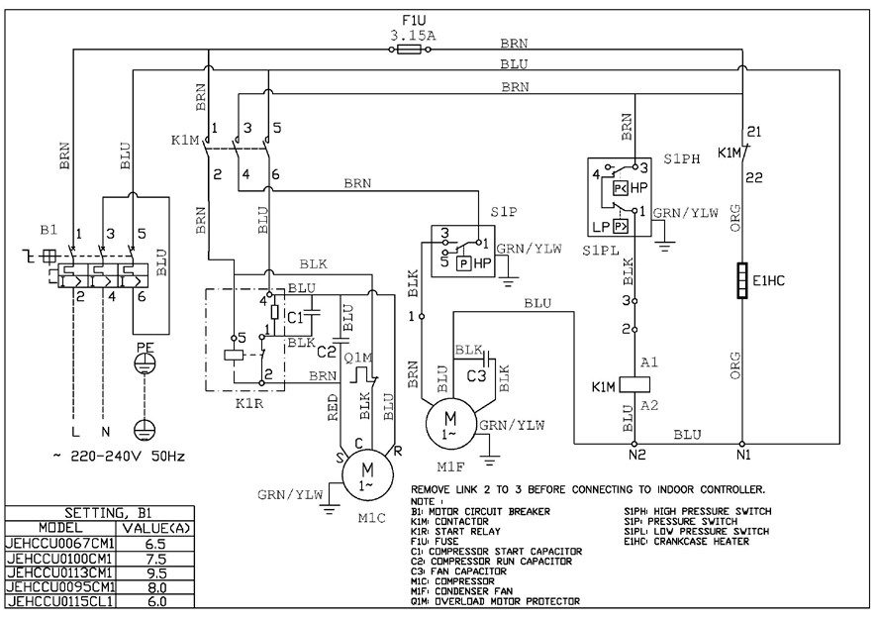

REMOVE LINK 2 TO 3 BEFORE CONNECTING TO INDOOR CONTROLLER

NOTE:

B1: MOTOR CIRCUIT BREAKER

S1PH: HIGH PRESSURE SWITCH
K1M: CONTACTOR

S1P: PRESSURE SWITCH
K1R
:
START RELAY

S1PL: LOW PRESSURE SWITCH
F1U: FUSE

E1HC: CRANKCASE HEATER
C1
:
COMPRESSOR START CAPACITOR
C2: COMPRESSOR RUN CAPACITOR

C3: FAN CAPACITOR

M1C: COMPRESSOR

M1F CONDENSER FAN

Q
M: OVERLOAD MOTOR PROTECTOR
1
SETTING
, B1

MODEL

VALUE <A>

JEHCCU0067CM1

6.5

JEHCCU0100CM1

7.5

JEHCCU0113CM1

9.5

JEHCCU0095CM1

8.0

JEHCCU0115CL1

6.0

JEHCCU0140CM1
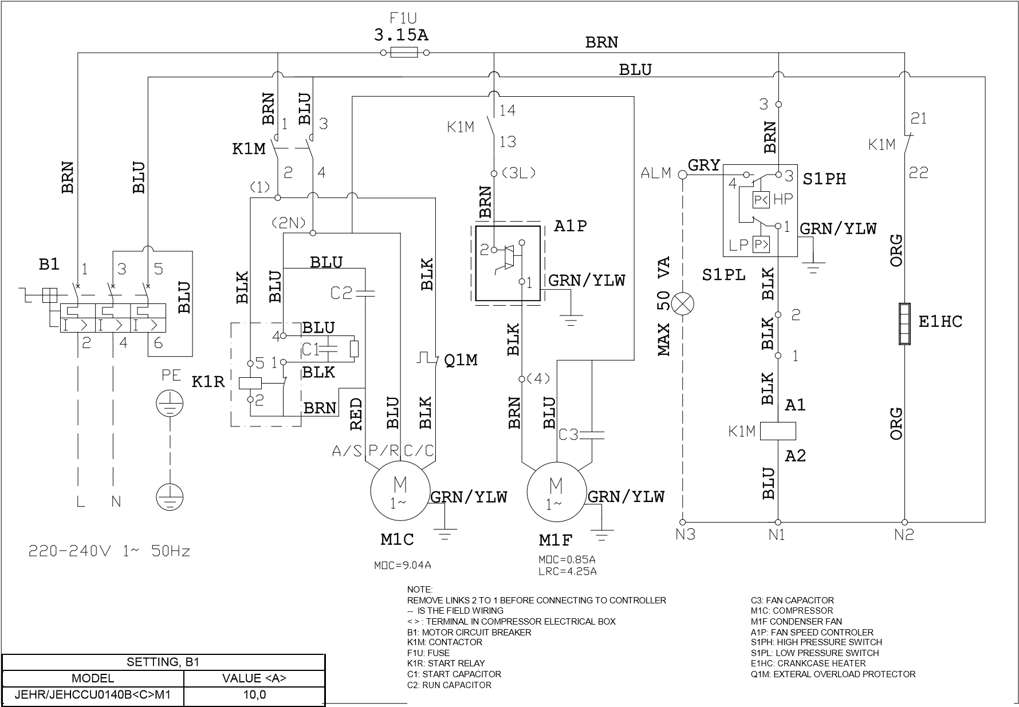

JEHSCU0200CM1, JEHSCU0250CM1, JEHSCU0300CM1
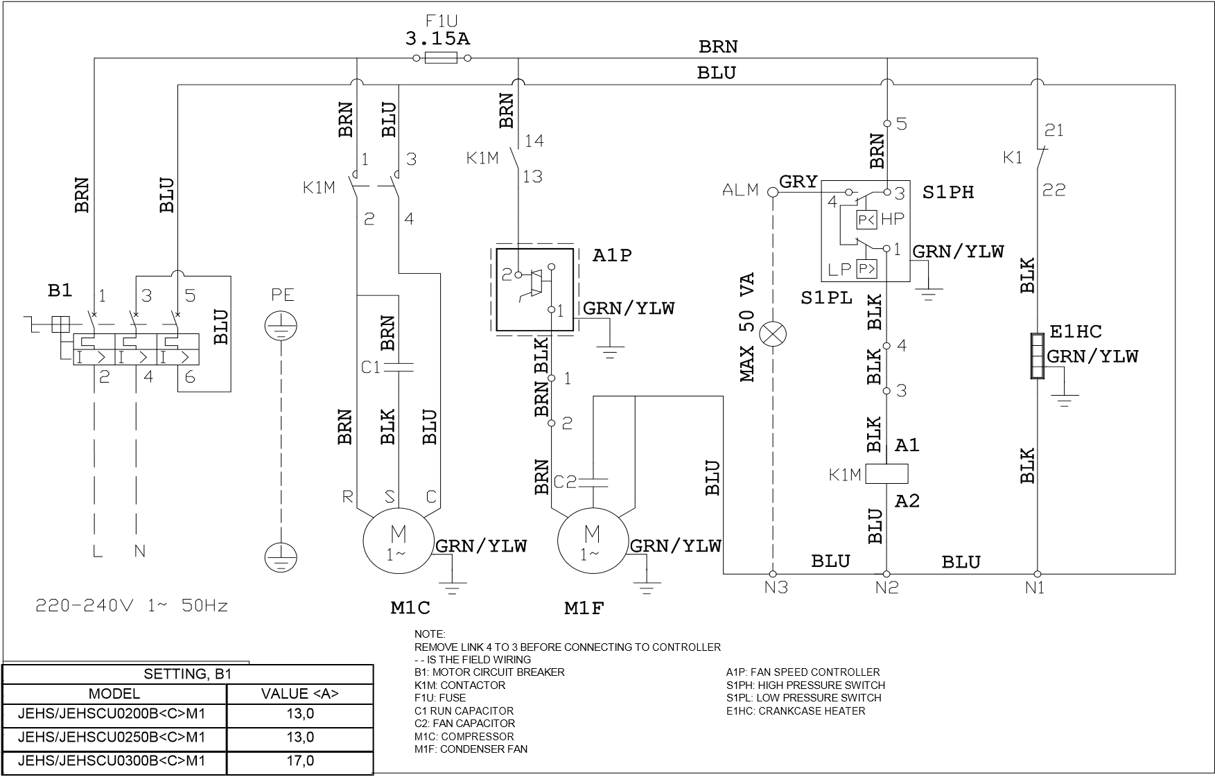

Three Phase
JEHCCU0140CM3
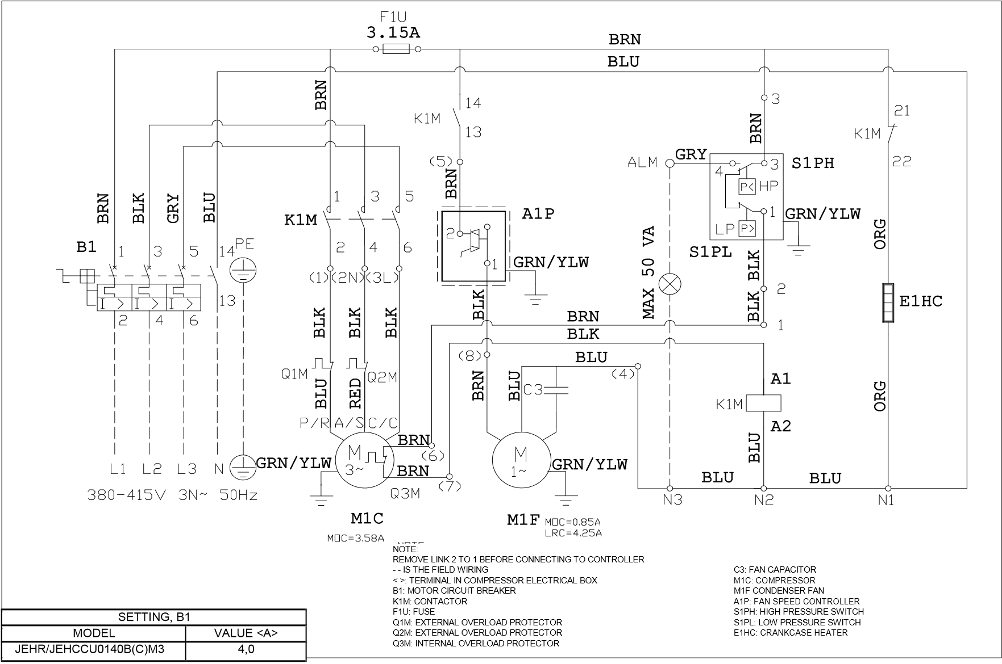

JEHSCU0200CM3, JEHSCU0250CM3, JEHSCU0300CM3, JEHSCU0350CM3,
JEHSCU0200CL3, JEHSCU0300CL3
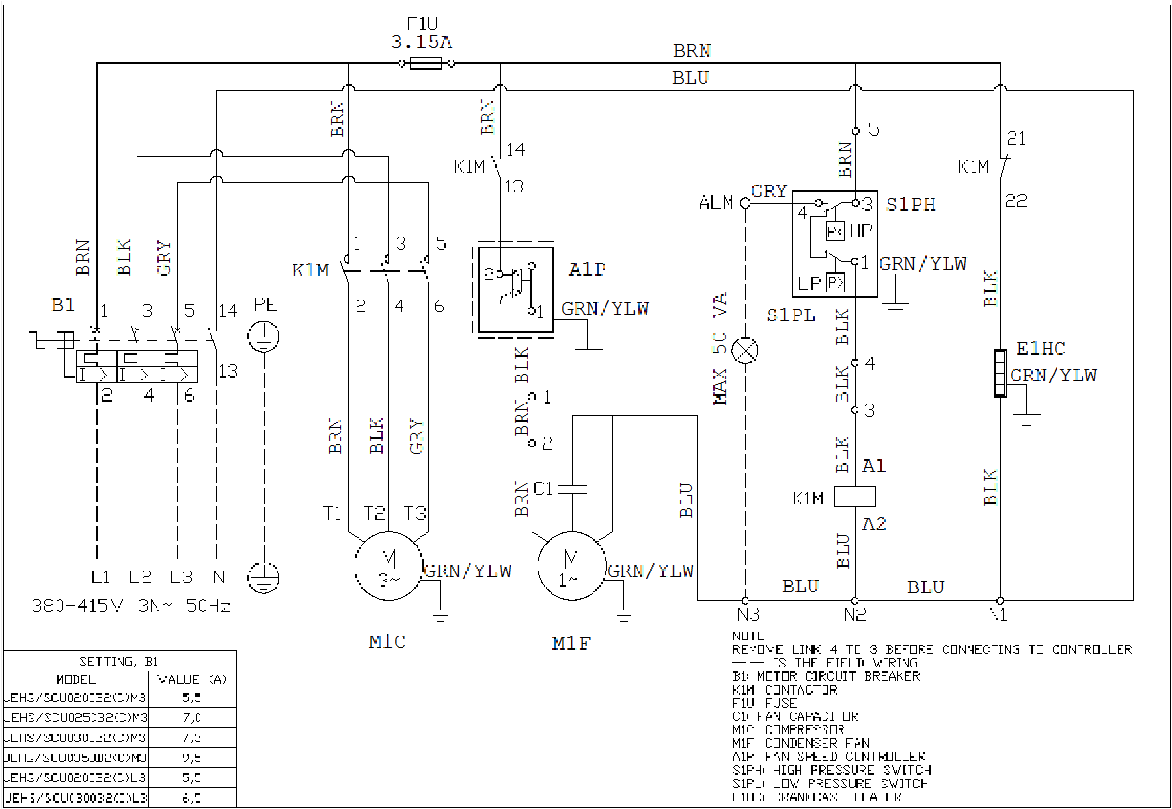

NOTE:

REMOVE LINK
4 TO 3 BEFORE CONNECTING TO CONTROLLER
-
- IS THE FIELD WIRING
B1: MOTOR CIRCUIT BREAKER

K1M: CONT
ACTOR
F1U: FUSE

C1 FAN CAPACITOR

M1C: COMPRESSOR

M1F
CONDENSER FAN
A1P: FAN SPEED CONTROLLER

S1PH: HIGH PRESSURE SWITCH

S1PL
:
LOW PRESSURE SWITCH
E1HC: CRANKCASE HEATER

SETTING
, B1

MODEL

VALUE <A>

JEHS/SCU0200B2(C)M3

5
5
,

JEHS/SCU0250B2(C)M3

,
0
7

JEHS/SCU0300B2(C)M3

5
7
,

JEHS/SCU0350B2(C)M3

9
5
,

JEHS/SCU0200B2(C)L3

5
5
,

JEHS/SCU0300B2(C)L3

6
5
,

JEHSCU0400CM3, JEHSCU0500CM3, JEHSCU0600CM3, JEHSCU0680CM3,
JEHSCU0400CL3, JEHSCU0500CL3, JEHSCU0600CL3

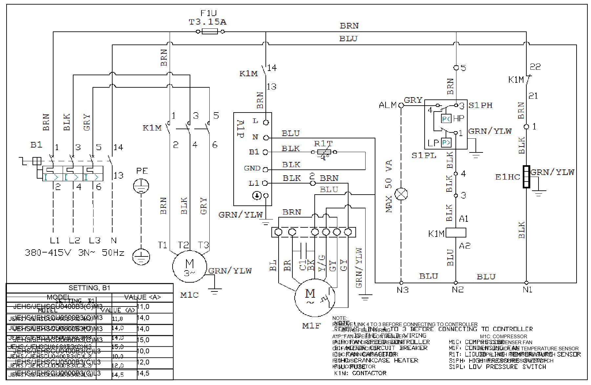

JEHSCU0800CM3, JEHSCU1000CM3

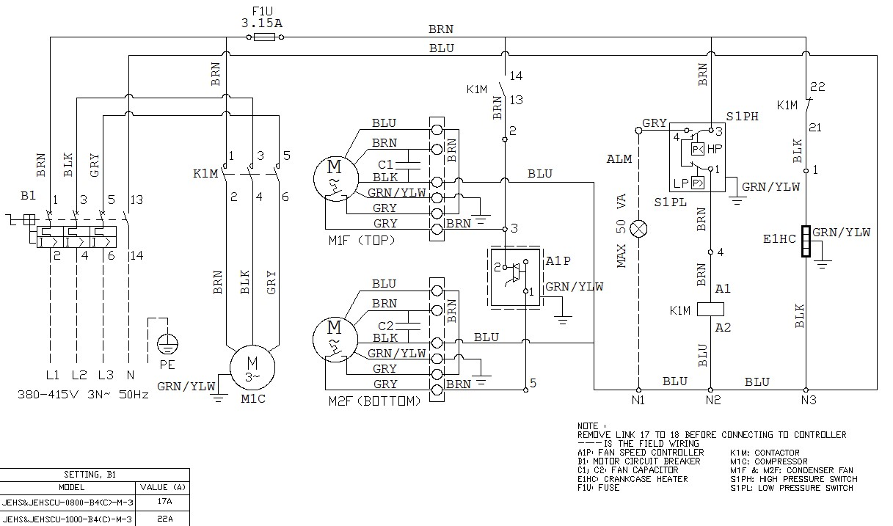
NOTE:
REMOVE LINK 17 TO 18 BEFORE CONNECTING TO CONTROLLER
- - - IS THE FIELD WIRING
A1P: FAN SPEED CONTROLLER
B1: MOTOR CIRCUIT BREAKER
C1, C2: FAN CAPACITOR
E1HC: CRANKCASE HEATER
F1U: FUSE
K1M: CONTACTOR
M1C: COMPRESSOR
M1F & M2F: CONDENSER FAN
S1PH: HIGH PRESSURE SWITCH
S1PH: LOW PRESSURE SWITCH
SETTING, B1
MODEL | VALUE <A>
JEHS&JEHSCU-0800-B4(C)-M-3 | 17A
JEHS&JEHSCU-1000-B4(C)-M-3 | 22A

JEHSCU0750CL3

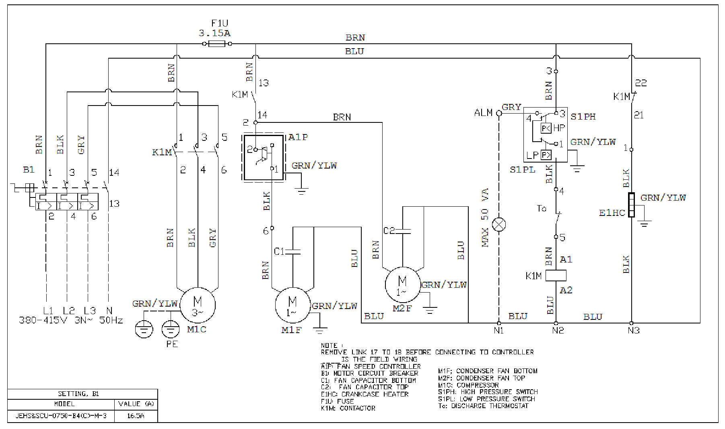

NOTE:

REMOVE
LINK 17 TO 18 BEFORE CONNECTING TO CONTROLLER
-
- - IS THE FIELD WIRING
A1P: FAN SPEED CONTROLLER

M1F CONDENSER FAN BOTTOM
B1: MOTOR CIRCUIT BREAKER

M2F CONDENSER FAN TOP
C1: FAN CAPACITOR BOTTOM

M1C: COMPRESSOR
C2: FAN CAPACITOR TOP

S1PH: HIGH PRESSURE SWITCH
E1HC: CRANKCASE HEATER

S1PL: LOW PRESSURE SWITCH
F1U: FUSE

To: DISCHARGE THERMOSTAT
K1M: CONT
ACTOR

SETTING
, B1

MODEL

VALUE <A>

JEHS&SCU
-
0750
-
B4(C)
-
M
-
3

16
,5A

11. Appendix

CHECKLIST BEFORE START-UP

NO. | Description | Record
1 | Is the unit in good condition and without any visible damage? | ⧠ Yes
2 | Has the unit been transported in upward position? | ⧠ Yes
3 | Is the crankcase oil level between ¼ and ¾ of the compressor sight glass? | ⧠ Yes
4 | Is the power supply on site in line with the unit specification? | ⧠ Yes
5 | Is air short circuit and/or air blockage avoided? | ⧠ Yes
6 | Is the location well ventilated? | ⧠ Yes
7 | Is there sufficient space for air flow and maintenance? | ⧠ Yes
8 | Is all the pre-charged nitrogen released before the field pipe connection started? | ⧠ Yes
9 | Has nitrogen been blown through the pipes during brazing? | ⧠ Yes
10 | Is there only 1 indoor unit connected to the CDU? | ⧠ Yes
11 | Does the field piping has the same diameter as the pipes coming from CDU? | ⧠ Yes
12 | Is the suction pipe insulated? | ⧠ Yes
13 | Does the bends have enough bending radius? | ⧠ Yes
14 | Is the total pipe length less than 25m? | ⧠ Yes
15 | Is the height difference within the specifications [refer page 7] | ⧠ Yes
16 | Are the oil traps in the vertical suction line correctly positioned? [refer page 3] | ⧠ Yes
17 | Does the CDU capacity matches the indoor unit capacity? | ⧠ Yes
18 | Does the TXV capacity matches the indoor unit capacity? | ⧠ Yes
19 | Is the TXV sensing bulb fixing in good position/condition? | ⧠ Yes
20 | Is there a MOP expansion valve installed? [refer page 3] | ⧠ Yes
21 | Was inert, dry gas (e.g. Nitrogen) used when pressure testing? | ⧠ Yes
22 | Could the leak test pressures be reached? | ⧠ Yes
23 | Did the test pressure stayed stable after at least 24 hours? | ⧠ Yes
24 | Could the vacuum condition (< -0.1 barg for 2 hours) be reached? | ⧠ Yes
25 | Did the pressure stayed stable for at least 1 hour, when turning off the vacuum pump? | ⧠ Yes
26 | Is the high/low pressure safety on the pressure switch set correctly? [refer page4] | ⧠ Yes
27 | Is the fan speed controller set correctly? [refer page 4] | ⧠ Yes
28 | Is the correct circuit breaker been used? | ⧠ Yes
29 | Is there an earth connection foreseen? | ⧠ Yes
30 | Are all terminal connections good/tight connected? | ⧠ Yes
31 | Is the crankcase heater been energized for minimum 12 hours before start up? | ⧠ Yes
32 | Is the refrigerant correct for intended use? | ⧠ Yes
33 | Is the high pressure above the minimum limit when charging the system? [refer page 5] | ⧠ Yes
34 | Is the refrigerant charge amount correct (clear sight glass)? | ⧠ Yes

Remarks: the system may only be started up if all questions can be answered with “Yes”.

CHECKLIST BEFORE COMMISSIONING

No. | Description | Record
1 | Is the suction pressure decreasing and the discharge pressure increasing? | ⧠ | Yes
2 | Is the compressor rotation (only for scroll type) correct (no abnormal noise)? | ⧠ | Yes
3 | Is the crankcase oil level between 1/4 and 3/4 of the compressor sight glass? (after 3 or 4 hours of operation) | ⧠ | Yes
4 | Is the discharge temperature within the limits (between 50 °C and 90 °C)? | ⧠ | Yes
5 | Is the suction superheat within the limits (between 5K and 20K) during normal operation? | ⧠ | Yes
6 | Is the suction superheat within the limits (between 5K and 20K) after defrost operation? | ⧠ | Yes
7 | Is the running current below isolator setting value? | ⧠ | Yes
8 | Is warm air blowing out from the condenser fan? | ⧠ | Yes
9 | Is the compressor On/Off cycle within the specification? [Refer page 4] | ⧠ | Yes
Remarks: The system may only be handed over to user/owner if all questions can be answered with “Yes”.
Additional advice:
- Do not leave the system unattended until the system has reached its normal operating condition and the oil charge has properly adjusted itself to maintain the proper level in the sight glass.
- Check periodically the compressor performance and all the moving components during the first day of operation.
- Check the liquid line sight glass and expansion valve operation. If there is an indication that the system is low on refrigerant, thoroughly check the system for leaks before adding refrigerant.

SITE RECORDINGS

Customer name : Field Settings
Installer name : Pressure switch settings : Installation date : Cut Out (High Side) :
Cut In (Low Side) : Unit model name : Differential (Low Side) :
Unit serial number :
Fan speed controller setting :
Indoor unit :
Expansion valve : Running conditions
Discharge temperature : Refrigerant type : Suction superheat normal operation :
Ambient temp. : Minimum suction superheat after
Thermostat setting : defrost operation :
Running current before defrost : Unit location/Field piping Running current after defrost : Piping length : Suction pressure (Pe) : Position of CDU : Above/below indoor unit Liquid line pressure (Pc) : Height difference :
.

1-13

