DESIGN, HERITAGE AND ACCESS STATEMENT

Greenfields Primary School
Ellesborough Close,
WD19 6QH
Proposed New Detached Building for Nurture Group
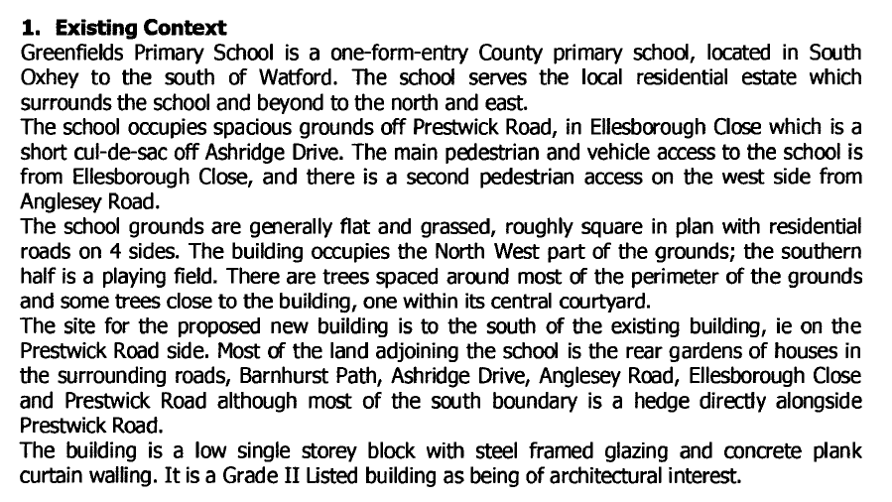
2. Reason for Needing the Accommodation
The function of the proposed detached building is for the school’s Nurture Group. This is where children with learning disabilities or social / emotional needs are taught by specialist staff when these children cannot cope in the normal classrooms. The number of children in the group at any one time is typically 3 or 4. The school is seeing increasing numbers of children requiring this specialised provision because of being on the autistic spectrum or having emotional problems on account of difficult home lives.
There is insufficient space within the main school building to provide the quiet and stable space of learning that these children require, hence the need for a detached facility. As a listed building it is not possible to make significant alterations in terms of adding space, but for the intended purposes described above, a detached building is preferable anyway.
The proposed building does not arise on account of an increase in pupil numbers at the school, nor for an expansion of staff, but only to improve the quality of provision for those children with challenging special needs. The project does not involve an intensification of an existing use, or an increase in the demand for car parking or vehicle movements.
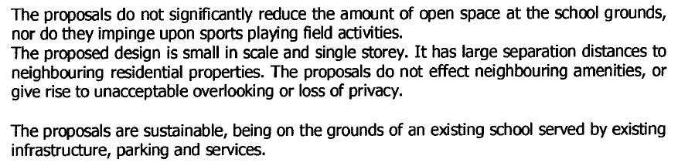
3. Heritage
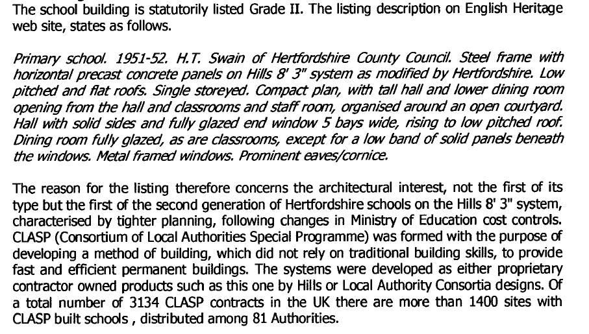
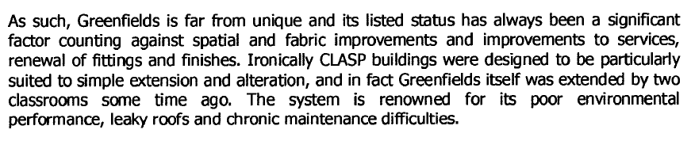
The proposed new detached building will have the following characteristics:
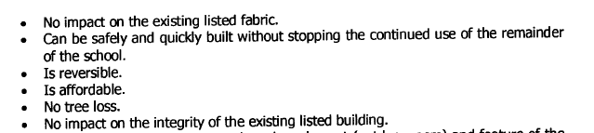
4. Design
The proposed detached building is a proprietary prefabricated timber clad “garden room” from SMART of floor area 6.9m x 4.3m and positioned on steel screw foundation piles. It will be fully insulated and equipped with climate control and double glazed doors and windows. Additional details to make it suitable for its intended purpose have also been included in the design, such as window blinds and dimmable lighting. Only electrical services will be required because there are toilets available in the adjacent buildings. It will all be on one level, have its own access pathway and access ramp, and have no impact on the existing school building. The proposal is for this to be erected over a few days in summer 2021 holidays when the site is essentially unused.
David Ray
Chair of Governors
07.01.2021

