Proposed access lane to Spittens Farm, Roundhill Road, Accrington BB5 3SW

Planning Statement

H | P
D | A

December 2020

Prepared by Hartley Planning and Development Associates Ltd

Procedural matter
The application spans the boundary between Rossendale and Hyndburn Borough Councils. The Planning Practice Guidance (PPG) advises as follows: -

What if an application relates to land in more than one local planning authority area?
Where a site which is the subject of a planning application straddles one or more local planning authority boundaries, the applicant must submit identical applications to each local planning authority.
See further guidance on how local planning authorities should publicise such ‘cross boundary’ applications. The planning fee is payable solely to the authority of wherever area contains the larger or largest part of the whole application site.
Paragraph: 011 Reference ID: 14-011-20140306
Revision date: 06 03 2014
Approximately 105 metres would lie within Hyndburn BC and 115 metres within Rossendale BC
The proposed development
Spittens Farm comprises some 80 acres and concentrates on beef cattle and sheep. Access is from Roundhill Road but at a highly dangerous point, below the crest of a hill, especially when exiting onto Roundhill Road with a trailer or tractor.
Therefore, the applicants wish to alleviate the danger by constructing an alternative access.
The alternative access would be alongside the line of footpaths 14-2-FP78 and 11-1- 264. There is already a field gate where it is proposed that the new access lane would meet Roundhill Road.
Access to and from the footpath would be maintained and the proposal includes a pedestrian access at the junction with Roundhill Road.

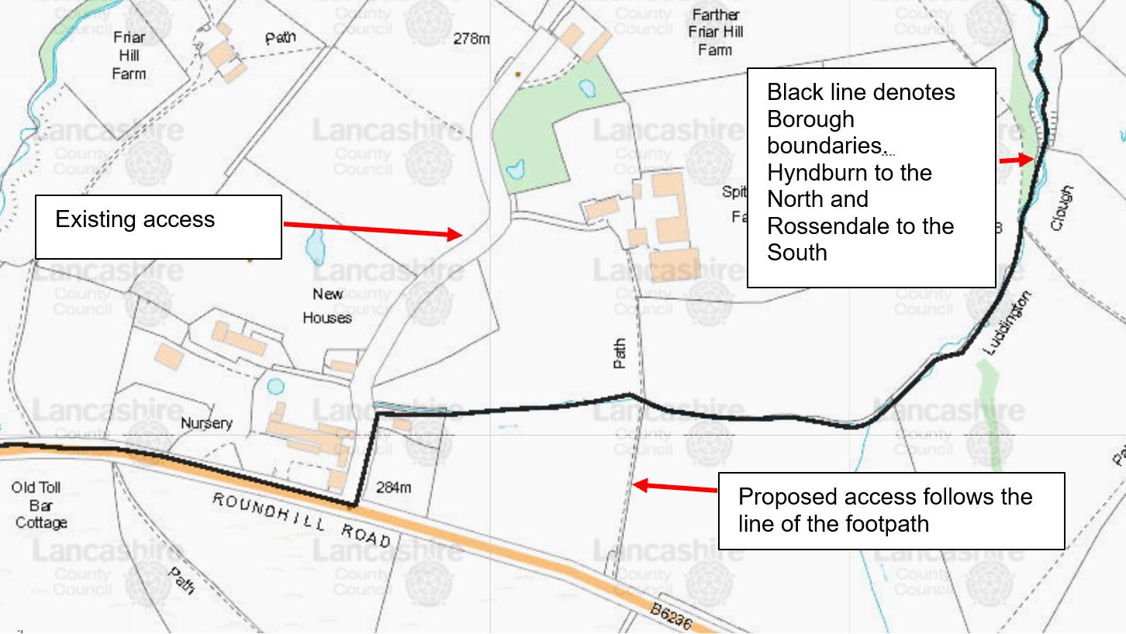

The submitted plans include a cross section to show the construction details and to show its proposed siting.
The proposal is for it to be 2* 1 metre wide * 200 mm deep excavations to be filled with free draining consolidated hardcore on textile geotechnic membrane to form twin track access with grassed central strip.
No changes to existing levels are proposed
Walling at the junction with Roundhill Road would be reduced to no higher than 800mm in order to permit sightlines in both directions of at least 90m when viewed 2.4 meters back from the edge of the carriageway. (See submitted plans)
The entrance gate would be set in from the carriageway by 10 metres to allow drivers with a trailer to pull off Roundhill Road in order to open the gate. This area would be tarmacadamed to prevent loose materials being brought onto Roundhill Road.
A separate pedestrian gate would be included where the footpath meets Roundhill Road.

