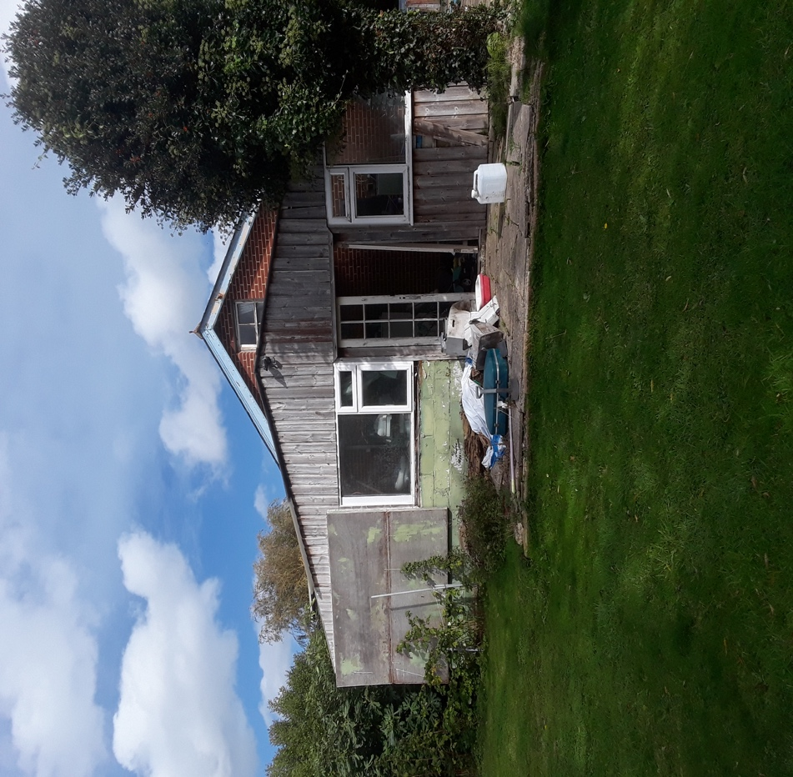

View to the rear of the existing dwelling

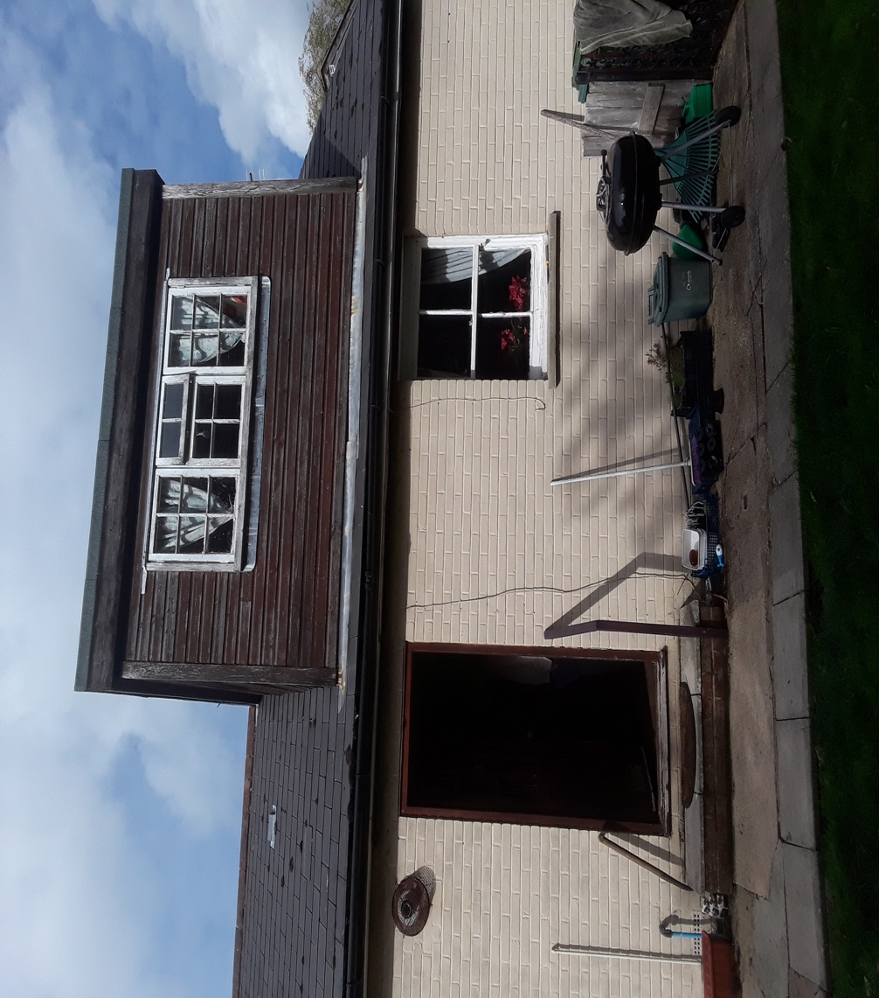

View to the side of the existing dwelling

Residential redevelopment, 21A Horsebridge Hill, Newport

