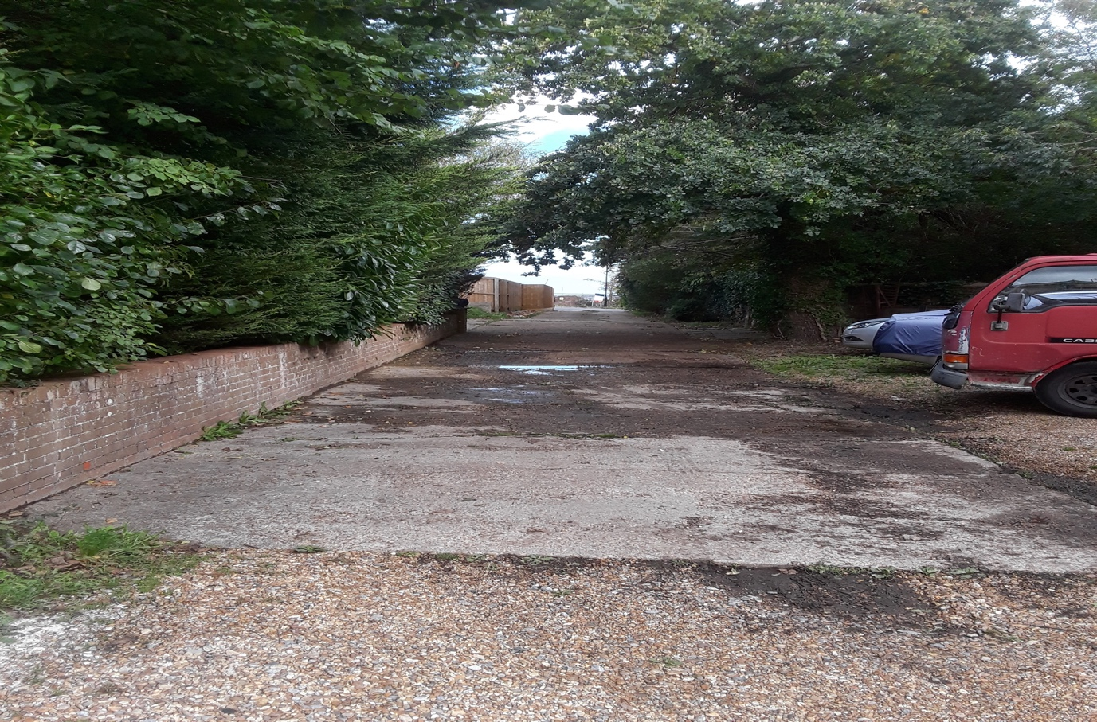

View from Site towards Horsebridge Hill

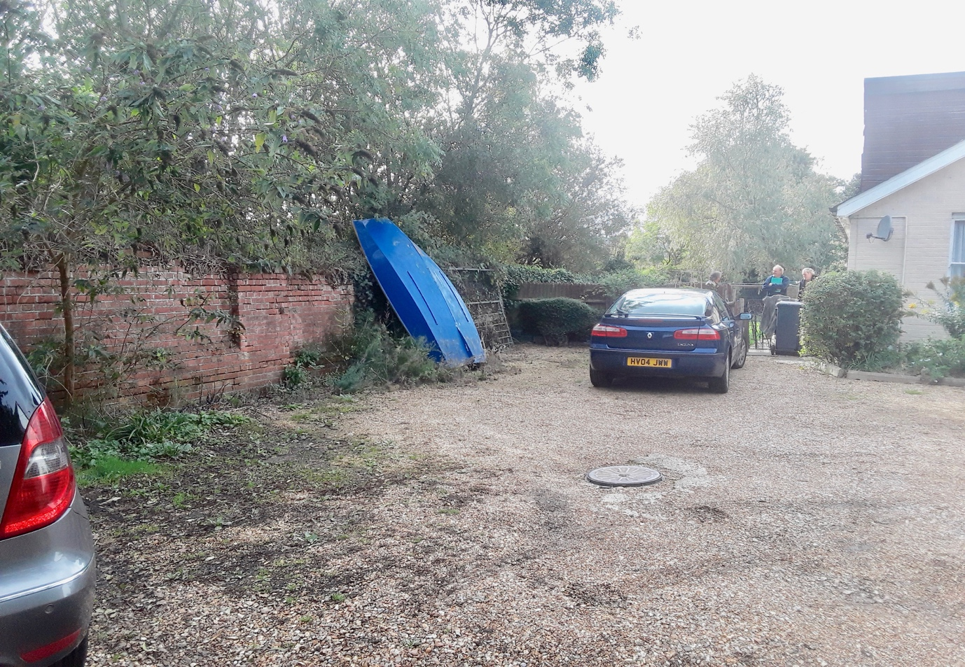

View from access road to site

Residential redevelopment, 21A Horsebridge Hill, Newport

