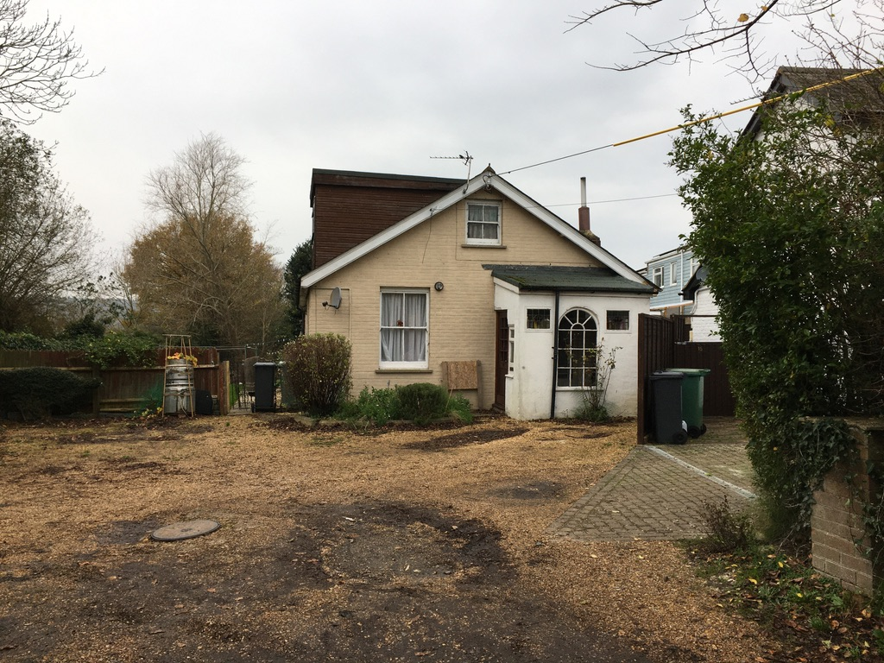

View from access road to the existing dwelling

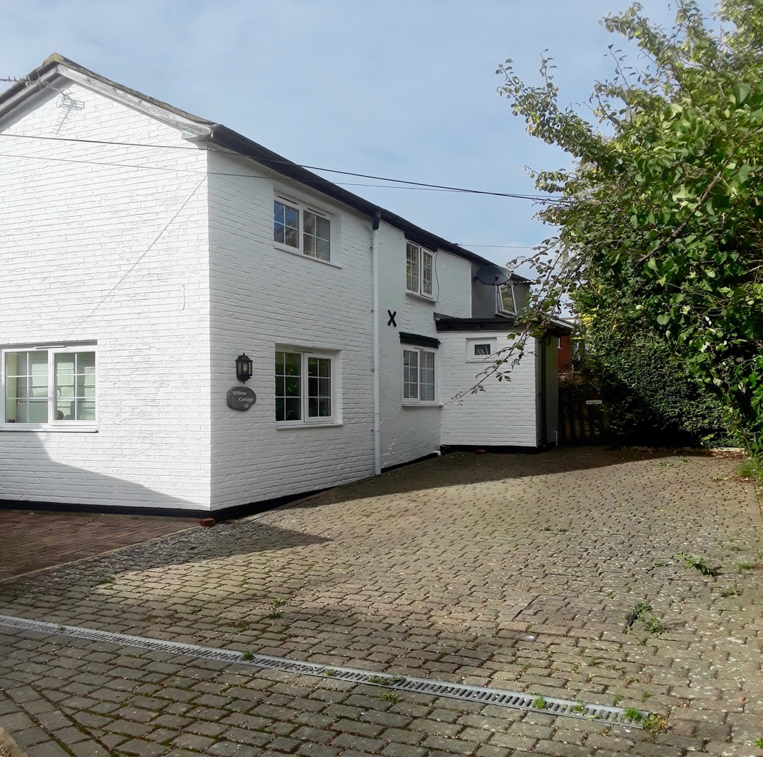

View from access road to adjacent dwellings Nos 15 & 17

Residential redevelopment, 21A Horsebridge Hill, Newport

