Trees at 7 Coldrose Court

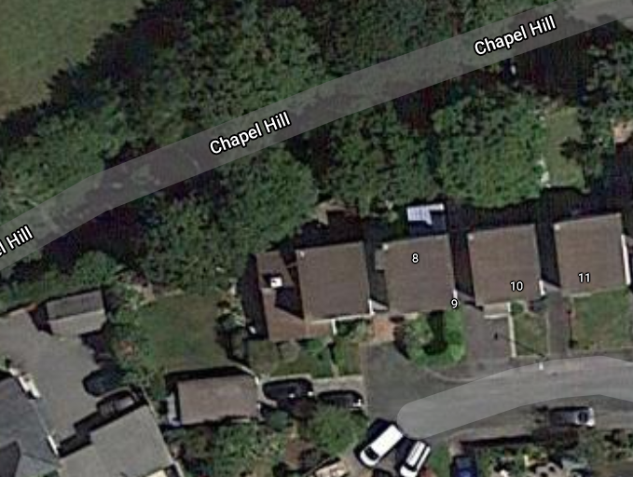
7
Ash Tree
Oak Tree

