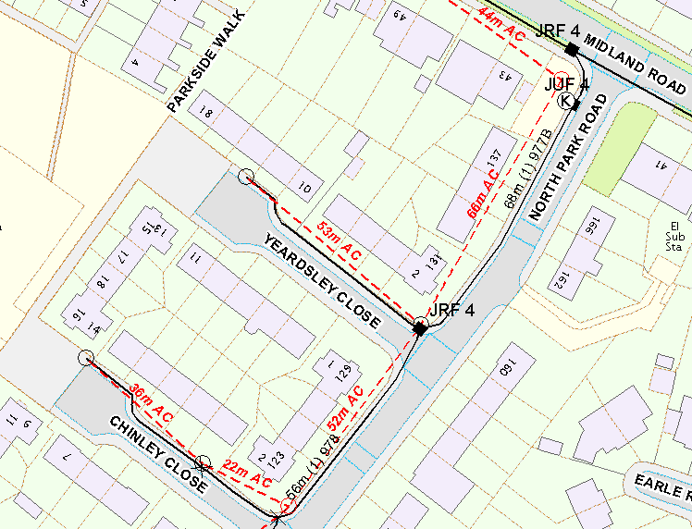

WP1: 10M MEDIUM

GRID REF: 389313 387258

WP2: 10M MEDIUM

GRID REF: 389377 387358

PROVIDE NEW 10M MEDIUM POLE IN SOFT FOR CARRIER POLE.

PROVIDE NEW 10M MEDIUM POLE IN HARD FOR CARRIER POLE.