Heritage Statement

To accompany application 20/04914/MAF

Introduction
The site is centered on NGR 415171, 437851. At present, we understand the site is currently vacant land. Bradford Beck bounds the site to the west, the Leeds and Liverpool Canal bounds the site to the south and the River Aire lies close to the northern boundary, all three of which are significant sensitive receptors.

Dockfield Road runs through the centre of the site (east to west) at a raised elevation. Several underground services are likely to exist below the site. The site was an operational Gasworks between 1847 to 1955. Most of the process plant was located off‐site to the west. The site was later used as a Council Depot (see OS map extracts attached).

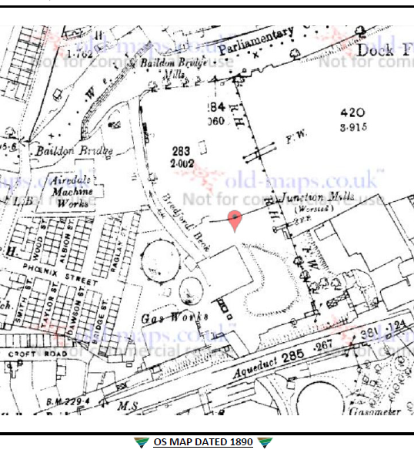

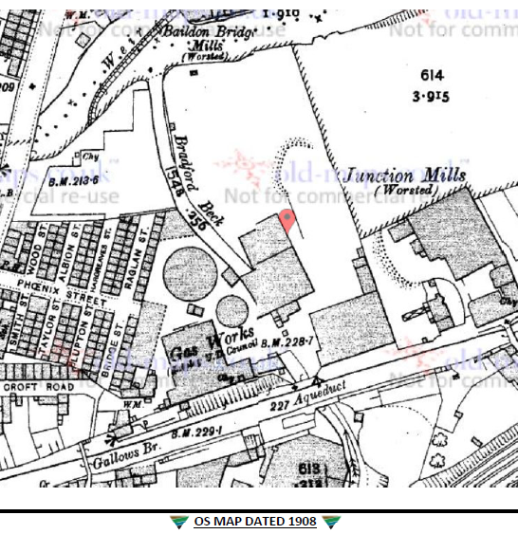

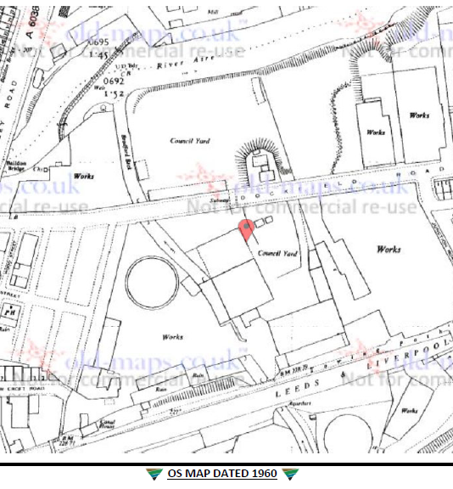

Proposal

The land as identified on the submitted location plan either side of the bridge will be used for the storage of valuable and sensitive equipment used in sectors such as Healthcare, this equipment will either stored on trailers parked up securely or within newly erected storage buildings.

Existing tress will be retained to the whole perimeter of the site as existing and the levels will be retained throughout.

Identifying the Heritage Asset

After consulting Historic England there are no historic or significant assets associated with this site, all existing boundary walls, brick piers and buttresses are be retained and all new storage buildings are been built away from them boundary considerably.

Extract of map from Historic England

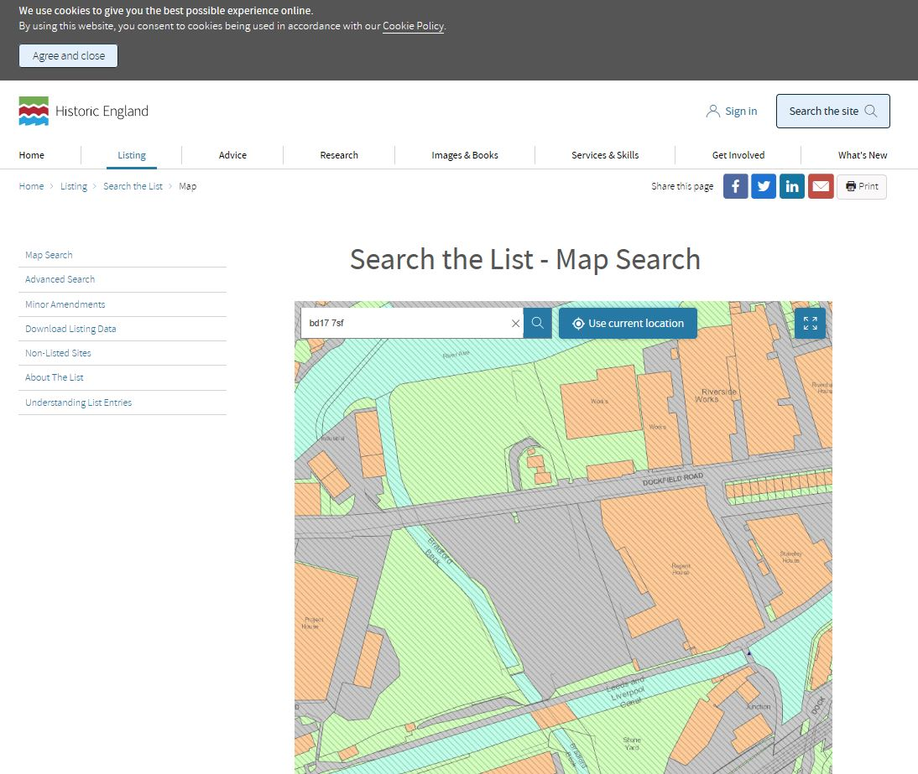

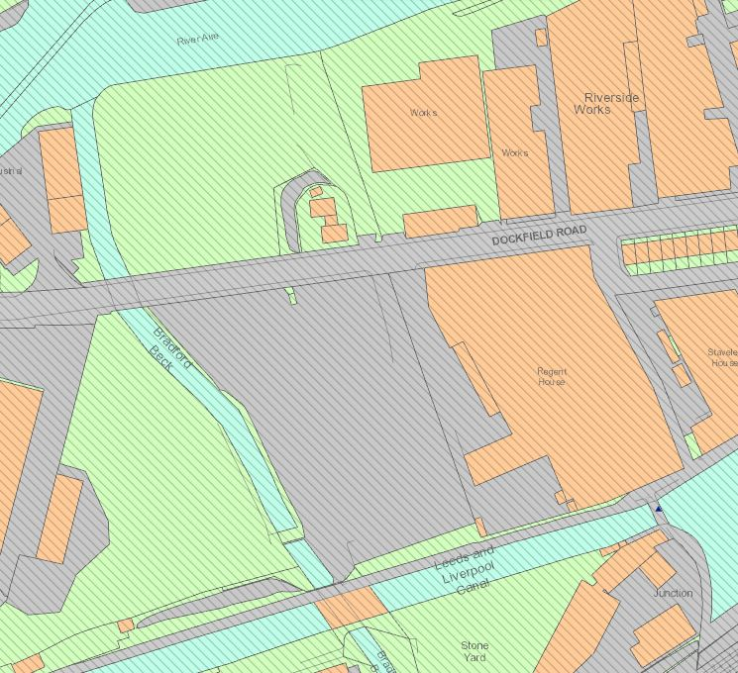
Only marker of interest nothing shown on our site
Assessment of Impact and Mitigation

The works involved in clearing the site and making it usable for storage of vehicles and equipment will have no detrimental effect on the land or its use.

There are no historical assets that will be affected.

Conclusion

There are no historical assets that will be affected.

Our client is re-using land that was once council storage for the same purpose and is willing to lant some addition al tress to the perimeter of the site near the bridge as a screening into the site if the council see the need.

