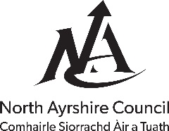
OBSERVATIONS ON PLANNING APPLICATION
NORTH AYRSHIRE COUNCIL - REGENERATION
To: ePlanning, Cunninghame House, Irvine
Application Number |  | 21/00036/PP | Planner
Recommendation |  |  | Regeneration Contact
Email |  |  | Telephone

Application Details
Type of Consent
Applicant | Barkip Biogas Ltd Fao Mr Paul Riley
Proposed Development | Section 42 application to remove condition 1 of planning permission ref.09/00444/PPM
Location | SSE Anaerobic Digestion Plant Dalry
Drawing Number(s) | Location Plan and Layout Plans
Dated | 21/01/21 | Date Received | 21/01/21

Comments
Active Travel and Transport have no transport related objection to this proposal.

Condition(s) / Reason(s) for Deferral

Signed: | C Fitzsimmons | Date: | 22/01/21
PP | CAITRIONA McAULEY, HEAD OF SERVICE, ECONOMIC DEVELOPMENT & REGENERATION

Notes for intimation to Applicant |  |  |  | Copies To:
(i) | A Construction Consent will be required by the applicant (S21)* |  |  | Roads
(ii) | A Road Bond will be required to be submitted by the applicant (S17)* |  |  | Roads Lighting
(iii) | A Road Opening Permit will be required by the applicant (S56)*
* Relevant Section of the Roads (Scotland) Act 1984

