**Photographs of Property Exterior – Front (Bath Road)**

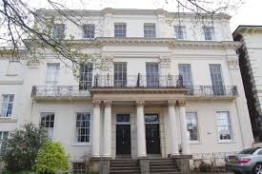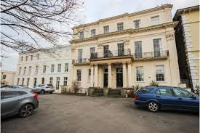

**Photographs of Property Exterior – Back (Flat 8)**

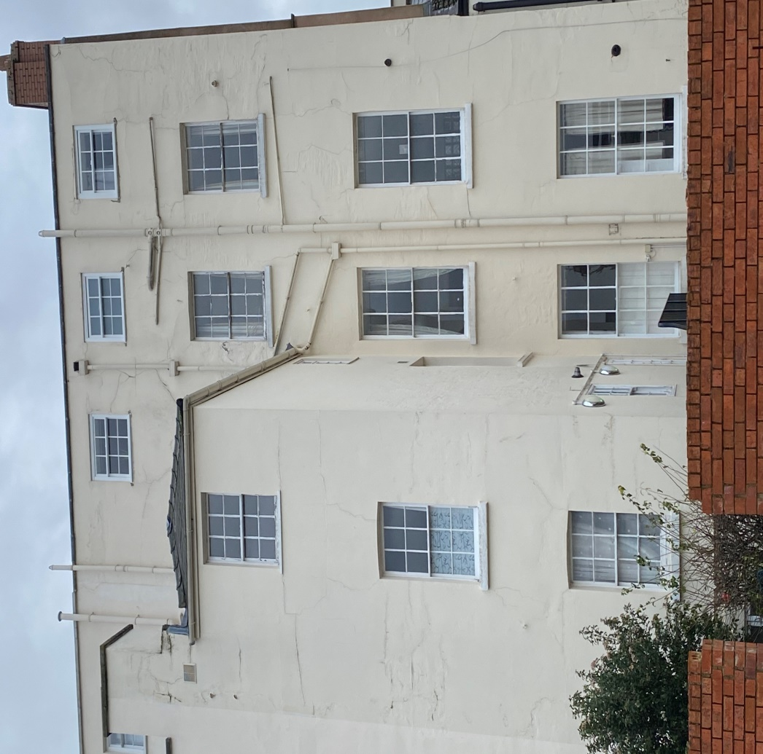

Bedroom window

Living room windows