Existing elevations, photos – Mulvra Stables outbuilding
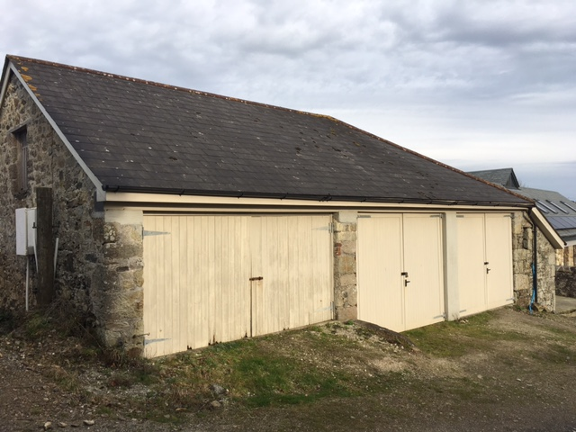
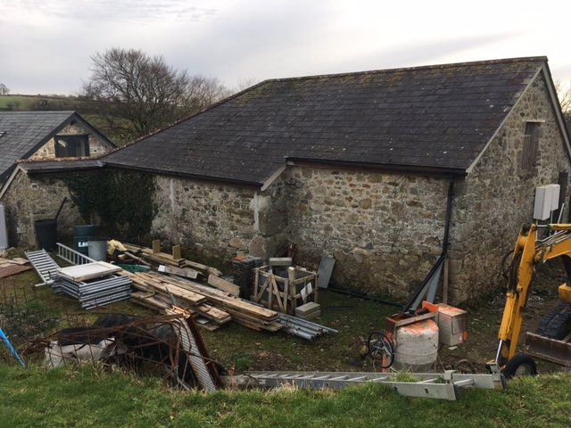
Front - South elevation Rear - North elevation 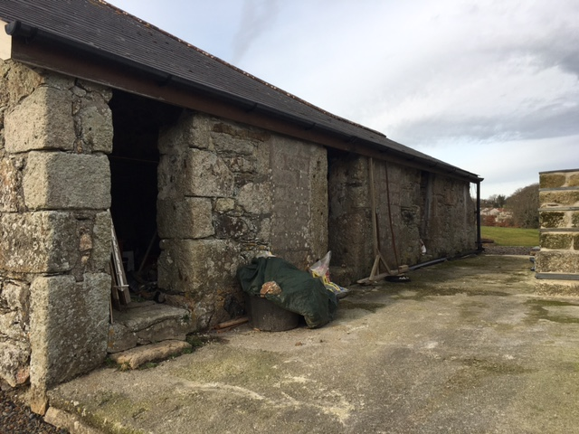 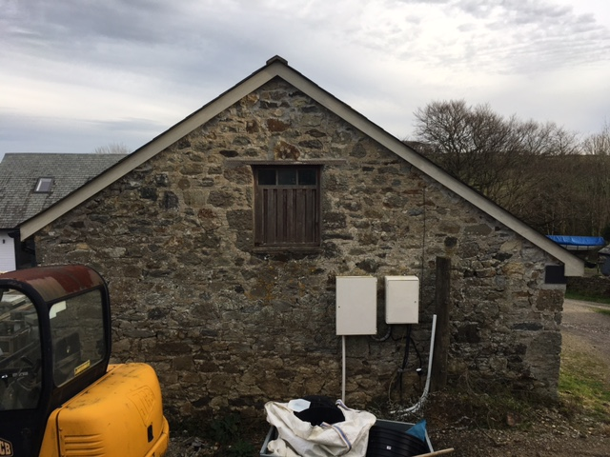
East elevation West elevation

