Mulvra, London Apprentice, St Austell PL26 7AP (approx. scale: 1:100)
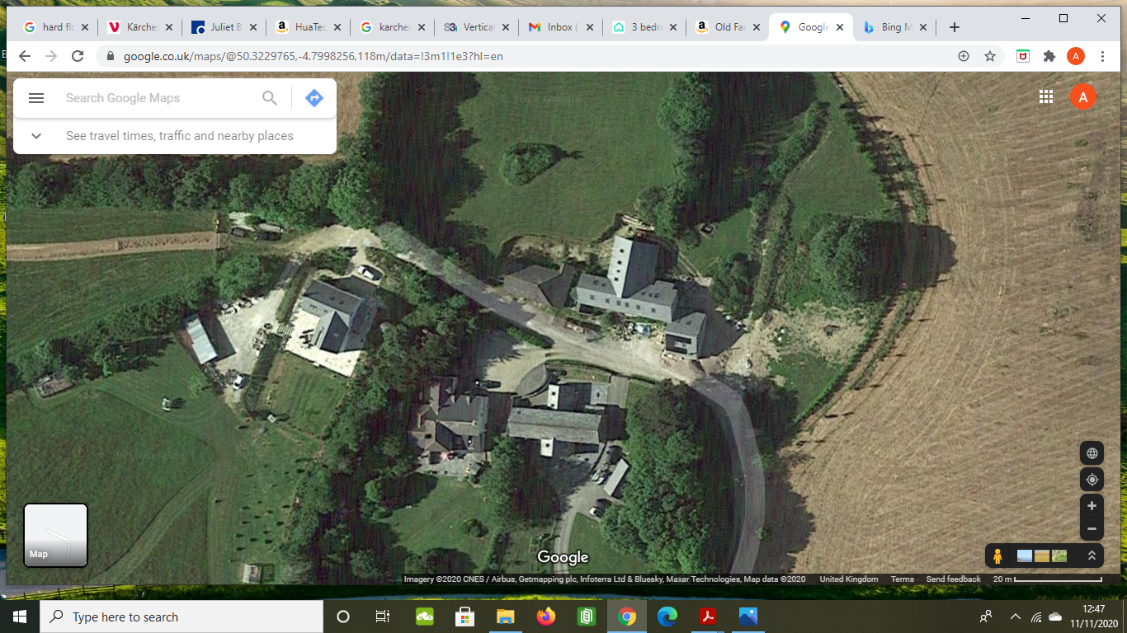
Mulvra Stables outbuiding
Mulvra Barn
Mulvra Farmhouse
Mulvra House
Mulvra Stables

