Design and Access statement/Heritage Statement and general information prepared in support of an Application
for Listed Building Consent in respect of
Cedar House 73 Blanche Lane South Mimms EN6 3PA

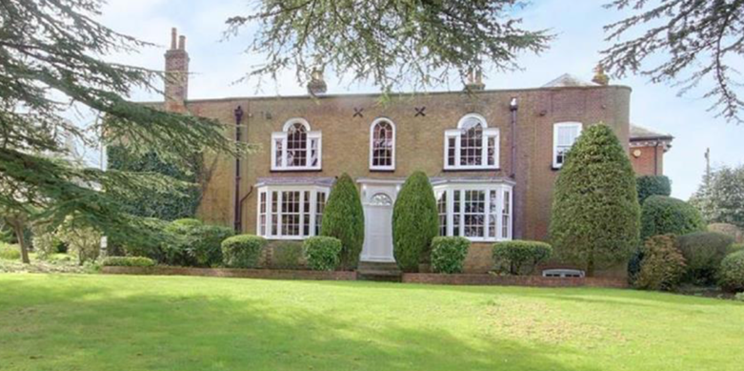
- Rear elevation, north

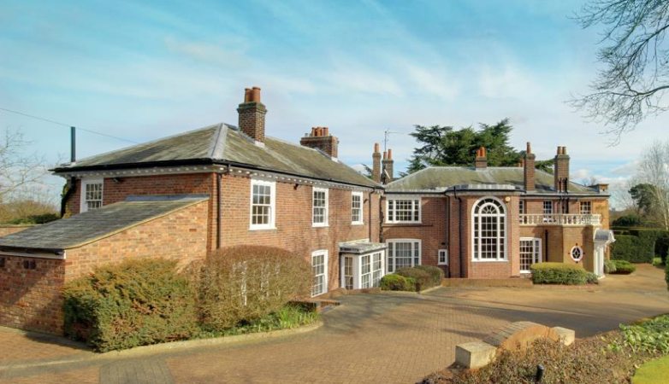
- Front elevation, south

- East flank and current entrance 4. West flank

Application

This application for Listed Building Consent is made subsequent to the receipt of Hertsmere’s Pre Application Planning and Listed Building advice and the Decision Notice dated 13 November 2020 to Application Number 20/1412/LBC.

Property

County – Hertfordshire

District – Hertsmere

Grade II Listed

Listed Entry Number – 1174600

Listed Entry location – Cedar House Greyhound Lane Potters Bar

Listed Entry

“House. Mid to late C18, extended and altered C19 and C20. Yellow brick extended in red brick. Slate hipped roof. 2 storeys. Original 3 bay front with central entrance. Panelled door, semi-circular fanlight. Doorcase with slim pilasters and bracketed, dentilled, moulded hood. 2 large C19 ground floor bay windows. First floor Venetian windows flank central round-headed window, all glazing bar sashes. Coped parapet. Extended to left with extruded stack on front wall with decorative scrolls on stepping up of breast to stack. Rounded angle to return on extension to right. Left return wall has 2 storey canted bay. To rear left single storey addition with diagonally set entrance in Neo-Georgian doorcase. Rambling extensions to right and rear with modillion eaves cornice and sashes. Interior not inspected.”

Documents included with application and Heritage Statement

- Response of Hertsmere Borough Council to Pre-Application consultation number 20/0059/PA

- Decision Notice dated 13 November 2020 to Application Number 20/1412/LBC

- Ordnance Survey style site location plan at a metric scale of 1:1250 showing the application site outlined in red and other land/ buildings in the ownership of the applicant outlined in blue, all neighbouring properties in full and two named roads.

- A set of metrically scaled elevation plans (existing and proposed).

- A set of metrically scaled floor plans (existing and proposed).

- Exploratory Investigation report from Chic Deco Ltd.

There is no Arboricultural document as no trees will be affected by the proposed alterations.

Volume

The existing volume of the building is approximately 690m³ and the proposed alterations will not change the volume.

Trees, Landscape and Ecological Impact

The proposed works are all internal to the property and as such will have no impact on the trees, landscape or local ecology.

Impact on Residential Amenity
The proposals will not have any harmful impact on neighbouring residential amenity. There will be no loss of outlook, daylight, sunlight, or privacy.

Impact on Car Parking Provision and Highways Safety

There will be no impact on car parking provision or Highway Safety as a result of the proposals.

Location

Cedar House is a large house located on the outskirts of South Mimms Village, its location shown on the map and site location plans below.

5a. Map of South Mimms

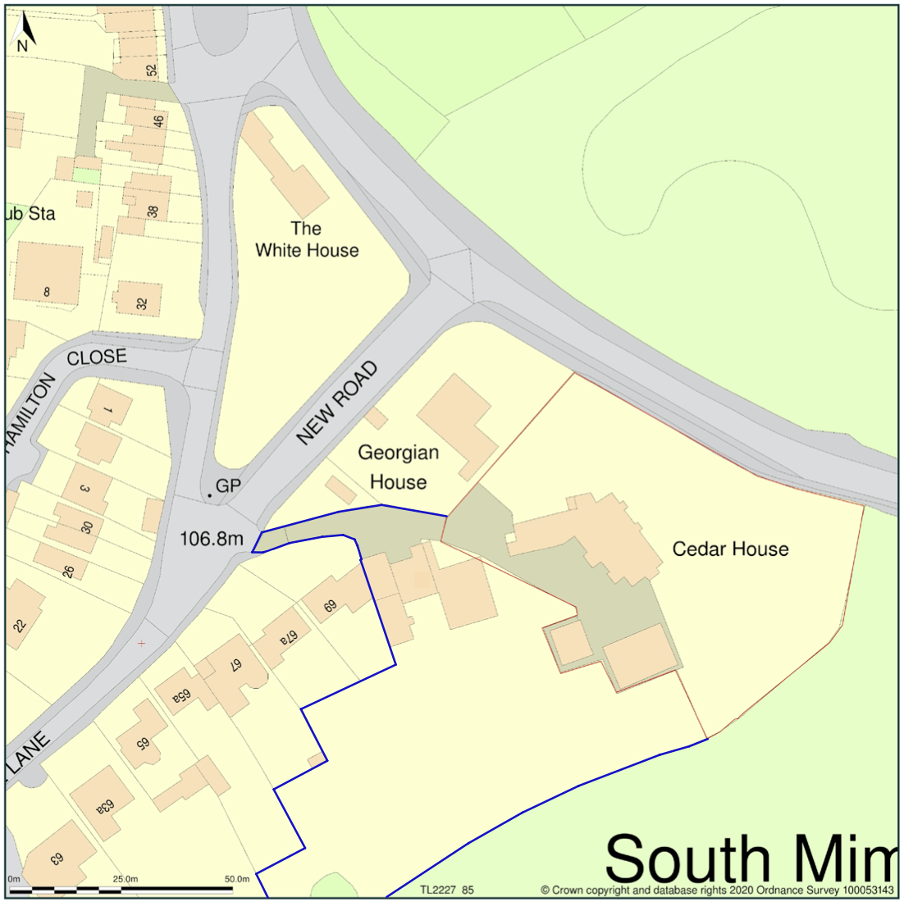
5b. Ordnance Survey Site location plan, showing Cedar House edged in red and Cedar Cottage edged in blue, scale 1:1250

The property known as Cedar Cottage is within the same ownership as Cedar House and is outlined in blue on plan 5b above.

South Mimms is a small village with few amenities. The amenities it does have include a primary school, a church and two pubs. The sole public transport link is a bus route. The village is located within a short distance of South Mimms Service Station to be found at the junction of the M25 and A1M.

Cedar House falls within the South Mimms Conservation Area dated 24.3.1969, Green Belt Hertsmere (1558), SADM23 and SADM28.

Description and History of the House

For the purpose of this document the original front (now rear elevation) is taken to be east facing (in reality it is north-east).

Research to date has revealed no detailed information about the evolution of this building. Therefore, to understand how the building has evolved there has been an exercise of map regression combined with architectural assessment by our Conservation Surveyor, Stephen Boniface. Mr Boniface has made his assessment based on materials seen (e.g. the various different brick types) and style of certain features (e.g. stairs, fireplaces, etc.).

The House is a detached property surrounded to the north and east by gardens and grounds and to the south and west by a driveway, forecourt and garage. The gardens extend to approximately 1 acre and grounds include garaging, an outbuilding formerly used as a chapel, a swimming pool and a tennis court. Some of these amenities are shared by (and indeed are situated upon land owned by) Cedar Cottage, a neighbouring property which is currently in the same ownership as Cedar House.

Cedar House is set back down a lengthy driveway from Blanche Lane, a predominantly residential road, although it can also be seen from Greyhound Lane. The immediate surrounding area is either residential (to the North and West) or countryside/woodland (to the South and East). The House is completely surrounded by fencing/hedging or neighbouring property and there is no public access to either the House or the grounds.

As per the List Entry, it is believed that the original brick built construction of the House originates in the late 18th century, with numerous side and rear extensions being added to it in both the 19th and 20th centuries.

With no plans for the earliest building one has to assess purely by architecture and it seems that the original 18th century building was a simple square plan form, possibly of four rooms to each floor and with the stair in the middle of the rear, facing the entrance in the east elevation with the main approach being from Greyhound Lane. This building had a small cellar beneath part of it.

At some point slightly later (late 18th or early 19th century) a two storey structure was added. It is likely that there was some form of interlinking although this structure had its own entrance in the north elevation from Blanche Lane. Whether they were completely self-contained is now difficult to assess.

By the time Ordnance Survey had started mapping the area in the 1860s both structures existed and are clearly present in the 1866 map.

6. OS 6 inch map surveyed 1866 (25 inch map not available from this date)

The following is an assessment of what is believed to be the earliest structure (outline green) and the slightly later structure (red).
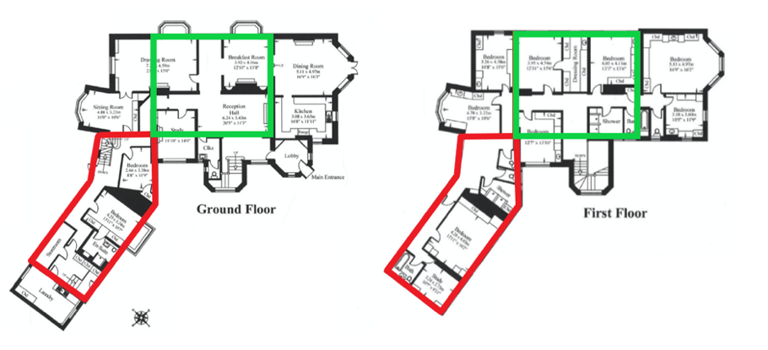
7. House progression

The next alteration was the removal of the rear part of the original 18th century building, moving the stair rearwards and incorporating a small extension between the stair and the north building. Also, the single storey bays were added. All of these features show on the OS map from the early 1890s. It is likely that these works took place over a period.

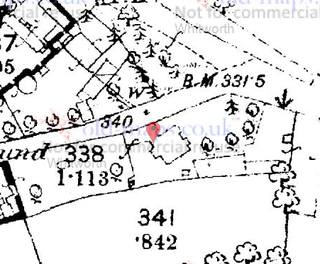
8. OS 25 inch map c.1892

The following plan indicates (in blue) the added areas, although the interior of the original building was drastically altered to the rear to accommodate the stair relocation.
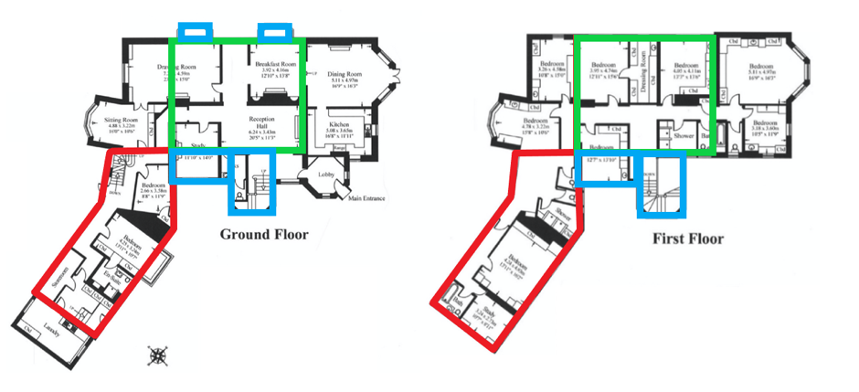
9. House progression

10. OS 6 inch map surveyed 1895

The above OS map is from 1895 and shows the north infill extension. However, maps from only a year or two later also show the extension to the south. From what is seen on site the southern section is certainly from about the mid 1890s.

The present northern section seems to be from the 20th century in terms of the brickwork, etc., and even the cellars have a later appearance to them. There is a possibility that a north extension was added and then subsequently changed again later (see later comments).

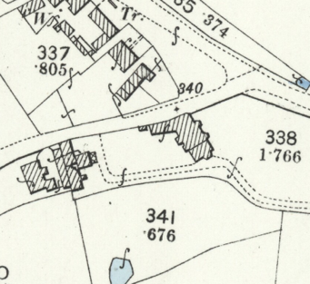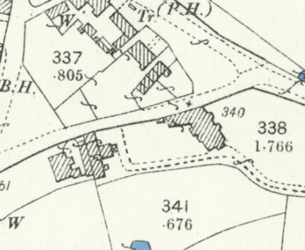
11a. OS 25 inch maps surveyed 1896 11b. and 1898

The following indicates (orange outline) the parts that are thought to have been added in the mid to late 1890s.
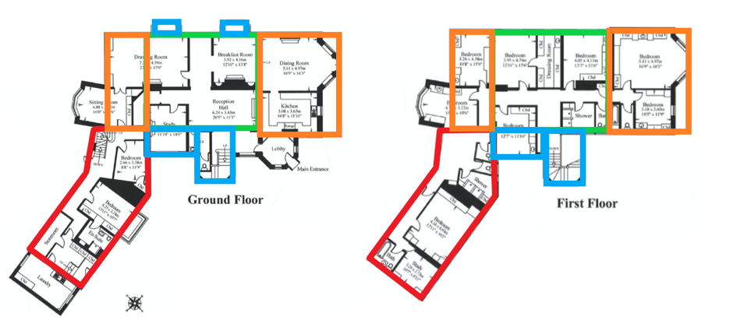
12. House progression

No longer exists
13. OS 25 inch map surveyed 1913

The map from 1913 shows additional rear additions and another structure at the rear. The areas outlined in purple indicate these areas.
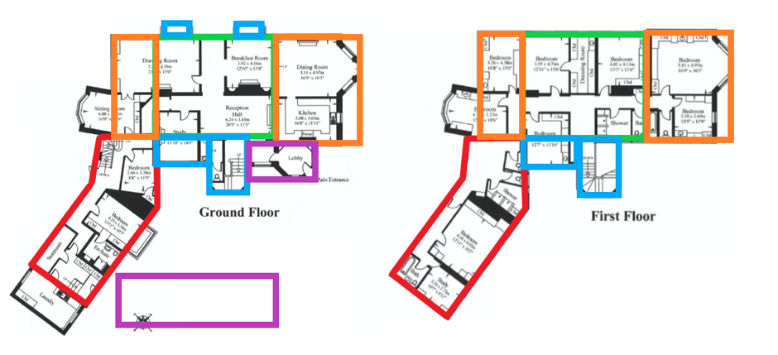

14. House Progression

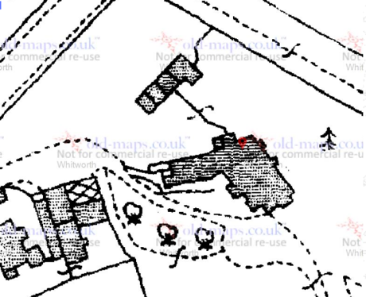
15. OS 25 inch map surveyed 1935

From the 1935 map it can be seen that the rear structure that had appeared in the 1913 map had gone by 1935. However, the northern bay now appears. This is an addition, but from what could be seen on site in terms of brickwork, etc., there is a strong suspicion that the earlier infill was demolished and rebuilt at the same time to incorporate both this northern bay and new cellar areas and a new access to the cellars. The single storey area was also added to the west end. These are all outlined in yellow in the plan below.
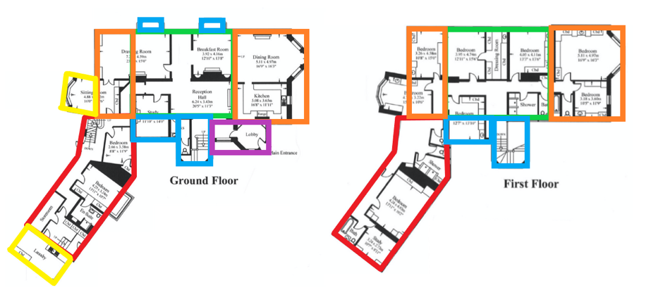
16. House Progression

Note also that the road had been moved by 1935 and a row of structures formed on the site of what has now been replaced by the house called ‘Georgian House’.

By 1970 the site had become more or less what is seen today.
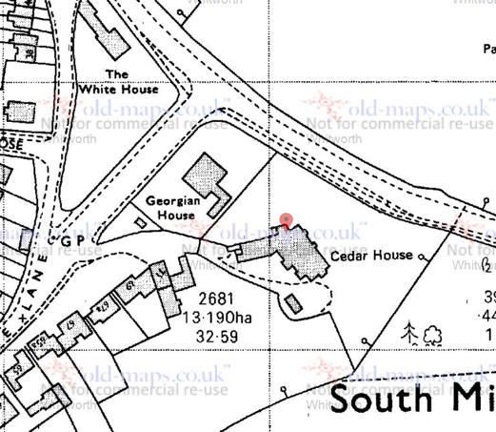
17. OS 25 inch map surveyed 1970

For ease of comparison the following shows the 1896 map side by side with a recent satellite image.

18. Geofenced view from OS 25 inch map surveyed 1896 side by side with google map view

The building has therefore been altered and extended on at least six previous occasions. The extensions have not been sympathetic to the building, particularly externally where the different bricks used, having been poorly matched in both colour and size. That said, one could argue that each phase of development has been of its era, albeit not particularly well integrated with what preceded it both in terms of appearance and flow.

At various points in the building’s history original, and indeed subsequent, walls have been removed; in particular the main staircase, which is believed to be original, has been relocated.

Over the years extensions have been built in-keeping with more modern standards of living, updating the House to ensure it retained its grand appearance. Indeed later extensions created an entrance for the House onto New Road which effectively relocated the main façade of the House from Greyhound Lane to New Road (also known as Blanche Lane) although this road itself was relocated at some point between 1913 and 1935.

The internal layout has been changed with the walls indicated below being assessed relatively modern with the areas shaded being thought to have had some alteration and change of use.
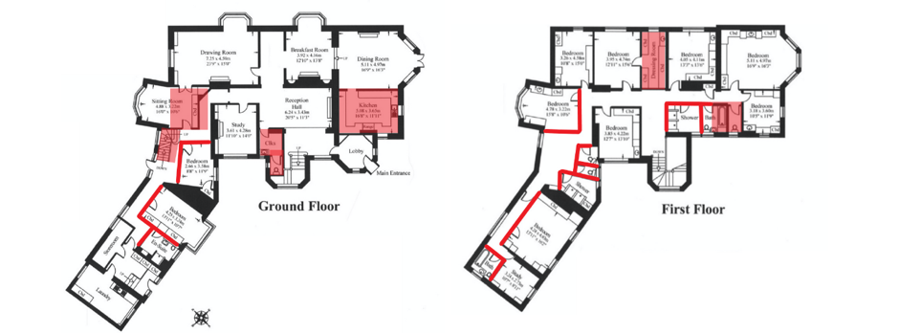
19. Previously altered areas of the House

Planning permission and Listed Building Consent was granted in 1992 (0471/92) for the “Erection of a single storey extension following part demolition of existing and erection of balustrade over south entrance and for alterations to windows”. Other consents exist but do not relate directly to the House.

The roof of the House was subject to a fire in the 1990’s and the entire roof was replaced at that time.

Internal decoration over the years has seen many of the original features lost, although some of the extensions are of an age that they are significant in their own right. The ground floor of the House has been largely decorated in poor wood panelling which is 30 – 40 years old and it is unknown what, if any, original features still exist beneath.

It is expected that beneath the panelling will be lath and plaster finishes, perhaps even remnants of previous plaster panels, but Hertsmere Council confirmed in 2016 that it would not require the wood panelling to be removed as the damage it may cause to remove it would outweigh the benefit of discovering what lies beneath.

Fireplaces in several ground floor rooms exist and several of these appear to be from the various dates of alteration, but some may have been moved within the building and some may be later alterations.

The House is carpeted almost throughout, other than the kitchen and the ground floor modern extension to the west side of the building.

It is believed that some of the cornicing in the House is original, and it has been replicated with what was available as in keeping alternatives in places to retain continuity. There is also more modern cornicing elsewhere in the house that is of indeterminate age.

An internal arch in the hallway has original detail to its upper surround and the original front doorway to the House has been blocked up. It is unknown if the door currently in place is the original door to the House, but it is hoped that as part of an application, this doorway and a suitable door can be reopened and restored.

The hallway walls to the first floor of the building are wallpapered, while the bedrooms and bathrooms on the first floor have been generally lined with board, plastered and painted. Other than the cornicing in places, there would appear to be no original features on show on the first floor of the building. Internal partition walls dating from the 1980s in the west section of the House have created a series of toilets and shower rooms associated with dorm living from being used as a children’s home and more recently as a seminary (see below).

The House has a small cellar. There is an original beam in the cellar which has been infested with and treated for rot in the past. This beam has been supported by two metal supports since at least 1979 as it pre-dates the previous owners.

Social History

Documentary evidence as to the use of the House prior to the turn of the 20th century is scarce but at about that time it was owned by a gentleman called Edward Laurence Hamilton and used as a family home for himself, his wife, his two children and their staff. Mr Hamilton appears to have been a prominent member of the local community and a wealthy individual who donated funds to the local Church (St Giles) to allow it to erect electric lights in the 1920’s, the first building to do so locally. Mr Hamilton died in 1940, although he did not own the property at the date of his death. The earliest conveyance we have been able to locate dates to 1955 and the House at that time was owned by a different family.

The House was purchased by the Retarded Children’s Aid Society in the 1960’s and used as a home for disabled children until 1979 when it was purchased by its current owners, Christian Corp, a US based religious order, who have used it as a base for their UK activities.

Between 1960 and 2000, the first floor of the House has been altered and decorated to accommodate dorm type living quarters, with numerous bedrooms (nine) with far fewer bathrooms/shower rooms and toilets and the original purpose of the House as a large family home has been all but lost.

General Significance

Cedar House was listed Grade II in 1949. There is no detail in the listing as to why Cedar House was listed originally and we have been unable to find any major local, historical or architectural significance to the building. The House is grand, albeit significantly smaller in size and estate to other local grand houses of the time such as Wrotham Park and Dyrham Park. It is assumed that the listing was created due to the House’s significance of age and size in relation to the local area. The House was not inspected internally when originally listed which indicates that the internal layout was of considerably less significance than the exterior of the House.

The exterior of the House is a combination of Georgian, Edwardian and Victorian architecture, with the main Georgian body of the building being the most significant with later additions gradually becoming less significant. The plan of the original House is significant, but far less significance can be attributed to later extensions with no significance attributable to the most recent alterations in the 1990s.

Exploration/Investigative works

The Pre-Application consultation undertaken with the local authority in respect of proposed alterations to be considered was generally welcoming and Application Number 20/1412/LBC was approved.

Proposed alteration
Under the terms of the permission granted for Application Number 20/1412/LBC, permission was given to alter an existing window in a bathroom as shown on the plan below into an access hatch for maintenance purposes for the flat roof over the lobby area. This proposal is to move the location of the hatch by a very short distance due to the impractical nature of the access being contained within a bathroom.

Attached to this statement are scale plans and elevations detailing the existing position and the proposed alteration, and an investigation document showing that there will be no loss of historic fabric. Additionally the hatch to be installed will be identical in design to the existing white frame timber windows to retain continuity and appearance.

This proposed minor alteration is in an unobtrusive location in a more modern addition to the House and is not visible from any location other than within the applicant’s property.

This hatch is necessary as minor damage has already occurred to the flat roof and access is essential to maintain the fabric of the House.

