Stour Valley Design  Swan Corner  Mill Lane  Bradfield  Essex CO11 2UT | Please ask for Eve Ramsden  Tel: (01255) 686227
 | Our Ref: 21/00009/FUL

29 January 2021

Dear Sir/Madam,

TOWN AND COUNTRY PLANNING ACT 1990
LOCATION | The Old School House Clacton Road Horsley Cross Manningtree
DEVELOPMENT | Proposed single storey rear extension and garage conversion and new pitched roof (resubmission of application 19/01470/FUL).
APPLICATION NUMBER | 21/00009/FUL

I write further to the above described application received on 18 December 2020 in relation to the above development.

I am writing to inform you that we will be unable to determine your application within the allotted time given, for the following reasons:

01 To allow sufficient time for the site notice to expire and for any comments received and assessed.

I therefore must formally request an extension of time from you so that we may consider this application further and that a decision can be made.

I look forward to receiving written confirmation from you that you are in agreement for an extension of time for this application until 5 March 2021.

Please sign and date the enclosed form and return to us to confirm your agreement to this extension of time.

Yours faithfully
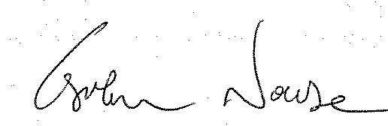
Graham Nourse
Assistant Director
Planning Services
Extension of Time Agreement Form

TOWN AND COUNTRY PLANNING ACT 1990
LOCATION | The Old School House Clacton Road Horsley Cross Manningtree
DEVELOPMENT | Proposed single storey rear extension and garage conversion and new pitched roof (resubmission of application 19/01470/FUL).
APPLICATION NUMBER | 21/00009/FUL

Further to the Tendring District Council’s letter dated 29 January 2021 in relation to the extension of time request for the above described development, it is agreed that the application target date can be extended to 5 March 2021.

Signed:……………………………………………  Stour Valley Design | Signed:  Graham Nourse  Assistant Director  Planning Services  Tendring District Council
Date:…………………………………………… | Date: 29 January 2021

