CRANSWICK COUNTRY FOODS PLC

WEYBREAD POULTRY PROCESSING PLANT

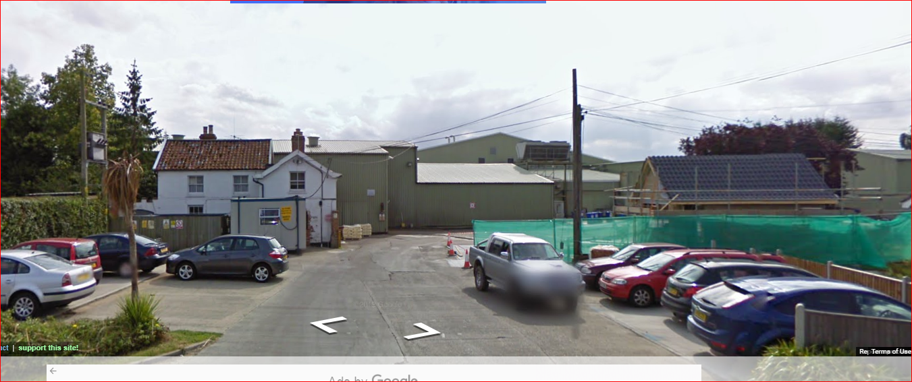

PROPOSED SITE INVESTIGATION STRATEGY

FOR THE REDEVELOPMENT OF THE SITE

JDA/342/AT/4/1 JANUARY 2021

Registered Address: 1, St. John’s Road, Queen’s Park, Chester, Cheshire CH4 7AL
Tel / Fax: 01244 677991 Mob: 07767 254443 Email:jcdavies@jdassocs.co.uk
Version Control Record
Description of Status | Date | Reviewer Initials | Authors Initials
Draft | 23:01: 21 | JCD | AT

1. Introduction

  - Cranswick Country Foods Plc have instructed John Davies Associates (JDA) to assist them with their application to discharge the Planning Consent conditions relating to possible contamination under their former Chicken Processing Plant at Weybread, Suffolk IP 21 5TL.

  - The works, located as shown on the plan at Appendix 1 to this document, is now closed. Machinery has been removed from the site and all services have been disconnected but no demolition or other works in pursuance of the planning consent have been undertaken.

  - Planning Consent reference DC/17/06326 Condition 25 clause 1 requires that “A Strategy for investigating any contamination present on site (including Ground Gases, where appropriate) be submitted for approval by the Local Planning Authority.” This document is submitted as the Site Investigation Strategy proposal.

- The Site Investigation Strategy

  - In 2017 when the Application for Planning Permission for the redevelopment of the site was first submitted, a Phase 1 Desk Study of potential contamination under the site prepared by A F Howland Associates, specialist Geotechnical Engineers, was submitted as part of the application documentation.

  - This Phase 1 Desk Study which can be accessed from the Planning file and which is available via the web link http://www.howland.co.uk/Reports/MSH-17.382-PhaseI.pdf indicated that the buildings and surrounding areas which had been used for poultry processing were the most likely areas to have been contaminated both as a result of Cranswick’s operations and also historically. A smithy was once located within the area used for chicken processing but no other areas of possible contamination from historic activities within the site area were identified in the report.

  - It also concluded that the arable fields surrounding the poultry processing plant, which form part of the planning application area were unlikely to be contaminated.

  - A similar investigation to that required by the Planning Consent is required in respect of that area of the site where poultry processing activities were regulated via an Environmental Permit which must be surrendered via an application to the Environment Agency before any redevelopment of the site can take place.

  - It is proposed to undertake one intrusive Site Investigation which will be relied upon in support of the surrender of the Environmental Permit and the discharge of the contaminated land conditions attaching to the Planning Consent for the redevelopment of the site for housing.

  - Following discussions with site staff familiar with the operations on the site and an inspection by their representatives, John Davies Associates, JDA have recommended that soil and where appropriate groundwater and ground gas samples, should be taken at eight locations for testing within the area covered by the Environmental Permit. The eight locations marked 2 ,3 ,4, 5, 6, 8, 12 and 13 and described in the table at Appendix 2 to this document, are shown on the attached drawings prepared by A F Howland Associates, references 20.382 SK01 and 20.382 SK02, attached at Appendices 3 and 4 respectively to this document. These eight sampling locations have been agreed with the Environment Agency for the purposes of the Environmental Permit surrender application.

  - In addition, further soil samples and where appropriate groundwater and ground gas samples will be taken from the consented areas outside of the Environmental Permit boundary also shown on the plans prepared by A F Howland Associates references 20.382 SK.01 and 20.382 SK02. These plans are also submitted as separate documents for ease of inspection and reference.

  - Where appropriate both gas and groundwater monitoring boreholes will be installed within the site at the indicated soil sampling locations depending upon the conditions encountered whilst acquiring the soil samples.

  - The sampling locations described above will be the minimum number of locations as the outcome of the fieldwork may indicate that more samples are required at other locations in order to determine the extent of any contamination found.

  - The work will involve breaking through concrete slabs, which may have a layer of mesh reinforcement in the top and bottom faces, and subsequently excavating through the sub-base and earth beneath the slabs. On completion of the works the excavations will be made safe.

  - For each of the locations the Site Investigation Contractor will take representative samples of soil and, where appropriate groundwater and ground gas, for subsequent analysis. Should contamination be found at any location further samples will be taken at increasing depth until there is neither visual nor olfactory evidence of contamination.

  - Samples will be submitted to a Laboratory for analysis using formally approved test methods (ie. UKAS, MCERTS accredited or equivalent against recognised analytical suites (such as BRE SDI) and including heavy metals, pH, Ammonia, Phenols, Sulphides, Sulphates, Cyanide and a full range of organics including VOC, SVOC, TPH and PAH.

APPENDIX 1

SITE LOCATION PLAN

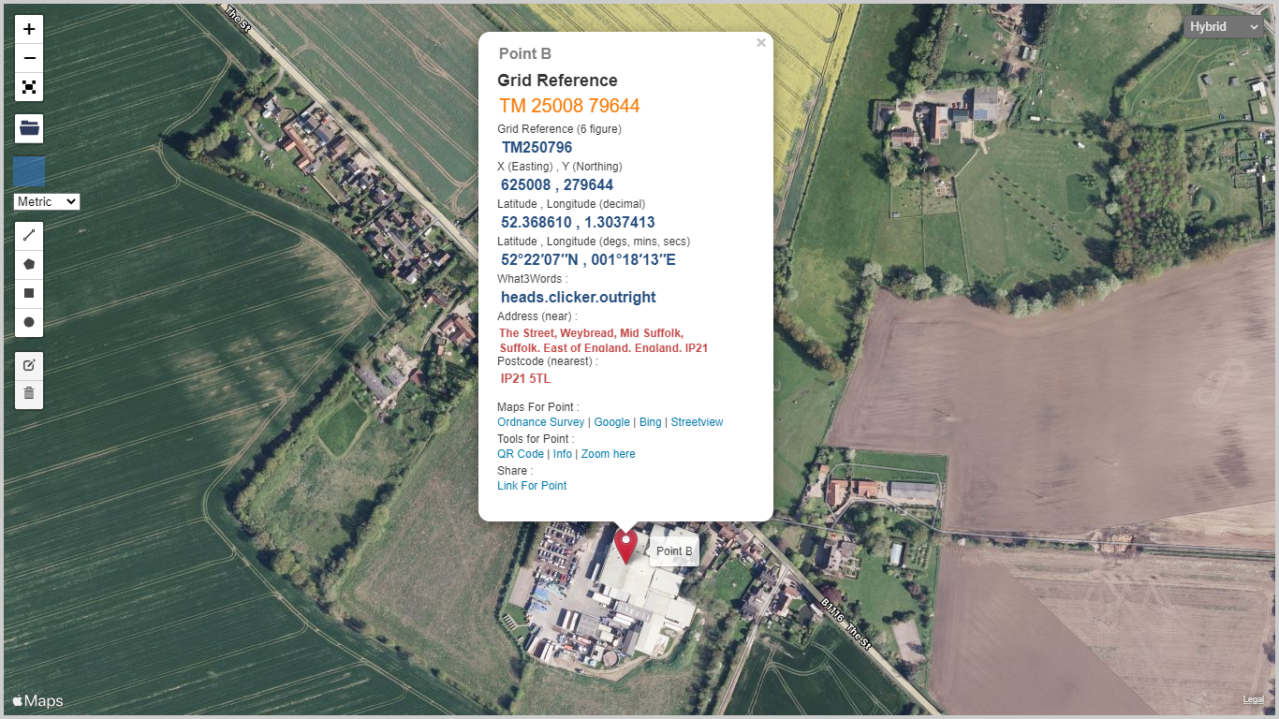

APPENDIX 2 - Table of intrusive investigation sampling locations in relation to Environmental Permit surrender application

Location | Observations | Soil Sampling Recommendation
- Fuel oil tank - (emergency generator fuel tank) | Integrally bunded fuel storage tank in very good condition. Empty at the time of inspection. Emergency generator used very little whilst in place (run on test for around 1 hour each week and very rarely required to generate power for use on site) hence number of tank filling cycles very low during plant lifetime. Permanently connected fuel supply line to generator drive. No evidence of spillage or leakage in vicinity of tank (see photograph reference WSC1). | Soil sampling not required at this location
- Diesel tank (fuel for road vehicles) | Integrally bunded tank emptied and removed from site prior to site inspection. Concrete at location in good condition with no evidence of staining from spills or leaks. | Soils samples should be taken from this location in line with the original site closure plan recommendation.
- Gas oil tank (fuel for site vehicles etc) | Integrally bunded tank emptied and removed from site prior to site inspection. Concrete at location in good condition with no evidence of staining from spills or leaks. | Soils samples should be taken from this location in line with the original site closure plan recommendation.
- Ferric sulphate tank | Tank emptied, cleaned and removed from site prior to site inspection. Concrete at location in fair condition with some staining evident suggesting that spills or leaks may have occurred (see photograph reference WSC2). | Soils samples should be taken from this location in line with the original site closure plan recommendation.
- Caustic soda tank | Tank emptied, cleaned and removed from site prior to site inspection. Concrete at location in fair condition with some staining evident suggesting that spills or leaks may have occurred (see photograph reference WSC2). | Soils samples should be taken from this location in line with the original site closure plan recommendation.
- Treatment chemicals tanks– Hygen 425 and Prechlor | Integrally bunded tanks in very good condition, emptied and cleaned prior to inspection. Concrete at location in good condition with no evidence of staining from spills or leaks. (see photograph WSC3). | Soils samples should be taken from this location in line with the original site closure plan recommendation.
- During the site inspection a spill was noted surrounding the external pipe work from a temporary unit known as the marinade store | Spill was very limited quantity and present for short duration only the source of the escape (a disconnected drain pipe) being quickly rectified. Material involved not a significant pollution threat being readily and rapidly biodegradable. No evidence of lasting effects on close inspection. | Soil sampling not required at this location
- Inspection CAR Report ID: BX4968IQ/0336539 Dated: 09/07/2019 -Contaminated water was noted around the blood tank | Integrally bunded tank in good condition, emptied prior to inspection. Concrete in vicinity of vessel and in particular directly beneath material loading point, in poor to fair condition with some significant wear and cracking. Some evidence of staining likely to have resulted from minor spills during collection. Material involved not a significant pollution threat being readily and rapidly biodegradable. (see photograph reference WSC4). | Soil samples should be taken from this location.
- At the rear of the lairage (vehicle washing end) spray from washing lorry trailers was escaping onto unmade ground | Escape of material onto unmade ground was very limited quantity and of short duration only before barrier installed to prevent escape. No evidence of lasting effects on close inspection. (see photograph reference WSC5). | Soil sampling not required at this location
- Heating oil tank (domestic) | Integrally bunded tank removed from site prior to inspection. Area around tank location free from from staining due to spills and leaks. Low usage rate as domestic heating source hence number of tank filling cycles low. | Soil sampling not required at this location
- Oil store | Small oil etc storage building within larger building for oil and similar materials in small portable containers. Portable bunds provided for containers in storage. Minor oil staining to concrete flooring inside building noted but concrete in good condition and no evidence of transmission to wider areas. | Soil sampling not required at this location
- Sludge storage tanks and former vehicle wash area | Sludge storage tanks emptied prior to site visit. Some evidence of spills and leaks onto surrounding concrete which is in generally poor condition. Same area used previously for collection of contaminated vehicle washings. (see photograph reference WSC6). | Soil samples should be taken from this location.
- Former fuel storage tank location area | Concrete in area is in good condition and free from staining resulting from spills or leaks. It stands immediately adjacent to fuel tank locations 2 and 3 above. (see photograph reference WSC7). | Soil samples should be taken from this location.

APPENDIX 3 – Sampling Location Plan Reference 20.382 SK01

APPENDIX 4 – Sampling Location Plan Reference 20.382 SK02

