Supporting Document – Flood Risk Assessment
35 Lauderdale Ave, Cleveleys, FY5 3JP
Application number 21/0062
In support of the recent application for this single storey rear extension at the above address, please find the attached and completed Householder Minor Extension Flood Risk Form as requested.
The map below indicates that the existing dwelling is located within a Flood Risk Zone 3 which benefits from localised Flood Defence. We are not aware of any flood incidents following the installation of Flood Defence in the area.

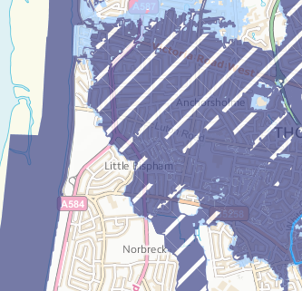

In order to comply with the guidance within “Improving the flood defences in new dwellings” CLG 2007 document, the construction of the new extension will be as follows:
- New floors to be no lower than the existing and to incorporate a 1200 gauge Damp Proof Membrane (Visqueen or similar) which is to be lapped and fully sealed to the Damp Proof Course.
- All electrical sockets and switches will be positioned a minimum of 450mm above finished floor level
In addition to this, the applicant is aware of the requirement to register with gov.uk for early warnings in case of flooding within the area.
This Flood Risk Assessment has been produced following the guidance given on the Environmental Agency FRA for minor extensions.

Mark Davis
DAVIS Group

