Condition 2 –
External Surface Materials
- External Render - K Rend Silicone Thin Coat in PEARL
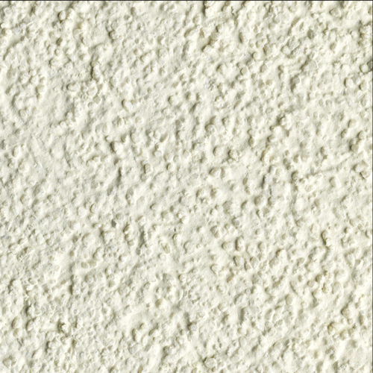
Front Door
- Wooden – Painted as below

Window
- Cortizo Casement window – Powder coated aluminium in WHITE

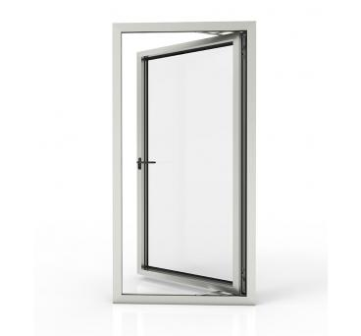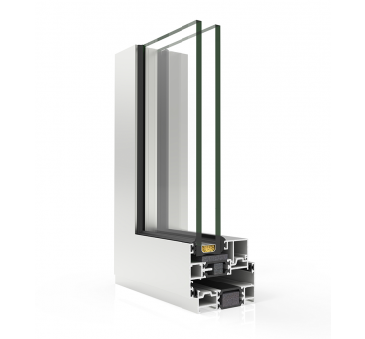

Bifold Doors
- Cortizo Bifold – Powder coated aluminium in WHITE
