Document B - Old Pound House summerhouse planning application
Design and Access Statement

We have chosen a traditional design of summerhouse sympathetic to the Tudor cottage architecture of the building (see illustration below left) with pitched roof and 12-pane 'Georgian' windows, echoing the multi-framed windows of house and garage, and very similar in design to the derelict one we are replacing. We plan to keep it in a natural wood finish. The dimensions are 3m L x 2.43 W x 2.5 H.
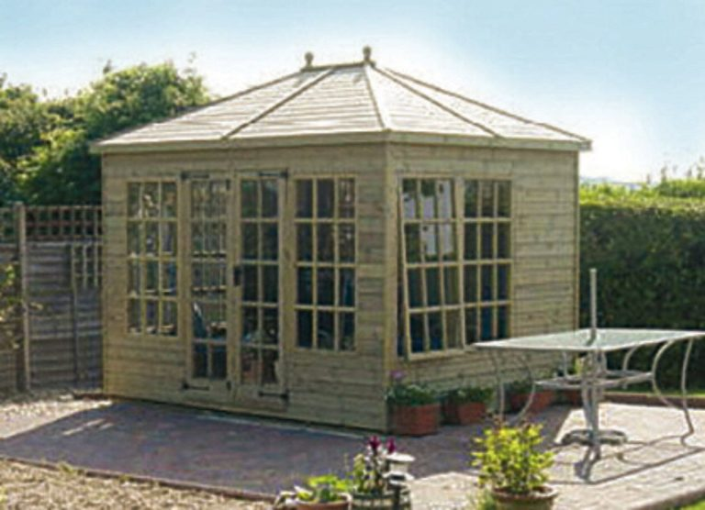
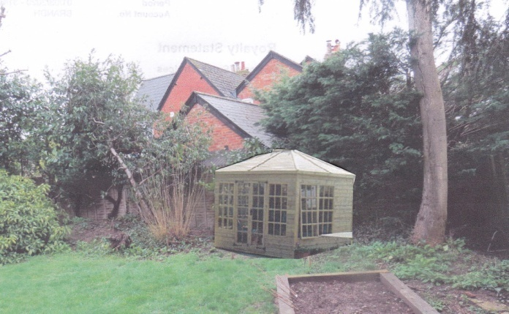

We have chosen a different site in the garden in order to get more sun and a better view. (See mock up picture above right, approximately to scale) This site is masked from neighbours by a 2 metre high fence and 7 metre high laurel and leylandii and cannot be seen from the road. The new summerhouse would be 2 m from boundary fence and 11 m from our house.
We will create a standing of hard core and gravel, rather than solid concrete so as not to interfere with drainage, and access via stepping stones across the lawn rather than adding a solid path. It will not stand above the existing garden level, so no disabled access issues.

The old summer house (pictured below) is 2.8m W x 1.8 L x 2.5 H and is too rotten for repair. It is not an old building and has no conservation interest.

