HERITAGE STATEMENT OF SIGNIFICANCE & IMPACT ASSESSMENT
Conversion of Woodland Cottage to outbuildings and erection of new dwelling, ‘Oak House’, set on higher ground within the setting of Woodland Cottage.

February 2021

  - This statement has been prepared to inform the design for an application for a replacement dwelling at Woodland Cottage Westhorpe Southwell NG250NE

1.2 In accordance with the policy set out in the National Planning Policy Framework this statement describes the significance of any heritage assets importance and is sufficient to understand the potential impact of the proposal on that significance.

  - This statement seeks to identify the local heritage assets that may be affected by the proposal and to consider what impact they might have on the surrounding assets.

1.4 This statement has been prepared by Allan Joyce who is an Architect accredited in Building Conservation (AABC) accredited Architect.

2.0 SITE LOCATION AND CONTEXT.

2.1 The application site lies on the south side of Westhorpe and is known as Woodland Cottage, formerly known as Toad Cottage.

2.2 The Cottage is detached and is recorded as an unlisted building of local interest in the Newark and Sherwood Map 13, Westhorpe Buildings. See attached map
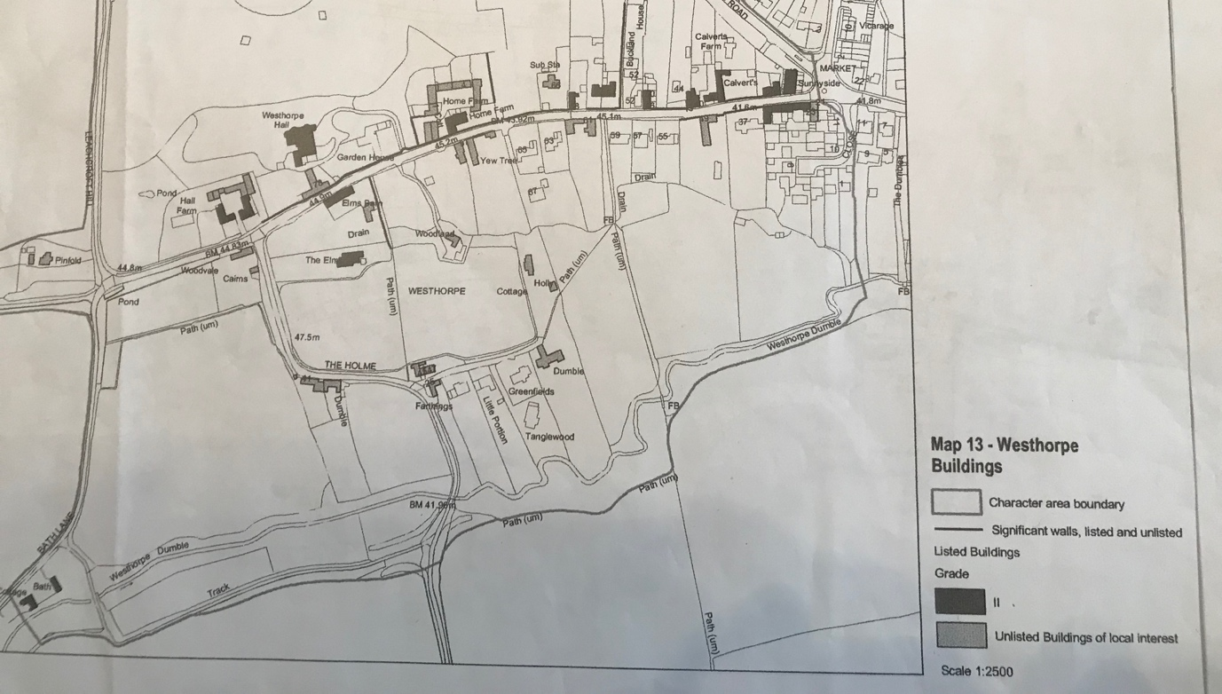

In addition to this identification, the cottage is surrounded by several grade 2 listed buildings, notably; The Elms UID 1369940, a large Georgian house to the west , Elms Barn, UID 1214801, a house converted from a barn to the north west, the Gate piers and wall to Westhorpe Hall UID 1052209, to the north and Westhorpe Hall itself to the north west. There is an open field to the south of the application site and to the south side of that there are some former farm workers cottages labelled as being of local interest to the south west and some rebuilt cottages almost directly south which are also labelled as being of local interest. Of these, the properties that are viewed together are The Elms, and the cottages to the south side of the open field.

The Elms is a very well preserved brick and slate roofed Georgian house and sits significantly further forward and higher than the site of Woodland Cottage and as such dominates the open field, both in stature and height. It has a backdrop of trees that screen it from Elms Barn and Woodland Cottage.
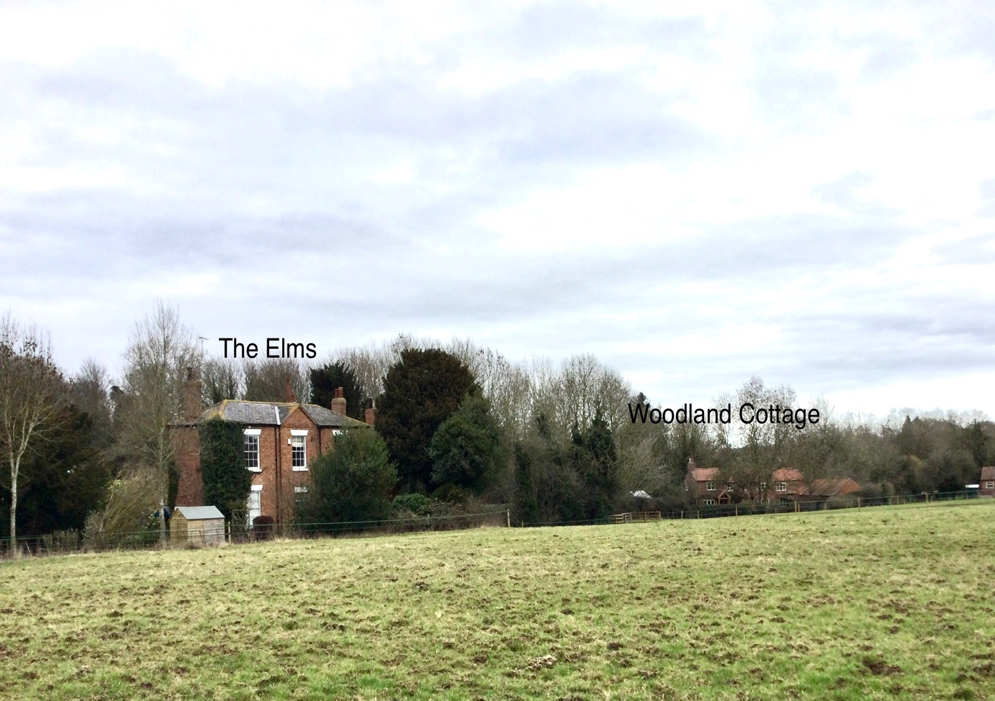

Both Woodland Cottage and the Elms are viewed from the footpath that crosses the field to the south of the application site. However Woodland Cottage occupies a site much lower than the Elms and has a lesser impact over the field.

Whilst Woodland Cottage is surrounded by the other listed buildings referred to, it is not viewed together with them, rather it is set within the context of these other character buildings.

3. SITE DESCRIPTION AND HISTORIC CONTENT
Development on the site of Woodland Cottage (Toad Cottage) is apparent on historic maps alongside the other Georgian properties in Westhorpe.
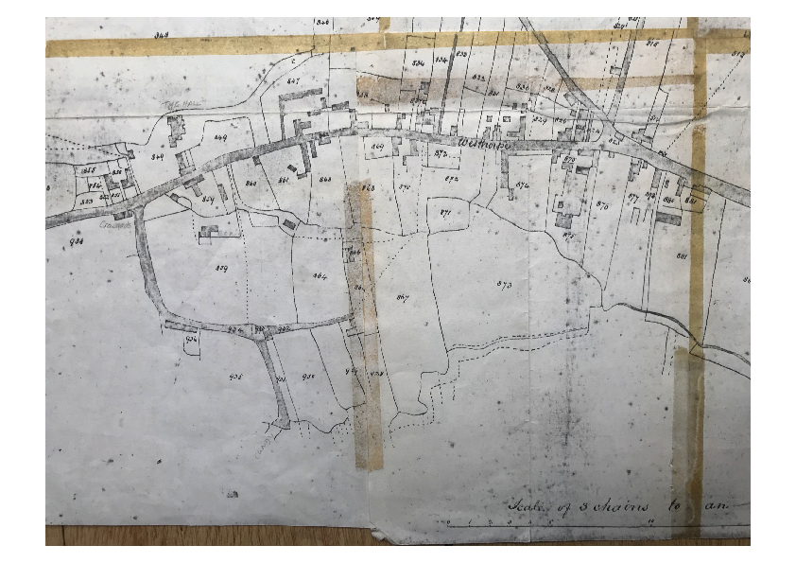

Westhorpe was originally a series of small farmsteads on the outskirts of Southwell, and it is assumed that Woodland Cottage was originally a farm workers cottage similar to Bath Cottage at the end of Westhorpe. It appears as a much smaller footprint than on maps of today and it can be assumed to be of much lower status than the other houses of the area.
It is known that the current garden area of the cottage originally belonged to The Elms and there is still a gate at the west end onto the footpath that would have provided access to it.

The cottage is very low lying again suggesting a lower status property.

By the 1970’s Woodland Cottage had become derelict, and it was not until 1993 that extensive rebuilding work was undertaken. At this time the property was rebuilt and extended to the south and east, with the addition of a kitchen wing, and lounge, a single storey office and double garage. The brickwork for this rebuilding is in a combination of reclaimed and new brick with new clay pan tile roof.
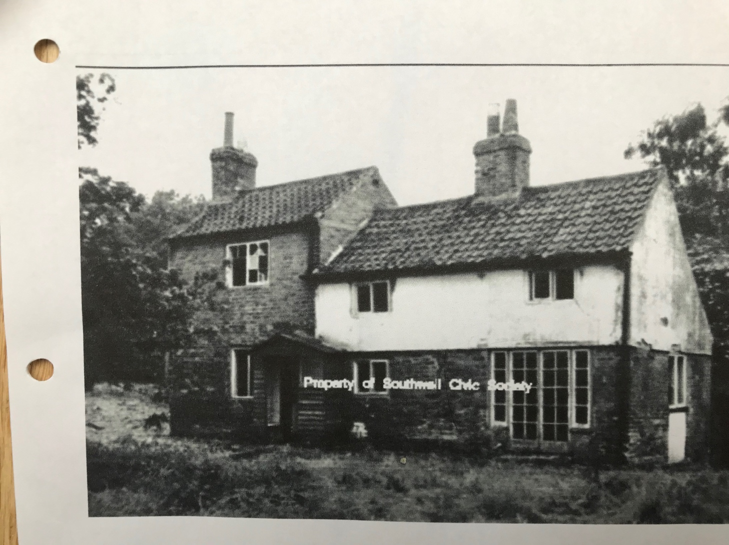

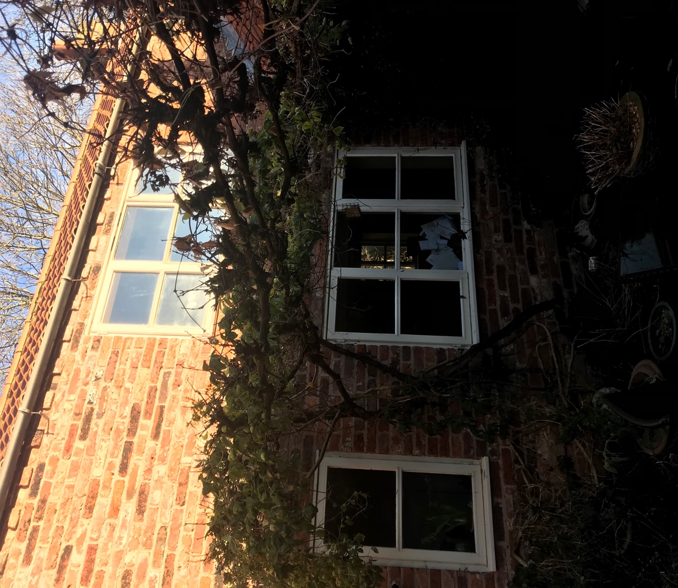

The northern most section of the cottage has a combination of Georgian and Victorian brickwork that has been largely repointed in a cement mortar.

Fenestration has been changed from the original Yorkshire sliding sashes to modern “storm proof” style windows. The replacement windows have largely lost the portrait form of traditional windows in favour of a more modern landscape aperture.
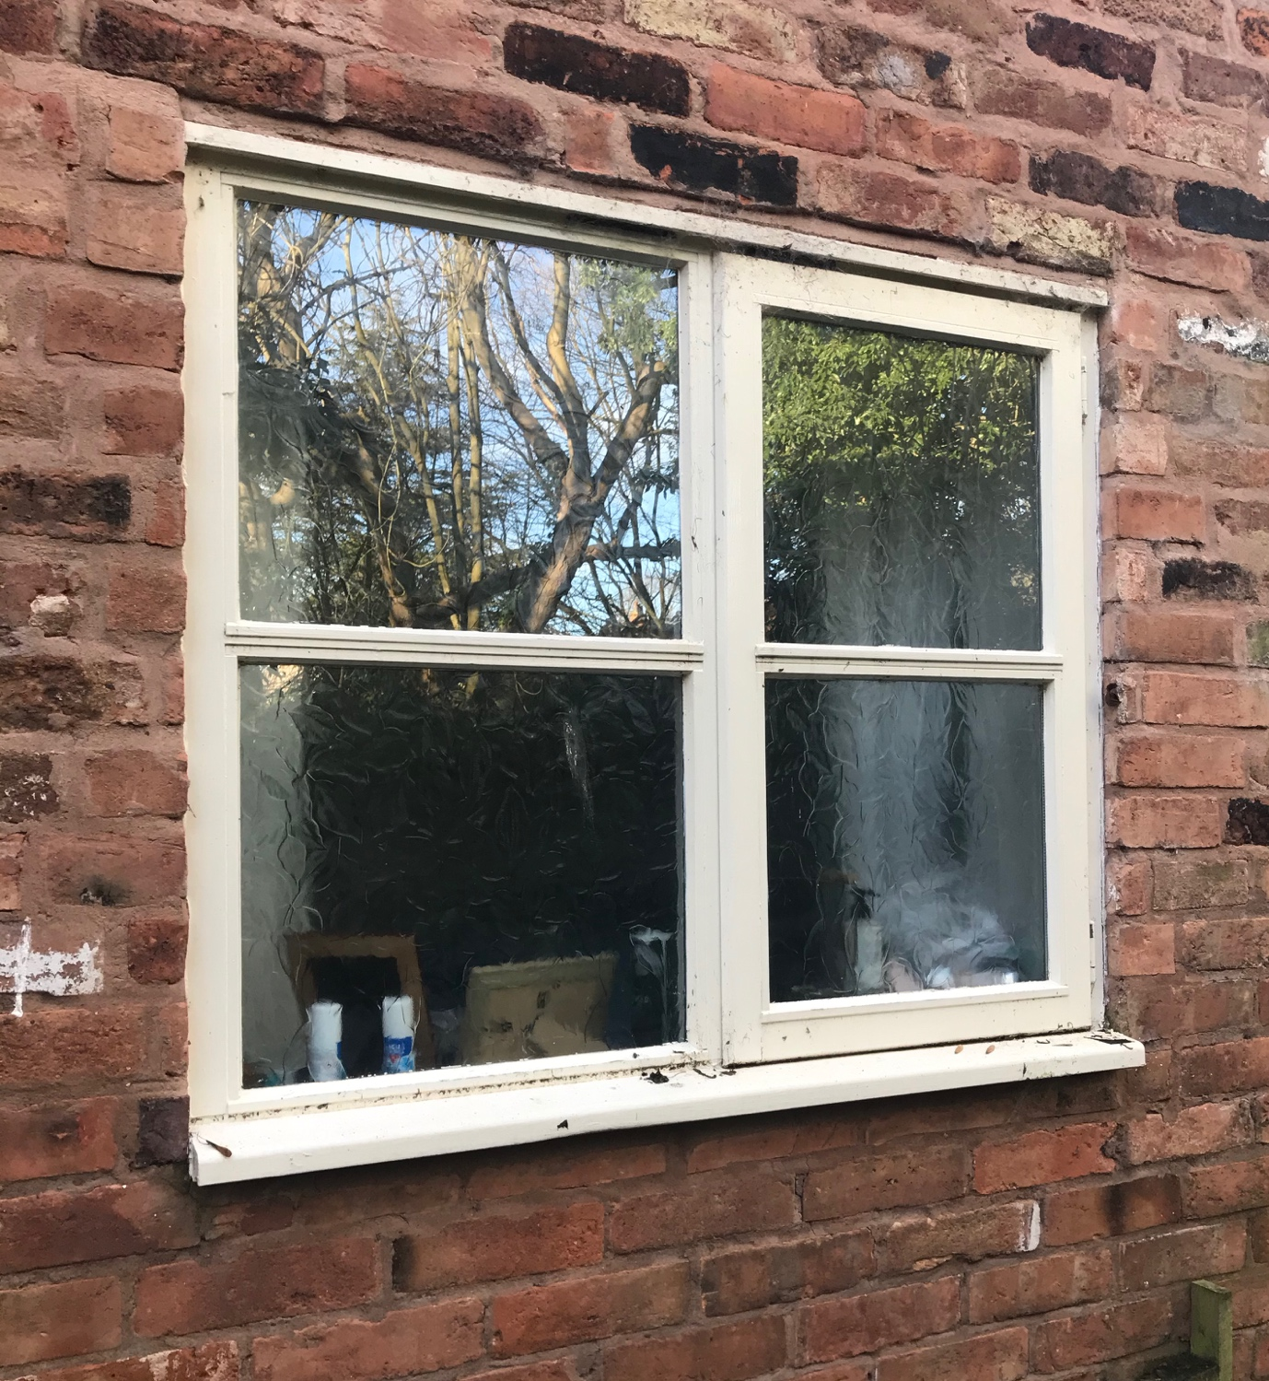
4. POLICY CONSIDERATIONS
4.1 Planning (Listed Buildings and Conservation Areas) Act 1990
The primary legislation relating to historic buildings is the Planning (Listed Buildings and Conservations Areas) Act 1990. This requires councils, when determining applications, to pay special regard to the desirability of preserving or enhancing the character or appearance of a conservation area (section 72) and to have special regard to the desirability of preserving a listed building or it’s setting (sections 16 and 66).
4.2 To promote sustainable development, the NPPF seeks to ensure that historic environment and its heritage assets are conserved in a manner appropriate to their significance (paras 17 & 126).
4.3 However, it recognises that the significance of a designated heritage asset can be harmed or lost through development within its setting, where setting is defined as ‘the surroundings in which a heritage asset is experienced’, recognising that ‘elements of a setting may make a positive or negative contribution to the significance of the asset’.
4.4 The NPPF therefore requires an applicant to describe the significance of any heritage assets affected, including any contribution made by their setting, proportionate to the assets importance and sufficient to understand the potential impact of the proposal on their significance, although it accepts that not all elements of a conservation area will necessarily contribute to the significance.
5. SUMMARY OF LOCAL HERITAGE ASSETS
5.1 The NPPF defines a ‘heritage asset’ as ‘a building, monument, site, place, area or landscape identified as having a degree of significance meriting consideration in planning decisions, because of its heritage interest and includes both designated heritage assets and assets identified by the local Planning Authority.
5.2 Existing Designations.
The existing buildings are located within the Westhorpe Conservation Area.
5.3 Listed Buildings.
Other properties within the immediate area
82-84 Westhorpe UID 1214856
Westhorpe Farm House UID 1046057
Westhorpe Hall UID1288340
Home Farm UID 1369940
Home Farmhouse UID 1046058
Barns at Bath Cottage UID 1045455
Bath Cottage UID 1045454
58 Westhorpe UID 1369939

Whilst these buildings make up much of the character of Westhorpe they are not directly affected by the proposal as they are not in view of the site.

5.4 Scheduled monuments
There are no known scheduled monuments within the immediate area
Parks and Gardens of Special Historic Interest
5.5 There are no known parks and gardens
6. POTENTIAL IMPACT OF THE PROPOSED DEVELOPMENT ON THE SIGNIFICANCE OF THE LOCAL HERITAGE ASSETS
It is considered that the originality of Woodland Cottage has been destroyed mostly by the alterations that were carried out in the 1990’s however the historic reference to development on that part of the site remains.
The aim of retention of a part of the cottage and the introduction of an external stair to first floor office will retain the fact that there has been a long-term development of the site, but it will revert the construction to a lower status building.
Woodland cottage would become a smaller element on the site and it would retain the brick and pantile roof that would have been typical of lower status building types.
The public view of the retained elements of Woodland Cottage will be very similar to the current position, with the exception of the double garage, which will be clad in oak and have the pitched roof trusses replaced with a flat green roof.
The new property will be constructed on ground, that does not flood, but will be a building of lesser scale than The Elms, but equally greater scale than the retained section of Woodland Cottage.
It will be a building that uses renewable materials in the same way that original Georgian architecture did, however the oak cladding and green roofs will be ressessive when viewed against the Elms, so as to retain its prestige as a country house. The oak cladding will take on a dark brown colour as it ages and this will make the house recede into the woodland to the rear.
The proposed replacement dwelling, to be built on higher
It is felt that the proposal demonstrates a high quality design that respects its local context and has regards to the objectives of Conservation policies and Guidance notes.

As a result of this considered design approach, and the liaison which has taken place between the Conservation Officer (Oliver Scott), prior to this application, the proposed
development promotes a high-quality design scheme that in terms of its scale, design, and materials of construction, has regard to its local context and character. It will take living accommodation out of flood risk and it will promote a design type that fulfils the objectives of Government policy to increase biodiversity.
7. CONCLUSION
As described above, it is considered that the overall design, and scale of the proposed development is sympathetic to its surroundings and to the area as a whole and will have no direct bearing on any of the nearby Listed Buildings.

