

**DESIGN AND ACCESS STATEMENT INCORPORATING HERITAGE ASSESSMENT**

**Proposed Replacement Dwelling-house**

**At**

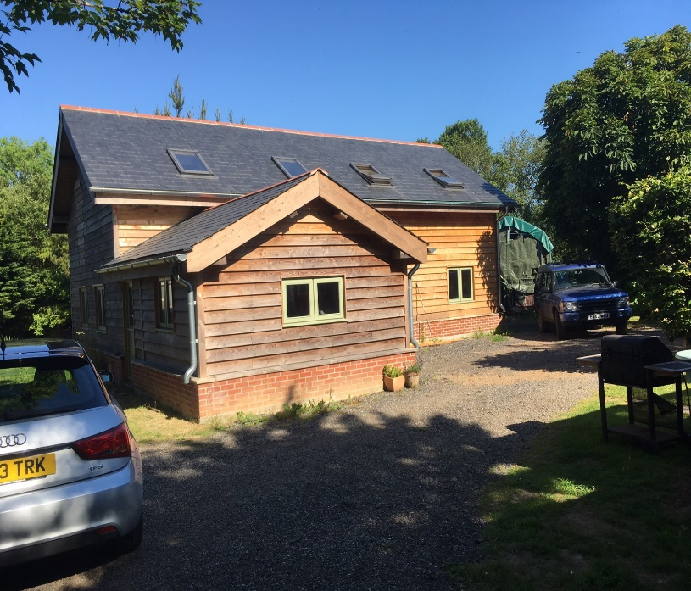

**Pen Bownder, Red Lane, Rosudgeon, Penzance,**

**Cornwall, TR20 9PU**

**On behalf of Mr P Keen**

**Prepared November, 2020**

Table of Contents

1. Introduction 3

2. Site location and description 5

3. Planning History and pre-application consultation 8

4. Proposed Development 9

5. Planning Policy and Guidance 12

6. Planning Considerations 18

7. Similar Proposals……………………………………………………………………………….20

8. Opportunities……………………………………………………………………………………………..21

8. Conclusions…………………………………………………………………………………….22

# Introduction

Situ8 Planning Consultancy Ltd have been instructed by Mr P Keen to act on his behalf in dealing with the planning process relating to a replacement dwelling-house. The existing residential dwelling-house (former caravan with the benefit of a CLEUD) is to be removed and the applicant will use the two-storey workshop/studio building as the replacement dwelling-house. The land is now known as Pen Bownder, Red Lane, Rosudgeon, Penzance, Cornwall, TR20 9PU hereinafter referred to as ‘the site’**.**

The statement will evidence the site has a lawful use for a single dwelling-house and also where planning permission was granted in 2011 for a two-storey workshop building to the rear of the CLEUD building.

The statement confirms why the proposal is acceptable in planning policy terms at local and national levels and meets relevant planning guidance as at today’s date. We also provide information regarding the site, the existing building and proposed dwelling-house as well as highlighting other approved applications on similar sites within Cornwall.

The applicant retains the legal freehold ownership of the site.

The whole site edged red has been used for residential use for a period of time significantly in excess of 10 years.

## The Site

The site formerly known as Fieldhouse and subsequently Cosy is located within the fabric of the settlement of Rosudgeon. In this locale there is a clear pattern of development of residential properties and rural businesses.

Figure 1 provides a Google aerial image which places the site in context.

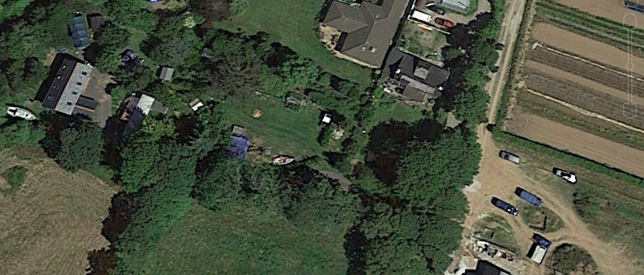

# Site Location and Description

The site is located within the settlement of Rosudgeon which comprises residential development of varying forms and styles i.e., traditional cottage forms and more modern housing including bungalows and two storey houses.

Rosudgeon is a dispersed settlement made up of the main built-up centre concentrated around the A394 with more sporadic development along the inter-connecting lanes between Rosudgeon and Perran Downs to the north (of which Red Lane is one).

The settlement has some public/community amenities including a public house, garage, shop and post office and is well connected to neighbouring towns by public transport.

The flat domestic application site is located to the north of the settlement and accommodates the applicant’s lawful dwelling-house (former caravan), mobile touring units, a two-storey workshop/studio and other shed like structures. All of these buildings and structures are located in a residential plot. Indeed, the land represents an extensive domestic garden which is bounded by vegetated boundaries on all sides.

A private driveway serves the site off Red Lane and there is a vehicular gateway at the western part of the site (the rear) that adjoins a public right of way. This route is used by pedestrians and vehicular traffic.

There are a number of new properties in this locale that have the benefit of planning permission (please see similar cases below). A site visit will reveal a number of houses that are currently under-construction that are sited directly opposite the application site at Red Lane.

The image below indicates the workshop/studio building currently on site, to be used as the applicant’s replacement home.



The application site is mainly enclosed on 4 sides and provides for a garden area/parking and storage facilities as described/illustrated above. The use of the workshop/studio will enable the applicant who is residing in the building (former caravan) to have more space for his family and their needs.

The site lies within the Parish of Perranuthnoe and is within the World Heritage Site.

The site lies does not lie within a flood zone or critical drainage area.

There is sufficient space at the application site to accommodate the applicant and his family within the existing two storey building.

## Site investigations

### Contamination

The Council confirm that this is a site that doesn’t lie in an area that is contaminated. We also consider that the land uses have been sensitive and therefore consider that the level of risk using the workshop/studio as a single modest dwelling-house will be negligible.

## Ecology

## The applicant has not commissioned an ecologist given that he has used the premises for workshop/studio and domestic use. There will be no changes made to the roof and minor alterations to the external fabric of the building.

# Planning History and Pre-Application Consultation

## Relevant Planning history

A planning history search via the council’s register has revealed the following planning applications submitted and approved by Cornwall Council’s local planning authority.

**Planning application PA10/03540- Construction of timber workshop/studio and formation of new access- Approved**

The building on site was historically placed at the site to accommodate a studio, workshop space for the applicant. It is a two-storey building sited within the domestic amenity of his existing home (formerly Cosy now Pen Bownder). The workshop/studio building has been extremely well built by the applicant and well-kept within a domesticised plot. It provides excellent thermal ‘green’ credentials and building regulations has also provided a completion certificate.

**Planning Application PA16/10579-** Certificate of lawfulness for the continued use of building for residential purposes. Land West of Nampara Red Lane Rosudgeon Cornwall - Approved

# Proposed development

## Introduction

# This full application relates to the replacement of the lawful dwelling-house known as Cosy with a 2-storey, 3 bedroom residential dwelling (from the workshop/studio building).

# No significant changes are proposed to the external appearance except for terrace/balcony/fire escape treatments to the side and front elevations.

# The site can adequately accommodate the applicant and his family within the former workshop/studio and ample parking provision and amenity space is also provided.

For the purposes of this application the proposal has been defined as the replacement of an existing poorly constructed former caravan (now a dwelling-house) with a two-storey, three-bedroom dwelling-house. The proposed dwelling-house will provide for family accommodation parking and amenity that will be future proofed for the applicant.

The plot will be utilised for family accommodation, with the accommodation being located at the back of the site. We contend that the design has been carefully conceived so as not to mimic surrounding development but to ensure that an appropriate form of 21st century accommodation commensurate to the plot is put forward for consideration.

In regard to the suitability of the scheme in terms of design, form, bulk, massing and appearance, the scheme is considered to comply with Policies 12 and 13 of the Cornwall Local Plan 2010-2030 and would result in a development that respects the character of the area, together with the scale and proportions of the neighbouring residential properties, whilst making efficient use of land.

The minimal changes made to the already accepted form has been formulated to maximise natural light with passive solar gain and meeting building regulations (fire escapes).

## Access

There is already an established access would be via the accessway known locally Red Lane. This will not change. A gateway access onto to the public right of way also exists serving the site. This will also not change.

## Layout

The internal layout will allow for three good sized bedrooms with kitchen, lounge, bathroom etc over two floors. There will be little in the way of change to the elevations and the applicant proposes first floor timber terrace/balcony/fire escapes to the front and side elevations.

## Appearance and scale

The scale and external appearance have already been considered as appropriate by Cornwall Council when assessing the workshop/studio development under PA10/03540. The final finishes will not change that will result in harm to the character of the area or neighbouring properties.

The built form has assimilated well into the landscape setting given that natural materials have been used to ensure the form blends with the domestic setting.

## Landscape impact

World Heritage Site

The site lies within the Tregonning and Gwinear Mining Districts World Heritage Site (WHS) and in accordance with the Framework great weight should be given to the conservation of this heritage asset. In this case the field patterns have already been substantially eroded by residential development in the immediate area.

Whilst the application site forms part of the WHS, it is not considered to contribute any significant value to its Outstanding Universal Value (OUV) given the modern development on site and the modern housing to the north and east of the site. It should also be noted from comparison of the maps that the pattern of smaller fields has changed over the last century or so into much larger fields.

We draw your attention to an allowed appeal for the erection of two houses and further development to the south of the site. Moreover, the application site has been granted permission for a lawful dwelling-house and also a two-storey workshop/studio. Please see similar cases below which highlights other approved developments for residential development in the immediate locale.

Given the changes to the building already approved are minimal and negligible it is considered that the proposal would not have an impact on the OUV of the WHS due to this development being set back from the road and not clearly visible from public vantage points. Furthermore, the site is already being used for domestic purposes and has been for well over 15 years. The application site is considered to integrate with the built form of the cluster of dwellings in the settlement and would not extend the built form into the open countryside.

# Planning Policy and Guidance

## Introduction to relevant policies

Under Section 38(6) of the Planning and Compulsory Purchase Act 2004, decisions on applications for planning permission and appeals must be taken in accordance with the development plan, unless there are material considerations that indicate otherwise. The National Planning Policy Framework (NPPF) was introduced in 2012 and stressed the importance of having a planning system that is genuinely plan-led.

The NPPF was most recently revised in February 2019 however maintained the emphasis that planning applications should be determined in accordance with the development plan, with the purpose of the planning system being to contribute to the achievement of sustainable development. At the heart of the Framework, so that sustainable development is pursued in a positive way, is a presumption in favour of sustainable development.

In Cornwall the development plan comprises the Cornwall Local Plan 2010-2030, including 'saved' policies from the adopted Local Plans which include Minerals Local Plans. It should be noted that currently there is no adopted Neighbourhood Plan (NDP) for Perranuthnoe Parish. We acknowledge that the NDP is being prepared but carries limited weight in decision making at this stage.

### National Planning Policy Framework 2019 (NPPF)

The NPPF 2019 confirms that sustainable development is ‘about positive growth – making economic, environmental and social progress for this and future generations’. Our view accords with the spirit and thrust of this advice where the development meets the criteria of Sustainable Development’s three dimensions, those being economic, social and environmental objectives. These objectives are interdependent and need to be pursued in mutually supportive ways, so that opportunities can be taken to secure net gains across each of the different objectives.

We begin with:-

**An economic objective** – to help build a strong, responsive and competitive economy, by ensuring that sufficient land of the right types is available in the right places and at the right time to support growth, innovation and improved productivity; and by identifying and coordinating the provision of infrastructure. In this case we are of the view that the site lies in the right location within a settlement. Indeed, Rosudgeon has been defined as being a settlement. We refer you to the following planning applications referenced below in Similar Cases section that have been recently approved in this settlement.

**A social objective** – to support strong, vibrant and healthy communities, by ensuring that a sufficient number and range of homes can be provided to meet the needs of present and future generations; and by fostering a well-designed and safe built environment, with accessible services and open spaces that reflect current and future needs and support communities’ health, social and cultural well-being. This development proposes the removal of a dwelling-house that is no longer fit for 21st century living purposes and the use of the of workshop/studio building as a detached dwelling-house will be totally appropriate for the site, the locale and the needs of the applicant and his family. The replacement dwelling-house will enable the applicant a local family man to remain in close proximity to his family, friends and employment hub.

**An environmental role** – to contribute to protecting and enhancing our natural, built and historic environment; including making effective use of land, helping to improve biodiversity, using natural resources prudently, minimising waste and pollution, and mitigating and adapting to climate change, including moving to a low carbon economy.

The applicant in developing the workshop/studio was keen to provide for a modest eco constructed 2 storey building with green credentials using high quality natural materials. The form and finish does not harm the landscape setting but ensures that it nestles in the site confines given the use of high quality and natural materials.

Ultimately the proposal is considered to accord with the above-mentioned objectives. This is said on the basis that the site’s location being within an existing settlement will make an efficient use of land that is sustainable and has the benefit of an established residential dwelling-house on site.

Paragraph 11 of the NPPF states that at the heart of the Framework is a presumption in favour of sustainable development. For decision-taking (paragraph 11) this means; approving development proposals that accord with an up-to-date development plan without delay; or where there are no relevant development plan policies, or the policies which are most important for determining the application are out-of-date, granting permission unless:

1. the application of policies in this Framework that protect areas or assets of particular importance provides a clear reason for refusing the development proposed or
2. any adverse impacts of doing so would significantly and demonstrably outweigh the benefits

It is contended that this guidance should be applied to the determination of this application.

The NPPF 2019 advocates sustainable development in rural areas and furthermore promotes housing to be located where it will enhance or maintain the vitality of rural communities. For example, where there are groups of smaller settlements, development in one village may support services in a village nearby.

### Cornwall Local Plan Strategic Policies 2010-2030

### It is our intention to focus on key policies as set out in the CLP 2010-2030. The policies are as follows:-

Policy 1 - Presumption in favour of sustainable development

When considering development proposals this policy states that the Council will take a positive approach that reflects the presumption in favour of sustainable development. Proposals should be approved wherever possible, to secure development that improves the economic, social and environmental conditions in the area. In our view, the proposal conforms to this policy in respect of an efficient use of land within a sustainable, built-up location, with residential development and road networks that ensure that further development will not erode the open countryside.

Policy 2 - Spatial Strategy

This policy states that new development should provide a sustainable approach to accommodating growth, providing a well-balanced mix of economic, social and environmental benefits, which should maintain the dispersed development pattern of Cornwall and provide homes and jobs based on the role and function of each place. A number of objectives are set out, specifically respecting and enhancing quality of place; providing solutions to current and future issues, and; generating and sustaining economic activity. Of particular relevance to the proposals, the proposed development would respect and enhance quality of place. We contend that this has already been achieved through sympathetic designed development featuring high quality materials and finishes to the workshop/studio.

Policy 3- Role and Function of Places

We are of the view that the proposal rests with this policy given that the council have already accepted other applications for development in this locale as a settlement. This proposal though is not proposing new development but the replacement of a dwelling-house with an already built out and used workshop/studio in a residential plot.

If the Council do not consider policy 3 to be relevant then we draw your attention to Policy 7 -Development in the countryside. This policy actively encourages and supports replacement dwelling-houses in a sustainable location.

Policy 12 and 13 - Design and Development Standards

This policy emphasizes that development must ensure Cornwall’s distinctiveness and maintain and enhance its natural and historic character. Design will be judged against fundamental design principles relating to character; layout; movement; adaptability, inclusiveness, resilience and diversity, and engagement process. In addition, proposals should protect individuals from overlooking and unreasonable loss of privacy, overshadowing and overbearing impact, unreasonable noise and disturbance. The proximity of the adjoining properties and the need to preclude any detrimental impact upon the amenities of the occupiers of this development will be negligible given the distances that prevail between properties. As a result, the introduction of the terracing/balcony/fire escapes will not result in harm or overlooking.

In design terms we are of the view that the development will function well and add to the overall quality of the area, not just for the short term but over the lifetime of the development. It will also be visually attractive as a result of good architecture, layout and appropriate and effective landscaping. The development does not intend to replicate what exists at the site or from the surrounding developments but provide for an exciting, well considered family home that is future proofed and makes efficient use of the land.

We contend that this proposal will effectively use land that meets the need for homes and will due to its location, siting and form safeguard the environment.

Ultimately the development makes good use of a site that is within a settlement. We believe that the local planning authority should give substantial weight to the value of using suitable previously developed land in such locations for homes.

The site has already been considered capable of accommodating the workshop/studio and the built form of an appropriate scale for the site.

There is an expectation of development being able to achieve the provision of a number of criteria, including; sufficient internal space, off-street parking and cycle parking; storage space for waste, recycling and compostables; avoidance of adverse impacts, utilising opportunities for natural lighting, ventilation, and heating. The use of the workshop/studio as the replacement dwelling-house meets the criteria of this policy.

Policy 21 – Best Use of Land and Buildings

This policy seeks to ensure the best use of land, by encouraging development to be given to sustainably located proposals that, amongst other criteria; increase building density where appropriate, taking into account the character of the surrounding area and access to services and facilities to ensure an efficient use of land. In addition, the use of previously developed land is encouraged by policy and the proposal does not result in an increase in building density.

We are therefore of the view that we meet with the aims and objectives of this policy.

Policy 23 – Natural environment

This policy requires development proposals to sustain local distinctiveness and character and protect and where possible enhance Cornwall’s natural environment and assets. The site lies within the WHS but we contend that the proposal given its footprint and form already exists will not be discordant with the advice and guidance from this policy

From a site visit you will see that the applicant has constructed the workshop/studio to an extremely high quality and principally used natural materials which complements the character

and nature of the area.

### Other relevant guidance

Planning Practice Guidance 2014

* Design
* Housing
* Natural environment

# Planning Considerations

## Principle of development

In our view the proposal is wholly compliant with Policies 1, 2, 3, (7), 21 and 23 of the CLP 2010-2030.

## Impact on the character and appearance of the area

Two core principles of the NPPF 2019 are to recognise the intrinsic character and beauty of the countryside and to conserve and enhance the natural environment. The harm to the WHS is negligible and is not prominent within the wider landscape due to its location within the settlement and dwellings located nearby.

## Access, parking and highway issues

As detailed above the existing access and subsequent driveway will continue to be used to serve the site.

## Impacts upon nearby residential occupiers

The size of built form that prevails (workshop/studio) is proportionate to other developments in the area. Due to its siting of this building within the residential plot it allows for good separation distances between existing dwelling-houses in the locale.

We can assert that the proposed replacement dwelling has been marginally altered from the approved workshop/studio development with consideration taken into account of the impact on the adjoining properties and residents in respect of preserving privacy.

# Similar Proposals

We draw your attention to some other similar proposals (despite there being many) where Cornwall Council have demonstrated consistency in their decision making, and have enabled development and economic growth within settlements.

**PA18/10499-** Proposed Removal of existing bungalow and replacement with 2 new dwellings Location of Development: 12 Holywell Road Playing Place Truro Cornwall TR3 6EP

**PA18/10661** - Demolition of two dwellings and their replacement with two larger dwellings complete with detached garages: Tregarth Whitehall Scorrier

**PA19/02038** [Redevelopment of site with replacement dwelling](http://planning.cornwall.gov.uk/online-applications/applicationDetails.do?keyVal=PNZRVKFGMQ000&activeTab=summary) Green Hedges Trenance Mawgan Porth Newquay TR8 4DA

**PA19/05214 -** Demolition of Sub-Standard Dwelling and Out-Buildings and construction of two Replacement Dwellings - 49 Treverbyn Road St Austell PL25 4EP

Locally the following applications are considered as relevant. They are as follows:-

• **PA16/05274** Approval for the erection of a single storey dwelling - Land at Nampara, Red Lane, Rosudgeon

• **PA15/03980** Appeal allowed for the erection of two dwellings - Rosebud Cottage, Red Lane, Rosudgen

• **PA20/03492** Outline planning permission granted for erection of a dwelling - Land At Rose Glen Red Lane, Rosudgeon, Penzance, Cornwall TR20 9PU

We would ask that these applications be reviewed against this proposal.

# 8.Opportunities

* Good use of land
* Meets the tests of the three objectives of sustainability
* Good access
* Provides a good standard of amenity
* Supports the local economy
* Provides for a much-needed future proofed family home
* Complimentary and exemplar design

# Conclusions

We trust that the information given within this planning statement demonstrates the suitability of the workshop/studio as a replacement detached dwelling-house, with the former caravan (CLEUD building) being removed from site.

We consider the proposal as a policy compliant form of development within a settlement. This site is part of a cluster of residential properties and lies in close proximity to other settlements. Localised policies that support such development include policy 1, 2, 3, (7), 21 and 23 of the CLP 2020-2030.

The proposed use of the land which is currently residential seeks the replacement of a poorly constructed lawful dwelling-house (originally a caravan), essentially not fit for purpose for 21st century living. As the site lies in a sustainable location with good access to local facilities and infrastructure, we are of the view that the principle of replacing the existing dwelling-house meets with current planning policies.

The design form and final finish of the replacement dwelling-house ensures an exciting and refreshing form of replacement dwelling-house that reflects the topography and domesticised appearance of the site.

We are of the view that an approval of this application will not have any adverse impacts to neighbours or the landscape setting, and so clearly it should be approved in accordance with planning policies and guidance as set out in the statement. It is hoped that Cornwall Council will support the application for the reasons detailed within this report.

Given the use of the site for the past 10 years as ancillary amenity with business and domestic storage we believe that the site itself is not considered to contribute greatly to the inherent amenity value of the area, which is designated as a WHS. Due to its position amongst residential properties and the established domestic nature of the site we consider that a residential use from the workshop/studio would not erode the character of the area or be discordant with planning policy.

We trust that you will support this policy compliant proposal for a single replacement dwelling in this sustainable location.