HERITAGE, DESIGN AND ACCESS STATEMENT

PROPOSED REPLACEMENT SUN LOUNGE

BROCKENCOTE STABLES
DOBES LANE
CHADDESLEY CORBETT

Apse Building Design Ltd
15 Quantock Drive
Kidderminster
Worc`s
DY10 1RZ
Tel: 01562 743782

TABLE OF CONTENTS

INTRODUCTION

EXISTING BUILDINGS

PHYSICAL CONTEXT

SOCIAL & ECONOMIC CONTEXT

PLANNING POLICY

EVALUATION

ASSESMENT OF SIGNIFICANCE

HERITAGE IMPACT ASSESMENT

INTRODUCTION

This Heritage Statement accompanies a full Planning Application demolish an existing UPVC conservatory and replace with a traditional sun lounge.

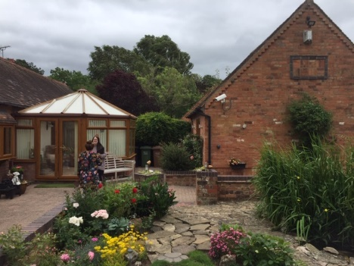
EXISTING CONSERVATORY

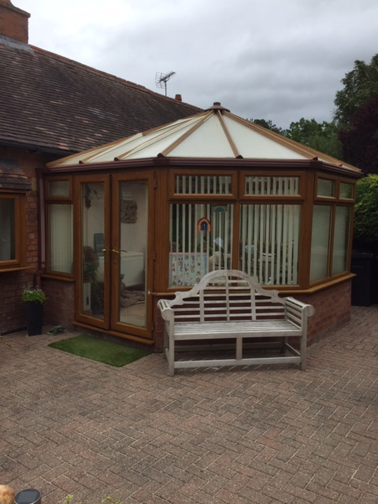

EXISTING CONSERVATORY

The property is a former converted stable block that formed part of Brockencote Hall.

PHYSICAL CONTEXT

“The earliest documentary record of the settlement at Chaddesley Corbett, then known as Ceadresleage, is from the Ninth Century A.D, when King Coenwulf of Mercia excused various local royal servants from paying 25 manentes (hides), presumably as a tax. The Domesday Book, in 1086, mentions two priests at Chaddesley Corbett, now known as either Cedeslaeh or Cedeslai, possibly suggesting that there may have been a church or chapel within the vicinity at this time. However, there is a lack of archaeological evidence to support this. The name Corbett comes from the family who owned the settlement during the late part of the Eleventh Century, and the early part of the Twelfth Century, and by the Fourteenth Century, the two names are incorporated, with the settlement now known as Chaddeslegh Corbet

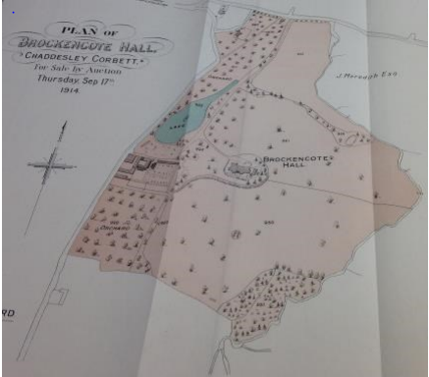
AERIAL MAP 1914

PLANNING POLICY

In order for the proposed development to consider and achieve the relevant
guidelines contained within the above policies, a detailed and fully considered
design must be achieved. This will hopefully result in a scheme that is site specific and one that will integrate successfully within the existing area.

Site Allocations and Policies Local Plan
Core Strategy
NPPF
Emerging Local Plan

EVALUATION
Based on an assessment of the site and the surrounding neighbourhood, a summary of the opportunities and constraints are as follows:

CONSTRAINTS
• The site consists of a single storey converted stable block and is Locally Listed as a building of interest

Opportunities:
• Well established road connections including the nearby A456 and M5 motorway.
• The site is well situated for access to Chaddesley Corbett High Street and Kidderminster Centre facilities. There is also public transport and nearby employment opportunities.
• Existing accesses to the site will be utilised.

ASSESMENT OF SIGNIFICANCE
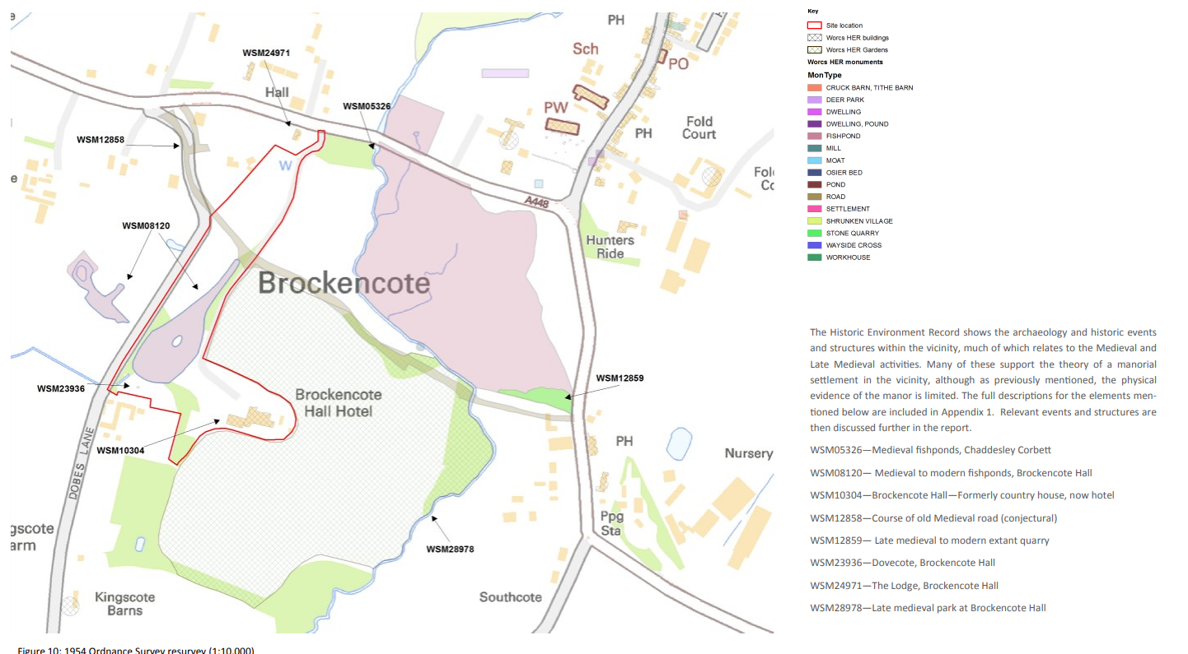

HISTORIC ENVIRONMENTAL RECORD PLAN

The stables once formed part of the Brockencote Hall estate and was subsequently split off and converted into residential dwellings as part of a complex.

The stable element has now been completely lost.

The Chaddesley Corbett Conservation Area was designated in 1967, and was subject of a boundary review in 1991. A Conservation Area Appraisal has been produced by the Local Planning Authority, the latest update being dated December 2014

IMPACT ASSESMENT

The proposal seeks to carry out the following works:

Demolish a UPVC conservatory and erect a replacement Sun Lounge.

The intention is to replace the conservatory with a traditional oak framed glazed conservatory.

The existing conservatory is constructed in unsypathetic materials and its design is incongurous with the simple form of the barn conversion.

The proposed replacement sun lounge would still allow the existing barn structure to be viewed through and would sit more comfortably with the converted barn and its rural setting using more appropriate oak and plain tiles.

The property is set within the Green Belt and we feel this proposal would enhance the setting and would not be detrimental to the openness of the Green Belt and therefore commend to you for your consideration.

The property is not visible from the road.

Overall the proposed works will enhance and preserve the integrity of the building and surrounding area. There is a positive in the sustainable use of
the building and its diversification to residential use.

Disabled Access Statement

The overall intention is to provide facilities that are accessible to all. All works to be carried out to BS 8300/2001

Sources and Guidance

Advice has been sought from a number of sources:
The following publications / references have been used:
- Disability Discrimination Act 1995 (DDA)
- Disability Discrimination Act 1995 – Code of Practice "Rights of Access – Goods, Facilities, Services and Premises"
- The Building Act 1984, Approved Document M 2004 Edition

- "Designing for Accessibility” published by The Centre for Accessible Environments, 2004 edition
- RNIB Fact sheet 6 – Reasonable Adjustments in Accessing Goods, Facilities and Services
- Colour, Contrast and Perception – Design guidance for internal built environments (Project Rainbow) published by The University of Reading 1997
- BS8300:2001 – Design of buildings and their approaches to meet the needs of disabled people – Code of Practice

- Building Sight (RNIB publication)

- Sign Design Guide (Sign Design Council)

Specific Issues

Site
The site is a converted stable block

The situation in respect of disabled access will not be made any worse or affected by the proposal.

