Our Ref.: SWG/LJG/SMITHS2/21

Date: 10th March 2021

Planning Department
Wyre Forest District Council
Finepoint Way
Stourport Road
Kidderminster

Dear Sirs,

RE: PROPOSED REPLACEMENT SUN LOUNGE

We are pleased to enclose Planning Permission in respect of the above to demolish the existing UPVC glazed conservatory and replace with an oak framed glazed sun lounge.

The proposed replacement is no greater than the footprint of the original conservatory. Although the volume is slightly larger this is due to the volume of the roof which was been designed to suit and match with the existing pitch of the main house. The proposal is only slightly larger than already approved under 20/0517/HOU but provides a reasonable amount of space for the provision of furniture.

The location of the sun lounge is set behind a garage and is only visible on approaching the front from an acute angle and is well screened from the road.

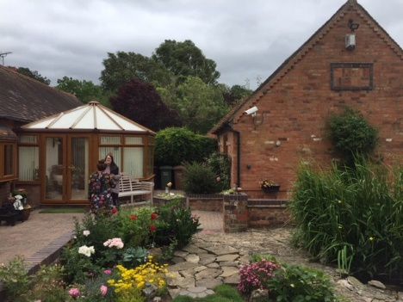

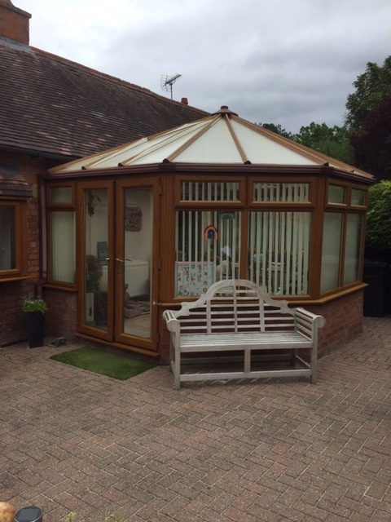

The existing conservatory is constructed in unsypathetic materials and its design is incongurous with the simple form of the barn conversion.

The proposed replacement sun lounge would still allow the existing barn structure to be viewed through and would sit more comfortably with the converted barn and its rural setting using more appropriate oak and plain tiles.

The property is set within the Green Belt and we feel this proposal would enhance the setting and would not be detrimental to the openness of the Green Belt and therefore commend to you for your consideration.

Trusting this is satisfactory,

Yours sincerely,

Jessica Greybanks Bsc (Hons)
For Apse Building Design Ltd

