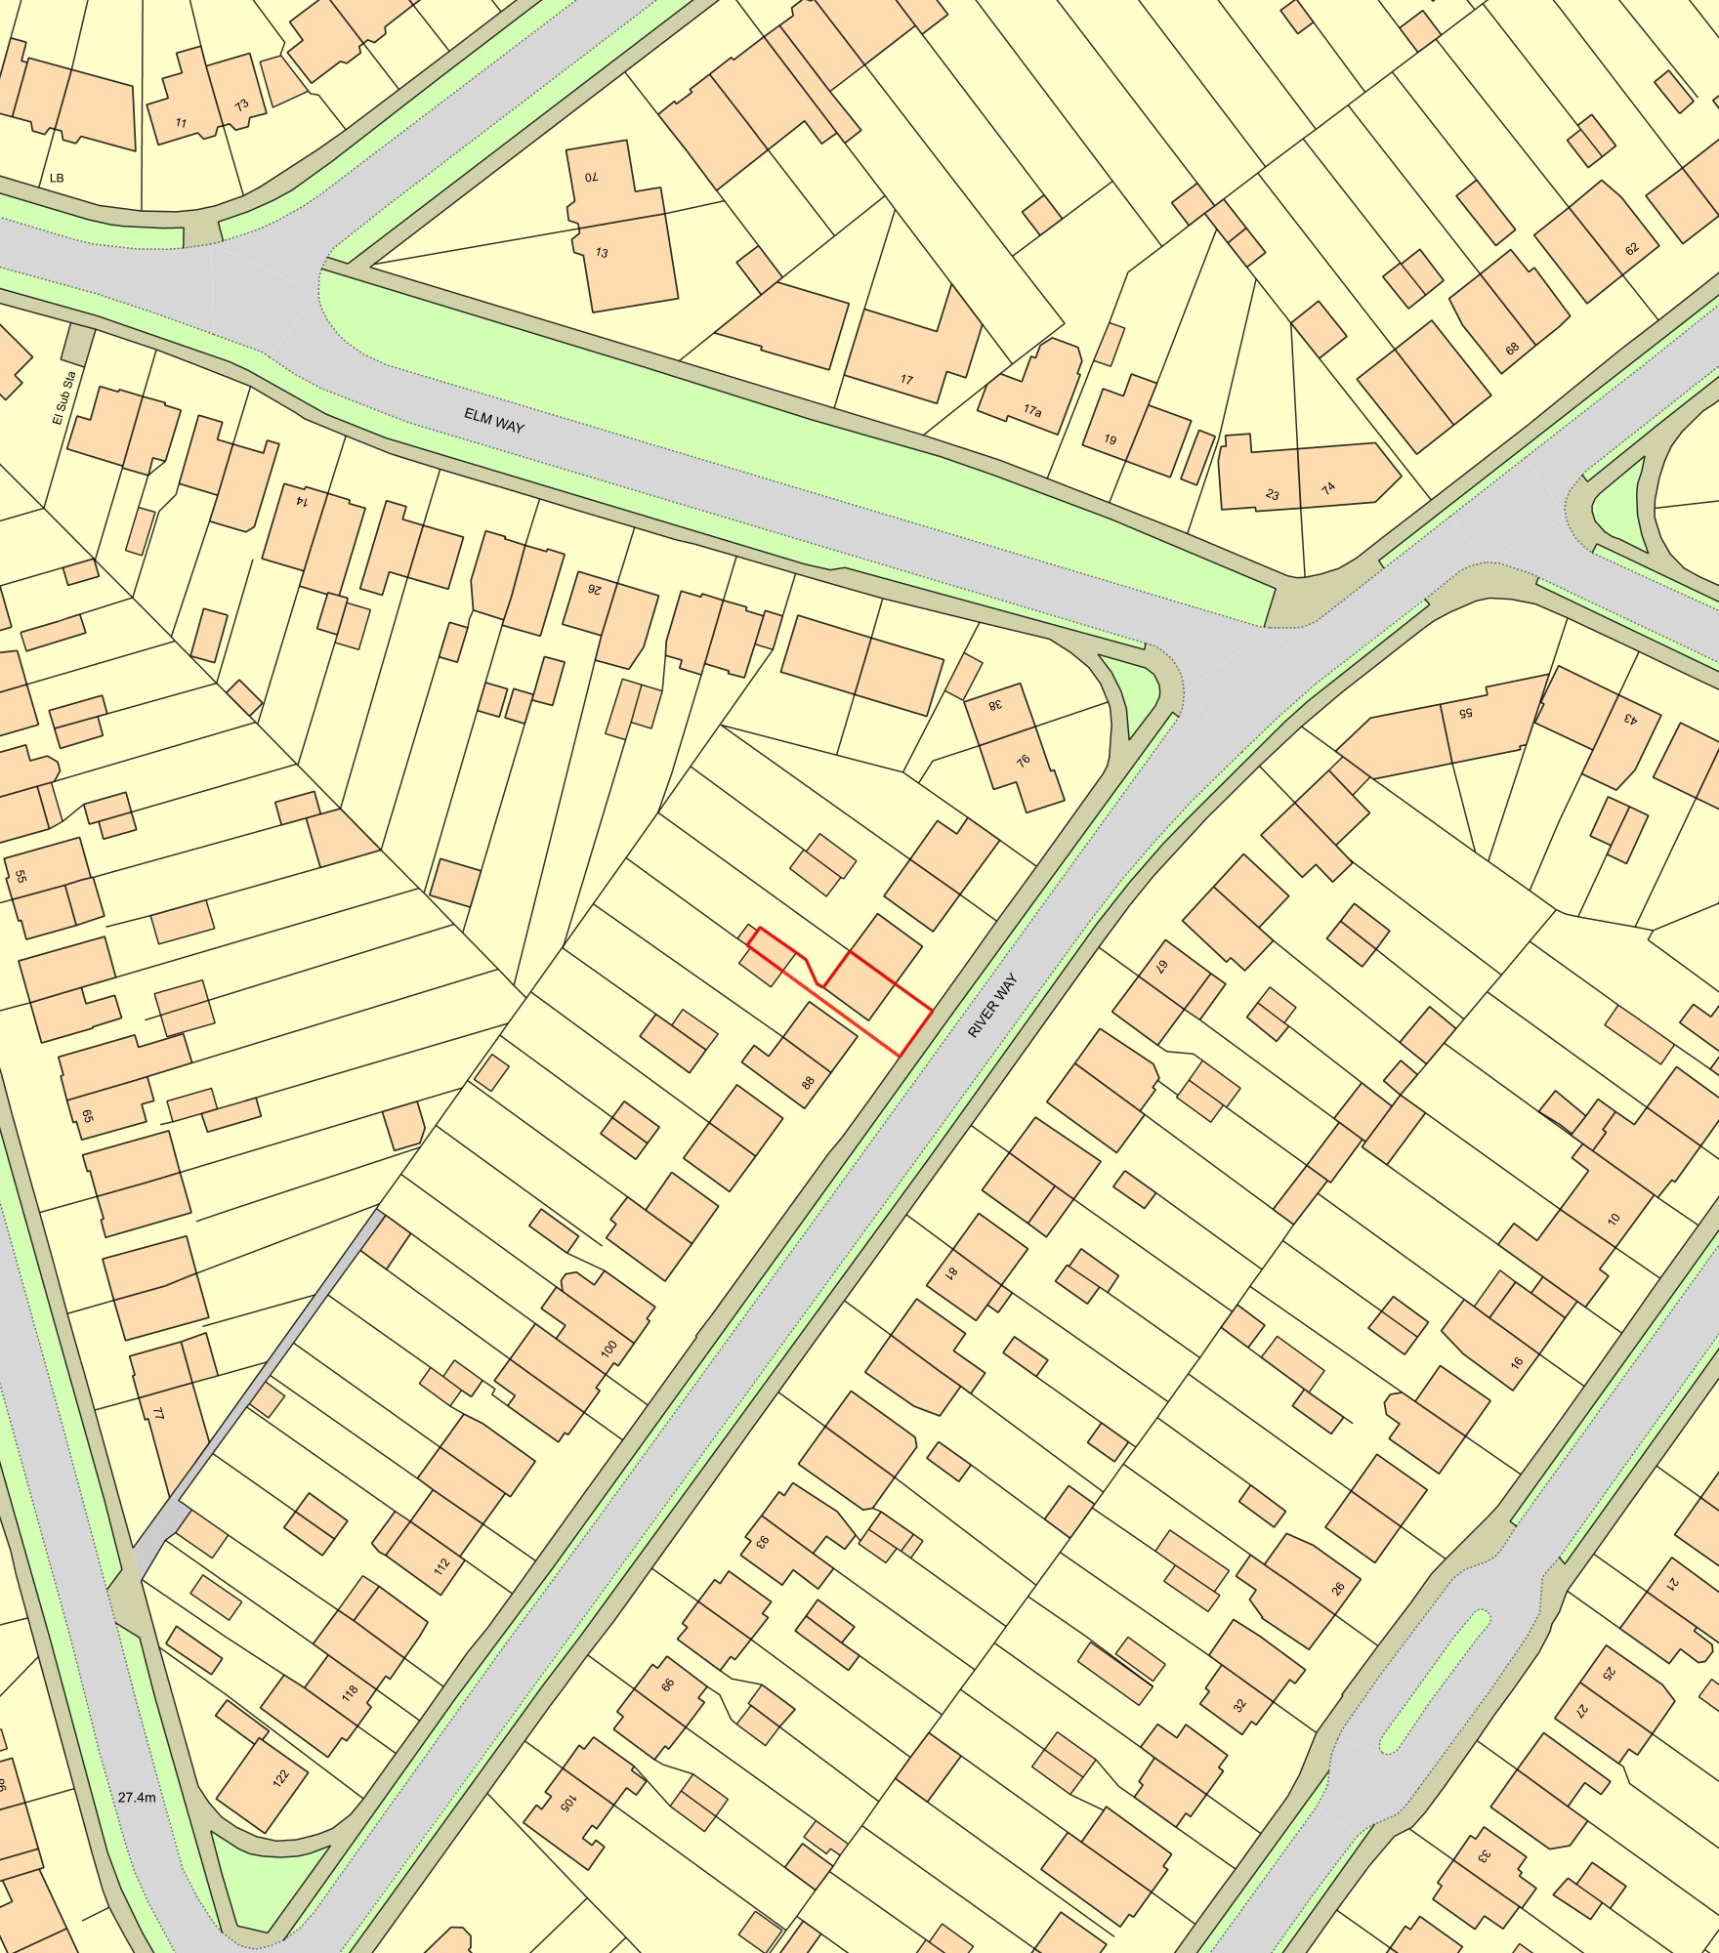84 River Way - Location Plan

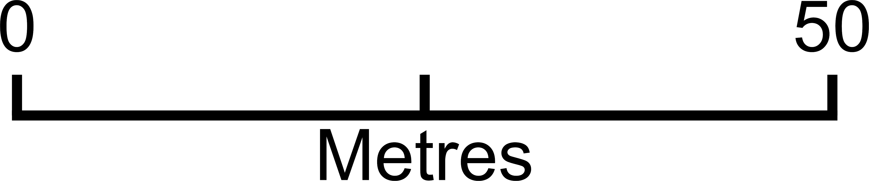
Plan Produced for: Elliot Cheesman
Date Produced: 25 Jan 2021
Plan Reference Number: TQRQM21025191012954
Scale: 1:1250 @ A4

© Crown copyright and database rights 2019 OS 100042766

