DESIGN STATEMENT
This design statement is for the retention of dry laid natural slate to the SE elevation roof, & the changing from poor quality, “reached the end of its life”, wet laid slate to dry laid slate (to match that on the SE elevation) to the 1st floor & main roof to the NW elevation.

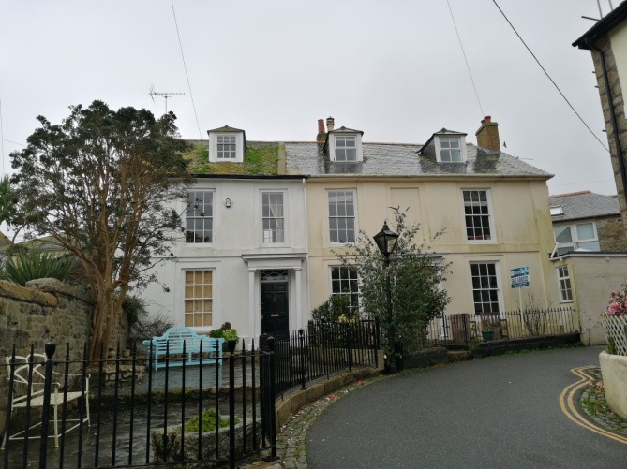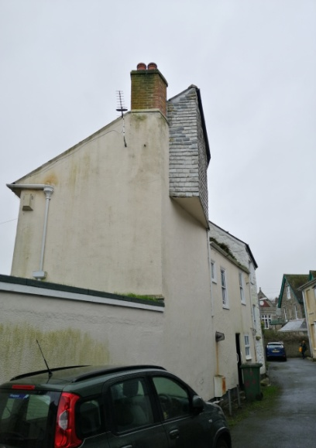
SE elevation NE elevation

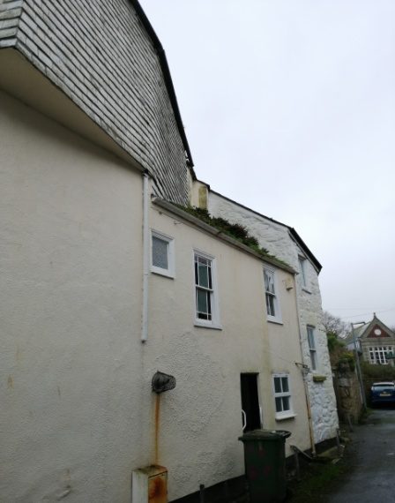
NW elevation

The proposed replacement slate will match that to the SE elevation, thus be regular coursed, copper
nailed 300 x 200 natural grey locally sourced.
Reuse existing ridge tiles

We note that all the other dwellings in Morrab place are either dry laid natural slate or cement fibre.

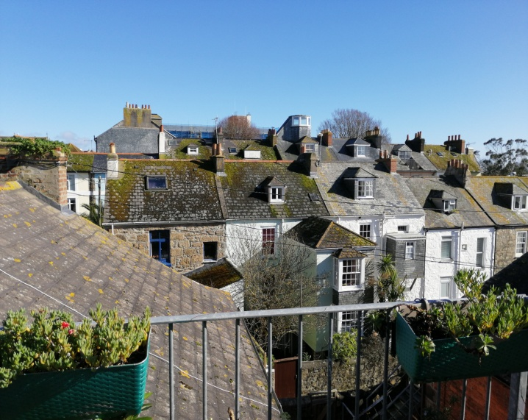
Looking East from Morrab Road to Morrab Place at nos 1-7 in front & 12 -17 behind.
Showing the dry laid natural slate or cement fibre roofs.

ACCESS STATEMENT

There is no change from the existing

