Planning Application
Heritage Statement

Priest’s House (Presbytery), St Mary’s Church, Harvington, Kidderminster, DY10 4LR

New WC in existing kitchen pantry

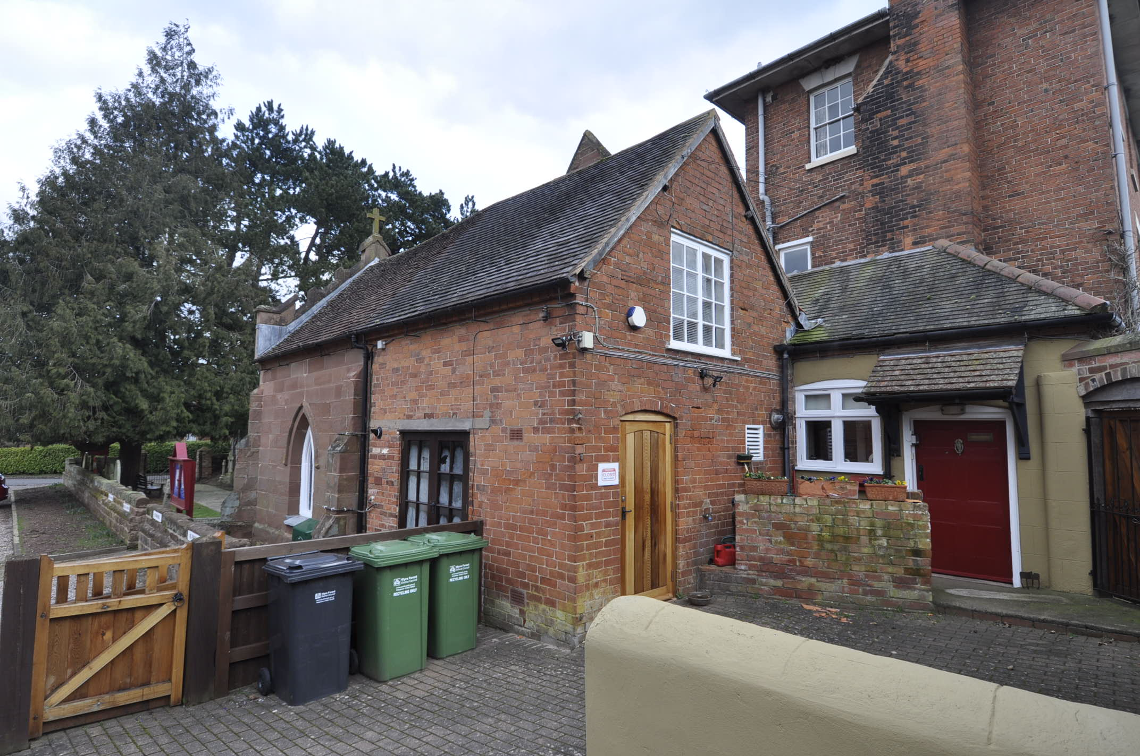

March 2021

Statutory Information:

Name: | PRIEST'S HOUSE
List entry Number: | 1100675
Type of record: | Building

Grid Reference: | SO 87815 74380
District: | Wyre Forest
Parish: | Chaddesley Corbett
Date first listed: | 18-Mar-1987
Grade: | II
HER reference: WSM40507
Legacy System nr: 157021
Legacy System: LBS

Protected Status
Listed Building

Full description
CHADDESLEY CORBETT CP HARVINGTON SO 87 SE 10/34 Priest's House GV II House. 1838 with some late C19 alterations. Brick with hipped slate roof. Three storeys, boarded eaves, three windows: 16-pane sashes under plastered wedge lintels. Second floor as first floor. Ground floor with pilastered wooden doorcase with flat canopy enclosed with C19 glazed conservatory. (Hodgkinson, H R: "Further Notes on Harvington Hall", Transactions of the Birmingham and Warwickshire Archaeological Society, Vol 73 for 1955 (1957), pp 98-9).

Significance

The listed building is a Roman Catholic Presbytery, attached to St Mary’s Church. Built approximately 13 years after the church, in brick rather than following the original sandstone ashlar.
The building sits within Harvington Conservation Area:
Harvington Conservation Area was designated in 1991 and consists of an agricultural hamlet focused upon the medieval Harvington Hall, together with its setting.
Harvington Hall is a Manor house, possibly dating from the fourteenth century but with seventeenth century alterations. It stands on an island with an attendant malt house and chapel, and is surrounded by a moat traversed by two stone bridges. To the east is Harvington Hall Farm dating from the seventeenth century, and St. Mary's Roman Catholic Church of 1825, with an adjoining Priest's House and stable.
Excerpt from: https://www.wyreforestdc.gov.uk/planning-and-buildings/conservation-areas-and-listed-buildings/what-is-a-conservation-area/conservation-areas-in-wyre-forest/harvington-conservation-area.aspx

Setting
The property is located off Harvington Hall Lane. The proposed site is south of St Mary’s Church and Harvington Hall Farm, and close to Harvington Hall.

Planning History
The only planning application listed on the WFDC website is:
13/0175/LIST – 2 buttresses added to listed brick wall forming part of Presbytery.

Development
This application is for a new WC to be added into the pantry of the Priests house.

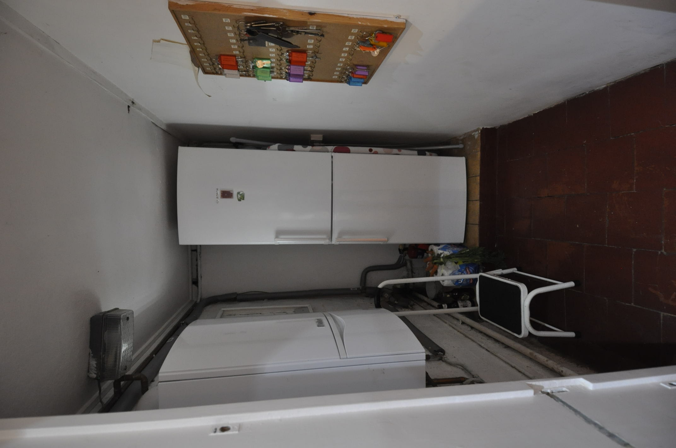
Photo of existing pantry

The new WC will be located in a current pantry which is located off the kitchen. The new toilet waste will connect to the current public toilet which is located the other side of the rear wall.

There is already a ceiling mounted light and light switch within the room. The light switch will need to be replaced with a ceiling mounted pull cord.

Mechanical ventilation will not be required as there is an existing louvred wall opening with a sliding internal glass screen.

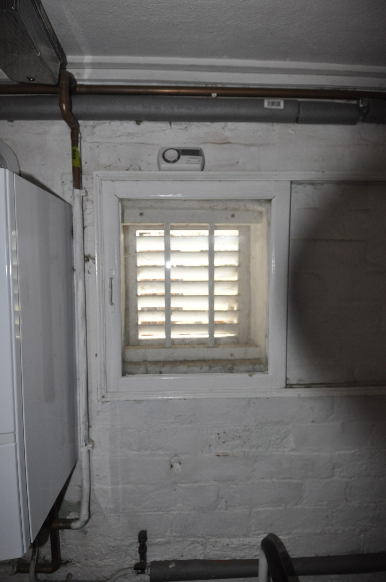
Existing louvred wall vent

The floor will be levelled following careful removal of the existing step. Quarry tiles to match the existing floor will be sourced.

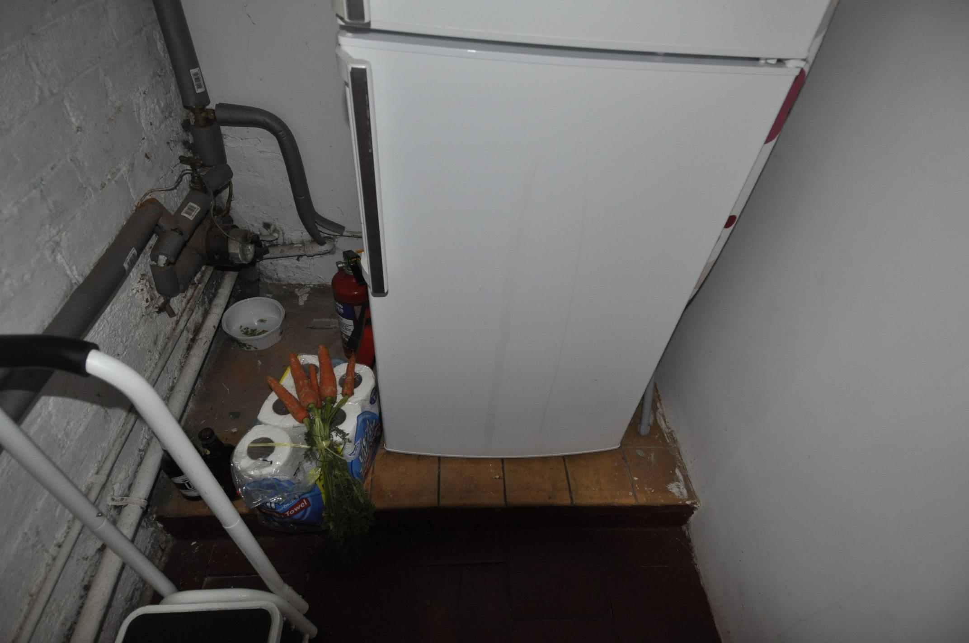
Existing step in floor with modern tiled floor finish.

Wall tiling will be installed up to 1.2m in height to match that in the public WC. Softwood framing and tile backer board will be installed (fixings through mortar joints), and tiled with painted softwood capping.

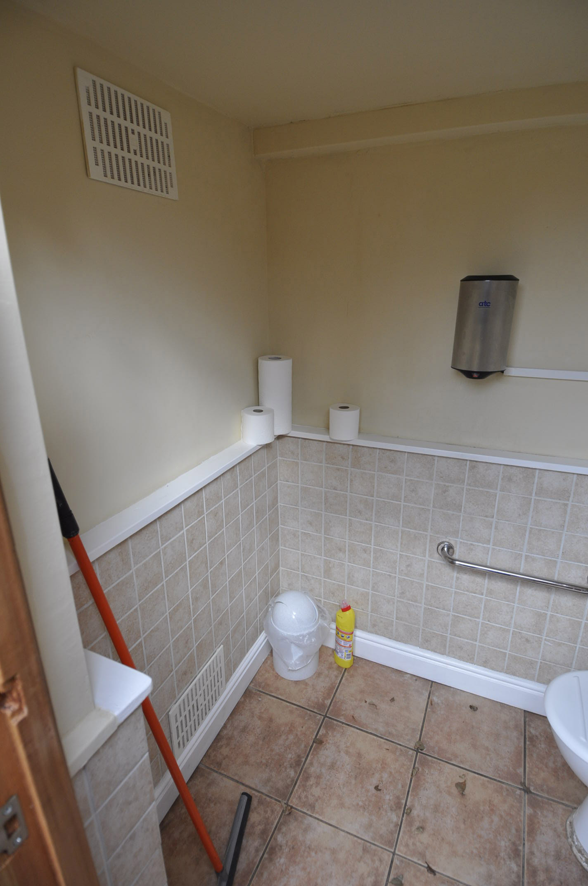
Tiled walls to existing public WC

Impact

There will be minimal impact to the existing fabric of the building and any works will be made good prior to completion.

The location for the new WC was chosen as it presented the least intrusive location for a new WC. The required services are present in this area (foul connection and water supply) and the space is only used for a small amount of food storage. The existing kitchen will be modified to provide a space for the fridge.

The only other suitable location was utilising the space under the stair, with a new foul pipe through the cellar chamber below. This would have been more intrusive to the existing building fabric. Also, the levels of the existing foul drainage system were found to be too shallow to allow this to be a gravity fed connection so this would have required a pumped system, leaving a system that required regular maintenance.

The new soil pipe will be connected to the existing through the wall which will require a 100mm diameter core hole, made good with lime mortar to match.

Justification

The Priest Father John Moran is advancing in years and finding it increasingly difficult to constantly go up and down the stairs to use the facilities. A downstairs toilet is the most user-friendly option and removes the need for other intrusive measures such as a stairlift. It will also be used as a guest WC.

Consultation

Peter Basset conservation officer at WFDC has been consulted and has no objections to the content of this application.

