Heritage Statement
The Granary, Shillbrook Manor, Black Bourton, Bampton, OX18 2PD
Introduction
This statement is in support of the Listed Building Application for alterations to this dwelling which forms part of a grade II listed collection of barns that are part of a collection of estate buildings including the manor house and other barns.
The buildings do not fall within a conservation area.
This statement should be read alongside the drawings of the proposals. It is based upon a site visit and on Historic England listing records.
Extract from Historic England listings
Location
Statutory Address:
RANGE OF FARM BUILDINGS CIRCA 35 METRES TO WEST OF MANOR FARMHOUSE, BAMPTON ROAD
The building or site itself may lie within the boundary of more than one authority.
County:
Oxfordshire
District:
West Oxfordshire (District Authority)
Parish:
Black Bourton
National Grid Reference:
SP2878903954

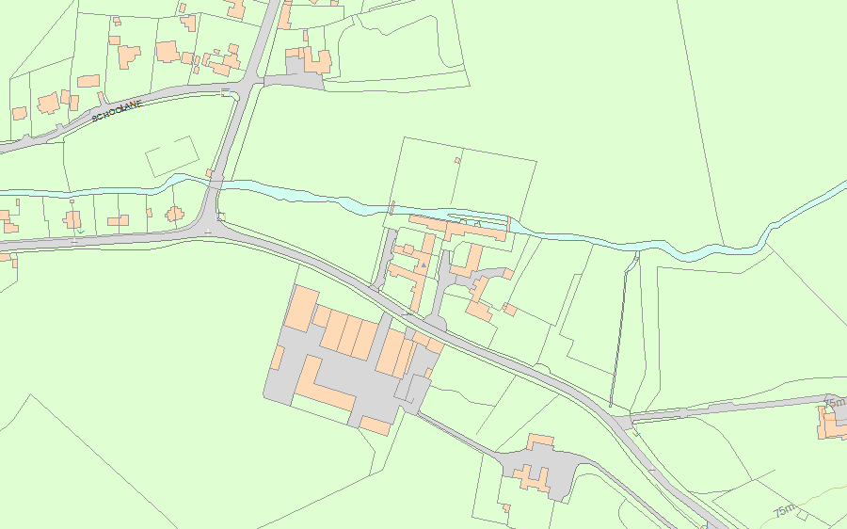
Details
SP20SE CARTERTON AND BLACK BOURTON BAMPTON ROAD (north side) Black Bourton 5/148 Range of farm buildings c.35m 17/12/86 to W of Manor Farmhouse

GV II Range of farm buildings, comprising from north to south: barn, lofted stable, stable, cartshed, and granary with cartshed below. Barn is probably late C18 in origin, altered; remainder added mid C19. Coursed rubble limestone with semi-dressed quoins; C20 slate roofs on C20 timbers to barn and lofted stable; stone slate roofs to remainder. Barn has 5 bays, with low vent slits, C20 sliding doors to central opposing cart entries, and square vent holes in right gable end. Lofted stable has 2 stable windows with wooden slat shutters, the right also with C20 fan, a boarded loft opening to centre, stable door to left, and stone steps up to gabled loft door to right. All openings except the last have segmental dressed stone arches. Single storey stable to left, of same build, has one stable door and one window of same type. To left of this is a 4-bay cartshed, under same roof, with wooden posts and small curved braces to front, and C20 trusses. Taller granary at left end of range, has C20 wooden steps up to board door with segmental stone arch and small gable over, and 2-bay cartshed below with shallow arches of dressed stone. Granary retains grain bins. Included for group value. Later stockyard ranges attached to west of this range are not of special architectural interest.

Listing NGR: SP2878903954

Legislation and policies referred to:
Legislation relating to listed buildings (and conservation areas) is contained in the Planning (Listed Buildings and Conservation Areas) Act 1990. Section 66 of the Act places a duty to have special regard to the desirability of preserving listed buildings and their settings.
Conservation (for heritage policy) is defined in Annex 2 of the National Planning Policy Framework (NPPF, February 2019) as “the process of maintaining and managing change to a heritage asset in a way that sustains and, where appropriate, enhances its significance”. This definition does not suggest conservation to be the same as preservation. Indeed, what sets conservation apart is the emphasis on maintaining and managing change and not on a reactive approach to resisting change. Relevant to this proposal conservation could amount to a change that at least sustains the significance of a heritage asset.
Paragraph 195 deals with substantial harm to, or total loss of, significance of a designated heritage asset. Paragraph 196 deals with cases of less than substantial harm and notes that any such harm should be weighed against the public benefits of the proposal.
Heritage protection and the conservation of heritage assets are recognised as of benefit to the public. Paragraph 020 of the National Planning Practice Guidance (NPPG) is relevant.
Relevant local planning policy is covered within the West Oxfordshire Local Plan 2013 (adopted September 2018) in which Policy HE9: Historic Environment.
Understanding the asset’s historical development
This dwelling was formed out of redundant estate barns to Shillbrook Manor in 1989 planning approval W87/1679
We have prepared a sketch of the layout of the barns, prior to conversion ( Plan ‘A’ attached).
The conversion of the barns to dwellings in the planning approval referred to, resulted in some significant alteration of the original cellular structure of the buildings, notably the splitting of the threshing barn and implement shed (see plan ‘B’ attached). The resultant dwelling layout can be seen on plan ‘C’, attached, and is formed from part of the original threshing barn and implement shed, plus a barn with hayloft over and stable.
Statement of significance
This building derives its heritage significance from its relationship within the old manor complex, by its external form and materials, particularly roofscapes, which are typical of this period of estate buildings This is particularly relevant to its public significance. Unfortunately, the conversion from agricultural outbuildings to dwellings was not done duly respecting the internal cellular layout of the original barns, or in detailing of windows, doors etc.

Proposals and impact statement
The proposals relate to alterations to the internal arrangement of spaces, and minor alterations to fenestration, all of which date from the conversion to a dwelling, and no heritage values of the original barns will be further affected.
None of the proposals will impact on historic fabric, but re-arrange/update work that was carried out to convert the original barns to dwellings. Indeed, the proposals to the kitchen area will re-instate a greater part of the original ‘implement shed’ into one space.
The proposals to the fenestration will compliment the existing style as implemented on the conversion to a dwelling and, retain the visual timber posts that support the roof and, by removing the stonework, open up the end bay, adjacent to the main building, as it would have been historically.
The changes proposed to the building arising from the proposed works do not harm the significance of this listed building, so paragraphs 195 and 196 of the NPPF are not relevant. In particular they do not harm the public benefit derived from these buildings. The proposals preserve the building with regard to the duty under section 66(1) of the 1990 Planning Act.

Graham Bannell
February 2021

