DESIGN AND ACCESS STATEMENT FOR A PROPOSED SINGLE STOREY DETACHED STUDIO BUILDING WITH SOLAR PANELS at Springfield House, Littleworth, Amberley. Stroud GL5 5AG
(To be read with application drawings SK01 to SK02 inclusive).

DESIGN STATEMENT

Background

The existing residential property is a detached house located on a large plot in Littleworth, Amberley (see SK02). The proposed single storey detached studio building is for the ancillary use of the main residential property as a craft and design studio. The studio is located approximately 67 metres from the rear Elevation of the main residence, just beyond the existing detached stable (see photograph 1.0), and approximately 4 metres from the Western boundary (see SK02).
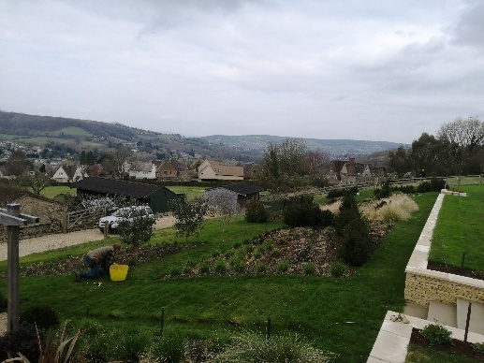

Photograph 1.0 View to the north (Existing detached stable at the centre
of the photograph – the proposed Studio will be to the right of this
Stable)

Design Concept

The main design objectives for the proposed Studio Building are: to locate the building away from the main residence in order to exploit the distant open views across the surrounding countryside; and to set the building down into the sloping ground level to minimise its visual impact. The North to South roof ridge provides an opportunity to install flush solar panels on the Eastern and Western roof slopes to maximise solar gain throughout the day as a way of reducing reliance on conventional energy sources. The veranda canopy will provide a sheltered covered area.

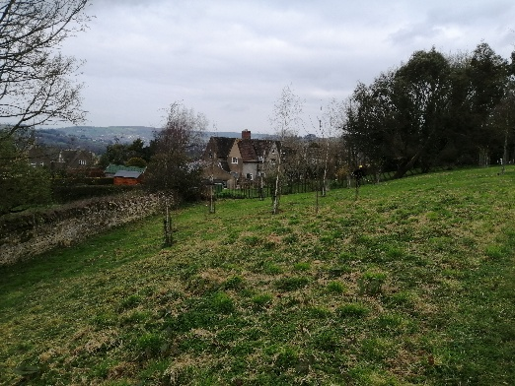
The open views are shown in photographs 2.0 to 5.0 inclusive

Photograph 2.0 Northward (view from Studio limited to one small window
In northern Elevation – see SK01 and SK02)

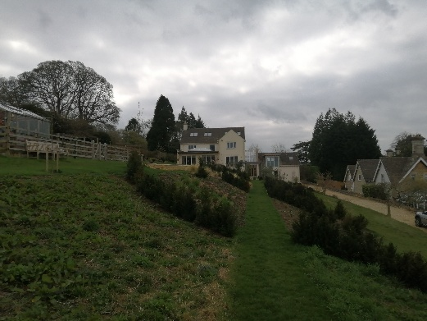
Photograph 3.0 Southward (view from Studio to main residence limited to main entrance door into Lobby – see SK01 and SK02)
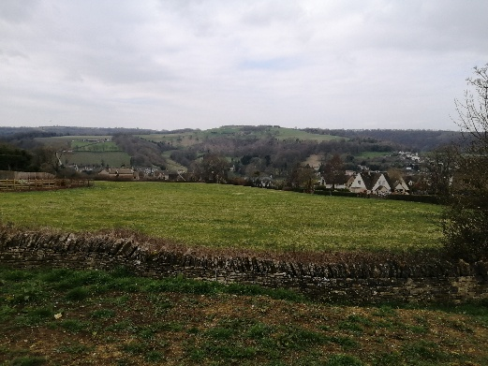

Photograph 4.0 Westward (main view from studio and associated Veranda – see SK01 and 02)
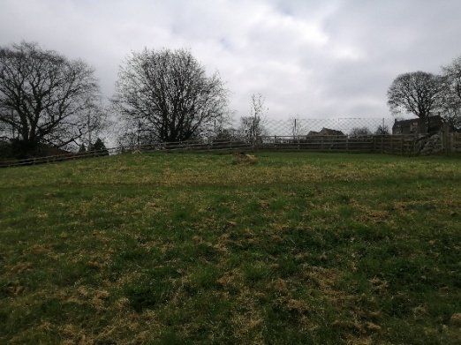

Photograph 5.0 Eastward (No direct views from the studio because the building is set into the slope of the land
– see SK01 and SK02)

Pedestrian & Vehicular Access

The existing pedestrian and vehicular access from the main southern property entrance, and down the western side
of the site remain as existing (see SK02 Site & Location Plan).

TM/240321

