DESIGN AND ACCESS STATEMENT

PROPOSAL:
Proposed crossover and off road parking

LOCATION:
3 Arnhill Road Gretton Northamptonshire NN17 3DN

Date: 08/02/2021

Contents.

Section |  | Page number
- Introduction |  | 3
- Design principles and concepts |  | 4
- Amount |  | 4
- Scale |  | 4
- Landscaping |  | 4
- Appearance/Context |  | 4
- Access |  | 5
Figures |  | 6-10

- Introduction
The original dwelling at number 3 Arnhill Road Gretton comprised a three bedroom bungalow of brick and rendered masonry construction with plain concrete tiles, hipped roof, double circular front bay windows and offset brick chimney. It currently has no off road parking and street parking is restricted by the narrow width of street.
The Bungalow has recently been extended by adding a first floor to create a 4 bedroom two storey dwelling
The prominent site is elevated steeply from street level and is bounded along the front by a stone faced boundary retaining wall curving with the highway. Refer Fig 1.
There are several existing driveways along Arnhill Road which are much steeper than 1 in 12. Fig 7.
A speed survey was carried out by Rad Data Services Ltd and the visibility lines based upon these findings are demonstrated as being achievable.
The Proposal.
The proposal is to create a new vehicular access and off road parking for two family size cars with turning space within the site to enable forward entrance and exit.

- Design Principles and Concepts.

- The principle and concept for the proposal is to form a safe vehicular entrance and much needed off street parking whilst minimising the impact upon the street scene.
- The existing on road parking is considered impractical and causes some degree of hazard within the highway. It is considered desirable that off road parking be provided and relaxation of the usual gradient limits should be considered favourably in the unusual context that this site presents.
- Existing retaining walls next to the highway are nor adversely affected by the proposals as the ground level retained is to be reduced.
- It is the intention to retain in-situ all highway edge retaining walls as far as possible along the curved section leading into Hardwick Road. However the Structural Engineer has produced replacement retaining wall designs which do not impinge into the highway verge.

- Layout.

- Various alternative designs have been considered but these have been dismissed due to the unviable deep cut adjacent to the dwelling and difficulty in creating enough space for turning within the site and restricted vision splay.
- The current proposal is at the highest point of the site therefore reduces the amount of earthworks and overall steepness of the finished parking area. The proposed design utilises the natural approach from the North creating a safe and open approach and exit from the site with good vision in all directions. Figs 3, 4, and 5.
- Refer to visibility lines based upon traffic speed survey data provided by RDS Ltd.
- Drawing SK1 Visibility Lines.
- There will be sufficient turning space within the parking area to enable frontal approach to the highway.

- Scale.

- A dropped kerb width of 5.0m has been chosen to make the approach and exit safer giving ample manoeuvring space to enable easy approach into the highway in whatever direction.
- Whilst there is a requirement to minimise earthworks the driveway and Highways requirement for turning space within the site has been created within the restrictions of existing boundaries.

- Landscaping.
- The grass verges will be graded at or below natural angle of repose and grass seeded

- Appearance.

- Retaining wall will be faced with random rubble local limestone to match the existing front highway boundary wall.
- Permeable block paving will be used for the driveway. The colour to be chosen in consultation with the Conservation Officer.
- Granit dropped kerbs will be used to match existing kerb edging.

- Context.
- The entrance and driveway will form a natural extension of the roadways and provide much needed off street parking to de-clutter the narrow lane.
- The cut into the banking and site will minimise the effect upon the street view and use of natural limestone face work will blend into the surroundings.

- Access.

- The site is presently serves by two pedestrian accesses via steep steps. One being at the high end of the site where the new vehicular entrance is now proposed and one at the lower end off Arnhill Road. Neither entrances are served directly from a public footpaths along the roadside. Refer Fig 1
- Due to the steep topography it is not possible to provide access for wheelchair users. If future access is required then the off-road parking will be used and an external platform lift or stair lift can be provided which would not be possible from the street.
- The present pedestrian access off the Arnhill Road – Fig 1, is to be retained and a vehicular and pedestrian access is to be formed at the junction of Hardwick Road and Arnhill Road. Refer Fig 2.
- The proposal is for a new dropped kerb 5.0m wide serving a graded free draining paved driveway and turning space for two cars.
- The maximum gradient of 1 in 12has been chosen as this is the maximum gradient suitable for wheelchair access which is approved under Building Regulations in accordance with Approved Documents to Part M and, whilst being in excess of the County standard of 1 in 15 the chosen gradient will minimise cut earthworks and retaining walls. See sectional drawings 09 and 10.
- It should be noted that Hardwick Road is not available as a through route for vehicles other than cycles and motorcycled due to the permanently restricted width further up the hill. It does however serve vehicle access to number 1 Hardwick Road.
- There is good all round vision along Hardwick Road and Arnhill Road from the proposed entrance and there is no pedestrian pathway along the frontage of the whole site due to the steep grassed verge. Refer Figs 3, 4, 5 and 6.

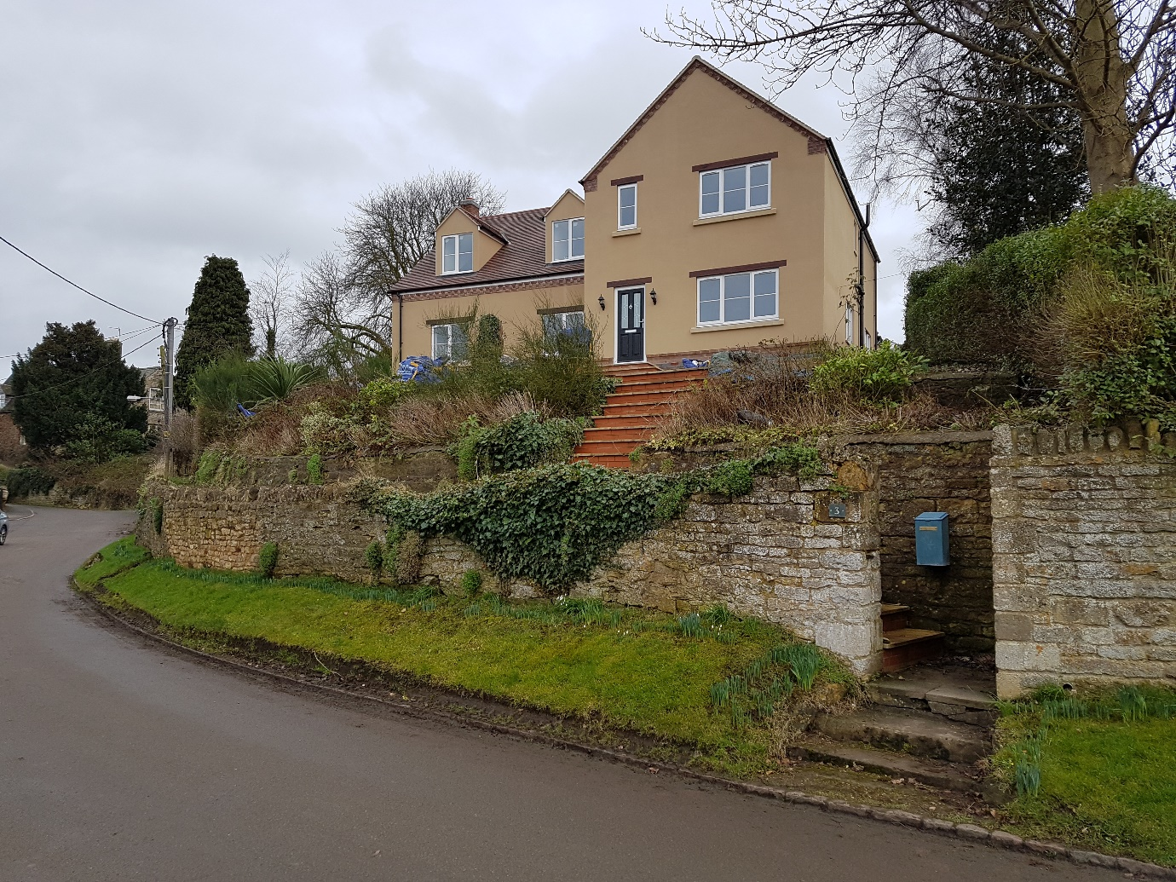

Fig 1.Pedestrian Access Arnhill Road
Fig Approach view.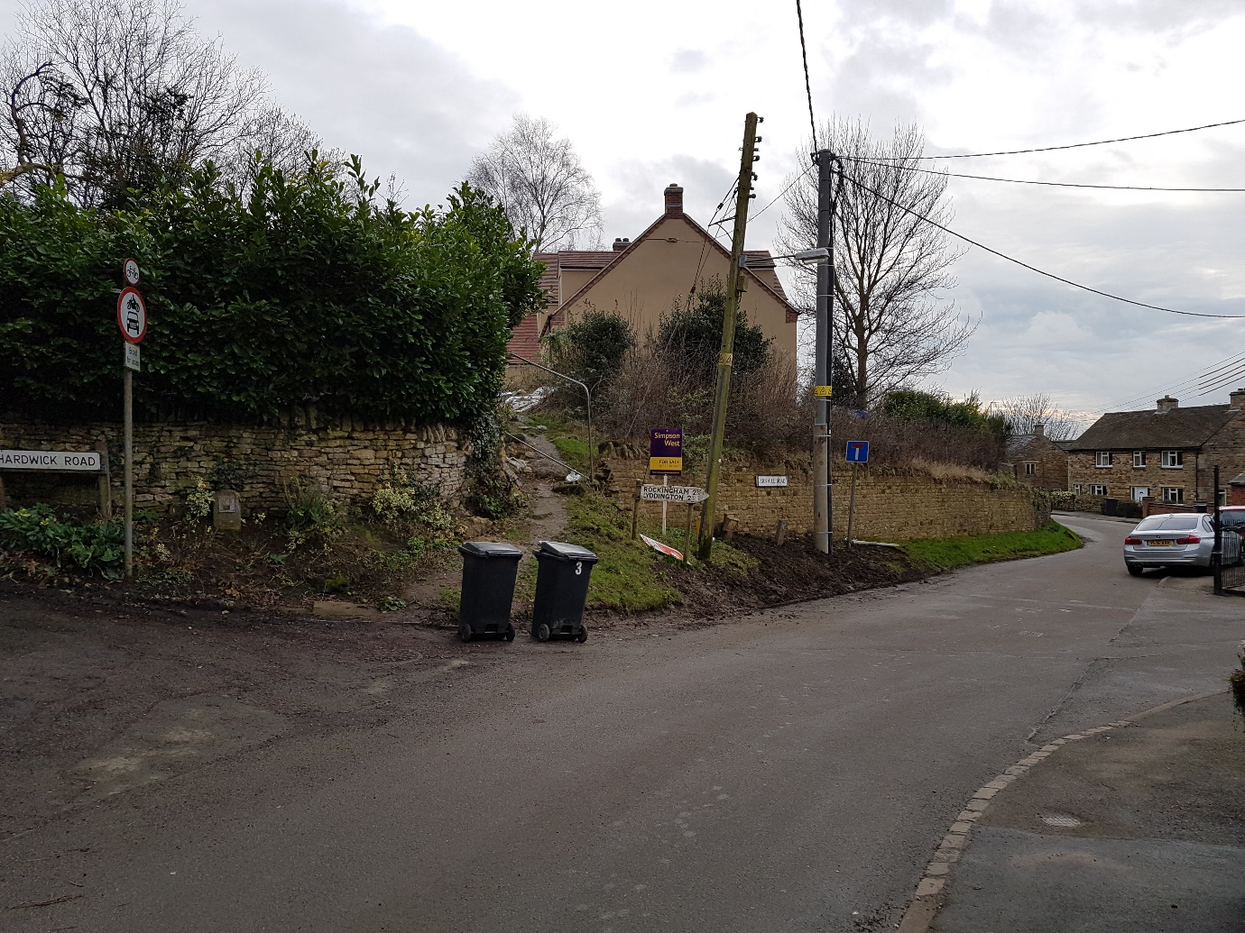
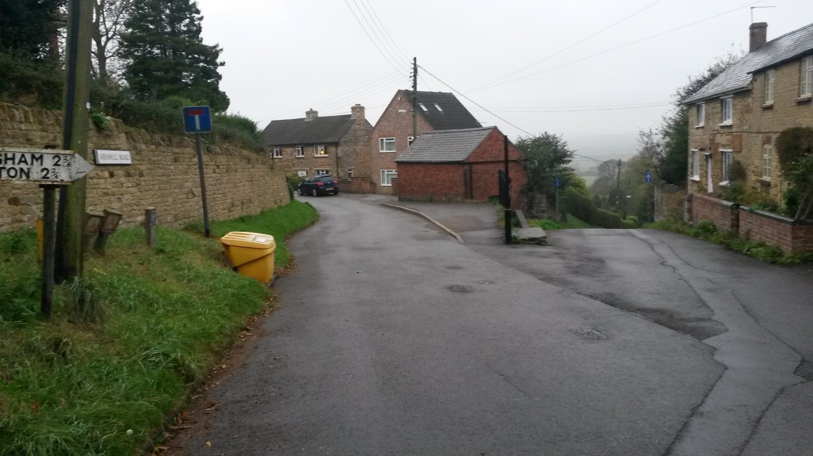

Fig 3 Restricted width of road for parking and vision from proposed exit.

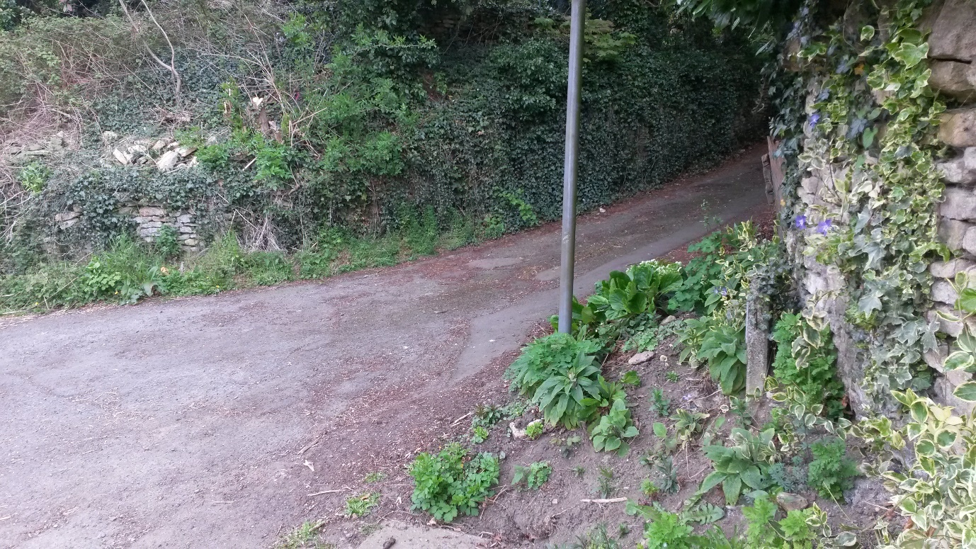
Fig 4 Exiting Drivers View Right.

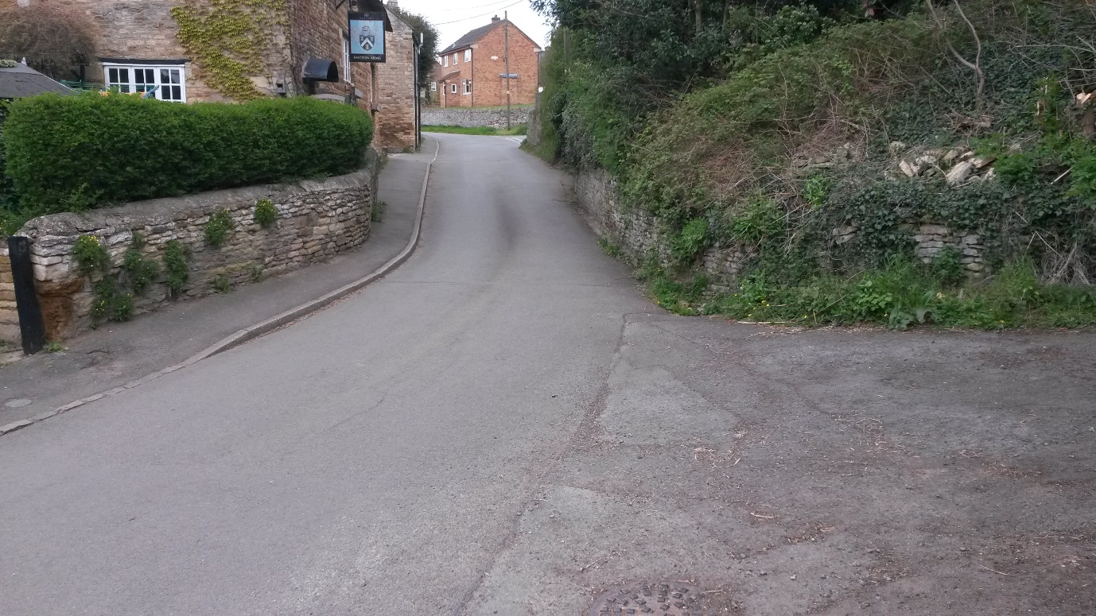
Fig 5. Exiting Drivers View Forward/Right

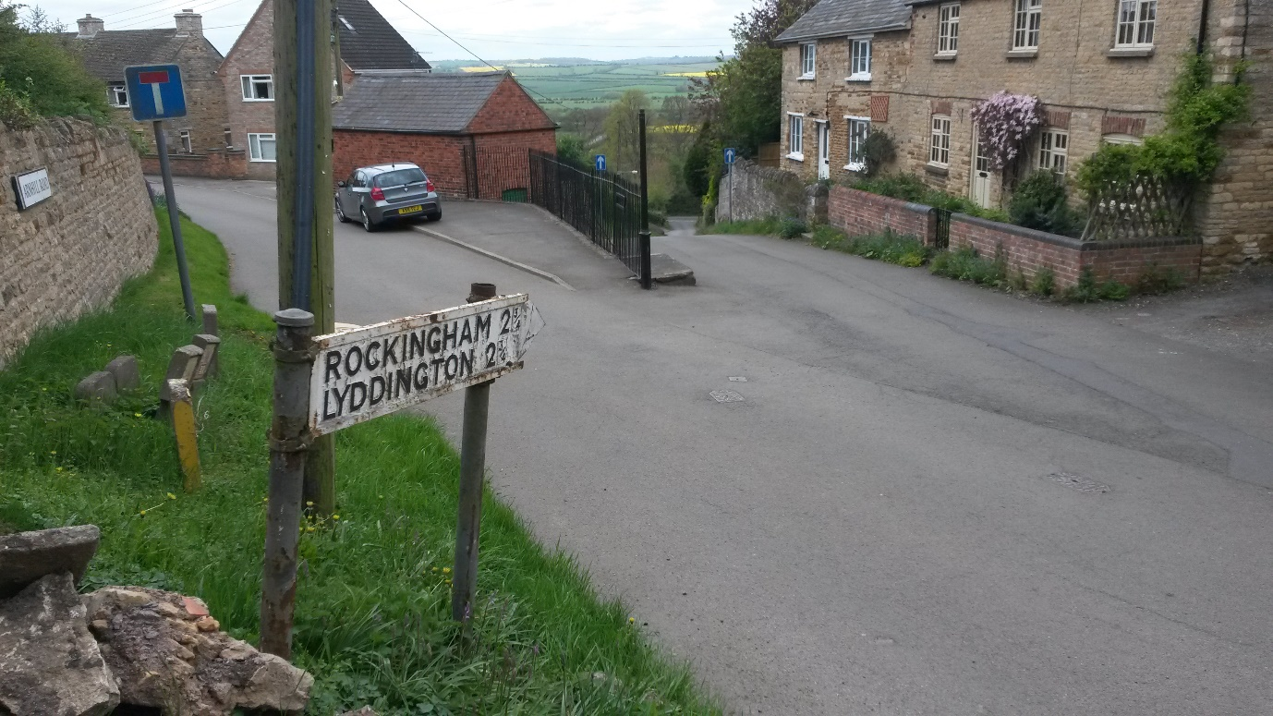

Fig 6. Exiting Drivers View Left.

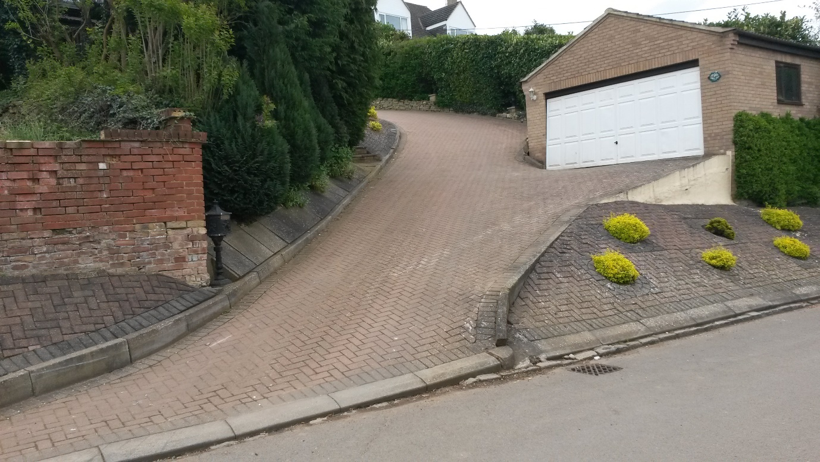
Fig 7. Example of Steep drive 1 in 3.4 gradient – 9 Arnhill Road

