

**Tree Risk Management Survey**

**The Gables**

**Prepared by:** Craig Watkins – Tree Consultant

**Checked by:** MitchHicken - Director

**Date:** 14/03/2021

**Ref:** ARBC/14/2021/03

**Kenilworth Road**

**Leamington Spa.**

Contents:

SECTION Page No’s

1.0 Brief 3

2.0 Methodology 3

3.0 Report Limitations 5

4.0 Statutory Legal Protection 6

5.0 Protected Species 6

6.0 Site Visit 6

7.0 Site Descriptions Findings 6

8.0 Recommendations 8

9.0 Conclusions 9

Appendices

1. Authors Qualifications
2. Tree Schedules
3. Location Plans
4. Tree Preservation Order
5. Survey Methodology
6. Glossary of Arboricultural Terms

# BRIEF:

I have been instructed by Julie Lockely to inspect all trees as a walk over inspection of the below area, and assess trees where they pose a threat to people and/or property. The report is to include results from a VTA survey and comment upon the health and safety, identify structural and physiological conditions and to make appropriate management recommendations for individual/ groups and woodland trees and to comment on long term management of each site.



1.1 **SITE CONTEXT.**

The survey site is land assocaited with The Gables, it comprises of carparks, highway, open space areas and buildings.

**2.0 METHODOLOGY.**

2.1 The survey has been carried out in the use of “Visual Tree Assessment” VTA and “Quantified Tree Risk Assessment” QTRA methodology. The survey and the subsequent report will use both approaches to identify significant visual defects within the trees structure and physiological condition while conducting VTA and assess the level of risk such defects present to persons and/or property as a result.

2.2 VTA is a concept idea founded by Prof Claus Mattheck’s book the body language of trees which describes the structural growth patterns of trees and specifically identifies the trees responses to abiotic and biotic effects from decay and physical damage. It enables the practitioner to clearly observe defects and identify appropriate management requirements for the benefit of the trees and the safe use of land.

2.3 QTRA combines the components of tree failure risk. It is possible to calculate with some accuracy the usage of vehicular and pedestrian targets upon which trees or parts of trees could fail. it is also possible to estimate the repair or replacement costs of property that could be damaged in the event of tree failure. The QTRA takes account of 3 principle components: -

1. Target – human/property/vehicular = 6 ranges

2. Size of part to fail - >450mm – 25mmdia = 4 ranges

3. Probability of failure – 1/1 – 1/10m multiplier = 7 ranges

2.4 It is broadly accepted that a probability of failure score within 1/1 – 1/10,000 is the unacceptable range for risk requiring necessary work being completed to bring the risk into the tolerable range of >1/10,000. This is broadly based on the health and safety executives “tolerability of risk framework property owners and managers have a duty under English law to ensure, insofar as reasonably practicable, that people and property are not exposed to unreasonable risk from the failure of structurally impaired trees within their ownership or management.

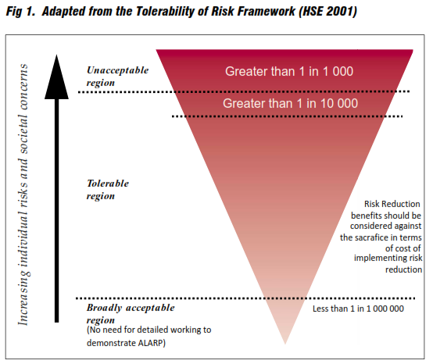

2.5 The general guidance is to complete periodic professional inspections of tree(s) within proximity to high risk targets, but it is not essential to have a written report for each assessment, but the tree(s) should be recorded where they are identified as having defects whether significant or not if they are close to high risk targets and are to be retained, with a suitable management regime identified.

2.6 Where it has been considered during the survey that trees have significant defects and are close to high risk targets, then they have been scored in accordance with QTRA with score ratings shown in part 1 of this report.

2.7 All tree data, observations and recommendations can be found in tabular format in tree data of this report.

Common names have been used for species types.

All tree dimensions are estimate unless otherwise stated.

2.8 All tree(s), tree group(s) and hedge(s) have been given a unique number reference on the plan and within the tabular schedules.

# Report limitations:

3.1 Trees are influenced by a variety of environmental variables, which can affect the health of trees causing biomechanical and physiological changes. All comments made on tree health reflects their physical condition at the time of the survey. Due to the changeable nature of trees and other site/environmental conditions which may influence trees, this report and any recommendations made within it are valid for a period of 24 months from the date of the site survey which was 10th March 2021.

3.2 The report is preliminary in nature and therefore all observations were made from ground level only and are visual in nature unless otherwise stated. Full aerial inspections using a rope and harness for access, ultra-sonic decay detection was completed, and results detailed herein. Root collar excavation, or any other form of intensive investigation were not carried out as part of the survey. **There are trees within the survey which are clad with ivy, excessive epicormical growth or vegetation that restricts the inspection. I am unable to take responsibility for defects which are hidden from view in this way but would be happy to re-inspect the trees if the ivy, epicormic growth and vegetation is removed, updating this report at additional costs (where appropriate).** Where appropriate further detailed investigation recommendations have been made in tree schedules (Appendix 2) and summary.

3.3 Any management recommendations have been made in accordance with “BS3998: 2010 Tree Works – Recommendations” and in accordance with industry best practice. Works have been recommended in accordance with any statutory obligations owed by the landowners or occupiers. Any reference to structural damage to buildings and associated structures is preliminary in nature, and further investigation will need to be sought from a qualified and experienced engineer.

3.4 No soil samples were taken, or soil analysis completed for the purpose of indirect damage analysis or new tree planting this survey.

3.5 This survey did not include an ecological survey of vegetation or habitat areas. Any ecological issues incidentally observed during the survey are reported on in the tree schedule. Further detailed habitat assessments may be necessary.

3.6 For the purpose of this report no samples where attained from site for analysis or any other reason.

3.7 The report and its contents are subject to copyright and as such are for the use solely of the client, copying or editing without the authors permission is prohibited.

## 4.0 STATUTORY LEGAL PROTECTION

### 4.1 There are two main sources of protection afforded to trees:

### 4.2 Trees within Conservation Areas (CA) are protected under Planning and Listed Buildings Act 1990, which affords the protection of trees with a stem diameter of 75mm or more by virtue of being within a Conservation Area.

### 4.3 Trees may also be protected by a Tree Preservation Orders (TPO) under the Town and Country Planning (Trees) England Regulations 2012.

### 4.4 It is an offence to carry out unauthorised works to trees protected by a TPO or within a CA the main offences to which the Local Planning Authority may seek prosecution relate to contravention of the Town and Country Planning act 1990 (as amended) for trees protected in a CA or protected by TPO where it is considered trees have been:

* Cut down, uprooted or wilfully destroyed; or wilfully damaged in such a manner as likely to destroy it; or to cause or permit any such activity.
* To carry out any other works in contravention of the regulations.

### 4.5 It is important to note that under the Regulations it is not only destruction of the tree(s) which is considered an offence but also any actions which may render the tree(s) less worthy of protection by TPO. In addition, the fine is extended not only to the person or persons undertaking the physical works upon the tree(s), but also to the person or persons who have either organised or allowed the works to proceed. If found guilty of an offence under the terms of the regulations a fine of up to £20,000 can be imposed by a Magistrates Court, or an unlimited fine on indictment.

4.6 For this report I have been provided with a copy of a Tree Preservation Order attached as Appendix 4, it is also believed that the site is with a Conservation Area. It is therefore recommended that prior to completing works to any of the trees that written consent from the local planning authority is sought.

## 5.0 PROTECTED SPECIES

### 5.1 Trees can contain features such as cavities, cracks, splits and loose bark which can offer potential habitat to species such as bats. Bats and their roosts are protected under Schedule 5 of the Wildlife and Countryside Act 1981 (as amended) as well as the Conservation of Habitats and Species Regulations 2012 (as amended) and are also listed under Section 41 of the Natural Environment and Rural Communities Act 2006.

### 5.2 Trees provide potential nesting habitat for birds and all UK birds are protected while on the nest under the Wildlife and Countryside Act (WCA) 1981, as amended. Bird species that are listed on WCA Schedule 1 are given further protection, including increased penalties as well as protection against disturbance of their active nest(s).

## 6.0 SITE VISIT.

6.1 The site was visited on a 10th March 2021 by me Craig Watkins.

6.2 The weather during the survey varied from sunshine to heavy downpours.

**7.0 SITE DESCRIPTION AND FINDINGS.**

7.1 The site are currently offices with associated parking areas off the main Kenilworth Road. There are open space areas to the rear of the site.

7.2 The trees were off varying age class with larger trees identified as individuals within the survey with groups making up the rest.

7.3 Most of the trees were situated along the boundaries and around the carpark as shrub/tree groups.

7.4 The vast majority of the work identified is for deadwood removal, some dead/structural defective tree removals, crown/branch reduction works and further investigation of suspected decay.

# 8.0 RECOMMENDATIONS.

8.1 The survey was for negative reporting of trees where they had defects only. The recommendations and associated scores can be found in Appendix 2. Where individual trees require works, they were tagged (*where access allowed*) with silver tree tag discs with specific numbers identified within the tree schedules in Appendix 2.

8.2 “**Advisories”** have been provided in tree schedules in Appendix 2. This is a general recommendation for works and is not considered as a risk associated action but works should be considered and actioned for the long-term benefit of the site.

8.3 The survey was restricted in part by significant amounts of ivy, dense vegetation and epicormic restricting access and individual tree assessments. It is therefore recommended that the vegetation and ivy is cut back to allow for future inspections, particularly in areas where trees are close to public areas i.e footpaths, highway etc.

8.6 **Table 1** below should be used in conjunction with tree schedules in Appendix 2 to determine the risk rating and action required, anything below 1/10,000 then generally the risk should be controlled anything above 1/10,000 the cost of risk control should be assessed and controlling the risk is necessary or its tolerable (ALARP As Low As Reasonably Practicable). Any risk over 1/1000,000 is broadly acceptable and no action required.

**Table 1.**

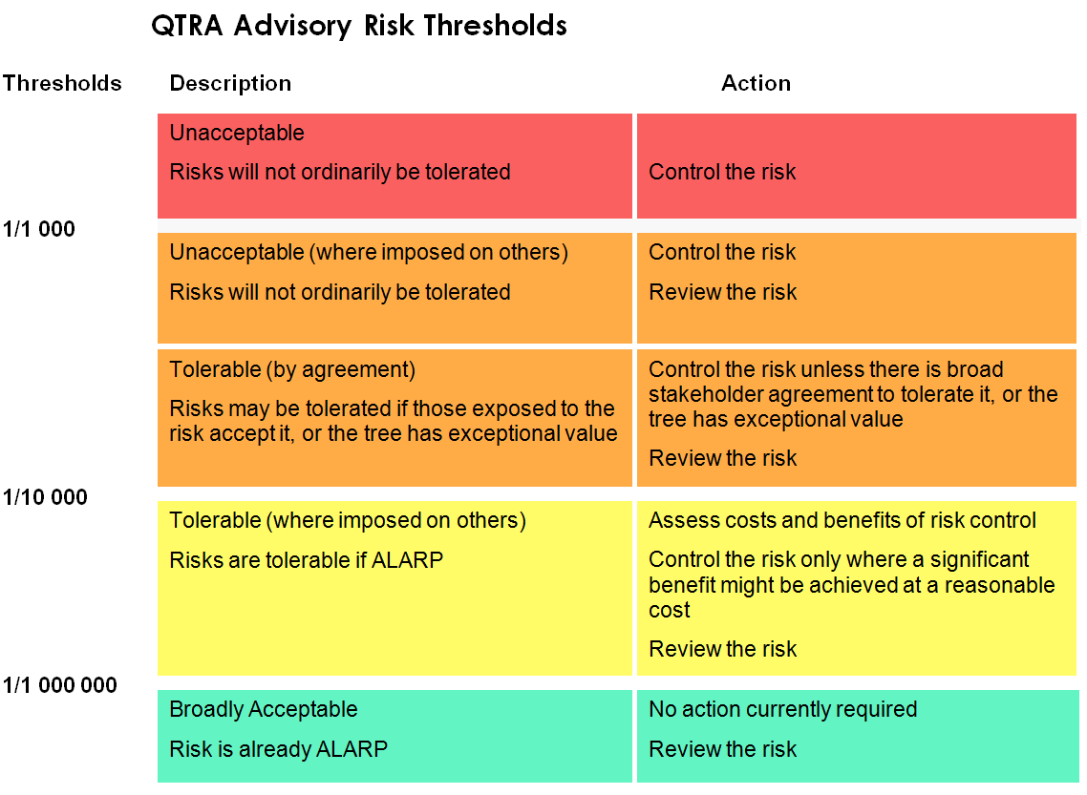

**9.0 CONCLUSIONS.**

9.1 There were a number of trees that pose a high-risk to mainly highways which should be attended to as soon as reasonably practicable in accordance with the risk scoring Table 1.

9.2 Further investigation and follow up inspections should be completed as identified within the Tree Schedules in Appendix 2.

# Authors Qualifications and Experience

**Qualifications:**

Lantra Accredited Mortgage (Home Buyer) Tree Report 2015

Technicians Certificate in Arboriculture (Merit) 2009

RFS Certificate in Arboriculture (Merit) 2007

Lantra Accredited – Professional Tree Inspector 2006

BTEC 1st Diploma Horticulture 1993

**Experience:**

Owner Morfe Valley Arb 2016 - Present

Tree Services Manager (National Company) 2015 – 2016

Senior Arboricultural Consultant Wardell Armstrong 2014 – 2015

Local Authority Tree Officer. (Risk Management / Asset Management) 2006 – 2014

Chargehand Arborist 2004 – 2006

Arborist (Tree Surgeon) 1998 – 2004

Horticulturalist 1994 – 1998

Trainee Horticulturalist 1993 – 1994

**Continuing Professional Development:**

Mortgage Report Writing 2017

Resistograph and Tomography 2016

Getting to Grips with Subsidence 2015

Valuing and Managing Veteran Trees 2015

Engaging Arboricultural Contractors 2010

Quantified Tree Risk Assessment System 2009/2016

Bats and Arboriculture – A Guide for Practitioners 2004

**Memberships:**

To stay up to date with current issues, Craig is a member of the following organisations:

1. The Arboricultural Association – Technician Member.

2. The Consulting Arborists Society – Member.

3. Accredited PTI Expert.

4. Quantified Tree Risk Assessment Licensed User

**2. Tree Schedules**

# 3 Tree Location Plan (approximate)

**4 Tree Preservation Orders**

# Survey Methodology

The following features of each tree, group of trees or woodland have been recorded in the Arboricultural Data Sheets:

* Species including the common names.
* Height measured in metres from the stem base. Where the ground has a significant slope the higher ground is selected.
* Crown height is measured in metres and is an indication of the average height at which the main crown begins.
* Stem diameter is measured in millimetres at 1.5m above the adjacent ground level (upslope on sloping ground) or immediately above the root flare for multi-stemmed trees.
* Crown spread is measured in metres and taken at the four cardinal points to derive an accurate representation of the crown.
* Age class of the tree is described as young, semi-mature, early-mature, mature, over-mature or Veteran: -
* Y – Young (newly planted tree)
* SM – semi-mature (1st 1/3rd of life expectancy)
* EM - mature (final 1/3rd of life expectancy)
* M - middle aged (2nd 1/3rd of life expectancy)
* OM - over mature (beyond life expectancy)
* V - veteran (over mature and of special conservation value)
* Physiological condition is classed as good, fair, poor, or dead. This is an indication of the health of the tree and takes into account vigour, presence of disease and dieback: -
* good – no health problems
* fair – symptoms remedial of ill health
* poor – declining
* dead – dead
* Structural condition is classed as good, fair or poor. This is an indication of the structural integrity of the tree and takes into account significant wounds, decay and quality of branch junctions: -
* good no significant defects
* fair - remedial defects
* poor – defects
* very poor –significant defects
* Comments include a brief description, if required, of the tree with comments on the form, vitality, health and any significant defects that may be present.

# Glossary of Arboricultural Terms

*For the avoidance of confusion, the terms used in this report follow the definitions given below:*

|  |  |  |
| --- | --- | --- |
| Abscission |  | The shedding of a leaf or other short lived part of a woody plant. |
| Abiotic |  | Pertaining to non-living agents e.g. environmental factors. |
| Absorptive Roots |  | Non-woody short lived roots, generally having a diameter less than one millimetre, the primary function of which is the uptake of water and nutrients. |
| Access facilitation pruning |  | One off pruning operation to provide access for development operation. Pruning that will not be detrimental to trees health or amenity. |
| Arboricultural Method Statement |  | A methodology for the implementation of development where encroachment within the RPA has the potential to cause damage or loss of retained trees. |
| Arboriculturist |  | Someone who through relevant training and experience has gained knowledge in the expertise of trees. |
| Adaptive Growth |  | The process by where wood formation rates increasing in the cambial zone, as well as wood quality, responds to gravity and other forces acting on the cambium. |
| Adaptive Roots |  | The adaptation of existing roots; or a production of new roots in response to damage or decay. |
| Adventitious buds, roots, shoots |  | Which grow in other than primary apical control. |
| Anchorage |  | The process in which a tree uses its roots system to support itself within the soil structure. |
| Arisings |  | Parts of the tree that has been removed for disposal, branches, leaves, roots etc. |
| Bacteria |  | Microscopic single-celled organisms, many species of which break down dead organic matter, and some of which cause diseases in other organisms |
| Bark |  | A term usually applied to all the tissues of a woody plant lying outside the vascular cambium, thus including the phloem, cortex and periderm; occasionally applied only to the periderm or the phellem. |
| Basidiomycotina (Basidiomycetes). |  | One of the major taxonomic groups of fungi; their spores are borne on microscopic peg-like structures (basidia), which in many types are in turn borne on or within conspicuous fruit bodies, such as brackets or toadstools. Most of the principal decay fungi in standing trees are basidiomycetes. |
| Bottle-butt |  | A broadening of the stem base and buttresses of a tree, in excess of normal and sometimes denoting a growth response to weakening in that region, especially due to decay involving selective delignification. |
| Bracing |  | The use of rods or cables to restrain the movement between parts of a tree. |
| Branch (Primary) |  | A first order branch arising from a stem |
| Branch (Lateral) |  | A second order branch, subordinate to a primary branch or stem and bearing sub-lateral branches. |
| Branch (Sub-lateral) |  | A third order branch, subordinate to a lateral or primary branch, or stem and usually bearing only twigs. |
| Branch bark ridge |  | The raised arc of bark tissues that forms within the acute angle between a branch and its parent stem. |
| Branch collar |  | A visible swelling formed at the base of a branch whose diameter growth has been disproportionately slow compared to that of the parent stem; a term sometimes applied also to the pattern of growth of the cells of the parent stem around the branch base. |
| Brown-rot |  | A type of wood decay in which cellulose is degraded, while lignin is only modified |
| Buckling |  | An irreversible deformation of a structure subjected to a bending load. |
| Buttress zone |  | The region at the base of a tree where the major lateral roots join the stem, with buttress-like formations on the upper side of the junctions |
| Canker |  | Area of dead cambium killed by overlying pathogenic tissues. |
| Cavity |  | A hole in the woody structure of the tree; often caused through decay. |
| Cleaning out |  | The removal of dead, diseased crossing branches, damaged branches and alien structures. |
| Competent Person |  | Person with training and experience in accordance with the proposed matter being addressed, having an understanding of a particular matter being approached. |
| Condition |  | An indication of the physiological vitality of a tree, but not the stability of a tree. |
| Construction |  | A site based operation that has the potential to affect retained trees. |
| Construction Exclusion Zone |  | An area based on the RPA from which construction activity is prohibited. |
| Coppicing |  | Removal of all aerial parts of the tree leaving a stump for regeneration of new shoot. |
| Crown/canopy |  | The parts of the tree that supports the leaves. |
| Crown lifting |  | The removal of limbs and small branches to a specified height above ground level. |
| Crown thinning |  | The removal of a proportion of secondary branch growth throughout the crown to produce an even density well balanced crown structure. |
| Crown reduction |  | Removal in the height to a specified description to maintain a flowing crown structure. |
| Deadwood |  | Non – functional branches which no longer support natural growing conditions of the tree, but may be beneficial for the support of habitats. |
| Defect |  | Any area of the tree that longer has an optimal mechanical uniformity of stress, making the tree unsuitable for its location. |
| Dieback |  | Death of woody parts of the tree starting at distal ends of the tree. |
| Disease |  | Damage occurring to living organisms as a result of pathogenic micro-organisms. |
| Distal |  | Furthest distance away from the main body of the tree. |
| Dysfunction |  | In woody tissues, the loss of physiological function, especially water conduction, in sapwood. |
| Epicormical growth |  | Growth from dormant or adventitious buds, not developing from the first shoot. |
| Girdling roots |  | A circling root which constricts the stem or roots, with the potential to cause death and the restriction of flow within the phloem. |
| Heartwood |  | Dysfunctional xylem which no longer has conductive properties, but which has become an integral structural part of the tree. |
| Heave |  | The swelling of shrinkable clay soils, often when vegetation has been removed allowing soil rehydration to develop, with the potential for listing structures i.e walls. |
| Included bark/acute forks. |  | Face to face contact of bark usually at fork unions, or branch unions. |
| Lopping/Topping |  | A term used to describe the removal of large sized branches. |
| Mulch |  | Material lay down over the rooting area of trees to suppress weed competition, increase moisture retention and increase some cases organic material and nutrients. |
| Pathogen |  | A micro-organism that causes disease within another organism. |
| Phytotoxic |  | Toxic to plants |
| Pollarding |  | The removal of the tree canopy to produce knuckles where new growth develops and is removed cyclically usually performed on young trees. |
| Pruning |  | Selective removal of parts of the tree to achieve a desired outcome. |
| Root protection area |  | An area around a tree identified by multiplying the stem diameter at 1.5 by 12 to produce a radial area or rooting volume around a tree to be protected. BS 5837 2012. |
| Service |  | Any above and below ground structure or apparatus for utility provision. |
| Size of part |  | Relating to risk assessments, identifying the size of the hazard, or parts of a tree which may cause harm if failure occurs. |
| Stem(s) |  | The main structure from the ground up supporting the crown |
| Stress |  | In plants, the physiological depletion as a result of environmental influences. |
| Structure |  | manufactured object, such as building, roads, path, wall or excavated structures. |
| Structural roots |  | The primary larger diameter roots which hold and support the aerial parts of the tree. |
| Subsidence |  | The shrinkage of soil through the absorption of water via vegetation and the sinking effects on surrounding architectural structures. |
| Targets |  | In risk assessment, persons or property at risk of harm as a result of a hazard (falling tree, branch etc.). |
| Tree Protection Plan |  | A scaled drawing informed by descriptive text where necessary, based upon finalised site proposals, showing trees for retention and illustrating the tree and landscape protection measures. |
| Veteran Tree |  | Tree that, by recognised criteria, shows features of biological, cultural or aesthetic characteristics of, but not exclusive to, individuals surviving beyond the typical age range for the species concerned. |
| Windthrow |  | The blowing over a tree at its roots. |

# 6. REFERENCES

### British Standard, BS 3998:2010 Tree work. Recommendations. (The British Standards Institution, 2010)

The Body language of Trees (C.Mattheck, K. Bethge, K Weber 2015)

### Quantified Tree Risk Assessment User Manual, (QTRA User_Manual_as amended). (Incorporating extracts).