Introduction
This planning statement is provided in support of a planning application seeking the change of use of land from nil use to residential curtilage (C3) for 19 Lymington Bottom.

Site Context
The land is situated between the land classed as C3 residential curtilage of 19 Lymington Bottom and a 1.8 meter wide section of ground which runs from the kerb of Lymington Rise and which is maintained by East Hampshire (EH) Highways.
Application land
Lymington Bottom
Lymington Rise
EH Highways land

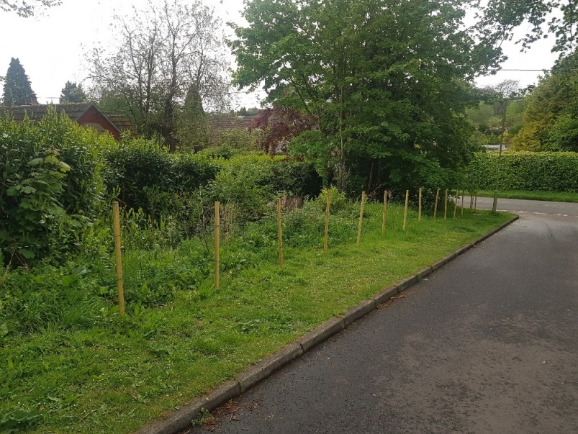
Photograph from Lymington Rise towards Lymington Bottom (seen at the top right of the photograph). The photograph shows the stretch of land maintained by EH Highways. The application relates to the land behind the fence.
Land maintained by EH Highways
Lymington Rise
Photograph from Lymington Rise towards Lymington Bottom. The application relates to the land to the left of the fence.
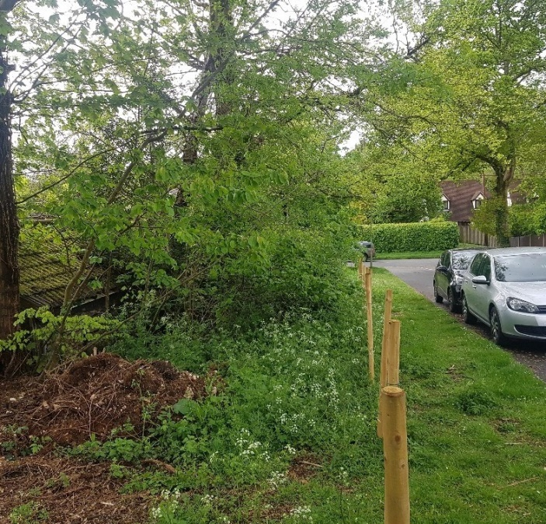
Land maintained by EH Highways

The proposal
This application is for a change of land use from nil use to residential curtilage (C3). The land is composed of a strip of hedges, mature trees and some grass. While we have been maintaining this land for the last 11 years, it has not been designated as C3 residential curtilage. This application seeks to formally designate this land as residential curtilage of 19 Lymington Bottom.

Impact on character and appearance
We do not believe this application would negatively impact the character or appearance of the area.
Our proposal is in keeping with the existing boundaries along both the north and south sides of Lymington Rise and does not interfere with or impact on the land set aside for pavement and maintained by EH Highways.
The land is situated on the south side of Lymington Rise and the proposed boundary would be a continuation of the boundary lines of both 1 and 1A Lymington Rise (please see below).

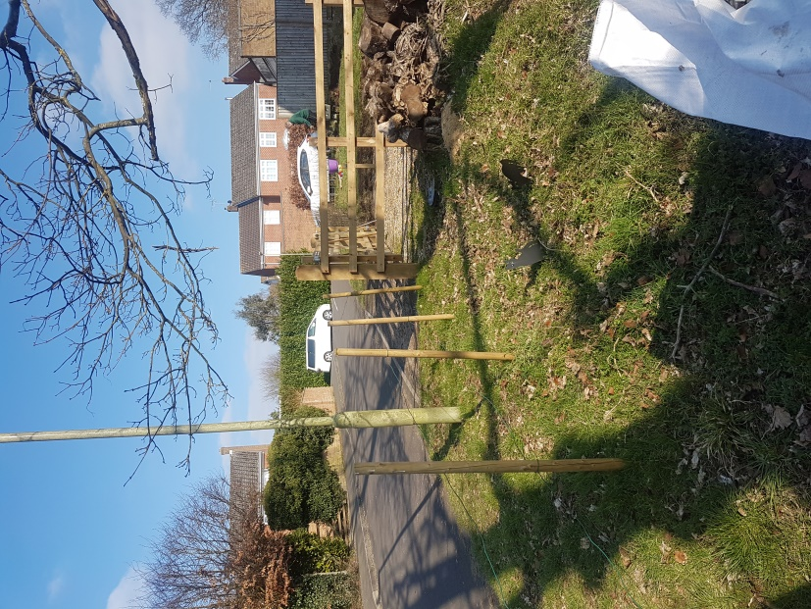
19 Lymington Bottom
1A Lymington Rise
Photograph from Lymington Bottom looking up Lymington Rise (seen on the left hand side of the photograph). The application relates to the land to the right of the fence.

This land is to be used as garden which is also in keeping with the existing land use along both sides of Lymington Rise.
Changes to land
We propose planting a hedge along the boundary of similar species to existing hedges in the local area. This is in keeping with hedge borders of properties in the immediate surrounding area (and as indicated in the site plan). It would also provide habitats for wildlife and is in keeping with local planning policies.
We would also like to erect a shed at the eastern most point of the proposed area at the boundary of the neighbouring property 1A Lymington Rise (as indicated in the site plan). The proposed shed dimensions would be 3 meters wide by 6 meters long and with a ridge height of 2.45m. As such, we have been advised that this does not fall under the requirements for planning permission however we have included here and in the site plan for your reference.
We are not developing the land and do not intend to remove any of the trees. We have included the position of existing trees within the site plan attached for your reference.
The land is not liable to flooding.

Access to the site is from 19 Lymington Bottom using existing entryways. We are not seeking additional access to the land in question from either Lymington Bottom or Lymington Rise. We are not seeking alterations to any neighbouring amenities.

Conclusion

This planning statement demonstrates that the proposed change of change of land use from nil use to residential curtilage is compliant with both national and local planning policies.

