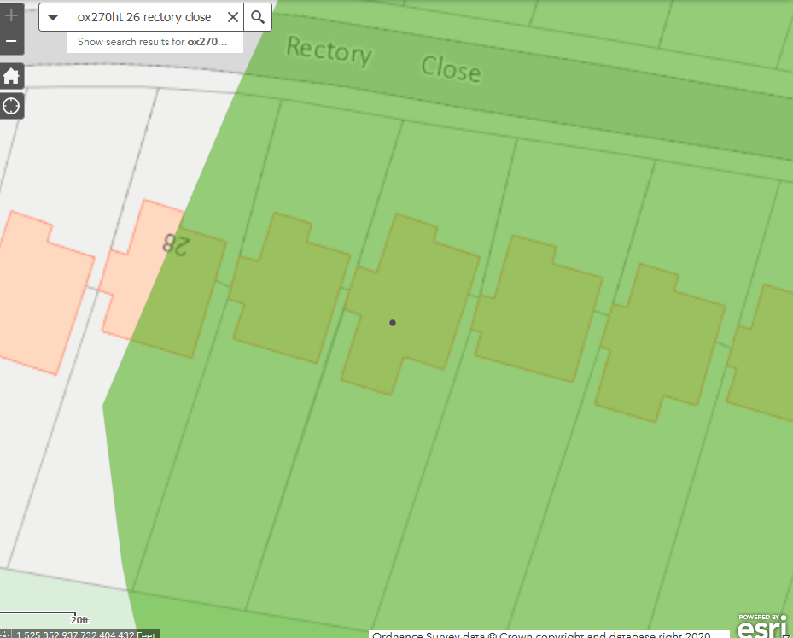
1

26 Rectory Close, Marsh Gibbon, OX27 0HT

1 - Sycamore

