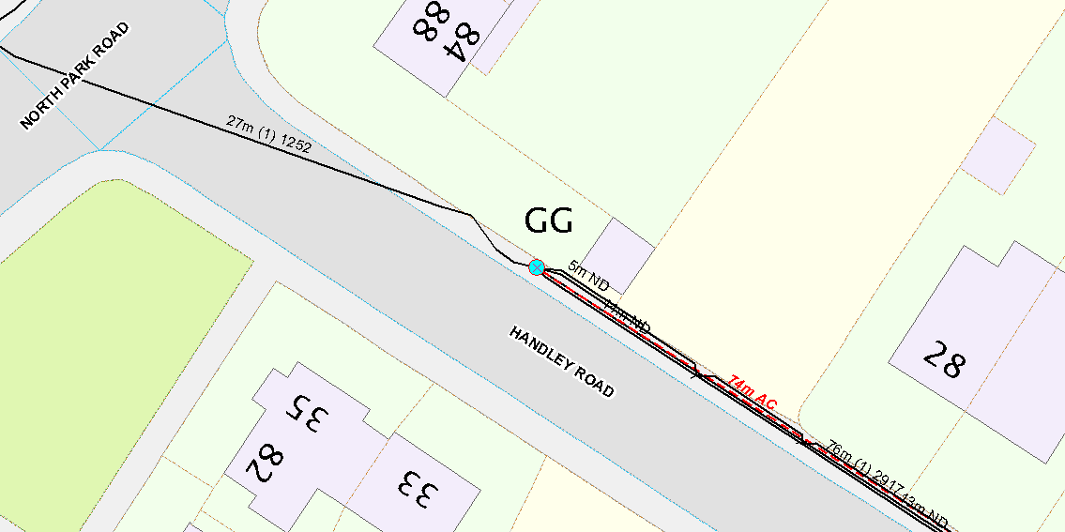

WP1: 10M MEDIUM POLE

GRID REF: 389211,387100

REPLACE EXISTING BT GENERIC POLE WITH 10M MEDIUM POLE AT WP1