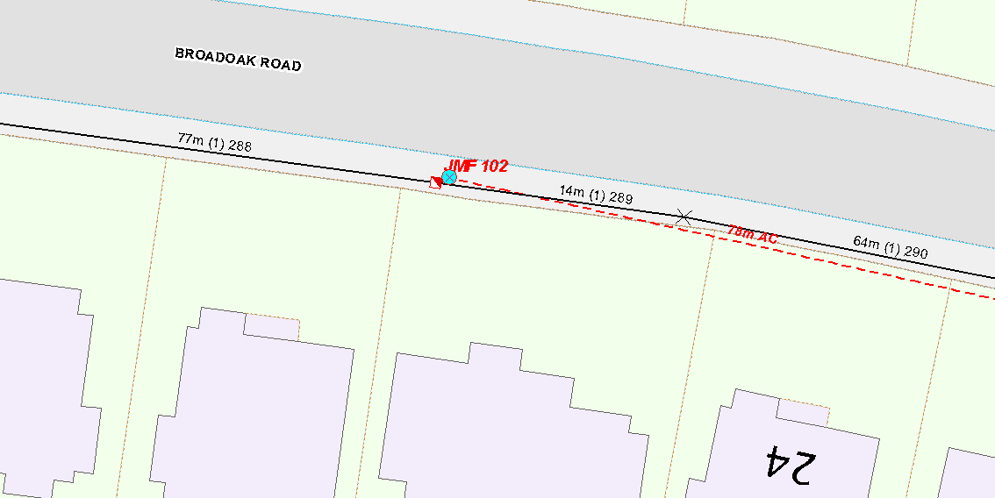

WP1: 10M MEDIUM POLE

GRID REF: 389743.386853

REPLACE EXISTING POLE WITH 10M MEDIUM POLE AT WP1