Schedule of Works

Schedule prepared by | Mitchell Fotheringham
Project address
Conservation area | Kings Park
Listed category | C
Client | Audrey McMenemy
Contact details
Brief description of works | Water ingress has been identified at the south west gable. Failure of the mortar at the abutment with the skew coping and water penetration through open joints between skew copes is suspected. Remedial works are to include replacement of the mortar skew with a more robust watergate detail (if practicable), and re-pointing of the skew coping. Raking out and re-pointing 100% of the chimney and replacement of timber to the dormer window is also included.
Important notes | This Schedule has been prepared by the Traditional Buildings Health Check (TBHC) on behalf of Stirling City Heritage Trust (SCHT) following inspection of the property as part of the TBHC inspection service. The inspection was restricted to elements which could be seen clearly, and no attempt was made to open up or employ any other destructive techniques.
 | SCHT shall in no circumstances be held liable for any works undertaken by the Client on any recommendation made in this Schedule.
 | Should a Contractor wish to see a copy of the TBHC Inspection Report, this should be requested directly from the Client.
Contents | Description of work for costing
 | Materials list for completion
 | Health & Safety information
 | Roof plan
Photographs
Location map

Description of Work and Costs
The contractor is requested to provide costs for the following items. The Contractor should amend, qualify, quantify or add to the items as necessary to reflect their own understanding of the required works.
All works to be carried out by appropriately qualified and competent workers.
Item | Description | Qty | Unit | Rate | Cost
1.0 | PRELIMINARY WORKS
1.1 | Allow for taking a photographic record of the existing condition of all areas that will be impacted by the works (dilapidation survey). | item
1.2 | Allow for submitting materials specifications and samples for approval before starting work. | item
1.3 | Allow for submitting evidence of the contractors’ public liability insurance.  Also allow for providing the client with a copy of the contractors’ Construction Phase Plan as required under CDM (2015). | item
1.4 | Allow for providing temporary toilet/welfare facilities if not provided by the client, including obtaining local authority permits as necessary. | item
 |  | TOTAL (c/f)

Item | Description | Qty | Unit | Rate | Cost
2.0 | ACCESS  Scaffolding must be constructed in accordance with Work at Height Regulations 2005. A handover certificate for erected scaffolding must be issued and records of mandatory scaffolding inspections made available.
2.1 | Scaffolding:  Provide suitable access for safely carrying out the works described. Allow for submitting a plan showing proposed location(s) of scaffolding.  Allow for loading areas and hoisting points as required. Allow for closing off and weather sealing scaffolding anchor points with plastic caps or appropriate mortar during or immediately following dismantling.  Contractor to confirm the scaffolding hire period and associated cost and also extended scaffolding hire costs. Scaffolding (with the possible exception of a chimney wrap) must be kept in place until a final inspection of completed works has been carried out.
3.0 | ROOFING AND LEADWORK
3.1 | South gable  Remove existing lead flashing at the abutment with the masonry skew coping at roof pitches R3.  Investigate the possibility of introducing a traditional lead watergate detail and advise the client of findings.
3.2 | South gable  Remove slates as necessary to allow fitting of a lead Watergate R3.  Include reinstatement of slates on completion of lead works allowing for any necessary adjustments to the detail.  Check structural timbers and sarking board and report any defects or timber decay to the client.
3.3 | South gable  Install lead watergate and associated cover flashings at R3.
3.4 | R1 and R3  Check roofs for slate defects and report findings to the client. A slipped slates were identified on R2 during a general inspection in September 2020.
3.5 | D1  Check roofs for slate defects and report findings to the client. A slipped slate were identified on D2 during a general inspection in September 2020.
3.6 | The section of facia which has been highlighted as an issue is on the dormer windows to the rear elevation.  Check all timber fascia’s and soffits and other components for decay and report findings to the Client.  Repair or replace timber components affected by decay using traditional materials and techniques.  Prepare all facias and soffits as follows:  - Remove existing paint (External painting to be assessed on-site and altogether remove paint or retain and prepare the timber for painting)  - All timber repairs to be in treated redwood.  - Sand down all surfaces in preparation for paint  - Paint colour to be agreed with client this is to be three Coats of breathable external paint
4.0 | STONEMASONRY
4.1 | CH1  Rake out all mortar pointing to the CH1, prepare the beds and joints for re-pointing. Allow for 100% of the CH1. Pointing should be raked out to a minimum depth of 35 mm. Lay aside all loose pinnings for re-use during re-pointing.  Re-point all beds and joints using appropriate lime mortars.  Allow for replacing isolated units of stone found to be decayed beyond practical use.
4.2 | CH1  Rake out all mortar pointing between sections of skew coping.  Re-point the joints using appropriate lime-based mortar.  This work should be coordinated with the roofing works to ensure that the joints are well packed and pointed on all sides.
4.3
5.0 | MISCELLANEOUS
5.1 | The contractor is to allow for making good any damage caused during the works, including replacing slates broken during scaffolding erection and dismantling. Also allow for clearing all gutters and outlets of debris resulting from the works, and flow testing.
5.2 | Tidy the site on completion of the works and following removal of the scaffolding. Remove all waste and debris from site using a SEPA registered waste carrier. Allow for obtaining local authority skip permit as necessary. Make good all damages to garden areas occurring as a result of the works.
 |  | TOTAL (c/f)

Item | Description | Qty | Unit | Rate | Cost
6.0 | PROVISIONAL WORKS (OPTIONAL OR AS NECESSARY)
 |  | TOTAL (c/f)

Summary
Preliminary works (Section 1)
Scheduled works (Sections 2-5)
Provisional works (Section 6)
TOTAL
VAT
SUM TOTAL

Contractors Notes
A Contractor, when pricing this Schedule should satisfy themselves of the need for the above items in their professional opinion, and highlight and/or qualify any differences in the Notes section below.
Continue on a separate sheet if necessary -

Materials
A materials specification is not provided and contractors are requested to provide a brief description and specification of the materials allowed for in their estimate using the tables below.
Mortars
Mortars to be accurately batched and thoroughly mixed. The substrate to be cleared of loose and decayed mortar and well washed down before placing new mortar. Masonry to be dampened down sufficiently to prevent rapid suction. Mortars to be adequately protected and appropriately cured to avoid rapid drying (wind or sun) and from rain and frost until the work has gained sufficient strength. Contractors to confirm the mortar specifications. For example, include types and classifications of lime, type of aggregate and the mix ratios to be used.
Note that cutting disks are not to be used for raking out.

Location | Details | Ratio
Sandstone replacement/indenting
Sandstone to be sourced and dressed to match the original. Stone to be free of unsightly discolouration, dries, clay pockets and other flaws. Where possible cut out the entire depth of the stone to be replaced. New stone to be built using appropriate traditional lime mortar. Ensure any voids to the rear of replacement stones are packed appropriately with mortar and stone pinnings. Point all joints and beds with lime mortar as described above.

Location | Details

Leadwork
Repair or replace to match the original. Ensure lead work complies with the Code of Practice for lead sheet roofing and cladding (BS6915) as illustrated and detailed in the Lead Sheet Manual issued by the Lead Sheet Training Academy. Contractors to confirm the codes of lead to be used.

Location | Details
Rainwater Goods
Where the gutter joints are leaking remove jointing bolts and separate the sections. Remove old sealant, thoroughly clean the gutter and remove rust by wire brushing and sanding as necessary. Repaint/treat any exposed metal where necessary to discourage rusting. Remake the joints using low modulus silicone sealant or specialist rubberized bitumen gutter mastic and galvanised/zinc plated gutter bolts.
New cast iron components to match the original. All to be primed as necessary and finished with undercoat and 2 coats gloss. Gutters to be painted inside and out.

Location | Details
Timber
Repair or replace timber components affected by decay using traditional materials and techniques. Prepare and finish as necessary with exterior paint.

Location | Details

Miscellaneous
Location | Details

Health & Safety
Including Construction Design Management (CDM)

Contractors should understand their responsibilities under Health & Safety law including:
- Health and Safety at Work etc Act 1974 (the HSW Act)
- Management of Health and Safety at Work Regulations 1999 (the Management Regulations)
- Construction (Design and Management) Regulations 2007 (CDM)
- Control of Substances Hazardous to Health Regulations 2002 (COSHH)

The Construction (Design & Management) Regulations (CDM 2015) applies to all building and construction work and includes new build, demolition, refurbishment, extensions, conversions, repair and maintenance.

Under the Construction (Design and Management) Regulations 2015 (CDM 2015) a construction phase plan is required for every construction project.

The Contractor must demonstrate an understanding of their responsibilities under CDM before construction starts.

Key points to CDM Regulations 2015

1. All projects must have:
- workers with the right skills, knowledge, training and experience
- contractors providing appropriate supervision, instruction and information
- a written construction phase plan

2. Projects involving more than one contractor (domestic or non-domestic)
- must follow Step 1 plus -
- a principal designer and principal contractor must be appointed
- a health and safety file must be produced

3. When work is scheduled to:
- last longer than 30 working days and
- have more than 20 workers working simultaneously at any point in the project
- OR exceeds 500 person days
- The project must follow all of Steps 1 and 2 PLUS the Client must notify HSE of the project

Roof Plan
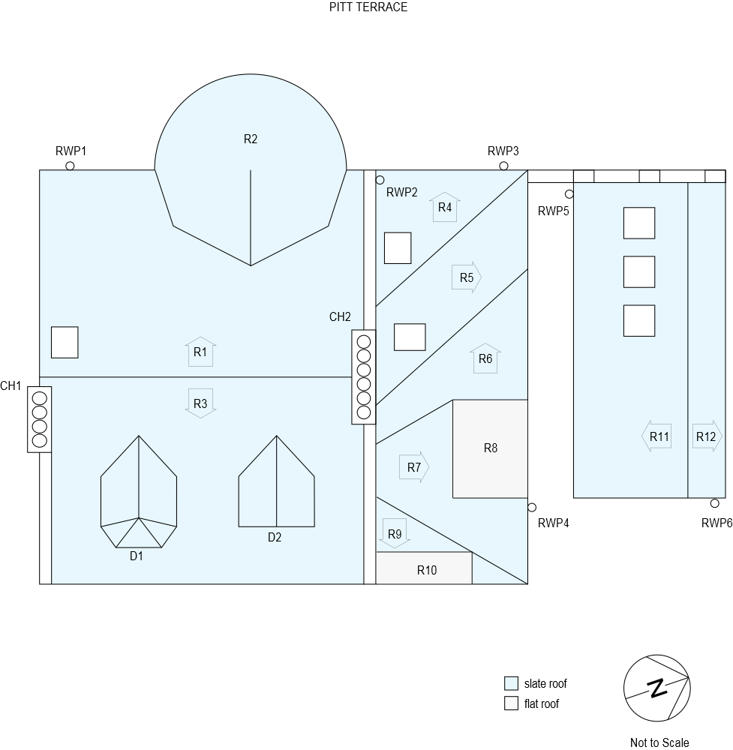

Photographs

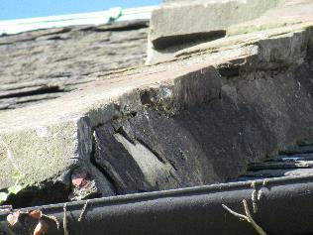  South Gable | 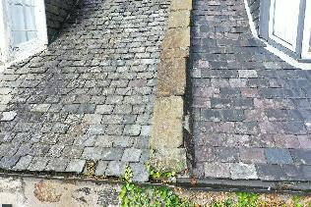  Gable skew putt (LH)
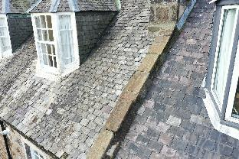  Gable skew putt (LH) | 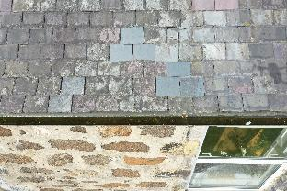  Slipped slates on R3
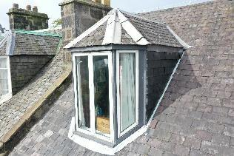  D1 | 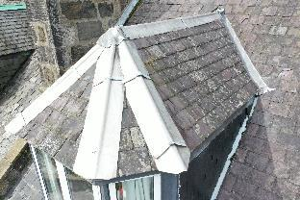  D1
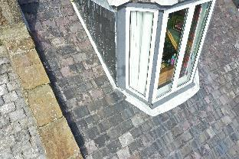  Gable skew putt and D1 | 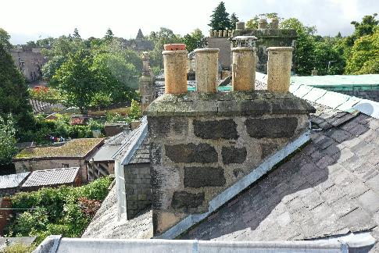  CH1
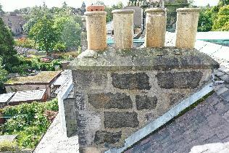  CH1 | 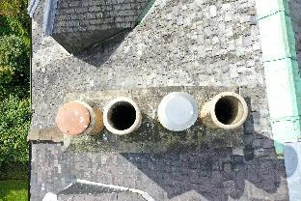  CH1
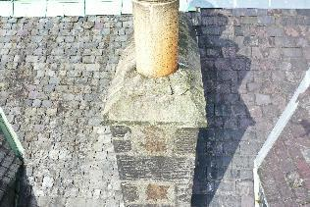  CH1 | 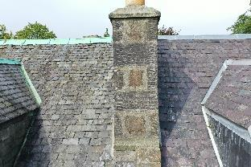  CH1

Location map

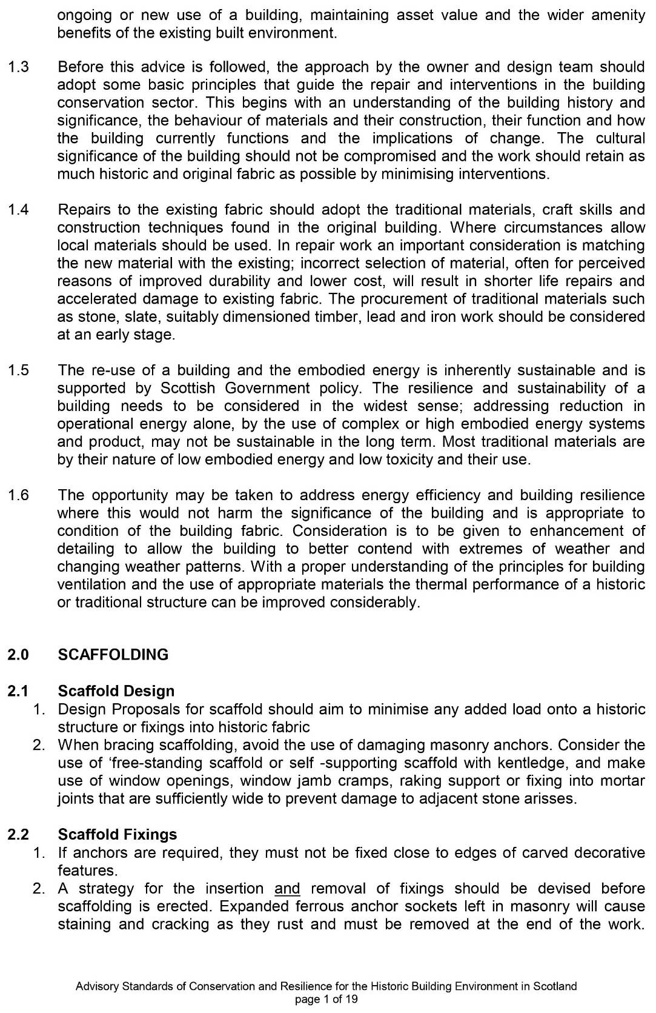
APPENDIX 1 - Historic Environment Scotlands, Advisory standards of conservation and repair for the historic building environment in Scotland.

