Planning Application DC/21/02051

- Front Fence Panels: Framed Willow Panels (Straight Topped)

Manufacturers specification:
Width: 1.8m
Height: 1.5m
Depth: 4cm
Supplier: Nelson Potter Limited
Supplier Description:
Heavy duty & Robust
Fully Framed treated timber
Half lapped frame
Traditional with the Rustic effect
Hand Weaved Willow
Imported from a regularly harvested plantation
Please note: as this is a natural product and you may notice variations in colour.

See Figure 1

- Back Fence Panels: Closeboarded Timber panels (Imported W/Board Panels)

Manufacturers specification:
Width: 1.828m
Height: 1.525m
Depth: 4cm
Supplier: Nelson Potter Limited
Supplier Description:
Imported W/Board panels fully framed & half lapped using 60mm x 27mm timbers
Fully framed & half lapped using 60mm x 27mm timbers
Heavy duty W/Board using 2ex 125mm x 22mm
Weather capping top rail nailed with Galvanised ring shank nails
Pressure treated in green

See Figure 2

- Wood Gavel Boards – to be positioned under all fencing

Manufacturers specification:
Height: 150mm
Depth: 22mm
Supplier: Nelson Potter Limited
Supplier Description: Pressure treated in ACQ Green – conforms toUC3(BSEN3351)

- Softwood Timber fence posts (Brown) – to be used for all fence and gate panels

Manufacturers specification:
100mm x 100mm square posts
Supplier: Nelson Potter Limited
Supplier description:
All 100 % Pine (Redwood)
Dried to an average of 28% moisture content prior to treatment
Pressure treated in ACQ Green or Brown to UC4)

- Front Fence Gate: Framed Willow Garden Gate (bespoke)
Manufacturers specification:
Width: 0.915m
Height: 1.5m
Depth:10cm
Description:
Frame, Ledge & Braced Pedestrian Gate
Heavy duty & Robust
Utilising Willow fence panel or willow screening
Traditional with the Rustic effect
Hand Weaved Willow

See Figure 3

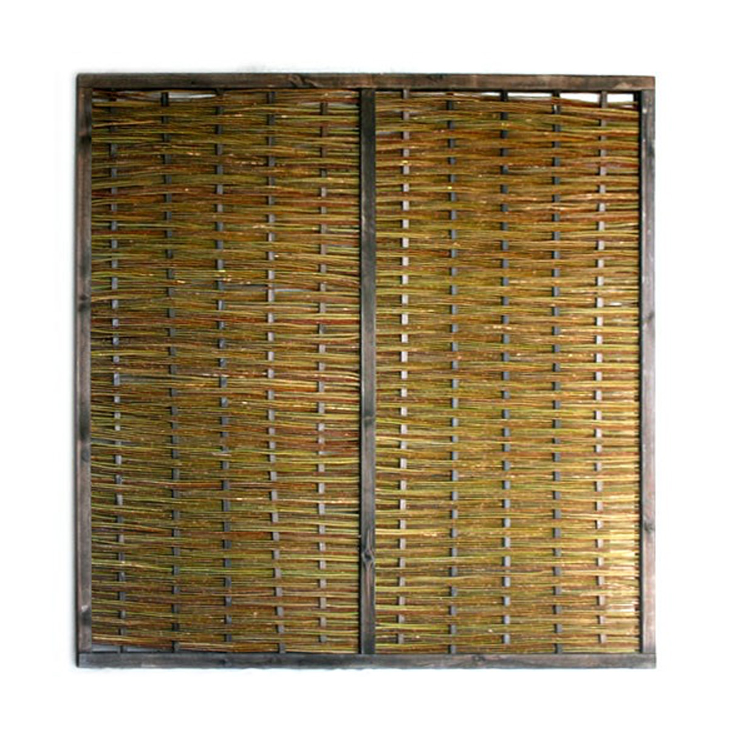
Figure 1: Framed Willow Panel – Front Fence

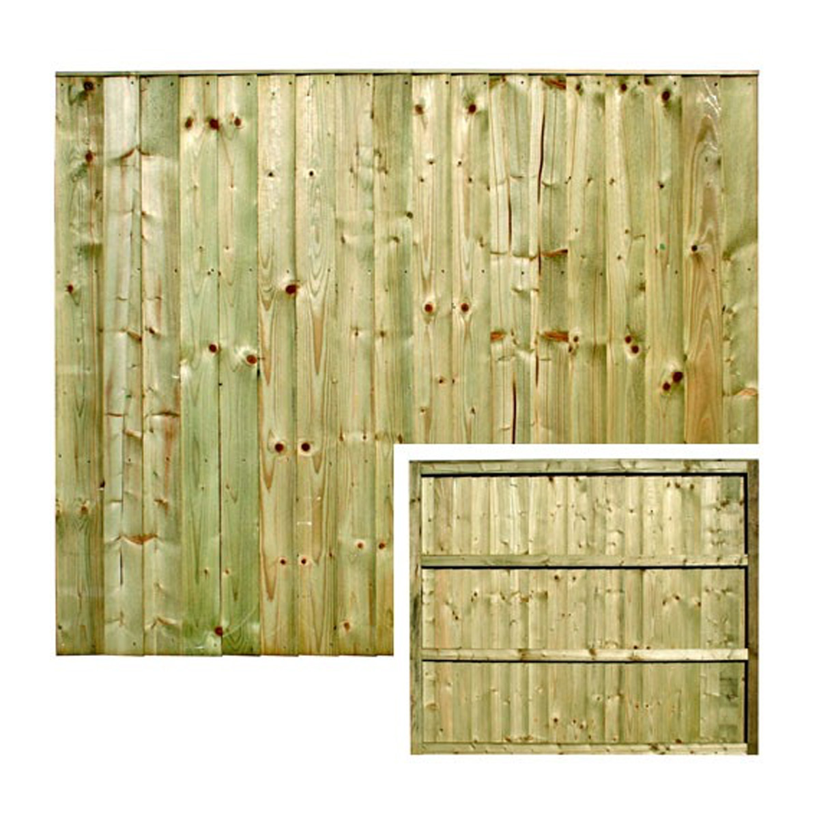
Figure 2: Closedboarded panel (back fence)

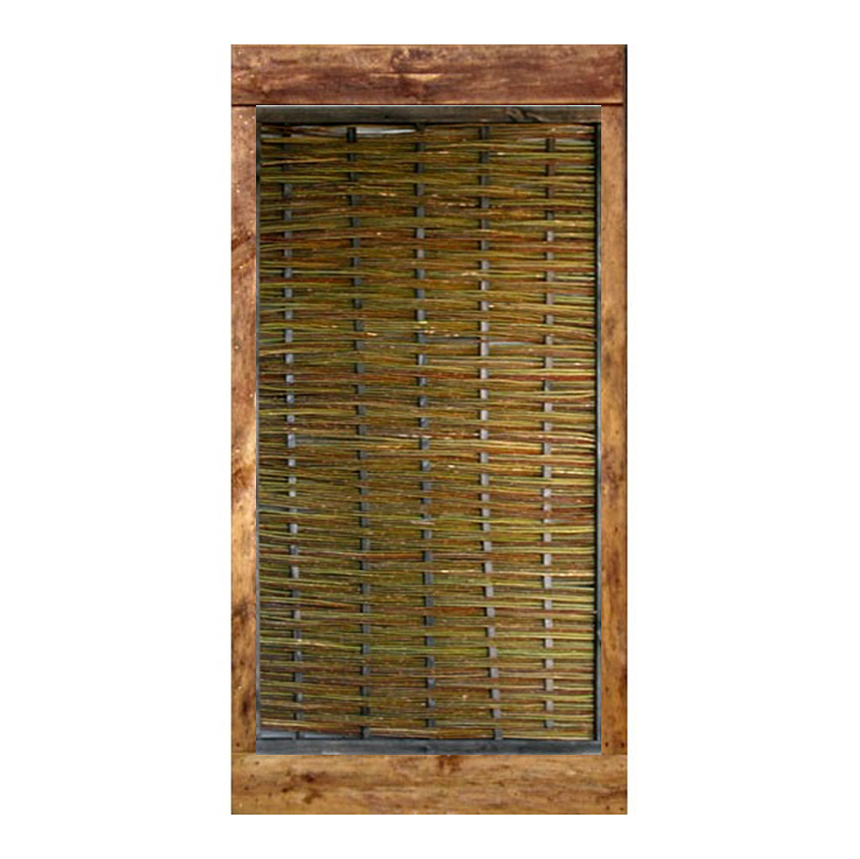
Figure 3: Framed Willow Gate for Front Fence access

