Design & Access Statement for Planning Proposal PP-09708699.

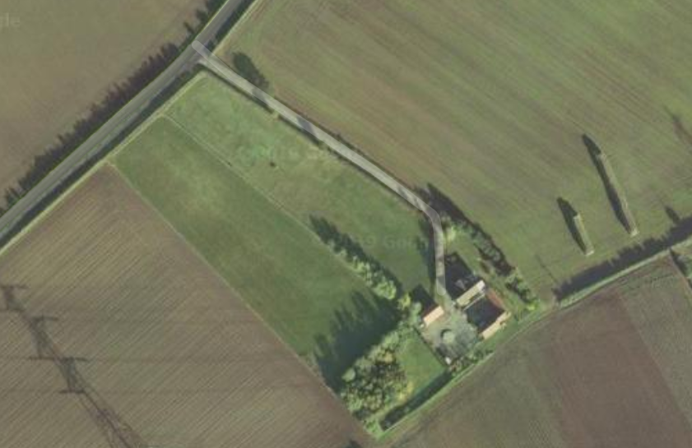

Eastfield Cottage Farm
Mill Lane
Kings Clipstone
Nottingham.
NG21 9JN

April 2021.

Contents

1 Introduction
2 Development Context
3 Pre-Application and Full Planning Advice
4 Vehicle Access
5 Development for Tourism
6 National and Local Plan Policies
7 Woodland Trust Initiative
8 Ecological Survey
9 Flood Risk Assessment
10 Landscape Character Impact Assessment
11 Summary
12 Additional Development Site Photographs.
1 Introduction.

This Design and Access Statement (D&AS) is to be read in conjunction with the following application drawings and related information:
- A Booth /21/1 (proposed site development plan)
- A Booth /Site Ordinance Plan April 2021 (proposed location plan)
- Emec Ecology report
- Woodland Trust report

This Design and Access Statement (D&AS) relates to the proposed development for the ‘change of use’ from agriculture to tourism. The D&AS is in accordance with the guidelines set out in the National Planning Policy Framework and CABE.
The application site area forms part of Eastfield Cottage Farm located between Kings Clipstone and Edwinstowe and in close proximity to Sherwood Pines and Sherwood Forest.

2 Development Context.

2.1 Physical Context:

Eastfield Cottage Farm lies within the rural countryside areas of the old Clipstone Estate Farmlands. Accessed from Mill Lane, the property and linked buildings are set well back with surrounding farm lands.

The existing dwelling is of traditional construction and has been extended to the side. There is an open courtyard with stable and barn buildings on two elevation sides (north/east and south east).

Immediately adjacent to the dwelling and separated by the access lane is a three-bay garage with a full 360-degree vehicle turning area to the rear.
There are two fields adjoining Eastfield Farm Cottage (fields 1 & 2) stretching up to Clipstone Road with a small woodland area to the south west side.

The existing farm including the connected buildings and fields cover an area of 19,441.0 m2. The development area (fields 2 and driveway access) covers an area of 2,400 m2. Mature hedgerows with post & rail fencing abound the site areas with trees dividing the two fields at the lower end and a small wooded area to the bottom of field 2. Both fields are grass covered for horse grazing.

The existing stable and barn building is approved for alteration/conversion to an annex.

2.2 Design Context:

The proposed developments are listed below with the inclusion in the ‘change of Use’ of the agricultural land to tourism. Within the 1200 m2 on field 2, the applicant proposes to site 2 static homes on the bottom of field 2 as holiday lets for tourism use. These static homes will be clad with wood to give the appearance of cabins and the area will be planted with trees and shrubs to provide screening from the road, privacy to the site users, additional habitat for wildlife and protection from the prevailing wind.

2.3 Development Plan Proposals:

- Change of use from agricultural to tourism - C3 to D2 and Sui Generis** to D2
- Main vehicle entrance widening works

Proposed Site Development Plan No. A1

The proposed development is to be enclosed with post & rail fencing to a height of 1.20m (Fig 1 below).

Fig 1

2.4 Main Vehicular Access:
The existing gated entrance at the immediate junction of Mill Lane is to be widened to allow two vehicles to enter and exit without obstruction to the oncoming highway users.

Entrance location (as shown) providing clear width of 5.50m and depth of 8.00m. Kerb radius 4.00m.Surface finished in tarmac.(Fig 2 below)

Fig 2
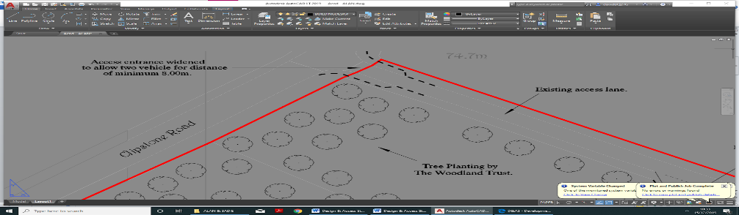

Proposed Highway Entrance design change/alterations (Fig 3 below)
Fig 3

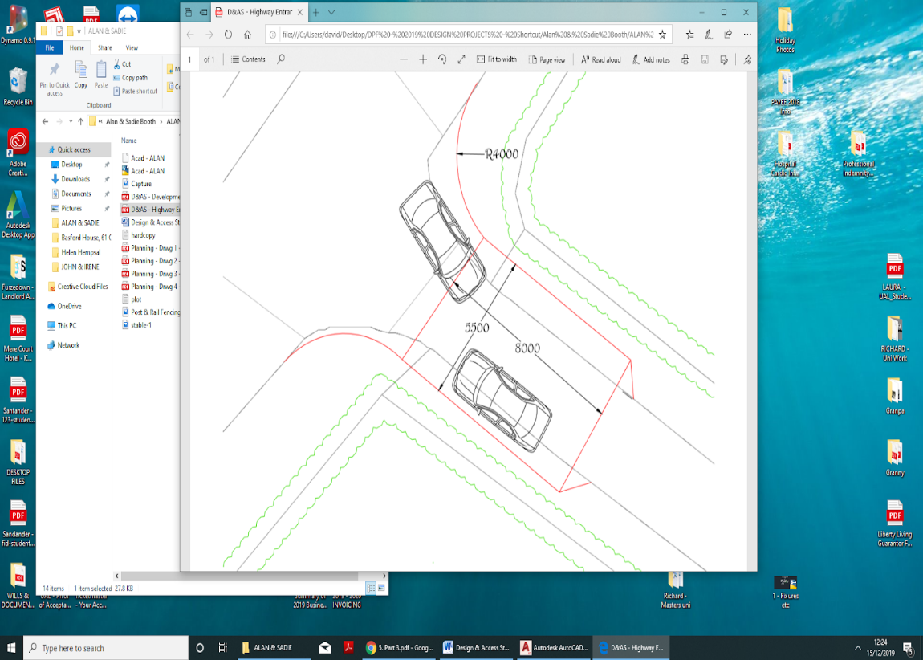

2.5 Access Lane Widening Point:
The mid-point along the access lane is to be widened for vehicle passing area Fig 4 below).

Fig 4
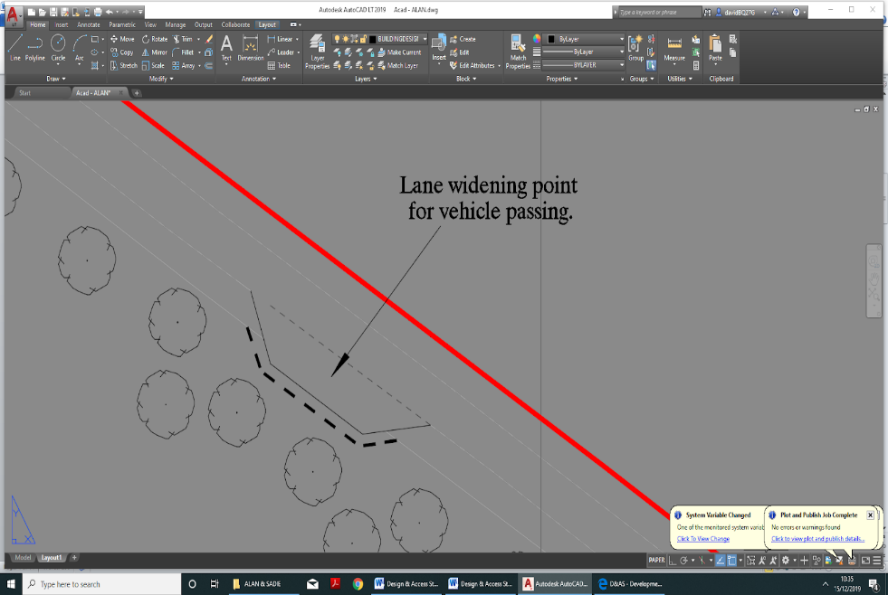

If required, the existing hedgerow removed to allow for the increased lane width. New Hawthorne hedge planting proposed to reinstate hedgerow removed and tapered back to line of existing hedge.

2.6 Proposed accommodation
The proposed cabins will be will be approximately 9.7m x 3.6m (32ft x 12ft) in size, and clad in wood to give the appearance of a cabin. Services will be supplied to the cabins and any foul sewerage will be discharged into a septic tank.
This site will apply a Leave No Trace policy in relation to waste, which is becoming increasingly popular with wild camping enthusiasts who are encouraged to take away any waste they make.

Fig 5
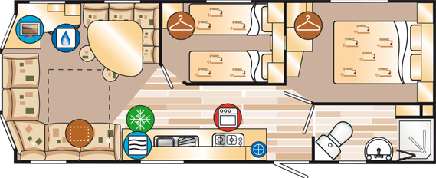
Internal image of proposed cabin

Fig 6
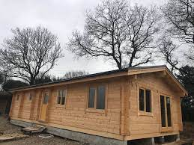
External image of proposed cabin

3 Pre-Application and Full Planning Advice.

Pre-application advice was formally submitted to the authority’s planning section with a detailed response to the proposals made (reference: PREAPP/00262/18), received 17th January 2019.

A detailed response was received setting out both National and Local Plan policies for consideration as part of the overall tourism proposals although changes to the description uses have been made.

An application for Full planning consideration was submitted thereafter in November 2019, for development for tourism. However, this was withdrawn owing to circumstances surrounding the garage conversion proposals. Application ref: 19/02255/FULM

A revised application for Full planning consideration was submitted thereafter in August 202, for development for tourism. This application was approved in November 2020 for 1.39-hectare site to be developed for tourism and is currently a live application. Application ref: 20/01530/FULM.

4 Vehicle access
As detailed within section 2.2 above it is proposed to widen the existing entrance to the Eastfield Cottage Farm lane as part of the tourism proposals, ensuring safe vehicle use.
Driveway widening to 5.50m and to a depth of 8.00m with increased visibility splays of 4.00m radius are proposed.
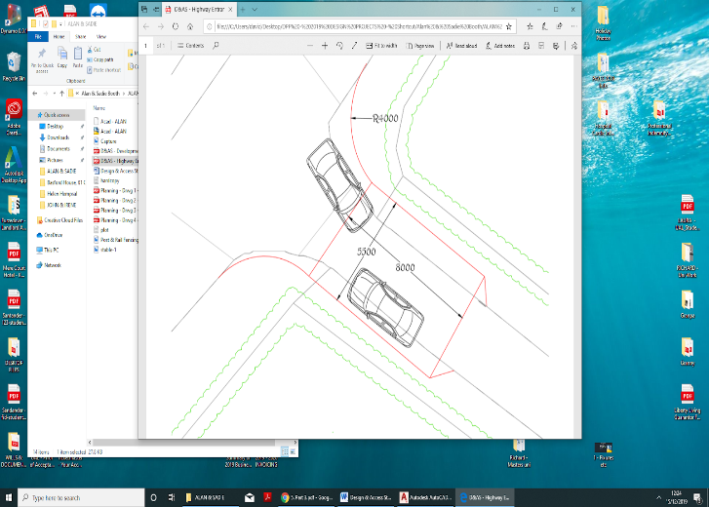

The new widened area is to have a tarmac surface with no water run-off on to the highway. The new entrance design proposals are to be in accordance with the 6C’s Highway Design Guidance for the number and size of vehicles and will also assist with fire appliance access.
A passing point mid-way along the lane is also proposed with new hedgerow planting, if required, where the existing Hawthorne hedges are to be removed.

5 Development for Tourism

The tourism proposals are to cater for camping or families/individuals, cyclists, walkers or for those visiting Sherwood Forest.

Eastfield Farm Cottage is located within very close proximity to Sherwood Pines, a busy and constantly growing activity area catering for horse riding, walkers and in particularly the mount biker with over 3,300 acres of outdoor space. Nearby are other local tourist attractions such as Clumber Park, Sherwood visitors centre, Rufford Abbey and Centre Parcs.

It is clear that Eastfield Farm Cottage lies within easy access and use to a variety of outdoor activity locations without traveling long distances. Visitors have the opportunity to travel without the use of their vehicle to these nearby centres.

6 National and Local Plan Policies.

The following policies will be subject to justification.

- Policy DM8 – tourism accommodation within the countryside.
- Policy DM5 – shall be appraised on the scale and density of the development.
- Policy DM8 – development in the open countryside
- Policy DM12 – presumption in favour of sustainable development
- Policy CP7 – tourism development to reflect NPPF strategy.
- D2N2 – study shows significant interest in the market potential for tourism and in particular in the Sherwood Forest area.
- Core Policy 7 – sets out tourism and visitor-based developments will be supported subject to a number of considerations.
- Core policy 13 – the proposals to meet the Woodland Trust Initiative of planting trees and shrubs will vastly improve screen cover and enhance the landscape character.
- Chapter 3 NPPF – recognises the need to support economic growth within rural areas and support sustainable rural tourism and leisure developments which respect the character of the countryside.

Planning permission must be determined in accordance with the Council’s
local development plan, associated planning guidance and The National Planning Policy Framework (NPPF). Newark & Sherwood District Council’s adopted Local Plan sets out policy requirements for new developments such as tourism and to promote, and encourage sustainable initiatives.

Where the use of land in rural areas can be used for other functions such as recreation and outside activities the authority in their decision making should be proactive but consider the significance without creating harm to the surrounding environment.

Section 3 of The NPPF requires local planning authorities to seek opportunities where there is a contribution towards good design, economic growth in the viability for agricultural land change use towards tourism and the social dimensions of sustainable development being achieved.

Policy CP7 supports Section 3 NPPF approach to sustainable development in the decision making to aid the continued economic viability of farm land and the diversification of activities (such as camping parks) that are of a scale, size and amount appropriate to the location.

Policies DM5, DM8 & DM12 – Proposals for the diversification of farm and
other land-based enterprises will be permitted where: (i) the character, scale and nature of the proposal can integrate well in to the rural landscape, (ii) the development conserves and enhances the historic environment, (iii) forms part of a diversification scheme as part of a land-based enterprise business and (iv) that effective measures have been incorporated to address highway safety.

7 Woodland Trust Initiative.
The applicant is keen to promote sustainability and encourage wildlife as part of the tourism application programme.
The proposal, with support and guidance from the Woodland Trust, is to plant a variety of trees and shrubs within approximately half acre of both fields 2. However, the planting scheme will link up with the existing wooded area and will continue up the left side of the development are before protruding slightly into the field 2, shielding both cabins from the view of the road. This planting will also provide horses with additional shelter and new wildlife environments.

8 Ecological Survey.
Emec Ecology has provided a full study report on their inspection and findings of the field desktop study and buildings. Full report can be found within the appendices.

9 Flood Risk Assessment.
The site lies to the South of Old Clipstone and West of Edwinstowe. Ordnance Grid Reference: 461960 - 365273
A flood risk assessment has been produced (within appendices) as part of the application submission with the land categorised as low risk level – 1.

10 Landscape Character Impact Assessment.
Eastfield Farm Cottage and surrounding fields/land are located within the open countryside near to Edwinstowe and Sherwood Pines. The site is accessed off Clipstone Road with the nearest neighbouring residents being within Edwinstowe and Lidgett, some 0.75km away.
The proposed site is set on land which is not prominent from the public realm due to the down-hill gradient from Mill Lane and is therefore not considered to be of detriment from the main public viewing aspect.
From Mill Lane, Eastfield Farm Cottage and detached buildings are located some 175 - 200m away. Hedgerows abound the field edges and lane down to the cottage with post & rail fencing hidden within. There are no listed heritage buildings and the site is not situated within the Green Belt.
The adjoining fields to Eastfield Farm Cottage (fields 1 and 2) are grass land with a small wooded area to the bottom south west side. Neighbouring arable farm lands surround the area giving the open countryside character.
Proposals for the planting of new trees and shrubs within 0.5 acre of field 2 will alter the aspect view significantly and soften any impact. More importantly it will assist in the screening and containing of the proposed development.

11 Summary.
There are social and economic benefits that are in favour of this new development enterprise and are considered to meet with the policy strategies at both local plan and national levels. The proposed diversification demonstrates a sustainable form of rural tourism development and will support economic growth

12. Additional Development Site Photographs.

Photograph 1. Entrance to Eastfield Farm Cottage off Mill Lane.

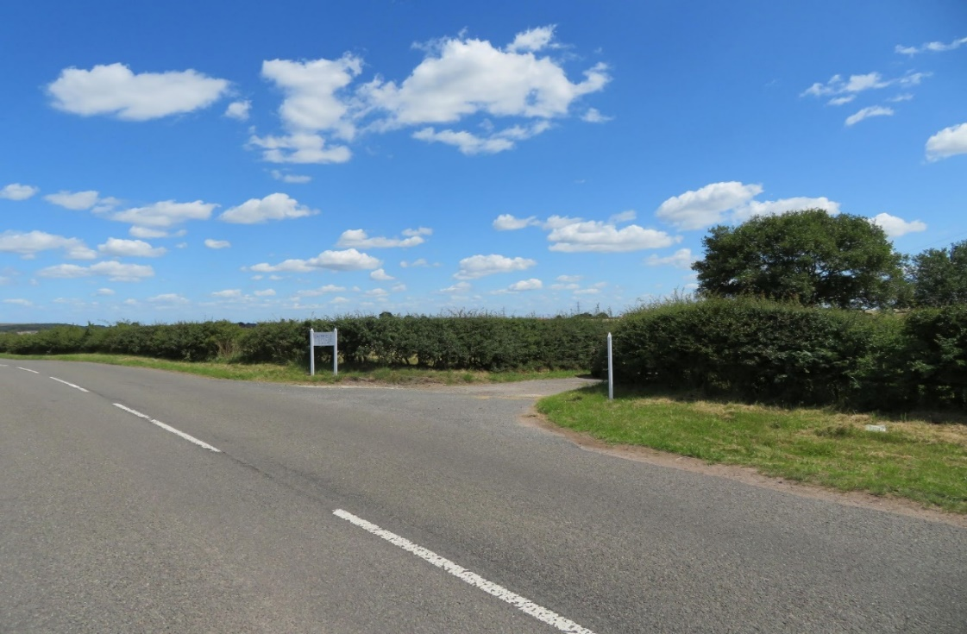

Photograph 2. Visibility splay north towards Edwinstowe and Lidgett

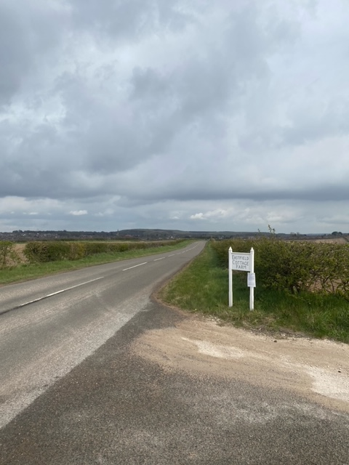

Photograph 3. Visibility splay south towards Sherwood Pines.

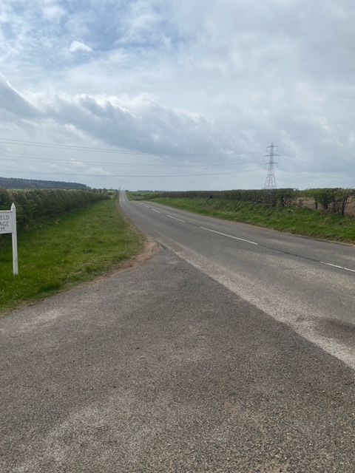

Photograph 4. View of the access lane towards Mill Lane.

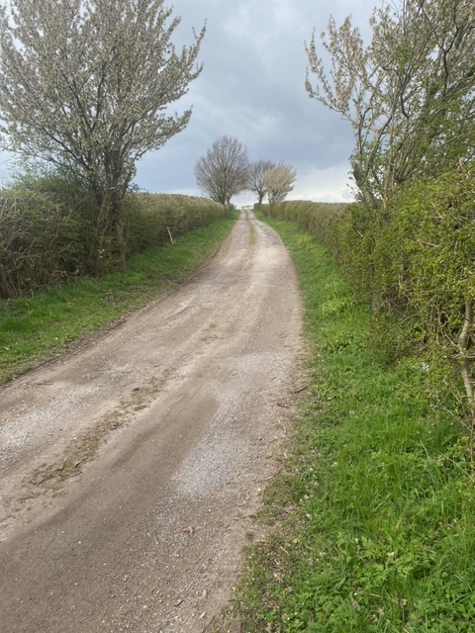

Photograph 5. View of the access lane from the cottage.

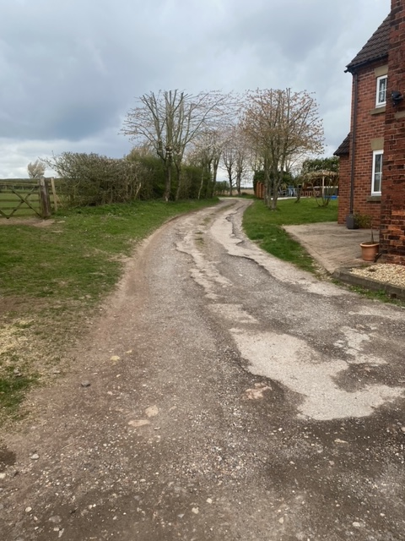

Photograph 6. View from the access lane onto field 2.

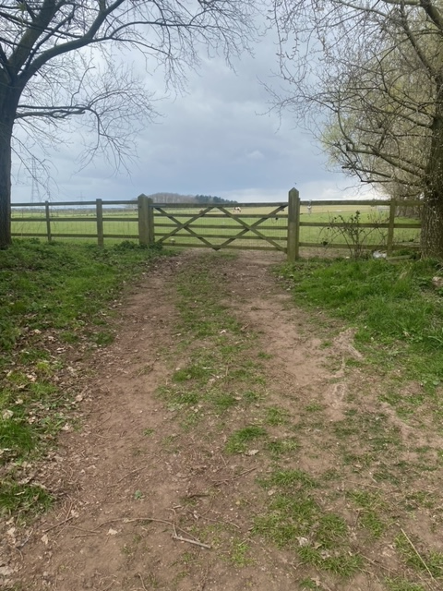

Photograph 7. View of development site from Field 2 entrance.
