****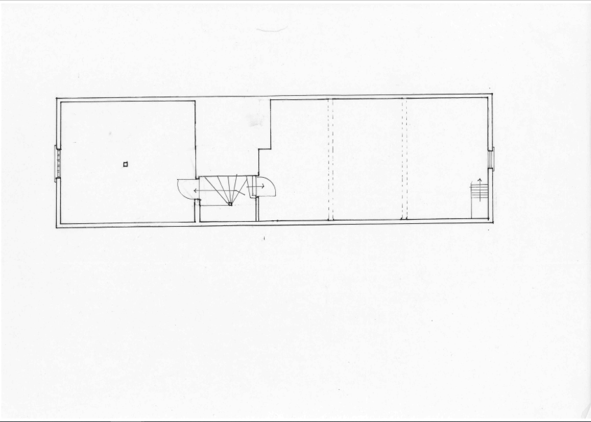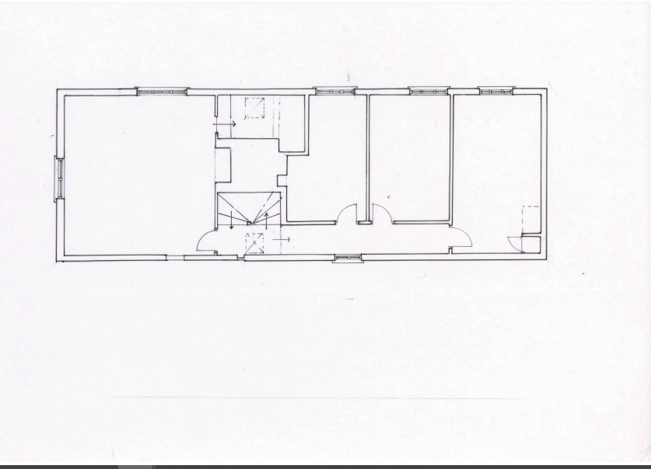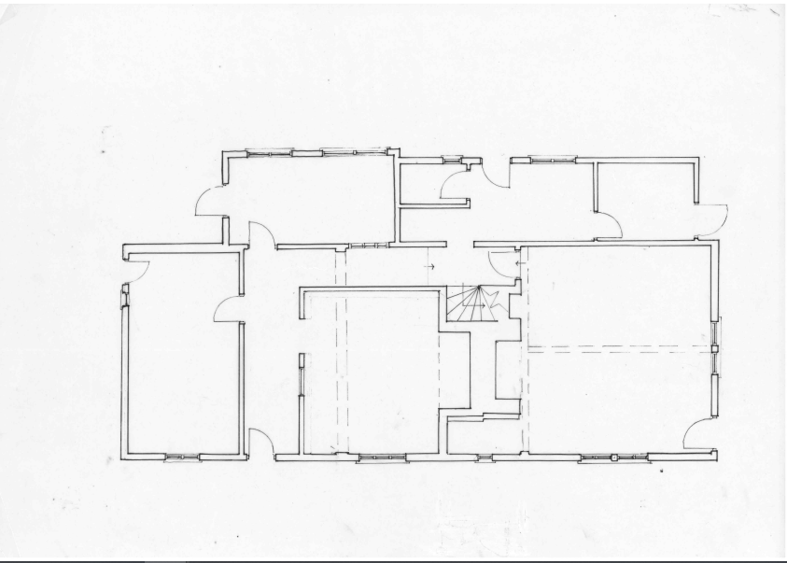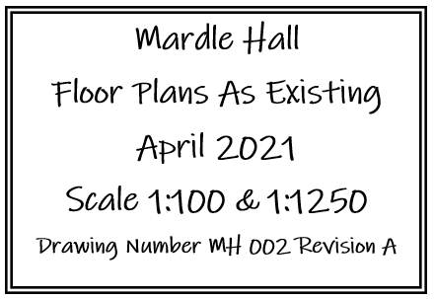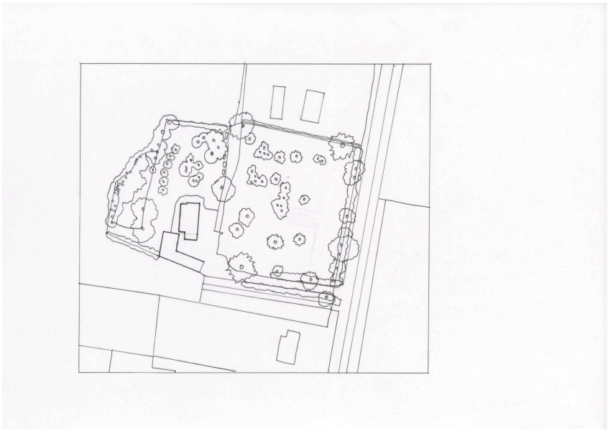

**Boot Room Toilet Utility Outhouse**

**En-Suite**

**Attic Bedroom**

**Kitchen Dining Room Lounge**

**Bedroom . Bedroom Bathroom Bedroom**

**Attic**

**First Floor**

**Ground Floor**