Heritage Statement
- 5321 TIVETSHALL ST MARY RECTORY ROAD (Long Road) Mardel Farm Cottages TM 18 NE 14/1240
II

- C17 timber-frame house, rendered. Thatched roof with gabled ends. Brick chimney stack off centre. Two storeys and attic (attic window in gable end). Four windows. Cl9, 3 and 4-light casements. Boarded door.
Listing NGR: TM1773585844
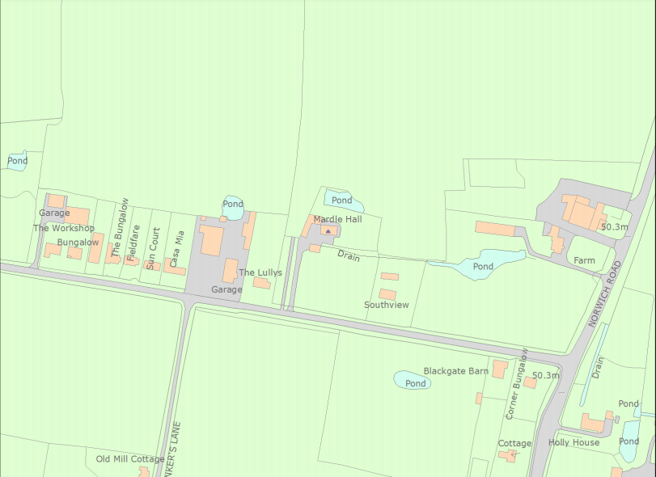

This historic statement is made by drawing together observations made by Edwin J Rose, my structural engineer, Stuart Armitage, and my own, having removed render to expose key aspects of the frame.
The house is a 2 story property with usable attics and measures 15.5m by 5.5m, with a central stack offset to the East, a much later and now unused stack to the West. It also has 3 additional single story extensions added to the back being 2.5m deep by 12m wide.
The property runs East to West parallel to Rectory Road, set back 65m to the North and sitting in a 65m wide by 105m deep plot, with farm land both front and back. To either side, sitting in smaller plots, are bungalow properties that sit much closer to the road and stand some 50 + meters away to the South East and South West
The house as it stands now comprises of three core elements, the part to the west of the stack is 15th/16th century. The part to the East 16th/17th century, possibly a rebuilt parlour and the three single story additions to the rear added as recently 20th century.
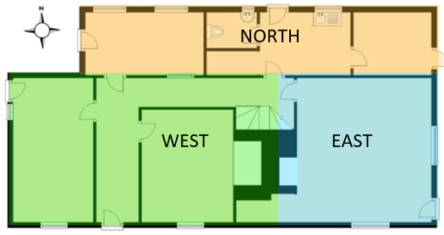

The house visibly tilts towards its South West corner, this is due to poor, or late, repair of defects and induced structural weaknesses caused by the relocation of window and doors reducing the number of supporting studs. Within the main house there are two different forms of construction apparent. To the West of the stack, studs in the main, run from sole plate to wall plate, although there are some apparent mid rail additions although these are more likely to be the lintels from a removed mullion windows.
To the East of the stack a very different method of construction is evident. Differences include a mid-rail, and curved braces joining the principal posts to the wall plate. As of writing I have found no evidence of mullion windows in this section.
Focusing on the West side as this side has always a house.
Possible evolution of Kitchen and Dairy with the introduction of a cross passage and movement of front door.
The current position of the front door is unlikely to have been its original position, due to the low height of the door and no lintel being present. The door frame is simply nailed to a stud, and there has been no attempt to support the wall above the frame. It is more likely to have resided where the central stack now resides and only got moved when the East and West sections were operated as two properties.
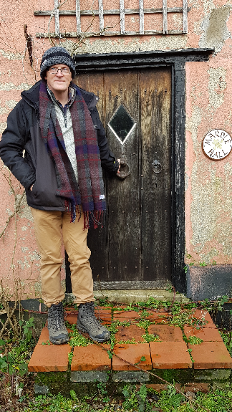
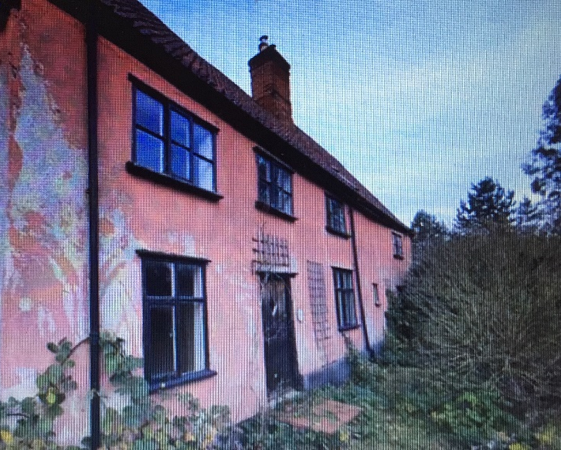
Removal of the cement render within the bay the front door currently resides in, has shown that of the 4 studs present, not one currently runs from sole plate to wall plate and this is ignoring the fact that no sole plate exists. It is therefore the door frame that is acting as the structural element for this bay and hence why it does not open. The front door, if it were to be opened, would open into what appears on first sight to be a cross passage, but the door to the north of the front door is not original, neither is the brick wall to the East of the front door. This is evident as it stands in front of an old mullion window and when the wall was built it has trapped ceiling material between itself and the floor boards of the first floor.
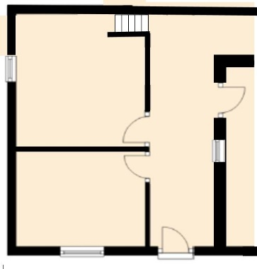
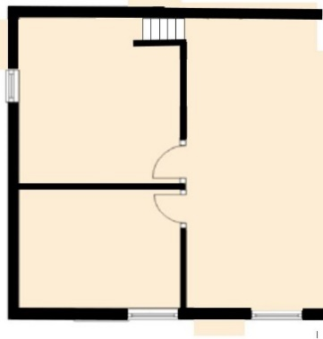
To the west of the front door is a wall that used to have two doors close together offset to the South of the passageway. Also within this wall would have once been an entrance to a solar staircase running West up against the North wall.

Possible Original Structure Wall built over East mullion, front door added.
Mullion windows in South wall West mullion window closed, replaced with new
Window to the east of blocked mullion
The two now unused doorways would have led to a small room to the South and a larger room to the North that would have been sandwiched between the solar stairs and the room to the South, this is evidenced by mortices in first floor, floor joists where the wall separating the two rooms was formally.
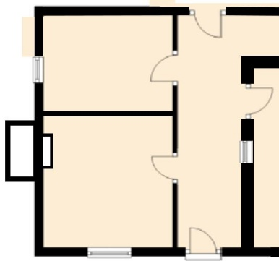
Partition wall moved north.
Old doorway closed.
New doorway added.
Chimney and fireplace added

The partition wall separating the two rooms, was later relocated further North, which is evidenced by lime markings on the floor joist. A new door opening was introduced between the original North room door and the entrance to the Solar stairs, this is evidenced by the lintel being nailed into position, between two pegged studs. Moving the wall, allowed the room to the South to be made larger.
It is likely that when the South room was enlarged, that the chimney on the outside of the West gable was added. This chimney is no longer in use and is very unstable. Both Edwin Rose and Stuart Armitage have stated that the chimney has little historic interest.
By interpreting the sales literature, 1987, when the properties went up for sale as two cottages the solar stairs were probably still in place, because the circular stairs that are now the only staircase in the property used to belonged to the East cottage. The chimney is mentioned as being present in the South room.
At some point after 1987 the solar stairs were removed, new floor joists and floor boards to the North room are evident where the stairs were once located.
There is currently no evidence that a fireplace ever existed, within the house, as a significant structural repair was made to the South and West wall of the house. Oak pegged studs run equally spaced across the West wall as they would have been prior to the chimney being installed.
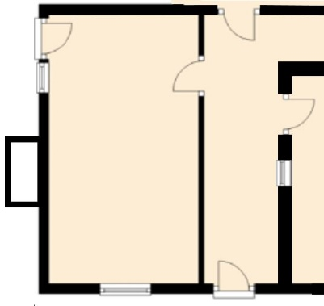
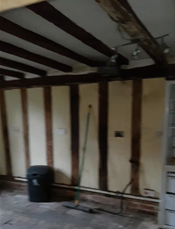
Oak studs and brick floor Partition wall removed
hide fireplace. Doorway to South closed.
Lime marking of old partion New door added to West
wall seen on Floor joist wall.

More recently around 2000 the partition wall was removed and the door to the South room sealed up making a single room. This recent change is evidenced by a redundant light switch being next to the door frame that operates a light to the south of the room.
The West room has most recently been used as a kitchen with a water supply, electric cooker point and extractor vent evident but no drain visible. An outside door has also been added to the North of the West wall and planning permission was gained for this change. The red brick floor within this room shows no evidence of the partition wall being moved, or that a hearth, or the solar stairs ever existed. It is therefore a late addition, possibly as late as the timber repair some 20+ years ago.
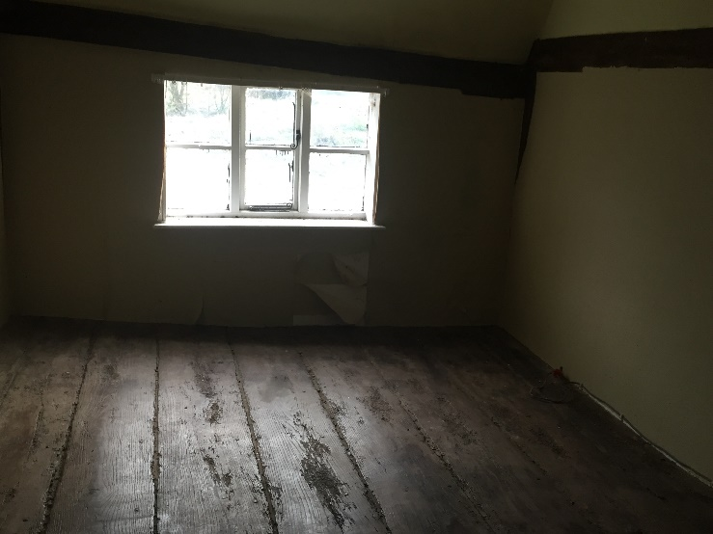
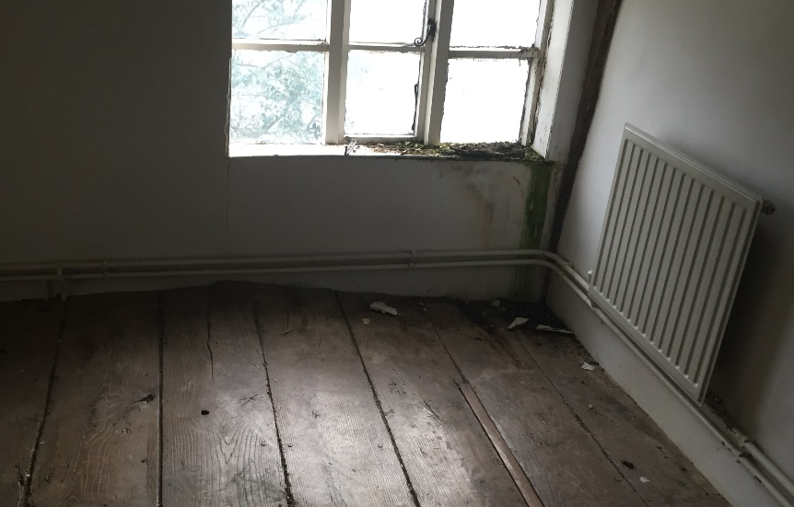
It is the first floor where the movement of the house is most evident due to late/non repair of the property with the floors in all rooms dipping towards the South and being more pronounced in the older western side with steep movement to the South West corners.

The tie beams are very low and have been cut into at some points to raise the passageway height. One tie beam has been removed completely to permit movement between the once separate East and West sections. Although according to the 1987 sales literature movement could be made at first floor level between the East and West sections.
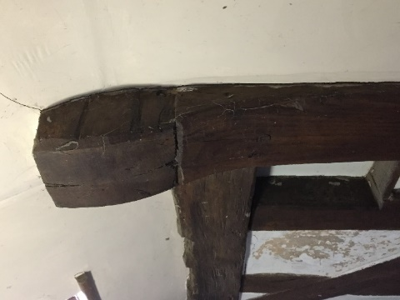
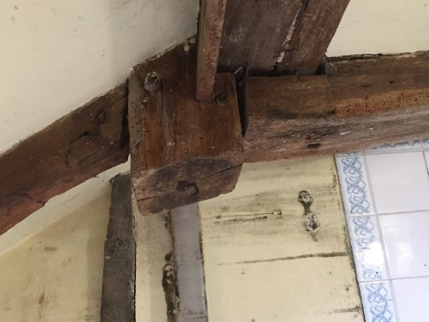

The attic to the west of the stack has three distinct bays. There is evidence that the 1st and 3rd of these bays were formally lime plastered out and had dormer windows, as evidenced by repairs seen to make good the once cut through and missing rafters, seen in red. Presumably this alteration occurred at a time when the property was rethatched. Bays 1 and 3 had walls separating them from bay 2 as evidenced by the mortices.
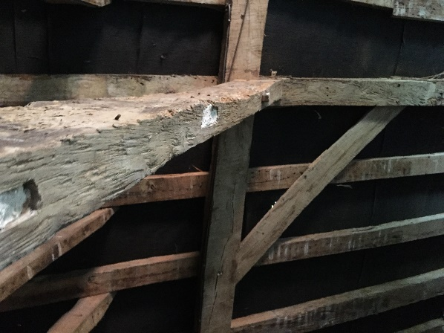
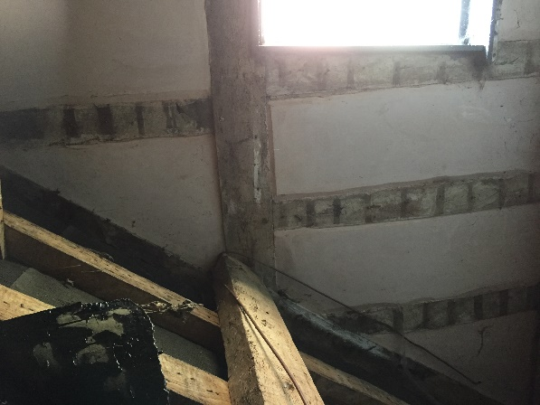

I have been told that before the thatch was removed from the front the rear was covered in corrugated iron. This is from a farmer, MR K Gapp of Mill Farm, Ram Lane, Tivetshall St Mary, who has ploughed the front garden of Mardle Hall many years ago. He said that the house became tiled before 1980 and prior to the listing.
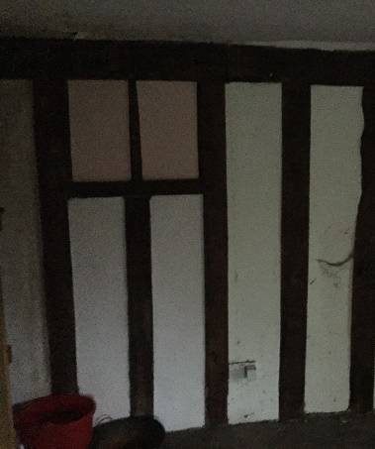
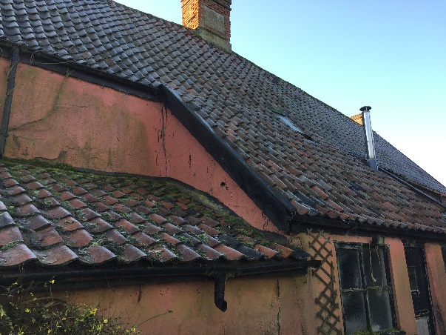
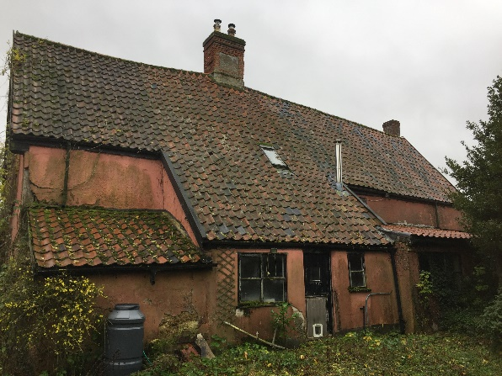
To the North of the house are three single story additions running across against the North wall.

The central section has been tied into the roof of the main house, but as this extended roof covers up first floor windows within the property this roof is clearly not original. This was possibly carried out when the thatch was replaced by pantile, although I have been told that the house was at one time thatched at the front and corrugated sheet to the rear, but I have seen no images to support this fact. To the East of the central building is a lean to shed with a low angled pantile roof. To the west is a modern, near flat roof extension that forms the main entrance to the property as the front door will not open. According to the 1987 sales literature the modern extension was not there and must have replaced a much smaller extension that served as the kitchen to the West cottage.

The East section
Over time the position of the window openings upstairs, in the East section have changed several times resulting in 6 sequential studs now being non load bearing, as they have been cut through.
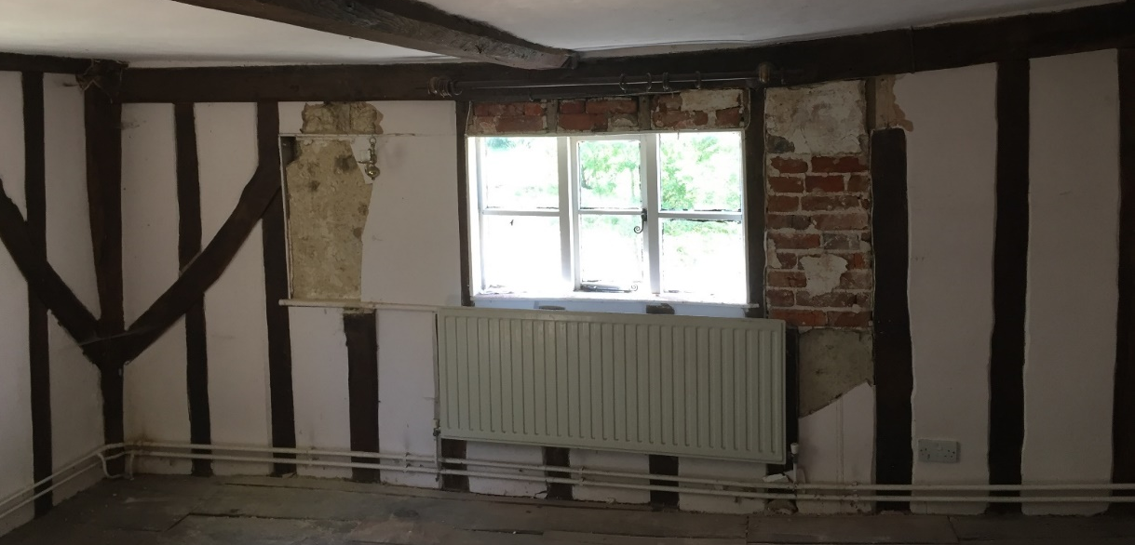

Downstairs reduced studs have resulted in considerable bending of the South wall’s mid rail.
At some point the stack was inserted, possibly into the cross passage as it is believed that the original front door was sited opposite the original rear/north door. Also at this time, or later, the East and the West sections were operated as two separate buildings, and it is likely that when the stack was built, or later, that the East section was rebuilt
At the moment a winding 180 degree staircase is housed to the north side of the stack and clearly resides in the West section, however the 1987 sales literature indicates at that time the staircase was used by the East cottage. A second winding 90 degree staircase goes on up to a proper attic room in the East section, that is finished as a bedroom with a window in the East gable. This leads to some confusion as to how the upper floors of the East section were accessed prior to the East section being granted access to this staircase. Evidence would point at there being solar staircase against the East wall of the East cottage. The floorboards have been replaced in a 27 inch section and two floor joists are new on the far south east corner.
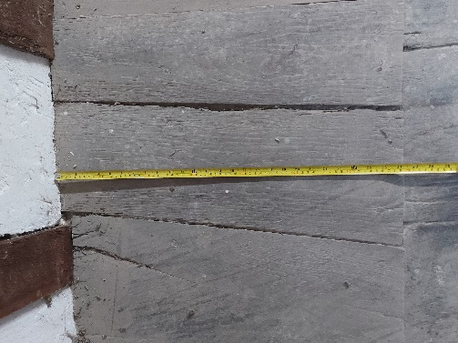
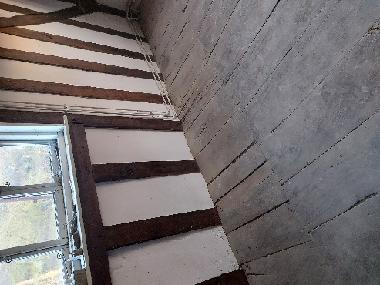
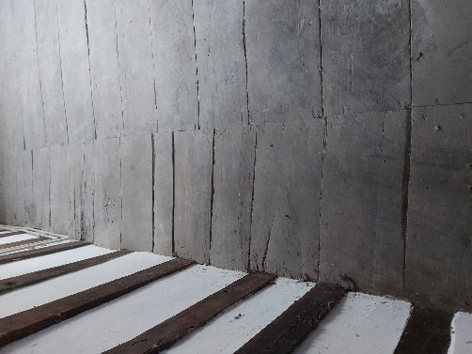

Is it possible that the East attic belonged to the West section? Or is it possible that there were three cottages, as there were three staircases and that there is evidence that it was common practice to have different properties accommodation residing above another property.
It is only in the last 40 years that the properties have moved back, or into, a single property. It was originally thought that at the time of this conversion that the tie beam belonging to the East section of the property was cut out to provide access into the property on the West, however looking at the sale details when the two cottages were sold at auction in 1987, the East cottage possessed a bedroom that resided over the West cottages living room and the attic belonged to the east side accessed of the circular staircase. The West cottage had the solar stairs in position as late as 1987.

