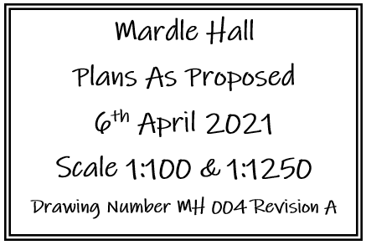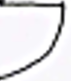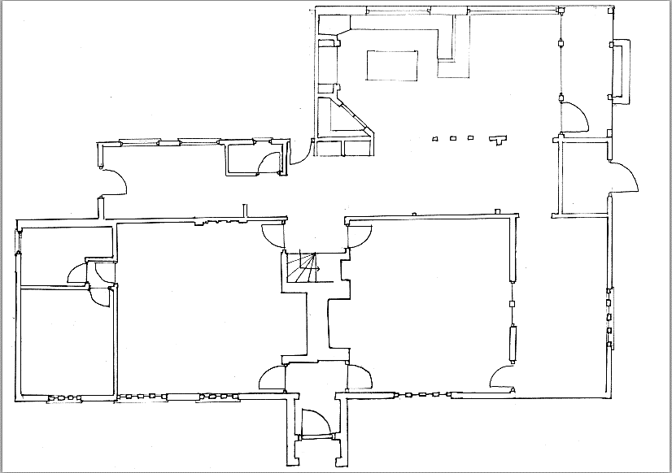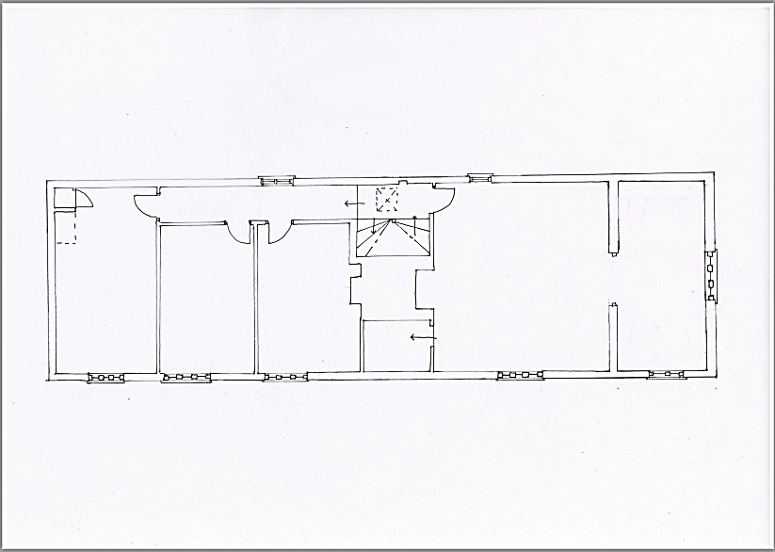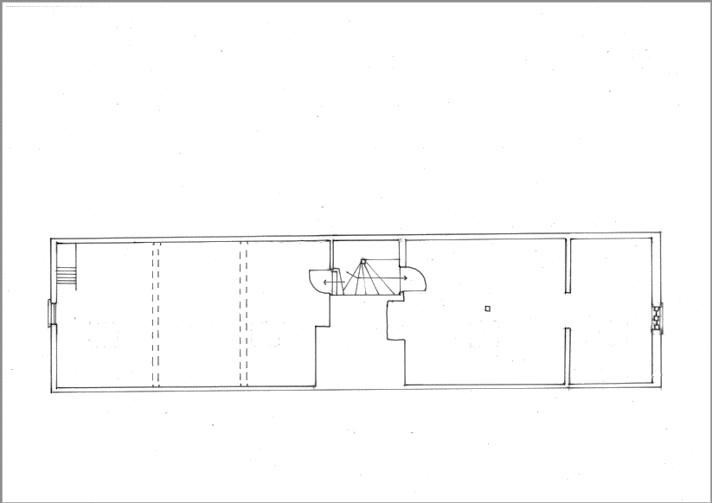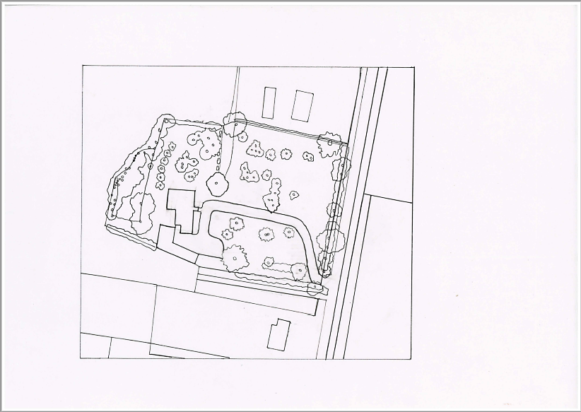

Existing window extended to make doorway

Existing window extended to make doorway

Some studs left exposed

Late addition walls removed

**Study**

New Wall in a position of an original partition.

new

**Dining Room Lounge Sun Room . (Bedroom)**

**Bathroom .**

New wall & door.

new

**Porch**

Roof lights

Roof light.

Toilet moved slightly North and West, with door opening moved from East to South. Doorway to stairs widened to improve access and lighting.

Side hung heritage escape windows.

Side hung heritage escape window.

Dormer window reinstated.

Dormer window reinstated.

Dormer window added.

Non original red brick wall removed.

Non original front and north passageway doors removed.

Doorway reintroduced to dining room. Opening to porch reinstated and widened.

Door reintroduced to dining room

Late addition wall removed allowing placement for shower.

Wall reintroduced.

Walk in wardrobe

**Toilet TV**

**. Room**

Reinstate window.

Dormer window added.

**Attic Bedroom Bathroom**

Late addition windows removed and relocated to maximise the reinstatement of studs where possible.

**Kitchen Breakfast Porch . Room**

**Boot Room Plant Room**

**Bedroom .Bedroom Bathroom Bedroom Bathroom**

**Ground Floor**

**First Floor**

**Attic**