Design and Access Statement - Planned Works

- 5321 TIVETSHALL ST MARY RECTORY ROAD (Long Road) Mardel Farm Cottages TM 18 NE 14/1240
II
- C17 timber-frame house, rendered. Thatched roof with gabled ends. Brick chimney stack off centre. Two storeys and attic (attic window in gable end). Four windows. Cl9, 3 and 4-light casements. Boarded door.
Listing NGR: TM1773585844
Works.
The property has been neglected for many years. Originally thatched the roof has undergone much work at one point it was thatched only on the front and was covered in corrugated sheet at the rear today it is pantiled and has been since before 1987. The roof space to the west occupies 3 bays and are currently all interconnected. Historically there would have been two, useable rooms at either end with the middle bay being separated from them, this is evidenced by mortices seen in the collar ties and nail holes and lime marks showing where the wattle strips would have been. The centre bay would have been open to the rafters.
Access to the West attic room is via a solar stairs running up the west gable at a steep angle parallel to the rafters. The East attic room, to the West of the stack, is accessed by a couple of steps coming away from the curved staircase that provides access to the attic to the East of the stack.
The house has under gone many centuries of change. Mainly the introduction of the stack which was possibly sited in a cross passage, the rebuilding, or the addition of, the section East of the stack which allowed a bedroom to be placed in the attic accessed off two new staircases.
The repositioning of windows together with the lack of repair to the sole plate and studs has caused movement of the house.
Most recently in the 1980s onwards, the house was converted from two cottages into one house. This included cement rendering of the whole house following some attempts to repair some structural elements and some rewiring.
Since removing small sections of cement render from the South West bay, it has become apparent that what looked like a solid repair turned out to be laminated oak planks onto heavily rotted studs. One pine window frame was found to be holding up a rotted oak stud rather than the other way around.

The House Condition Overview
Considerable repair is required to the oak frame including sole, wall plate and mid rail. The plinth is shallow only a few bricks deep and in the main appears in reasonable condition. In one area where there is evidence that the plinth has been rebuilt using new bricks and cement there is some apparent rolling. It is also thought that some movement and rolling of the plinth has occurred from ground moisture changes, as the house was originally thatched with rain running off the house uniformly across the length of the roof at a distance from the wall, to the position when it was newly tiled where no water run off would occur, to the position now, where gutters are damaged, drains are blocked and the water is pooling in localised spots close to the plinth. Rolling will also be due to the rotting out of the sole plate and subsequent movement of the studs which are angled between 1 and 5 degrees.
The Walls
Unfortunately a decision was made at some point to cover the house in concrete render. Concrete’s strength and impermeability to water at first appears an advantage but it’s inability to absorb the movements of the oak frame causes it to crack. Cracking in turn allow water to seep into the structure and to get trapped between the frame and the concrete leading to rot of the frame. Unfortunately the smooth concrete walls with occasional cracks appears smart but hides the structural imperfections. It is not until the concrete is removed that the structural imperfections can be fully appreciated. When my structural engineer came to inspect the property I had removed areas of render where I thought interesting discussion points may arise.
His comments on this limited view of the frame are as bellow
Previous structural alteration may have been poorly designed. Frame members often cut and windows inserted. Some sections of stud no longer fixed to any other structural members either top or bottom.

Recommendations

- Expose, wall elevation by elevation only, along with short returns to corners.
- Modern blockwork to be removed only as frame repair progress (as it adds to bracing).
- Outside face of studs is poor, with loss of section. Also much alteration/cutting of studs.
- Assess existing alterations as exposed and consider any necessary improvements.
- Use new timbers to secure structurally isolated original studs, and restore structural continuity top to bottom and side to side over openings.
Propose to expose original remaining members realign (where possible) to window mullions etc., but not overall, and apply 2” thick by 6” wide structural furrings. These will be treated softwood and C16 full height where they can be, and some will overlay frame studs others with be located strategically to structure, such as alongside window/door openings and be fixed to the wall plate, studs, first floor rail and sole pate wherever possible. Also horizontal lengths of the same or deeper over window heads.
- Check corner/main connections and consider hidden stainless steel ties/bracket as required. To be agreed.
- Use stainless steel fixings.

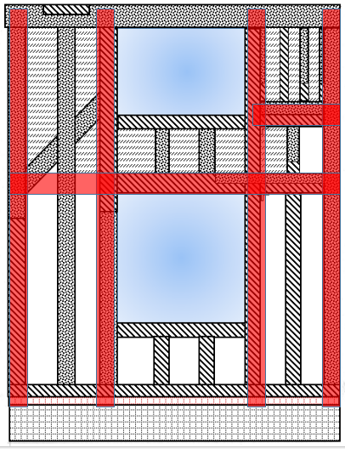
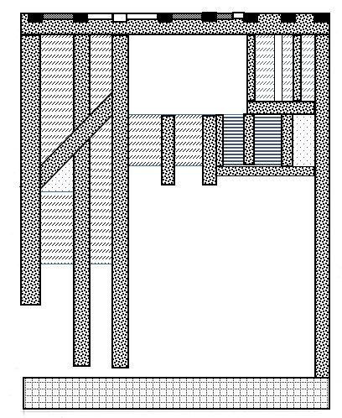
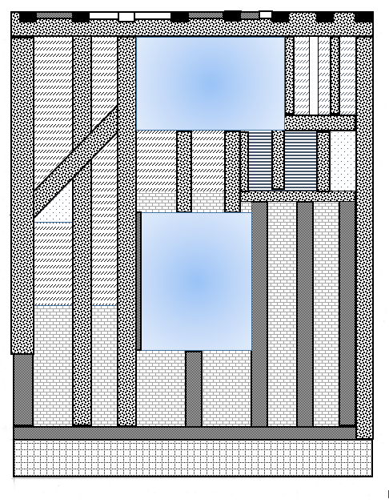
Stuart Armitage

Sole Plate
Surveyors comments

Sample opening up indicates that plates are extensively decayed, some appear to have been removed and others raised. Replacement in past has not been to a high standard.

Recommendations

- Expose and assess extent of replacement, repair or re-instatement section by section as found required. All to be dry oak, and level to be discussed. Noting; fair extent of stud and post base repair required, and also where plate level is seen internally. The extent of post/stud repair/extension will have a significant impact on costs.
- Sole plate may need to be 100% replacement.
- Temporary support needles will be required and a sequence of works adopted to work on one area at once.
- Additional props advised at first floor and attic level at collar ends. Carry down on same lines to ground floor. This will make sure that the roof is propped, as the bottom of the wall frames will be free once the plate if out.
- Do approx. 3.0-4.0m sections with lapped and bolted joints section size to match and must be dry oak. Work in with proposal (as below) to add 2” oak to front of plate to align with proposed structural furrings.

Plinth/Foundation
Surveyors comments

- Brick coated in hard cement render (some cracked & rolled) and painted. Generally poor to front elevation, some sections likely have been re-built/patched as sole plates have been removed.
- Obvious sign of rolling out and damage to front elevation in conjunction with sole plate decay.

Recommendations

Likely need to be rebuilt to front elevation and possibly elsewhere, subject to findings, with brick and lime mortar to match. Include slate dpc.
- Review ends and rear, rear may be better as protected now internally. Subject to further inspection.
Likely need to be renewed to front elevation and possibly elsewhere, subject to findings, with say 16” wide x 8” thick limecrete on existing consolidated wall line to finish 2 courses below ground level
- Trail holes recommended to identify condition and formation depth at various locations.

Walls Infill
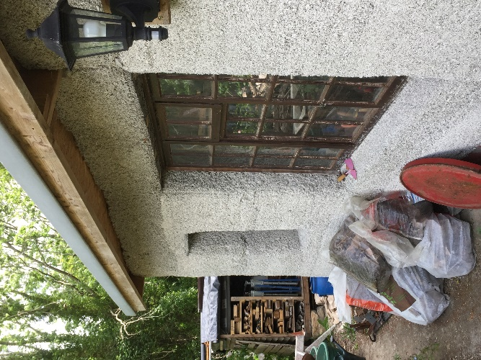
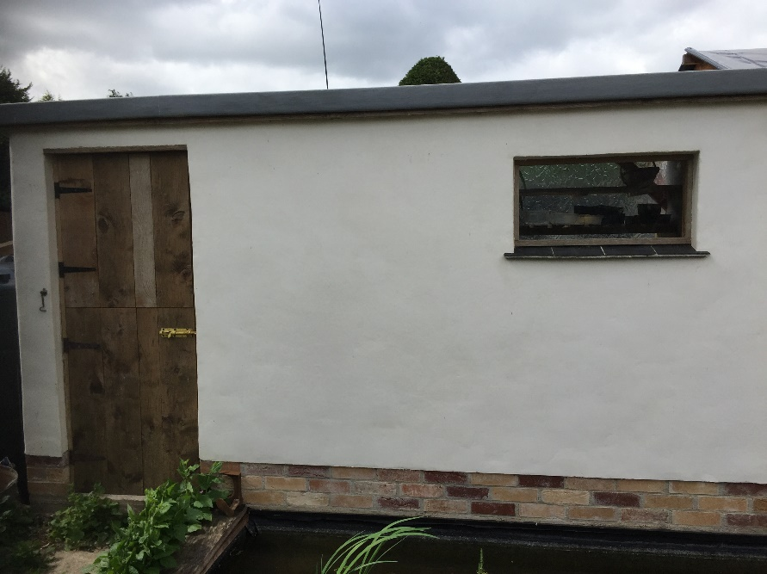
Concrete has not only been used outside but inside as well. The frame is infilled with a range of materials from wattle and daub, daub, red brick and breeze block. It is my intention to replace the majority of this material with hempcrete where it can be built to surround the restored stud work and the pine exoskeleton thereby consolidating the structural integrity and removing cold bridging and leaving a surface onto which lime render can be added inside and out. Hempcreate offers very good insulation properties. U value of hempcrete can easily reach the U values of new build standard of 0.28 W/M²K, and 300mm can get down to 0.21 W/M²K. and its overall performance is much better than many insulators due to its thermal mass that results in smoothing out temperature highs and lows. insulating render would further improve this performance, whereas wattle and daub properties offer a thermal performance of typically around 2.1 to 2.4 W/M²K . Hempcrete also has a low carbon footprint as it locks in CO₂ and only uses minimal binder to ensure structural rigidity.
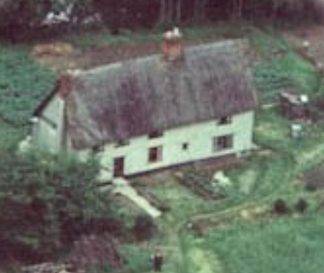
I will be working with a local hempcrete specialist, Graham Durrant. He specialises in hempcrete spraying for insulation, but the images above show structures he has built both rendered and non-rendered, the latter to demonstrate that hempcrete even when non-rendered is still able to withstand weathering over a long period of time.
An outer skin of lime render will be added with a white limewash finish as it appeared at one point.

The Roof
The current roof is made of pantile sitting on battens and a non-breathable membrane, it is in a poor condition. The pantiles, battens and felt all require replacement. There is no insulation.
The rafters are in surprisingly good condition. There is evidence that there were at least two eyebrow windows at the front to the west of the stack, the rafters have been repaired when these were removed.
The resultant widening of the walls, see wall section, will be complemented by a raising of the roof so the gutter heights/proportions are maintained. This will be achieved by removing the old tiles which are presently starting to slip due to loss of their lugs cracking off and edge erosion, together with battens and under felt. A warm roof design will be followed
Stainless steel plaster lath will be fixed to the top surface of all existing roof members to receive plaster and skim finish to the underside exposing all timbers internally. Fix minimum 38 x 19 mm treated counter battens on rafters. Fix 30mm Actis Triso Super 10 Plus insulation to entire roof fully in accordance with manufactures instructions. Ensure insulation is tight between all counter battens to maintain air spaces above and below insulation. Fix minimum 38 x 19mm treated counter battens over insulation. Fix Klober Permo Life breather roof membrane over, or similar, with minimum 38mm x 19mm treated tile battens and replace roof tiles. Adjustments will be made to gables eaves and sprockets. Re-new chimney flashings where required and replace capped gable barge boards.
This warm roof construction will not only achieve min 0.35 U value (actual U value 0.19), but will raise the roof so that it complements the increase in wall thickness thereby maintaining the gutter line.
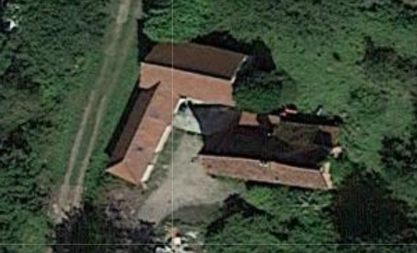
The current tiles will not be replaced due to their poor condition, and it was considered to replace them with the Sandtoft pantile that currently cover the outbuildings as they possess a superior locking system.
The outbuildings seen here to the West of the property are luckly set back otherwise they would dominate the property, this is one reason it is proposed to resite the drive so that the approach is away from the barn.
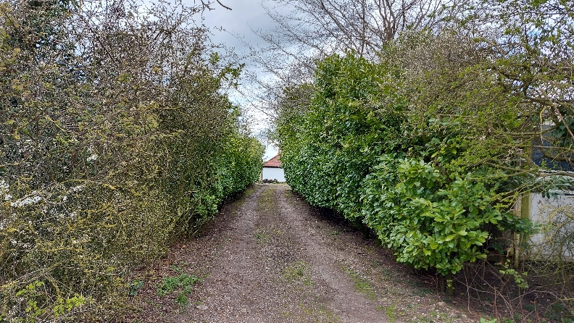

It is considered that using the same type and coloured tiles on the house as the barn would result in both the house and the outbuildings looking very similar except one is Grade II listed house and the other is a 30 year old out building.
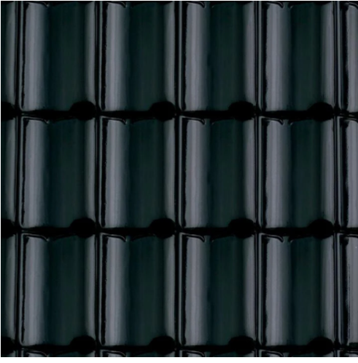
The proposal is therefore to replace the current pantiles with black glazed pantiles, so as to differentiate the listed property from the 20th century outbuildings it is proposed that Sandtoft Flemish 401 black glazed pantile be used, that are similar in design to other grade two properties in and immediately surrounding the village.

Mill Green Farmhouse, Ram Lane Tivetshall St Mary. 1301791 Black glazed pantile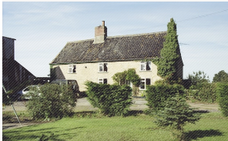
Glebe Farmhouse, Glebe Road, Hall Green, Gissing. 1304561 A mixture of black glazed and terracotta pantiles on the same roof together with terracotta tiles on the porch
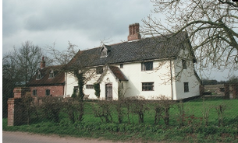

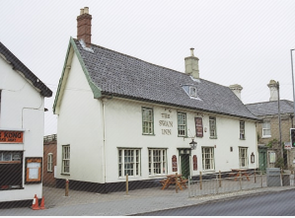
The Swan Inn, The Street, Long Stratton 1373290 Black glazed pantile

Elm Tree Farmhouse, School Road, Tivestshall St Margaret. 1050009 Black glazed pantile
Lodge Farmhouse, Ipswich Road 1373266 Black glazed pantile
Carters, The Street, Long Stratton1153797 Black glazed pantile
Chestnut view, The Street, Long Stratton 1153897 Black glazed pantile
I believe the black glazed pantile not only would help to differentiate the two buildings at the property but that if the house had been historically reroofedfrom thatch to pantile, rather than reroofed in the 80s, that it could have been black, if not black glazed pantile, as evidenced by the other properties which by looking at the pitch of their roofs were probably also at some point thatched.
A black glazed pantile has also been selected to differentiate the property from the many black tiled bungalows in the village.
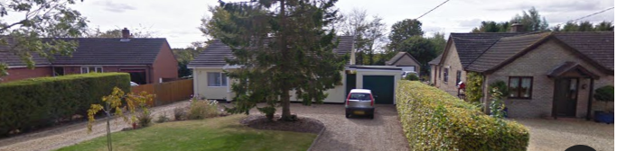

Reinstatement of attic windows
It is believed that the two rendered attic rooms, to the west of the stack had eyebrow windows installed at some point. This is evidenced by the repair to two adjacent rafters in both the 1st and 3rd bays of this attic and central to each of those bays. The size of the repaired holes is in keeping with window openings, which would point strongly to there being windows at some point historically.

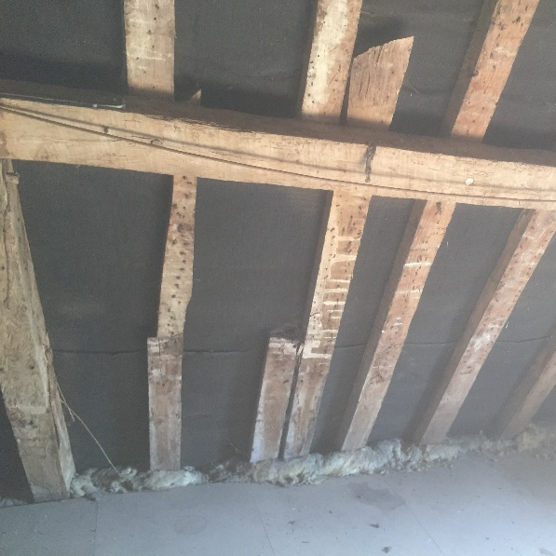
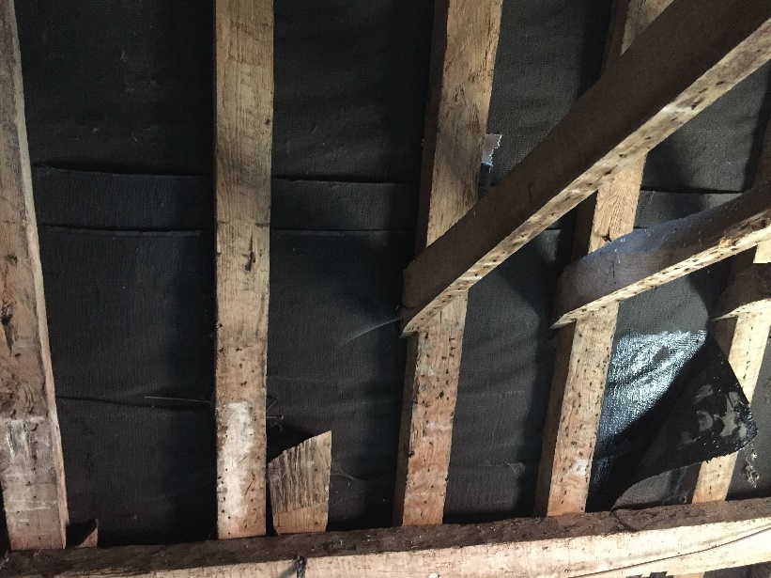
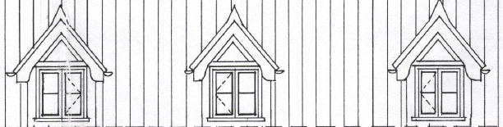
While the attic roof is under repair it would be an opportune time to reinstate the windows to the front of the house and to add roof lights to the rear.
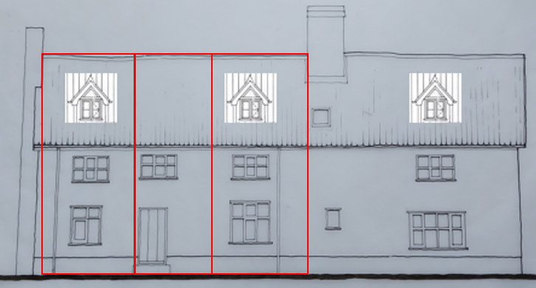
It is proposed that Dormer windows are inserted into the roof of a design similar to those inserted into Elm Tree Farm, Tivetshall St Margret, but that only in the 1st and 3rd bay. To make a balanced design an additional dormer will be added to the Attic room East of the central stack as well as to the proposed extension.

It is intended that roof lights be added to the rear of the property while the roof is off, these will be side opening conservation escape rooflights that will permit an emergency escape path down onto the single story extension directly below, thereby conforming with building regulations.

Chimney Adjoining West Gable
The Chimney stack adjoining the west gable is a late addition to the property and is of no historic interest. It is freestanding and is redundant as it has no openings into the house. Where a hearth would have once been, there are now pegged studs clearly in place.
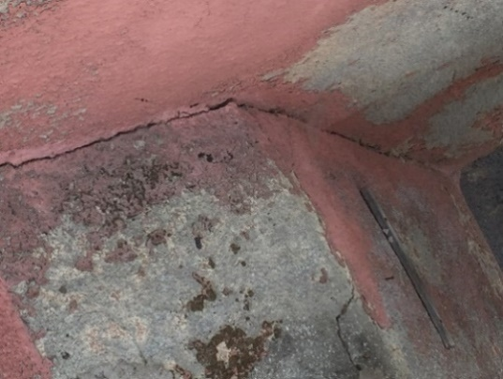
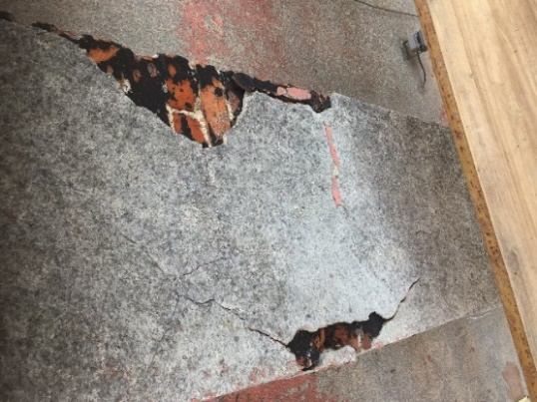
The Structural Engineer, who is experienced in Conservation, inspected the stack from ground level, and advises that it is in poor structural and fabric condition, especially due to blown bricks (some areas only being ½ brick thick originally), some separation from the gable, and jacking and cracks caused by built-in expanding rusting ironwork. Any repair would be extensive and seen as disproportionate given it is late addition and of no historical interest.
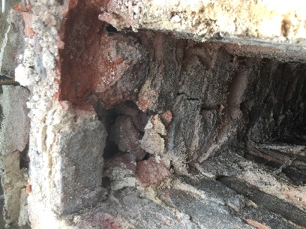

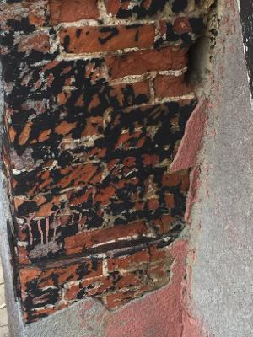
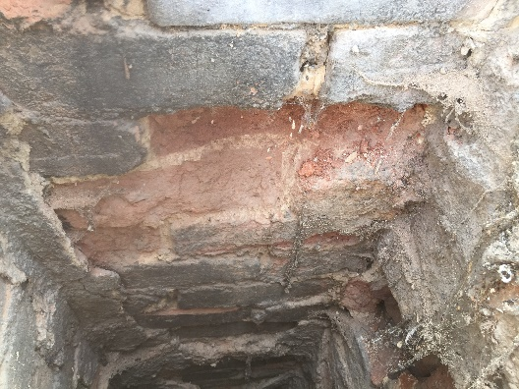
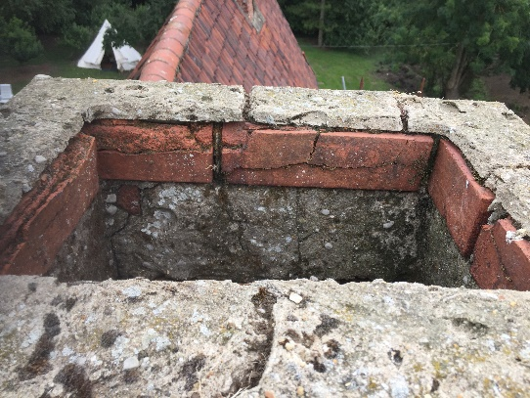
Removal of Concrete Floors
The current floors are all concrete slabs apart from in the far west room which has a red brick floor, which is suspected to be a recent addition, as no evidence of a hearth, the existence of different partition walls or the staircase are seen in its layout.
At present there is no working heating system. There is a broken LPG boiler and it is my intention to install a ground source heat pump as its replacement. Heat pumps due to their low temperature output, work well with underfloor heating.
The plan is to remove the floors and carefully excavate the ground beneath adhering to TY Mawr’s sublime insulated flooring system. Sublime is a LABC & LABSS registered breathable, insulated floor system that uses Glapour, a foam glass substrate that is vapour permeable, while not allowing water movement through capillary action to occur. This will be topped with an underfloor heating matrix and a limecrete slab. Ty Mawr suggests a methodology for installing the system in properties with shallow foundations and having spoken with the technical department I have discovered that I would be able to reduce the depth of the excavation to 220mm minus the thickness of the concrete floor thereby ensuring the stability and minimal disturbance to the structure and yet still produce a U value of 0,32 W/M²K. An excavation depth of 330mm minus the thickness of the concrete would deliver UK new build levels of insulation.

Front Door
The front door, is not original, nor is it in its original position. This is evidenced by the door being very low, there being no lintel and the frame simply being nailed into position and not jointed in any way.
The door presently sits in a bay where not one of the original four studs is load bearing due to rot, no sole plate being present or being cut to insert the door. The intention is to repair this bay, repairing the frame so that studs would run from sole plate to wall plate and that new lintels would be inserted and mullion windows repaired so as to be load bearing. The front door and frame would be removed and a window inserted that would sit beneath a window that currently exists above.
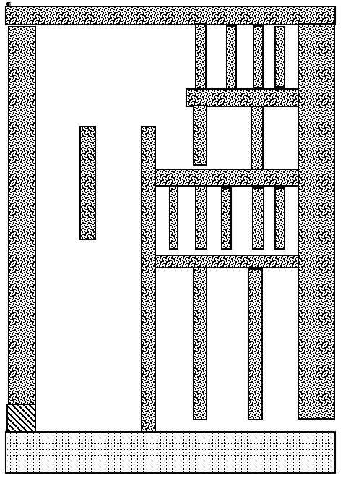
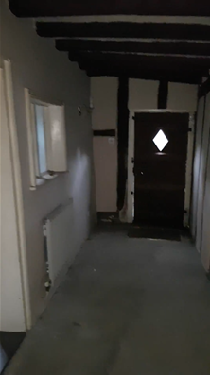
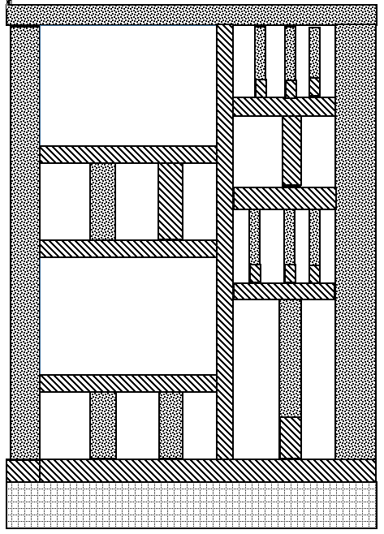
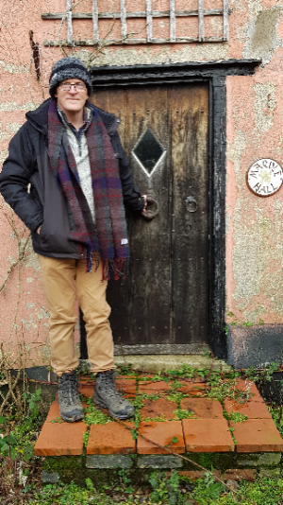

The third bay, that include the stack, is from exploratory holes appears the most complex, possibly due to numerous repairs. This section is being supported by the cement render as at this time no sole plate being present. Work on this bay, will be delayed until work on the south wall to the east side of the stack has been completed.
Reinserting the front door and addition of porch of a design similar to that that was added to Elm Tree Farm, Tivetshall St Margret, except it would be extended forward to allow shelter for those calling at the house.
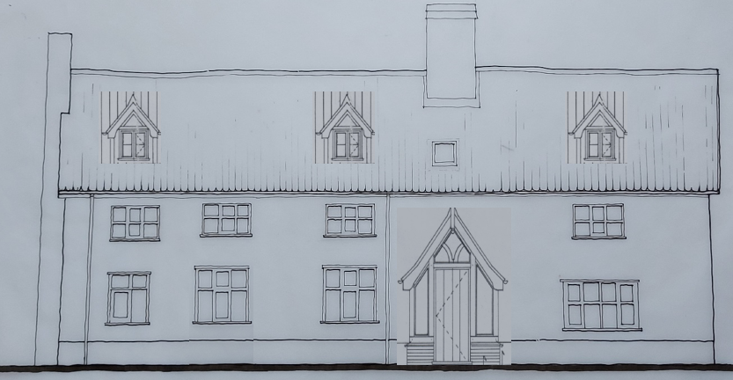
The Front door would be nailed panelled oak
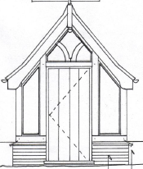

Floors and Timbers
Although the floors to the ground level are all concrete apart from a late addition brick, the first floor and the eastern attic have wide oak floorboards. As there has been considerable movement of the house with the floor dropping by as much as 30cm North to South, it is intended to retain the levels in most cases. Where floor rafters now fail to reach the wall plate due to movement of the front wall both dropping and away from the rear wall, bespoke metal reinforcement with ss fastening will be used to make good these internal structures as per the Society for the Protection of Ancient Buildings (SPAB).
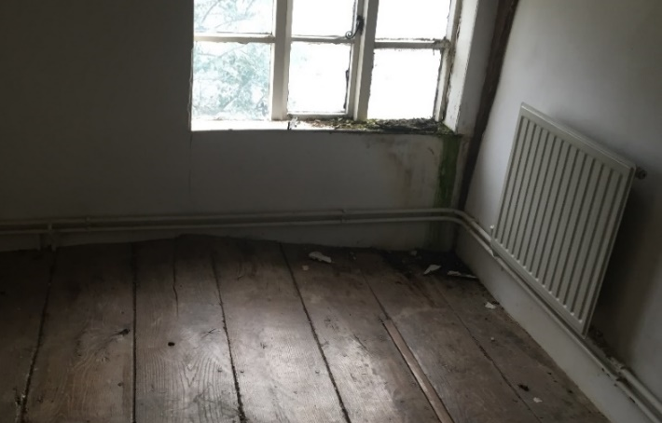
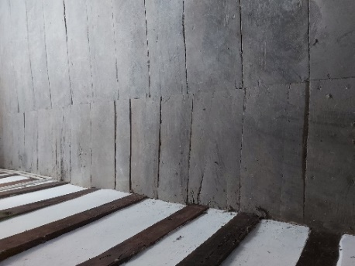

It is intended to use a heritage approved oak restoration company to surface clean the floorboards and other exposed timbers. Controlled blasting will restore the boards etc., to their former glory while retaining the alignment imperfections of the floorboards/timbers, which is a character feature of the property.
Carbon Footprint – Solar panels
One overriding decision before we took on this project was to reduce the energy consumption and carbon footprint of the restored house. A ground source heat pump is an extremely efficient form of heating only disadvantaged that it is run on electricity, which is currently more expensive than other forms of energy, Oil and LPG. With this in mind I am considering the installation of solar panels on the outbuildings. I would therefore like to install solar PV panels on the out buildings.
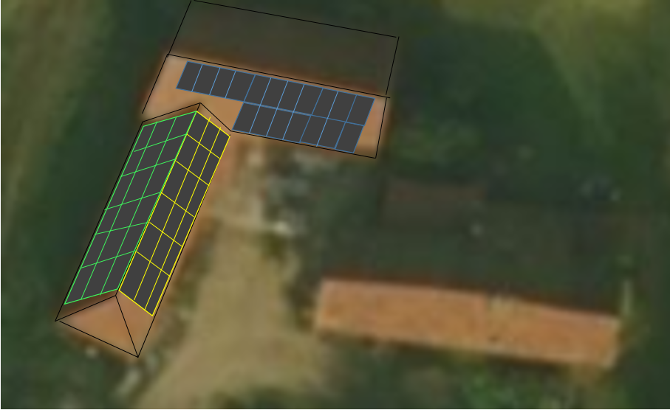
The outbuildings have three possible areas on which to site the panels. Blue, Yellow and Green. Calculations have shown that the blue/south facing barn although close to the house will not result in a great reduction in available energy despite its close proximity to the house. It is possible to see that no shadow is falling on the barn.

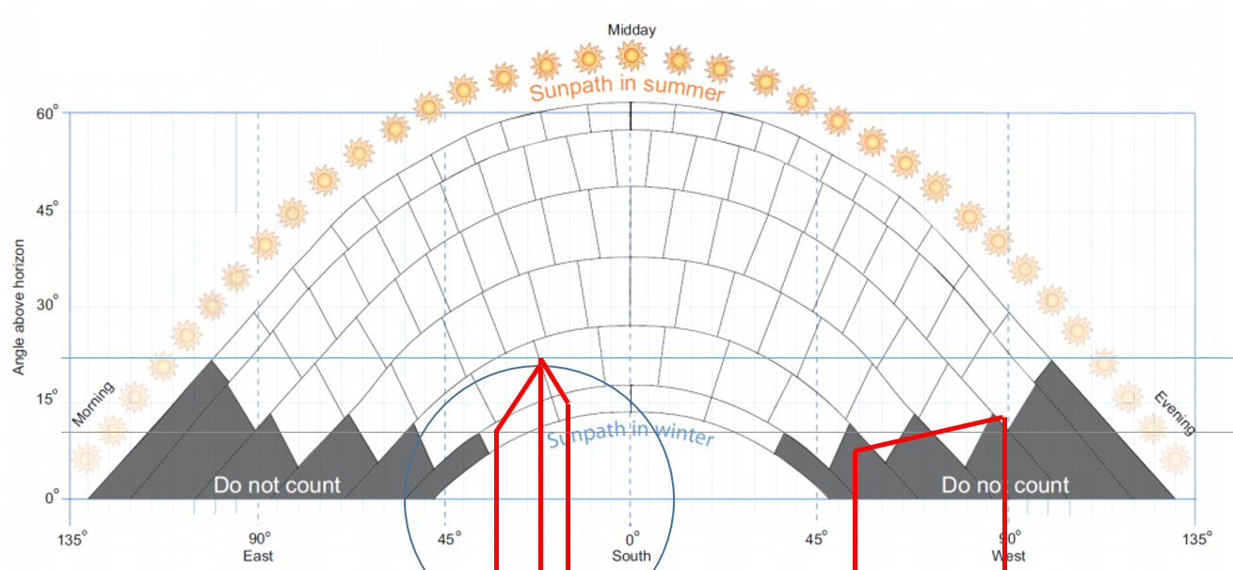
As of today calculations have demonstrated that it is not possible to become energy neutral by the installation of a large solar array with battery backup without paying the equivalent of the power consumed over a ten year period upfront.
South Roof’s Sun Shading Calculation

The sun’s radiated energy drops from a peak intensity in the summer to only 17% of that in the winter and only available during the shortened day. As the solar energy would be used to provide energy to the heat pump it would require a large array to support winter heating minimum 3KW and to run it at night it would require a large battery backup. Very little is published regarding this and the talked about selling of excess energy back to the grid is not a reason to buy panels, although it provides some payback, but does not cover the cost of the installation. It would appear that the time is not right to be totally off the grid, as the pay back is approaching the life expectancy of the components.
So regarding the proposal the current thinking is that a solar array is required to support the heating of the property at some point, helping predominantly in the autumn and spring and marginally in the winter, but would be able to run other household appliances such as washing etc. all year round, along with some battery backup to permit lighting in the evening, but this is to be decided from running a small system, for a year or two to gather data.
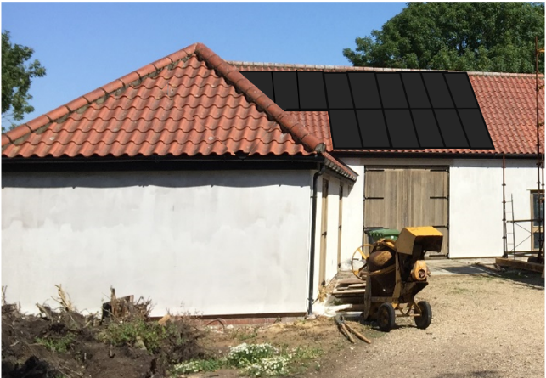
The application is therefore requesting an installation of 20 south facing panels. The rendered photograph demonstrates an installation of 16 panels on the south facing aspect. The panels at the top right gain no shadow so are optimised. The shadow calculation shown above is worked from the centre of the array. The more the centre of the array is moved to the east the lower its performance.
As the cells are mounted on a roof that sits behind the house, the house itself obstructs the view of the array. The new drive now approaches the house square on as seen in the diagram below.
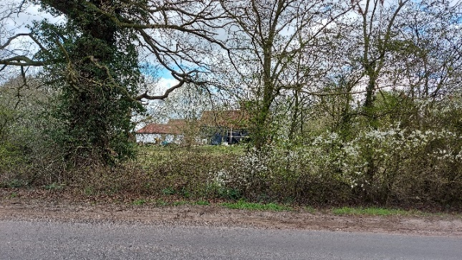
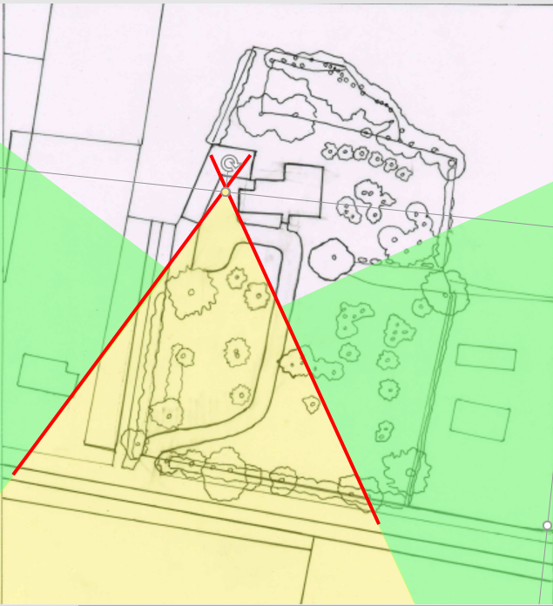

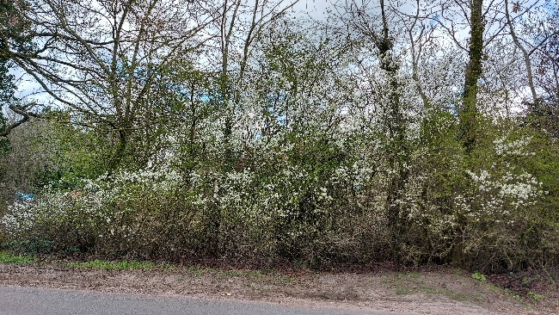

The green region shows where it is impossible to see the solar panels from the road or within the grounds of the house. The yellow region is where some sighting of the south roof may be possible, subject to hedge thickness and leaf coverage. The two other images show the most visible view of the south roof prior to leaves coming out and a typical hedge-line view. From the road, during the summer months the cells will not be seen, in the winter once the hedge has grown back this will also be the case.
Should approval be given for all 20 cells then it is anticipated that a smaller array would be initially installed 6-8 cells without battery backup, to gain information on the optimum size which may well reach the maximum applied for in this application which is 20 cells. It is possible that one day s as the cost for cells, batteries drop and the cost of electricity rises that an new application would be made with data to demonstrate a case for installing additional cells on the East and/or West facing roof sections.
Driveway
It is intended to change the direction of the drive on the property whilst maintaining the existing entrance from the road.
The current drive approaches the barns directly rather than the house which has resulted in two people coming up the drive to what they thought was the house called the White Bungalow, Rectory Road, which is a further 250m down the road.
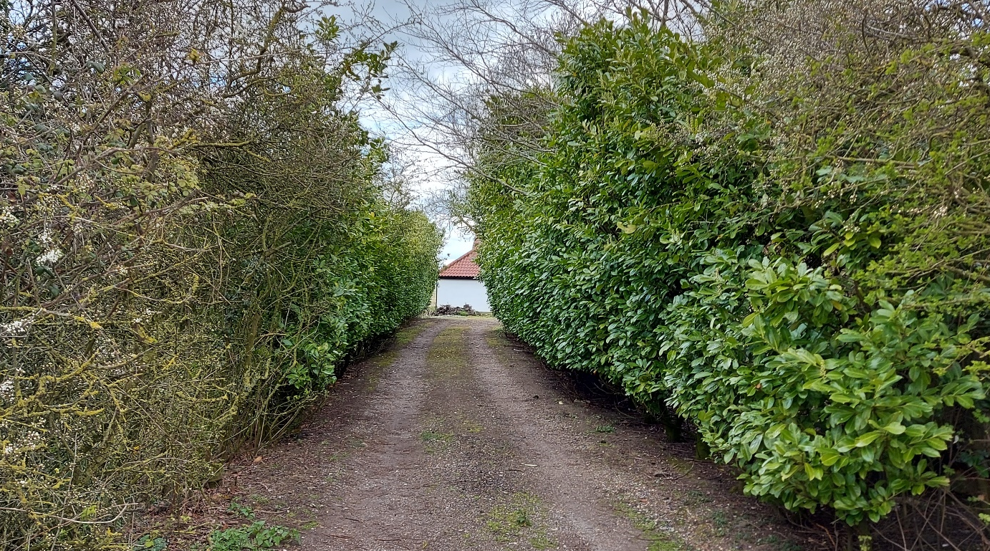
The new drive will sweep right/East and then return to heading north approaching the house in line with the new front door.
According to the old plans/deeds the original drive did start at the same place as it does now but came up further to the east. The new plan is to move it even further east and approach the house where the front door has been relocated.
The new drive will be dug into the lawn and will sit over the new underground heating matrix.
It will comprise of layers of Terram geotextile, mixed compacted hard-core and gravel < 20mm.

Ground Source Heating Matrix
The ground source heating matrix will be laid prior to the drive installation The pipework ill be laid according to manufactures specifications within the yellow region below. The drive will after compaction be laid over some of the array.
