27 Upper Gordon Road  Camberley  Surrey  GU15 2HJ | Chris Orkney  HISTORIC BRICK MASON  Shepperton  cjo.hbm@gmail.com
The property situated at the address above is late Victorian. It is not listed but sits within a conservation area.

Conservation of Brickwork:
A sympathetic approach will be taken regarding the conservation of the Brickwork.

The paint marks on the images (made by client) are to highlight the bricks that are spalling or cracked.

These are to be replaced with new handmade bricks of similar size & colour (samples acquired).

A period of trialling mortars for the pointing colour and finish will be set aside.

The lowest section of brickwork to plinth height will only pointed where there is a void, due to the very hard and poor finish of cement pointing, this will be to avoid any un-necessary damage.

Small areas of patch pointing will be addressed where needed.

Ongoing assessment through the works duration as each area is addressed, will be to determine the condition of pointing and brickwork. Replacements and pointing will only be carried out if deemed necessary.

The proposed works should be viewed as the beginning of good practice after a series of poor attempts of maintenance using cementitious mortars.

This approach will be continued to all elevations to the full height once the tubular access scaffold is provided by the client.

27 Upper Gordon Road  Camberley  Surrey  GU15 2HJ | Chris Orkney  HISTORIC BRICK MASON  Shepperton  cjo.hbm@gmail.com
~ Page 1 ~

An estimated number of brick replacements is 120 up to a height of 1.5 metres from ground level on all elevations.

As most of the brick replacements are singular or small batches, the segments of re-pointing will be patch repair.

Due to the variation in the colours of cement mortar the suggestion is to match in the new replacements and pointing to the immediate surrounding area.
This is to avoid another colour and joint finish to the overall appearance.
The lime mortar is to be sacrificial in the event that a more extensive approach to the brickworks conservation, happens at a later date.

There are three joint finishes on view:
Half Round and Struck & Cut which are in sand/cement mortars of varying shades &
Flush finish in lime sand/ mortar.

A flush joint in red sand /lime mortar, which evidence suggests was the stopper mortar for a black convex tuck pointing.
The new pointing in these areas will be in a similar colour and left flush but very slightly recessed.

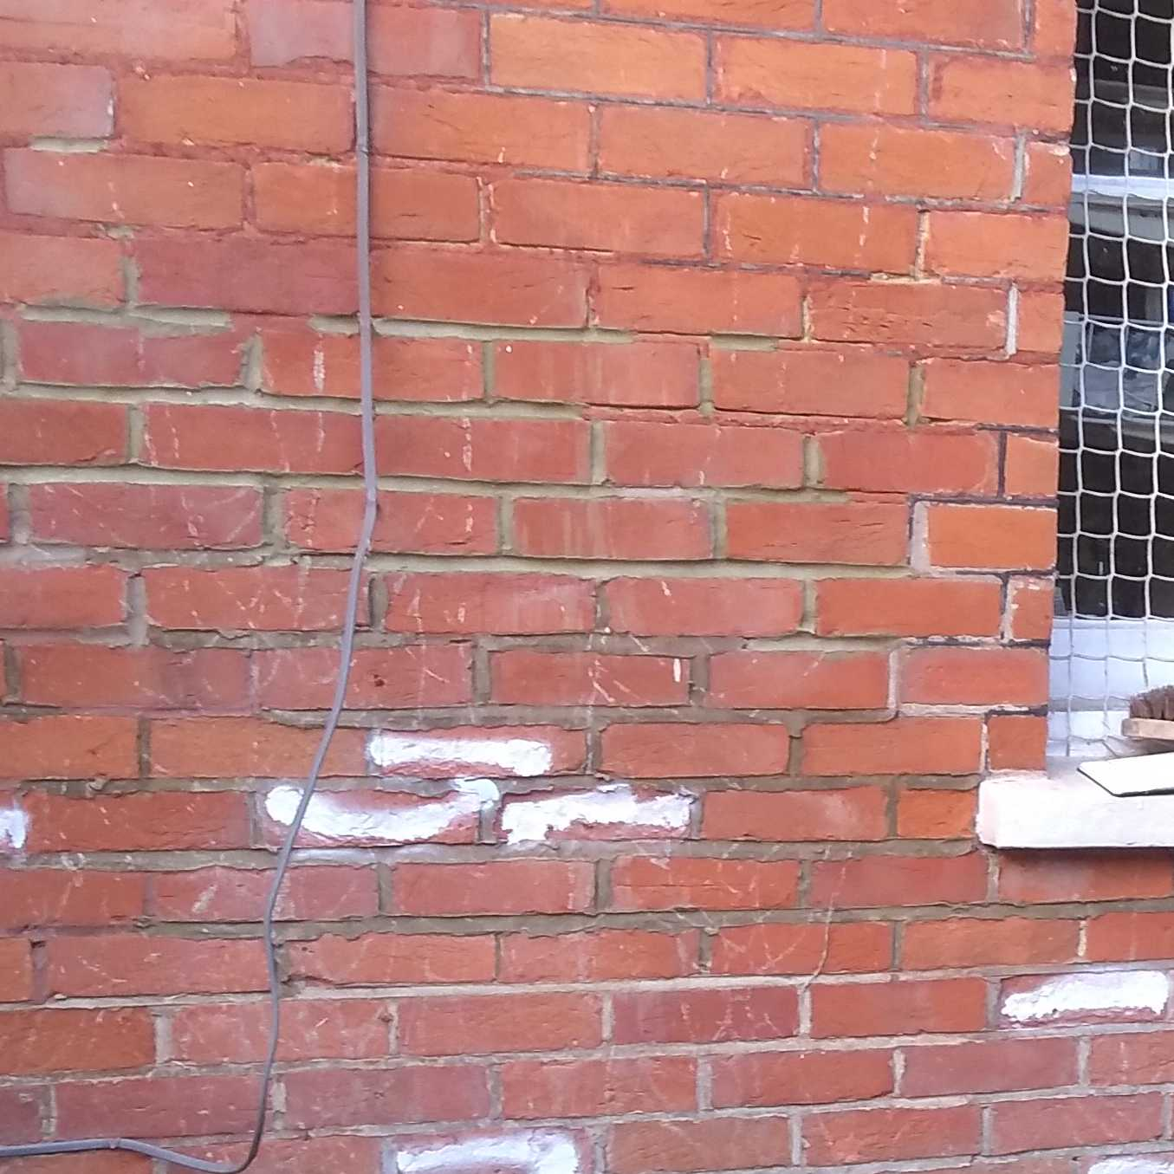

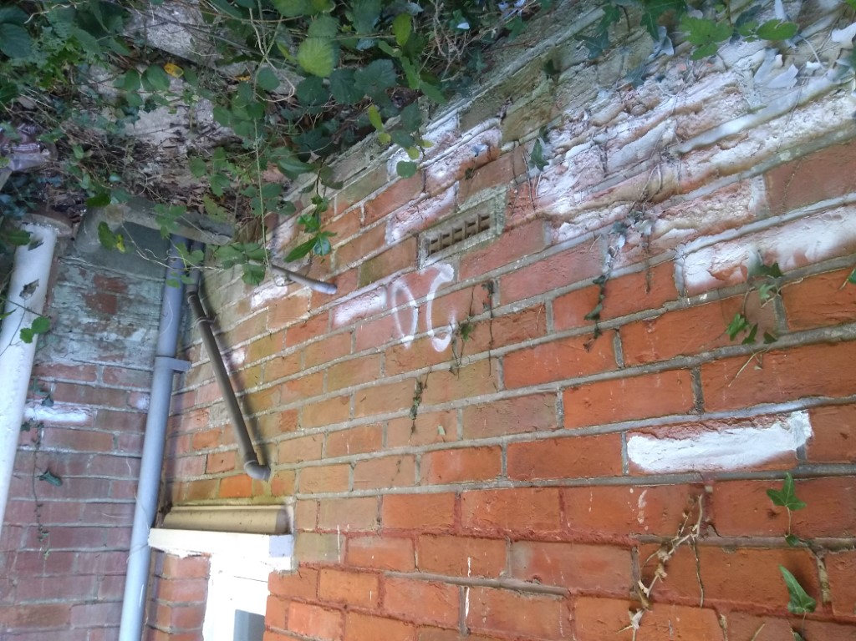

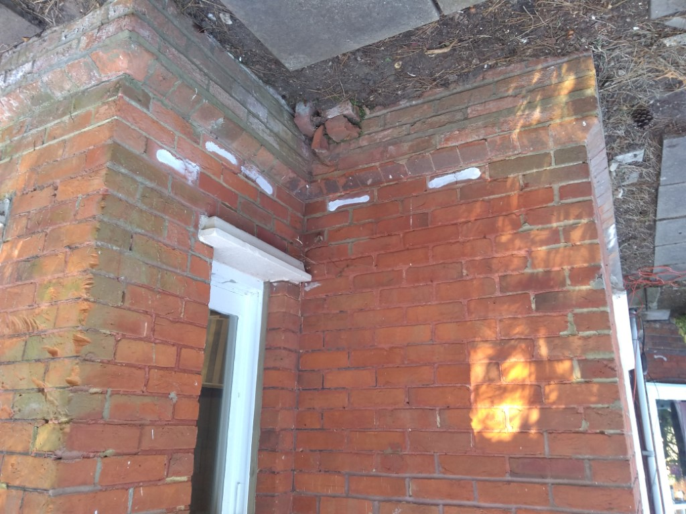

27 Upper Gordon Road  Camberley  Surrey  GU15 2HJ | Chris Orkney  HISTORIC BRICK MASON  Shepperton  cjo.hbm@gmail.com
~ Page 2 ~

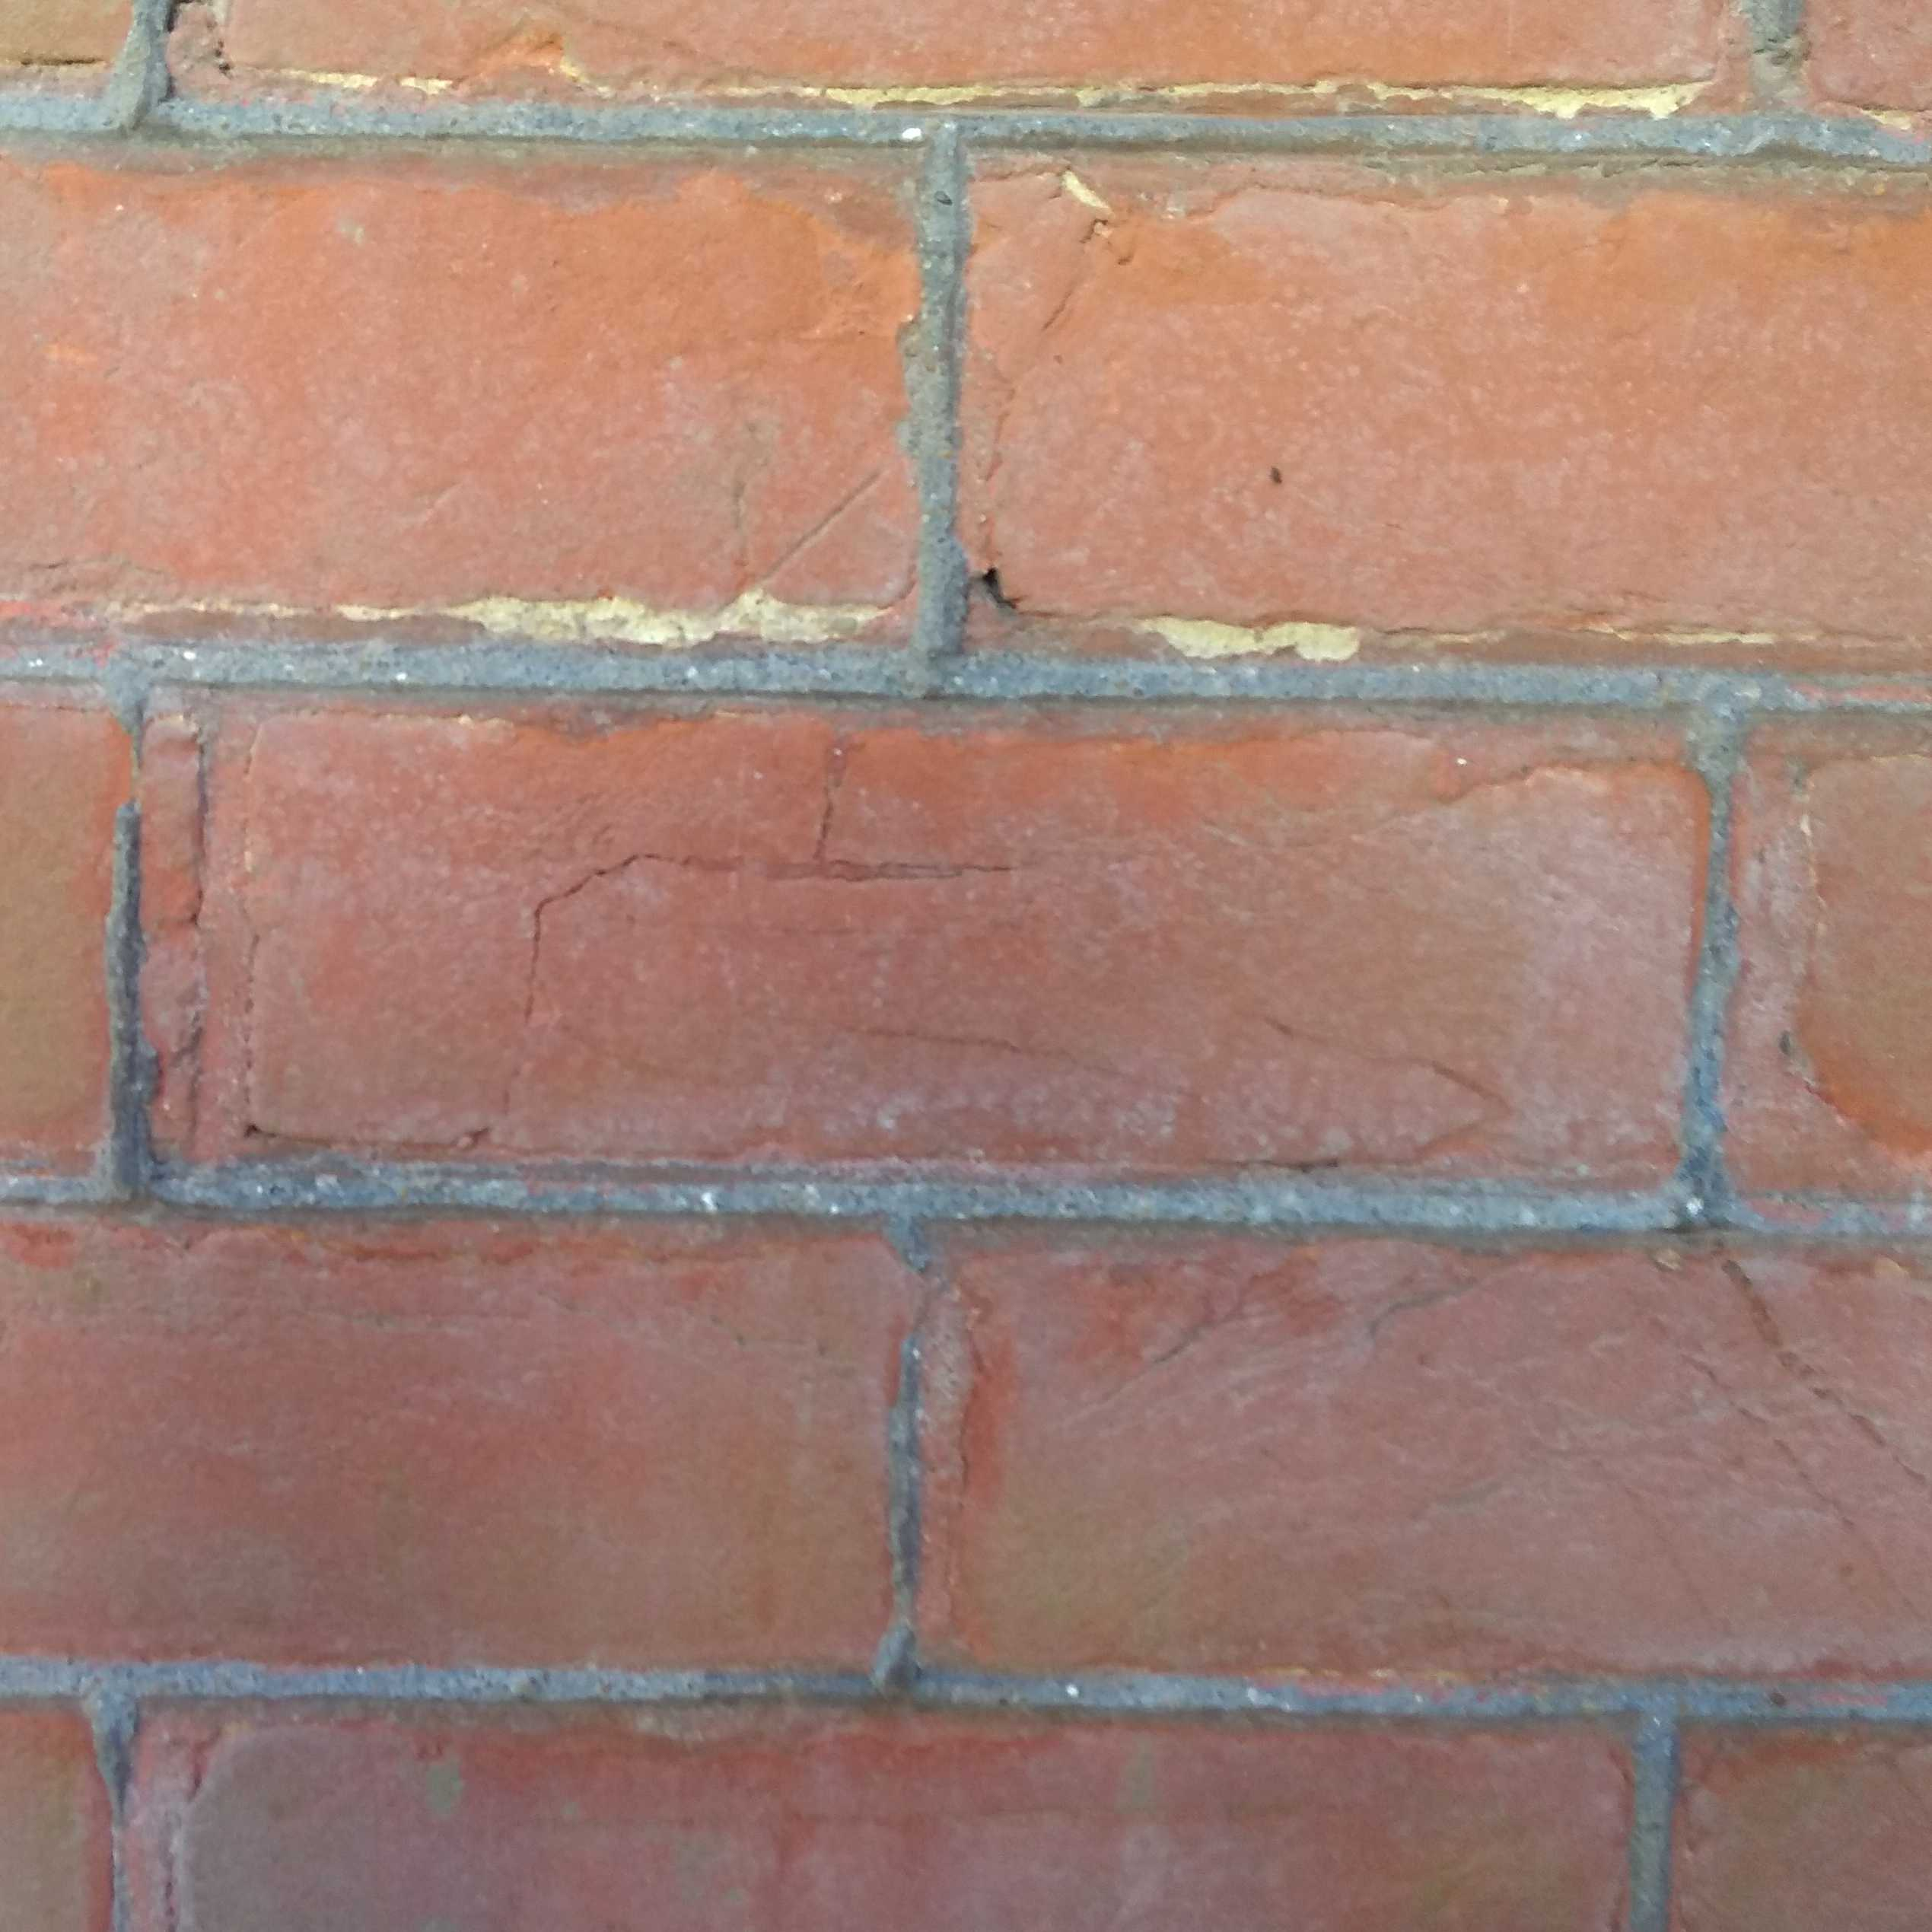
An area of the tuck pointing still in good condition.

Three plinth bricks that may be salvaged and re-worked if possible or replaced by a new mild clay red rubber moulding.

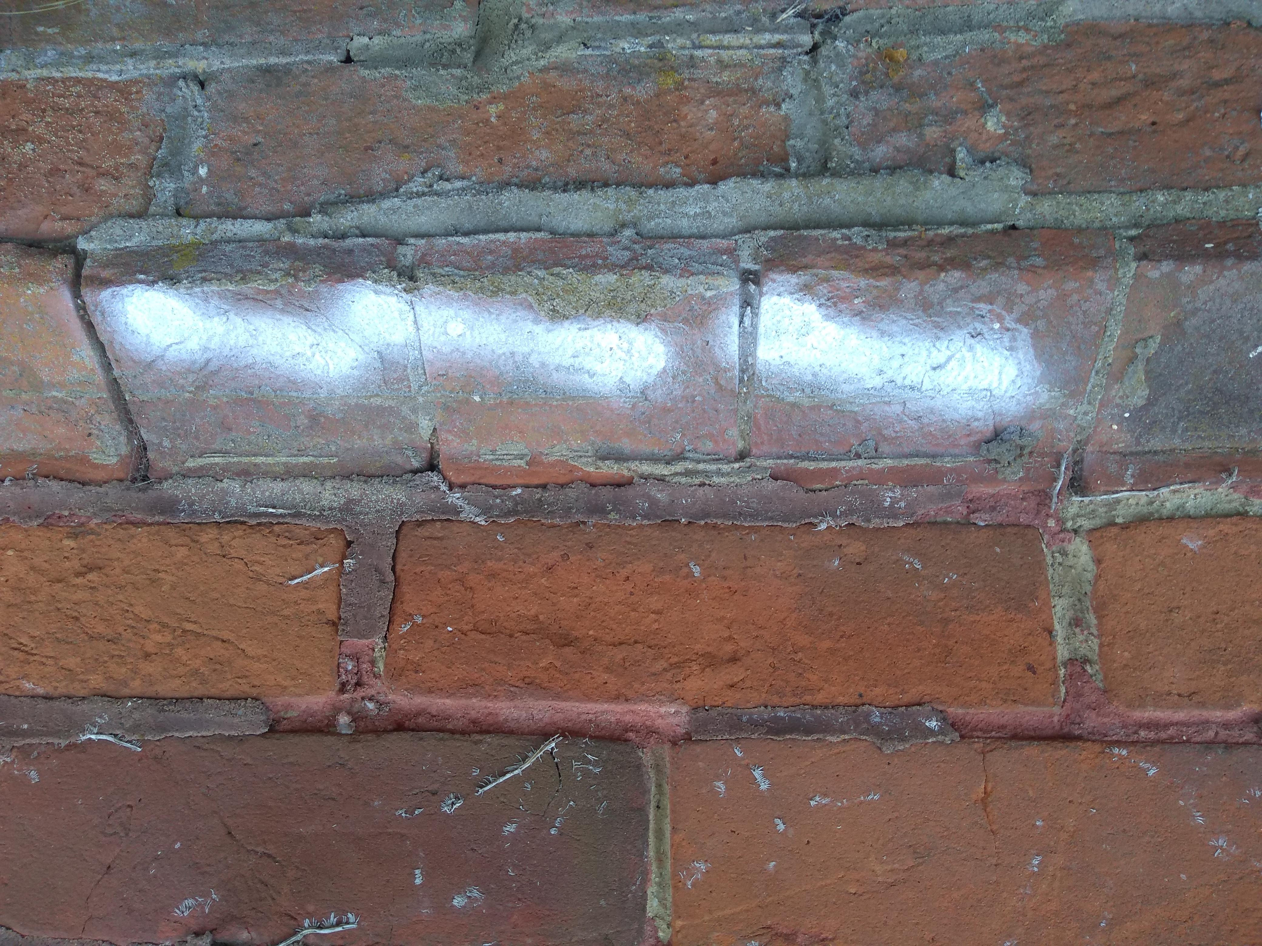

27 Upper Gordon Road  Camberley  Surrey  GU15 2HJ | Chris Orkney  HISTORIC BRICK MASON  Shepperton  cjo.hbm@gmail.com
~ Page 3 ~

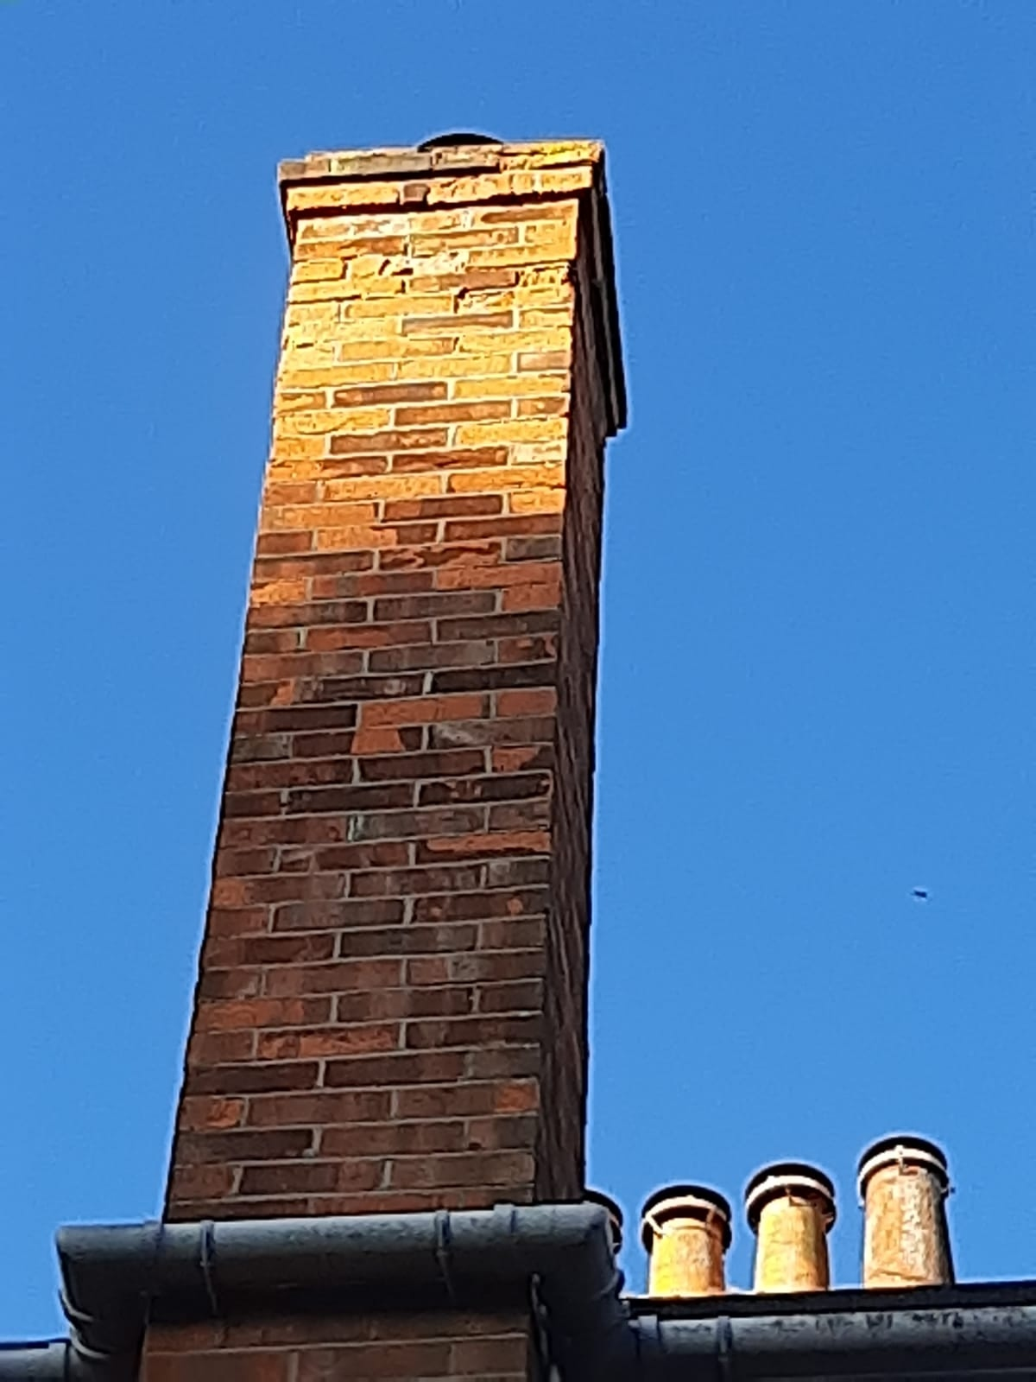

The boiler flue is not part of the original buildings structure.

After surveying from ground level, it appears the top third of the chimney is severely perished.

As the chimney is no longer in use, the proposal is to take it down to a level just above the roof line, and cap it off with a lime mortar flaunching.

