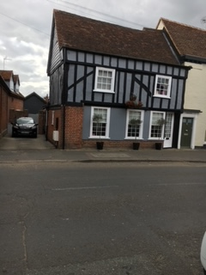

**Design & Access Statement**

**Incorporating the Heritage Statement**

Le Soken House

High Street

Thorpe Le Soken, CO16 0EA

This Design and Access Statement is submitted to support an application for listed building consent for internal works to Le Soken House. It also constitutes the Heritage Statement for the purposes of the same application.

The property is Grade II listed (UID: 1322621 designated 30/01/1987) and set within the Thorpe Le Soken Conservation Area.

A copy of the listing description is provided as Appendix 1. Extracts of the listing description are also used to inform the description provided below.

In accordance with paragraph 189 of the National Policy Planning Framework (2019), this statement seeks to describe the significance of any heritage assets affected, including any contribution made by their setting, and provide an assessment of the impact of the proposed works on the heritage asset.

Paragraph 189 also notes that the level of detail provided to support an application “*should be proportionate to the assets’ importance and no more than is sufficient to understand the potential impact of the proposal on their significance*”. This statement has been undertaken with the consideration of the level and extent of the proposed works, and is not to be considered as a full historical report or conservation plan.

**Description**

The building is located in the village of Thorpe Le Soken, a civil parish with the Tendring District of Essex.

Wrongly shown on OS map as part of Homeleigh House, the property was converted from a shop into a house in cira 2016. The property dates back to the 16th century and was altered and modernised during the 18th, 19th and 20th centuries.

As shown in the Figure 1 below, the property is a 2 storey, timber framed building, plastered with some exposed framing and some weatherboarding, and roofed with handmade red clay tiles. There are 2-bay range facing North East and a 18th century parallel range to rear.

During some point in the 19th century, a single-storey brick extension was added to the rear of the property, with one internal stack.

On the ground floor, there is a central glazed door, below a jetty supported on the three 20th century brick piers. There is an original plain bracket at right end, the post below it is hacked, but probably having had an attached shaft originally.

On the first floor, there are two sashes from the early 19th century. Exposed timber framing with 'Suffolk' braces are trenched outside the studding, partly restored, and there is an 18th century timber framed parapet, with frame exposed.

On the left return, the ground floor is clad with red brick in Flemish bond. The first floor has exposed framing, and the gable is weather boarded with jowled posts. The first floor has been rebuilt, with chamfered axial beam and plain joists of vertical section. There is a clasped purlin roof. The property was formerly part of Homeleigh, immediately to the North West.

**Setting of heritage asset:**

Le Soken House is set within the Thorpe Le Soken Conservation Area. The adjoining building, Homeleigh, is also listed, along with several properties in the close vicinity.

The character of the area retains much of the appearance as when the area was up-dated in the 18th and 19th century, however, the High Street has been developed over time and is very busy during the day, and additional signage has been erected.

**Significance**

The significance of the property can be considered to be the age of the original aspects of the building which date back to the 16th century. The building reflects the wealth of the village through key developments in time, including its original construction, gentrification, and the formation of the rear extensions.

**Condition of the asset**

Overall the building is in good condition and has been well maintained, although there are some internal areas which could be considered as out dated and a general refresh is required in places.

**Proposed Scheme**

It is proposed to:

* Remove the modern plasterboard ceiling in the first-floor bedroom, in order to expose the vaulted beams and provide improved head-height in the main bedroom.
* Retain all original beams as part of the works.
* To plaster and isulate in-between the beams.
* Part of the work will require the bedroom walls to be made good where they met the ceiling and to repair a small section of the interior wall which was damaged due to a previous water leak from the roof.

There will be no impact on the external appearance of the building as all proposed work will be undertaken inside the property.

**Impact Assessment**

**External**

There will be no impact on the external appearance of the building as all proposed work will be undertaken inside the property.

**Internal**

The works to remove the internal ceiling and make good the internal walls is deemed to have positive impact of the character of the house as it will remove an unsympathetic, modern plasterboard ceiling (see photos in Appendix 2). The removal of this ceiling will allow the building to be read as originally constructed and provide a more comfortable head height for residents.

The external appearance of the building will not be affected.

**Impact on Listed Building**

It is deemed that the proposed works do not cause harm to the significance of Le Soken House as the proposed works do not affect the original structure, alter the original floor plan or cause the loss of any historic fabric.

Impact on Conservation Area The proposed works to the interior of the premises cannot be seen from any public areas; therefore, it is considered that the proposals will not have any impact on the conservation area.

**Access**

The proposals do not involve any works which would give rise to any access considerations.

**Appendix 1**

**Listing Description**

[**https://historicengland.org.uk/listing/the-list/list-entry/1322621**](https://historicengland.org.uk/listing/the-list/list-entry/1322621)

Location

Statutory Address:

LE SOKEN ANTIQUES, HIGH STREET

The building or site itself may lie within the boundary of more than one authority.

County:

Essex

District:

Tendring (District Authority)

Parish:

Thorpe-le-Soken

National Grid Reference:

TM1778722425

Details

THORPE-LE-SOKEN TM 1622-1722 8/88  
  
HIGH STREET (south-west side) Le Soken Antiques  
  
GV II  
  
Wrongly shown on OS map as part of Homeleigh. House, now shop and house. C16, altered in C18, C19 and C20. Timber framed, plastered with some exposed framing and some weatherboarding, roofed with handmade red clay tiles. 2-bay range facing NE, and C18 parallel range to rear. C19 single-storey brick extension to rear, with one internal stack. 2 storeys. On ground floor, C20 shopfront with central glazed door, below jetty supported on 3 C20 brick piers. Original plain bracket at right end, the post below it hacked, but probably having had an attached shaft originally. First floor, 2 sashes of early C19 type of 3 + 6 lights, exposed timber framing with 'Suffolk' braces trenched outside the studding, partly restored, and C18 timber framed parapet, with frame exposed. On the left return the ground floor is clad with red brick in Flemish bond, the first floor has exposed framing, and the gable is weatherboarded. Jowled posts. First floor rebuilt, with chamfered axial beam and plain joists of vertical section. Clasped purlin roof. Formerly part of Homeleigh, immediately to the NW.  
  
Listing NGR: TM1778722425

**Appendix 2**

**Pictures of property:**



Fig 1, Front elevation – no works proposed

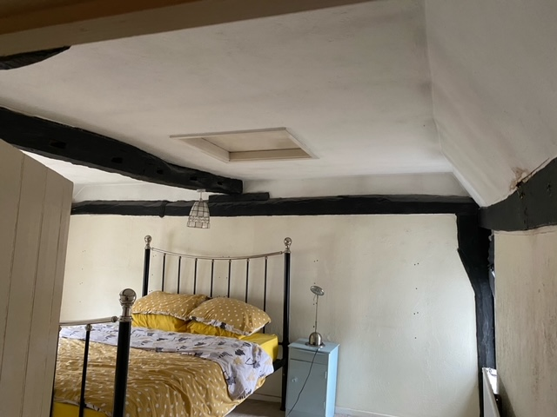

Fig 2, Picture of the bedroom where proposed work will take place. Modern ceiling hatch to access attic above. All exposed beams will be retained.

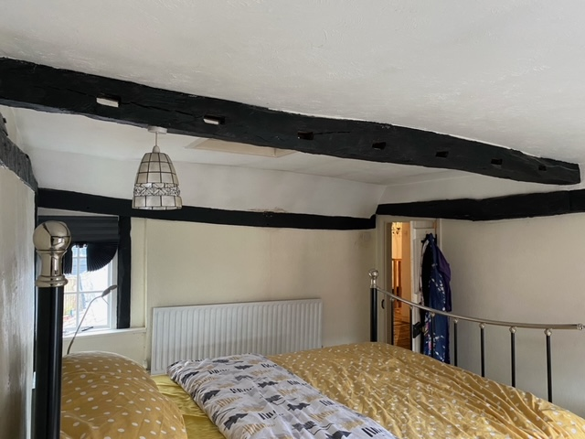

Fig. 3. As above. All exposed beams will be retained.

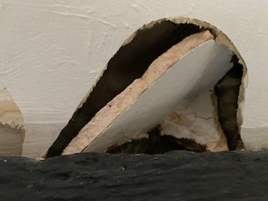

Fig 4. Picture of the small area of existing damage to the internal ceiling showing modern plasterboard construction.

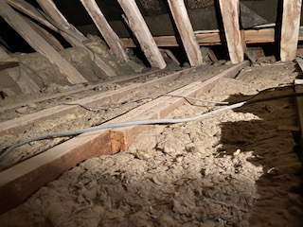

Fig 5. Floor of attic – modern joists have been used.

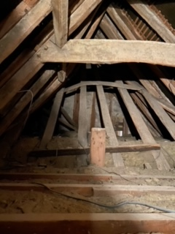

Fig 6. Attic, all beams to be retained with new insulation and plasterboard to be used between the beams.

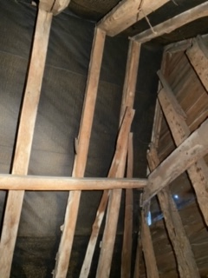

Fig 7. As per description above.

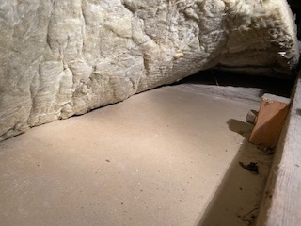

Fig 8. Plasterboard used for the ceiling.

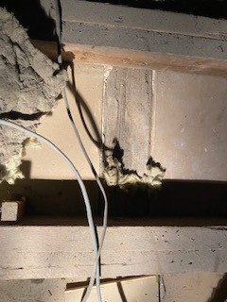

Fig 9. Picture taken from within the attic, highlighted box is original beam that runs the length of bedroom, as seen in Figures 2 and 3. This beam will be retained.