HERITAGE STATEMENT

Proposed Rebuilding of Substandard Link & Alterations at

21 Dunstanville Terrace, Falmouth, TR11 2SW

Client : Mr C & Mrs B Stiles

Date : February 2021

Submission by

ROSEMARY A. LYNCH
CHARTERED ARCHITECT
BA HONS. D’ARCH RIBA

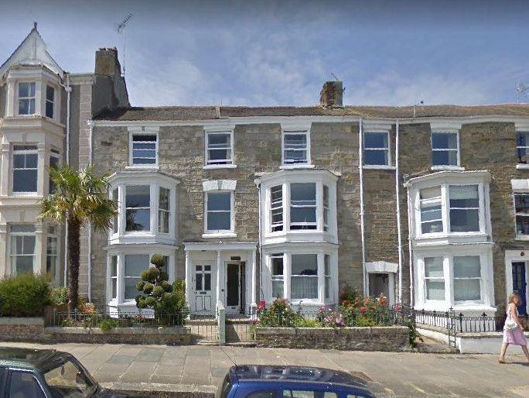
View of the East Elevation at 21 Dunstanville Terrace

Table of Contents

1 Introduction, Brief & Outline
2 Historic and conservation notes and map
3 Development Proposals
4 Planning History
5 Materials
6 Drainage
7 Access
8 Sustainability
9 Summary
10 Supporting Documents

1 Introduction

No 21 Dunstanville Terrace, Falmouth has been owned by my client’s family since the 1980’s and consists of a main townhouse (currently used as two residential flats) and a small, two storey, residential cottage to the rear of the property. There is a steeply rising terraced garden to the rear, accessed via a passageway under the cottage and along an external staircase, which also leads to the main door on the first floor of the cottage.

The ground floor flat of the three-storey building is accessed via the East Elevation, directly off Dunstanville Terrace, whilst the higher flat and the rear cottage are accessed via the ope between no 21 and 22.

The property is within the Falmouth Greenbank conservation area. No21 is part of a large terrace of individual styled townhouses that face the harbour with views of Flushing village across the river there is in front an elevated walkway that provides a wide promenade that is one of the main access routes via the old high street into the town with spectacular views of the river and Trefusis Point .

The rear cottage and the link building attached to the cottage and the house are in need of significant refurbishment. The link building in particular can only be described as ramshackle. This application is for the renovation / reconfiguration of the cottage and the rebuilding of the link. We are proposing to add a sliding sash window to both floors on the rear elevation of the cottage and widening the existing first floor access door to create a more usable, practical entrance to the garden for the user.
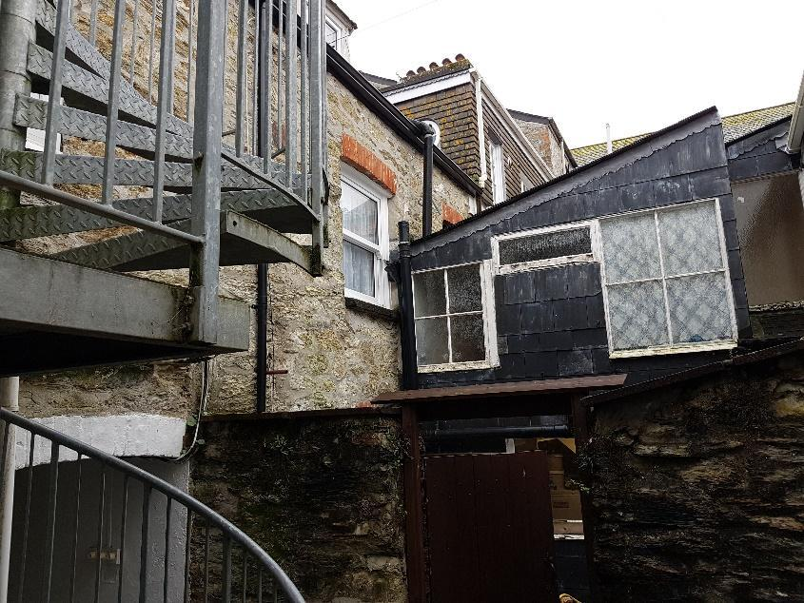

The east elevation of the link

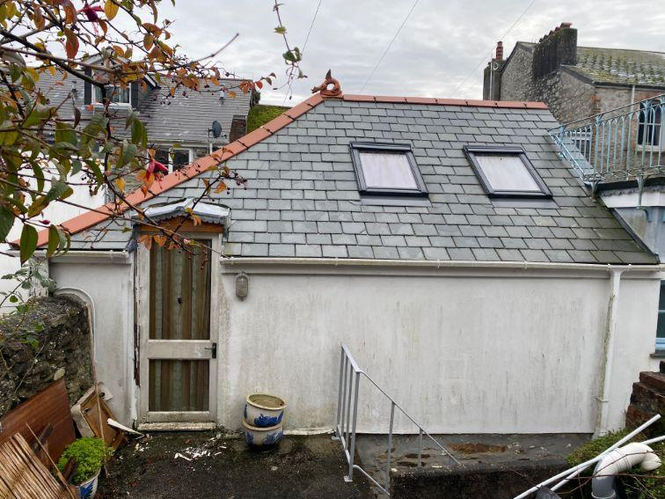

The existing rear main access door, to the first floor of the cottage
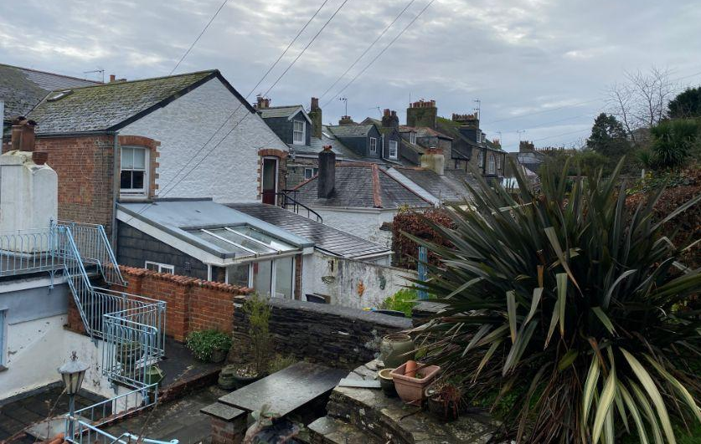

View of the Rear elevations across the garden of no 20 of Dunstanville Terrace

Historic Maps and Conservation Notes

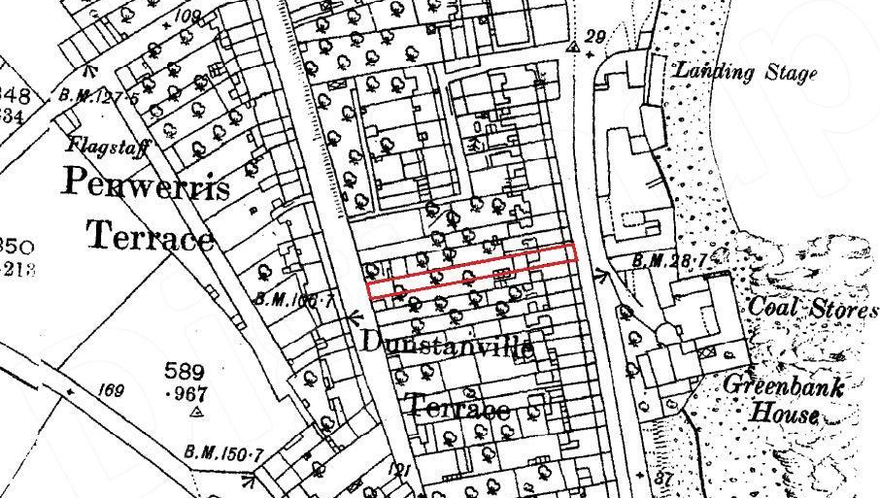
Historic Map of 21 Dunstanville Terrace from the 1880s

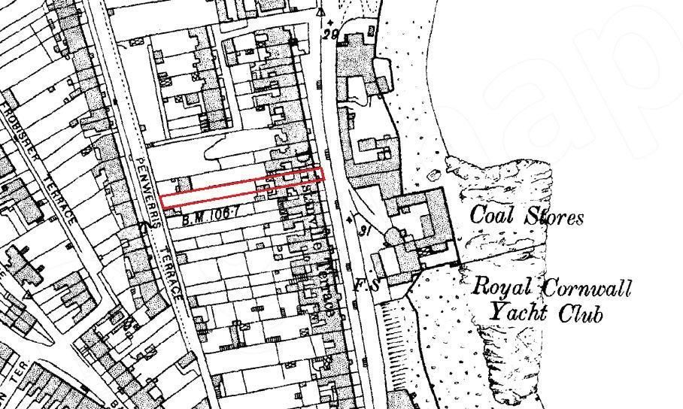
Historic Map of 21 Dunstanville Terrace from the 1900s

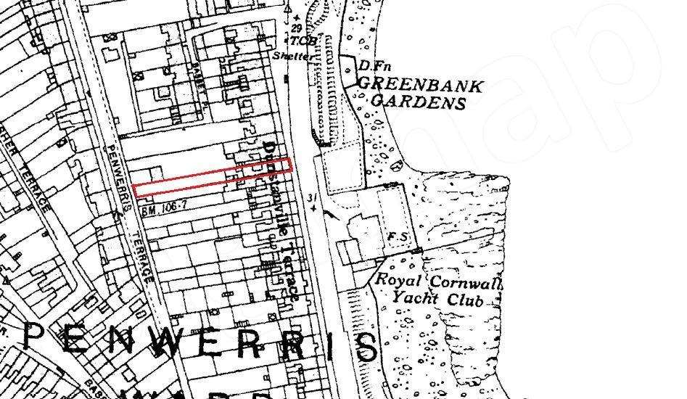
Historic Map of 21 Dunstanville Terrace from the 1930s

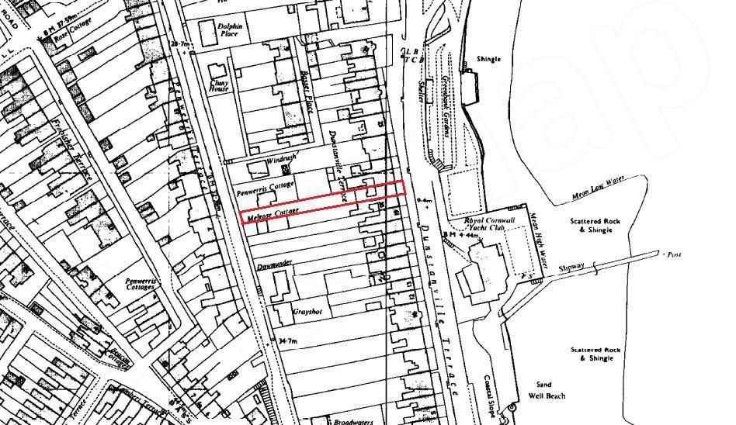
Historic Map of 21 Dunstanville Terrace from the 1960s

Site Map

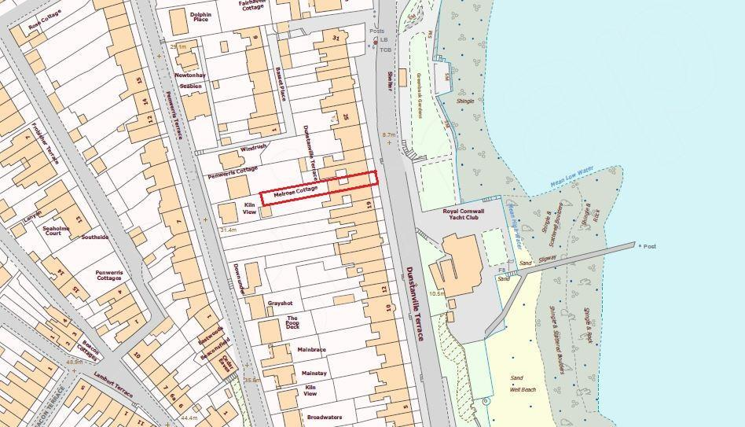
Contemporary Map of 21 Dunstanville Terrace - NTS

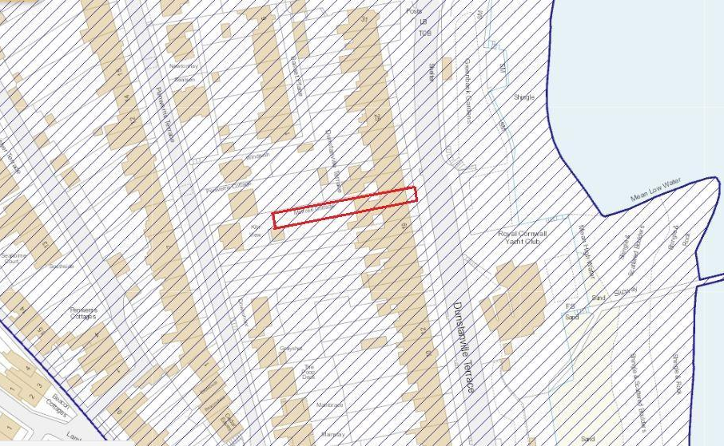

Falmouth Conservation Area including 21 Dunstanville Terrace - NTS

Conservation Statement
from the Falmouth Conservation Area Appraisal - 1989

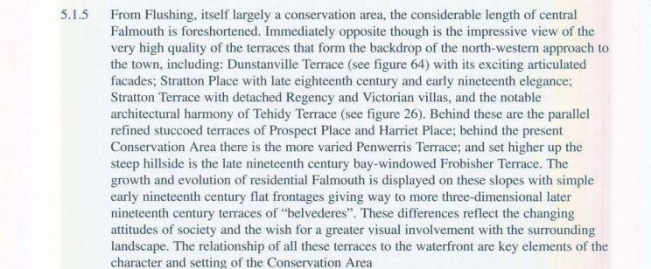

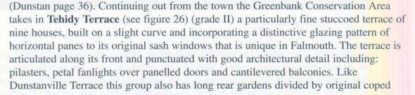
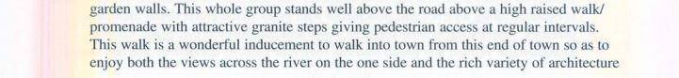
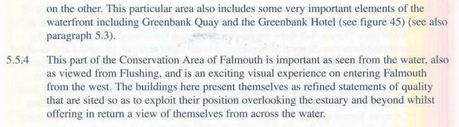

Conservation statements in relation to Dunstanville Terrace

3 The Proposed Development

This application is for the rebuilding of the existing link between the main house and the rear cottage, as well as the renovation / refiguration of the existing cottage. We are proposing to add a sliding sash window to both floors on the rear elevation of the cottage, with a widened existing access door to create a more practical entrance door. There are also some internal improvements, with a new staircase and shower room to replace the existing substandard stairs and bathroom.

We are proposing to put a dedicated utility room & refuse storage in the ‘link’ building, rebuilding the access staircase to the first floor flat (to comply with regulations) with an updated, secure porch and a replacement showeroom for the flat.

4 Planning history

There have been no applications for the property, although we understand it was changed into flats in the mid 1970s. The property was bought by my client’s family in the 1980s as a holiday letting business, with flats in the main house and a self-contained cottage to the rear.

5 Materials

The rebuilt link will be replaced with a painted cavity blockwork on the ground floor, with a boarded cladded stud wall above. The proposed white uPvc windows have been chosen to match the rear of the existing house. The roof to the link will be fibreglass or similar finish. The windows in the cottage will similarly be uPvc.
(see image of existing below)

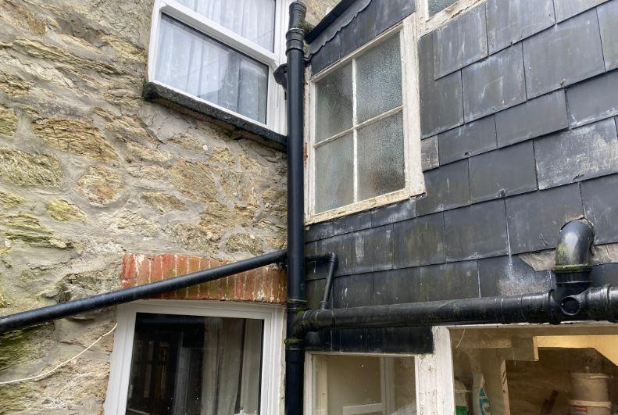
Existing house and link windows

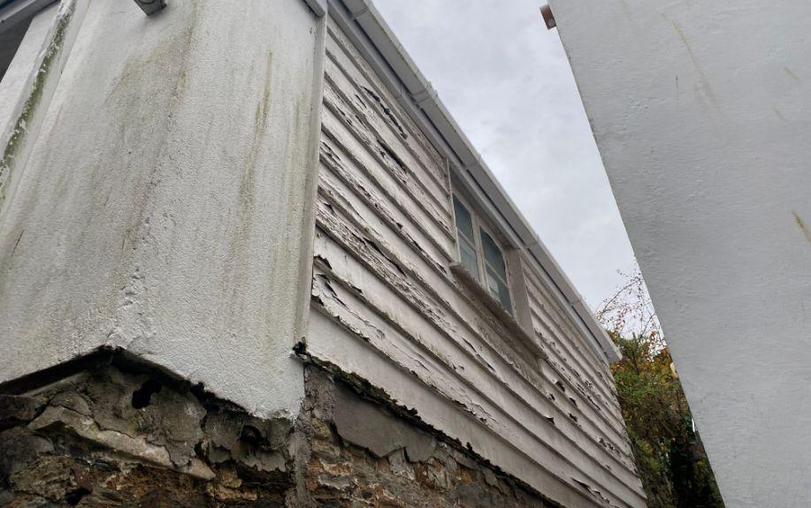 The existing cladding to the side of the cottage

6 Access & Refuse

Vehicle cycle and pedestrian access is from the main access road along Greenbank that goes into the town, there are bus stops nearby and 3 railway stations in the town. The parking is on the main rd in front of Dunstanville terrace. There is a dedicated refuse and storage area to the flats and cottage , that will collected by the local authority on a weekly basis

7. Drainage

The drainage will be as per existing and is connected to mains drainage

8.Sustainability

The clients will upgrade the existing property with additional insulation, and the proposed construction of the replacement link building will be a significant improvement on the existing, improving the buildings longevity.

9. Summary

The proposed rebuilding of the two-storey link access to the first floor is necessary as it is in a very poor condition and unsafe and is of substandard construction. The rebuilding will greatly improve what is presently there and will be appropriate to its surroundings and rationalise and improve the present access and first floor bathroom.

The Cottage is presently in an unliveable state and in need of serious renovation. The proposed alterations will improve the property, with the new openings providing increased natural light, easier access and better views of the garden from the first floor.

The proposed changes will be a significant improvement to the property.

10 Supporting Documents

858.1 - Location Plan - 21 Dunstanville Terrace
858.2 - Existing Block Plan - 21 Dunstanville Terrace
858.3-7 - Existing Drawings - 21 Dunstanville Terrace
858.9 - Proposed Block Plan - 21 Dunstanville Terrace
858.10-13 - Proposed Drawings - 21 Dunstanville Terrace

