Knight Architectural Design Ltd.
A
D
K
NIGHT
RCHITECTURAL
ESIGN
Unit 7 The Quarterdeck
Port Solent
Hampshire PO6 4TP

DESIGN AND ACCESS STATEMENT
141 Albert Rd, Southsea, Portsmouth, PO5 2SQ
CONTENTS:
- Location
- Existing
- Proposed
- Highways
Location:
Photograph 1 showing street scene from Albert Road/ Lawrence Road junction.
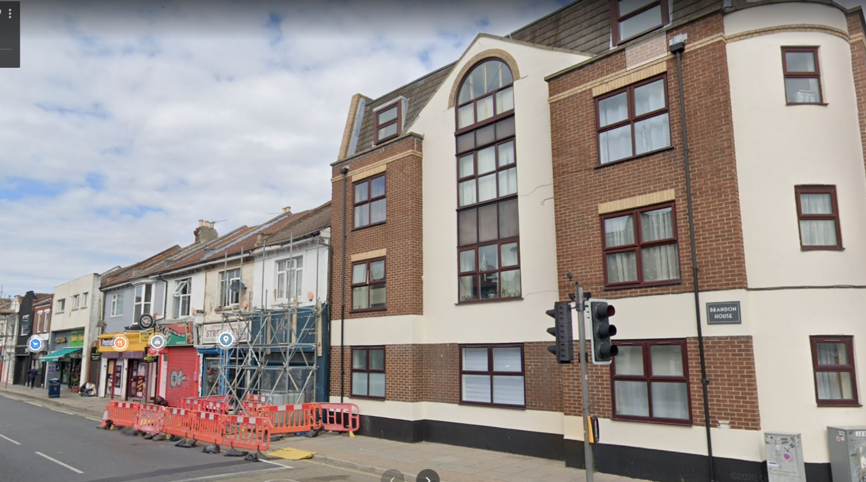

Photograph 2 showing front elevation of 141 and neighboring buildings along Albert road.
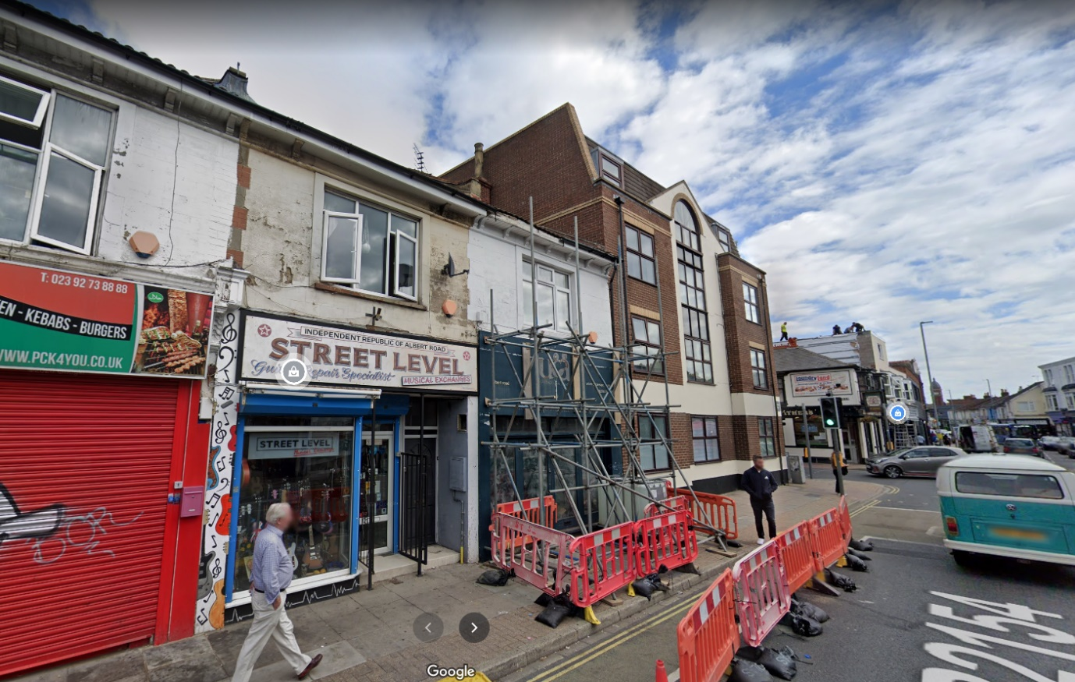

Photograph 3 showing 3D of 141 and neighboring buildings along Albert road.
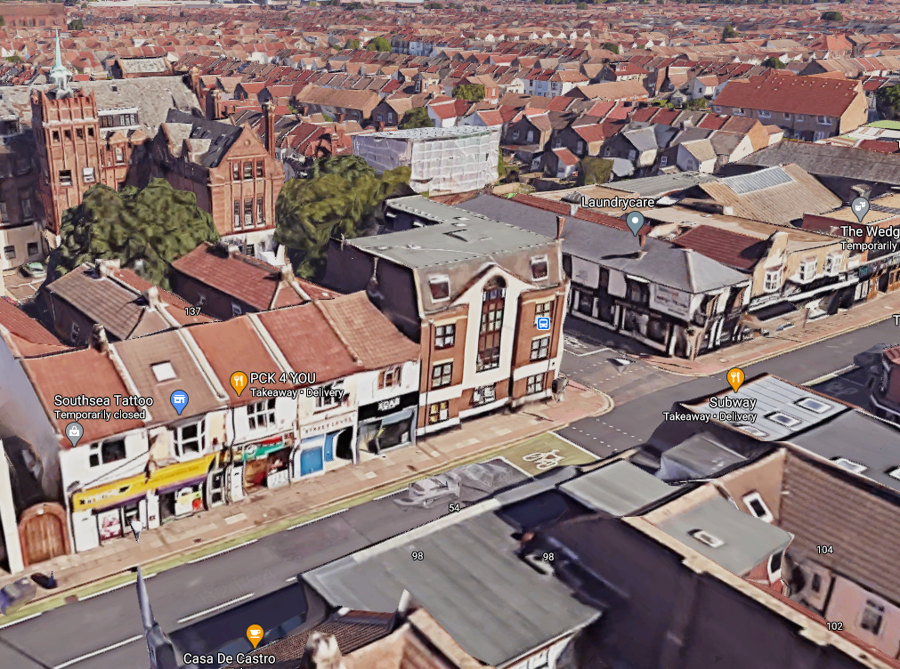

Existing:
141 Albert road is currently a mixed-use building with a ground floor retail frontage and rear shop area. The upper floors consist of a single residential unit. There is currently a rear garden area which has had external stairs recently approved for the upper floor flat to access along with the ground floor retail unit. The current frontage has also just received planning approval for a single door for upper floor access from the street (20/01173/FUL)
Proposed:

We are proposing to reduce the shop internally to allow for a smaller more rentable unit with separate facilities at ground floor. This will allow the rear area and existing first floor area to become a 1 bedroom 1 person flat at 40m2. The flat will benefit from a rear garden/ courtyard area and will be accessed from a new internal corridor from the front street. This will be completed under Part M.

The remainder of the existing first floor residential unit will become a Studio flat which will be converted using Part G. The studio flat will be accessed from a new centralized staircase serving all 3 flats on the upper floors.

We are also proposing to use section 20 AB (please see attached checklist) to extend the upper floors to allow for x2 residential units. These will both be mirror copies as 1 bedroom 2 person units at 50m2. Both flats will be accessed from the central staircase which leads to a street frontage door.

We have designed the new building floor levels to be re-positioned and lowered apart from the shop frontage. This allows the building to sit alongside its neighboring corner building, Brandon House, as a continuation of the street scene in matching its exact height and parapet mansard upper floors. The shop frontage will remain the same height as per the neighboring terrace to ensure the retail signage remains uniform.

All units will have access to a communal ventilated and secure bin store which will be positioned underneath and to the side of the proposed communal staircase. This has been positioned towards the front of the unit to reduce the distance from the highway.

Highways:

There is currently no existing parking space on the site. There is on street permit parking zones around the front and side of the site. The nearest bus stop is located 75m from the entrance door to the proposed units. This is a main bus line running along albert road.

Material Palette for proposed two storey & ground floor rear extension:

- Matching facing bricks & render to be used as per the neighboring corner building
- Brown UPVC windows as per the neighboring corner building
- Slate style roof tiles as per the neighboring corner building
- Rainwater goods black UPVC as per existing

