- B 1.3 site map
Map below showing the emission points marked in red.
The installation area is marked in green including 11 exraction fans, 2 main filters units with built in bag filters, 20 tonne silo and biomass.

- B1.3 site maps
Map below showing waste storage and 20 tonne silo storage marked in red

B2.1 Utopia Process flow diagram
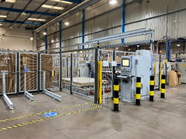
Wood storage facility
Goods IN
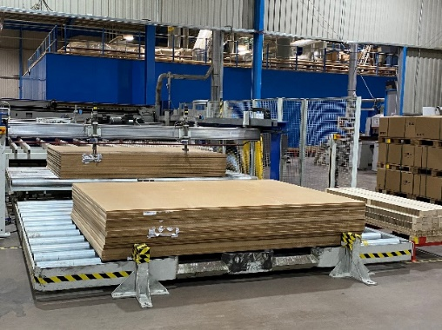
Rear loading Saws / Routers to cut MDF / MFC.
Extraction Duct
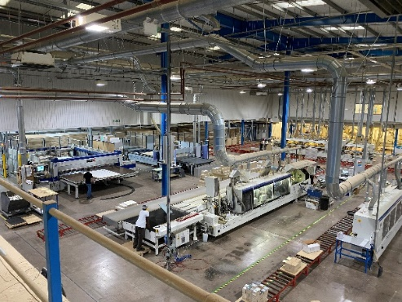
Cut MDF/MFC is edged or profiled through edgebanders or routers then drilled.
MDF / MFC is stocked and orders are picked for ready for assembly

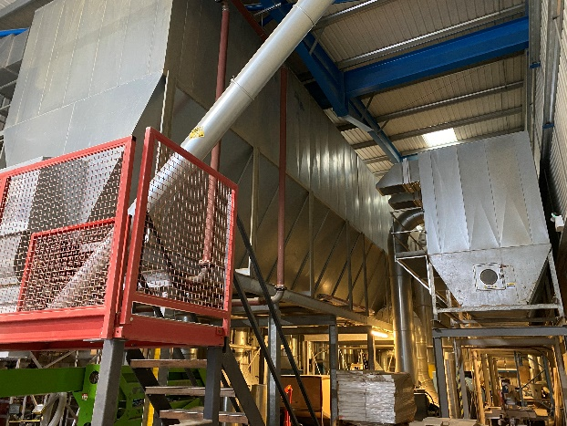
Extraction Filter 2
Filter 1
Filter 2
MDF / MFC dust is carried through extraction ducts into two filters containing filter bags
Extraction Filter 1

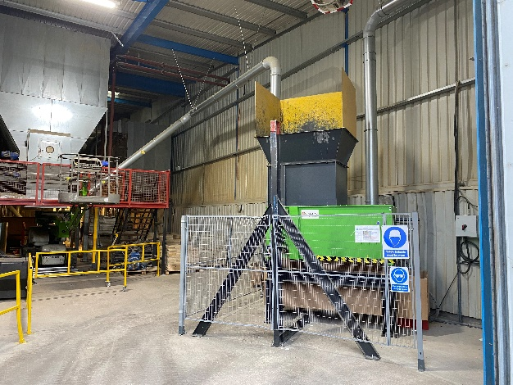
Shredder MDF/MFC Offcut Waste
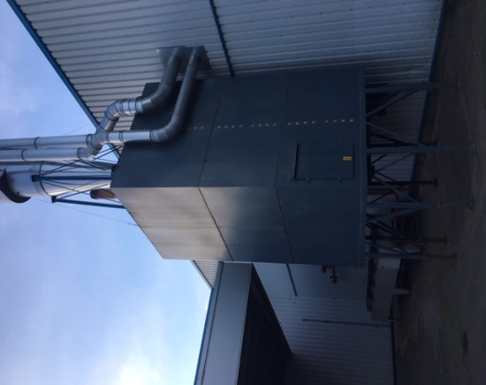
Silo storage
Biomass
Chimney stack Emissions ref EMC ltd report.

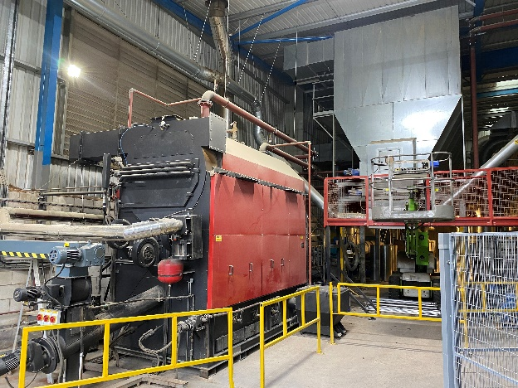

Utopia detailed process description

Utopia furniture located at Springvale avenue, Springvale business park, Bilston, Wolverhampton, WV14 0QL, manufactures and assembles bathroom furniture of which the majority is MDF and MFC,
Utopia purchases MDF and MFC in 2m x 3m sheets from approved suppliers, these are stored in our automated wood stores facility at the goods in area.
The Mill
Orders are received and the board is automatically picked out onto one of two beam saws or a router where the furniture parts are cut to size, MFC parts are then moved to the next process of edgebanding where the pvc edge tape is glued to the panel giving us the finished edge, they then go onto the next process of drilling ready for assembly.
MDF parts will take a different route to their next process of profile routering which gives the edge of the panel the chosen style, the MDF is then drilled ready to go into the foil press department.
All machines in the mill area are linked to extraction duct which extracts MDF/MFC dust into 2 main dust extraction filters via 11 x 20-80kw fans. Wood only skips are provided for offcuts. LEV testing is carried out annually by Zurich to ensure the correct amount of extraction is achieved, servicing of the extraction filters / motors is carried out annually and the filter bags are replaced every 5 years as recommended by the manufacturer.
Biomass & extraction
A talbotts 999kw biomass boiler is installed in the purpose-built extraction room, all of the waste MDF/MFC dust is extracted from each machine and transferred into 1 of 2 main extraction filters,
1 x JHK17 + 4T/C chain filter with 1275 TNF Filter bags 180 dia x 2240 long total filter area is 1581m2 approx max air volume 140,000m3/hr
6 fans extracting from dust making production machines discharge into the filter
1 x JHK10 + 3/C chain filter with 500 TNF Filter bags 18 dia x 2240 long total filter area is 620m2 approx max air volume 56,000m3/hr
5 fans extracting from dust making production machines discharge into the filter
The system is fitted with an Ecogate extraction on demand damper system which allows extraction air to machines to be shut off if not in use and reduce the fan speeds and decrease the air volume entering the filters, so the max air volumes are very rarely achieved. This is done automatically from machine signals and inverter drives.
Both filters are positive pressure with main extraction fans on dirty side of system. Fans blow dust and air into a top inlet section of the filter where pre separation takes place with the air speed reducing allowing larger particles of dust/chips to drop into the hopper section of the filter The air and fine dust will then enter the filter bags where the dust will be filtered out with the cleaned air discharging into either the main filter room (exiting the room to atmosphere out of wall mounted louvres or open roller shutter door) or returned back to the factory. Each filter unit is split into a number of separate filter sections (17 and 10). Each section is fitted with a reverse flow regeneration fan, cleaning 1 section of bags at a time in a cycle every 10/20 minutes and continuous cycle on clean down.
The dust and chips in the hopper are dragged to one end of the filter via a chain conveyor and pass through a rotary valve air lock allowing only the waste to exit the valve and not any air. This gives a pressure free discharge of the waste into a closed loop transfer system which also picks waste up from a chipper and discharges the waste under pressure free conditions into the biomass silo via a high efficiency cyclone and rotary valve. The air from the cyclone is returned back under the filter rotary valve to form a sealed closed loop.
Both outlets from the filter rotary valve and cyclone rotary valve are fitted with level bindicators to detect blockages/over filling of the system and will stop the system to prevent major blockages and damage to the filters/cyclone/rotary valves. Also the filter chain is fitted with a movement sensor and will stop the system if chain detected as not moving to prevent blocking of the filter unit.
Interlocks are in place to not allow main filter units to run if the transfer system to the silo is not running or is in fault.
The system automatic start-up will start the cyclone rotary valve then after a short while the main transfer fan, when this has been running a short while then the main filter rotary valve will start followed by the chain. The system will then allow the main extraction fans to start when required. The cleaning fans will start a clean cycle after 10/20 mins with fans cleaning one at a time until full cycle of all sections finished then will wait another 10/20 mins before cycling again.
On shut down/clean down the system will turn all main fans off, put the chain conveyor into step mode so as not to overload the transfer system with waste after 5 mins the regeneration fans will begin to constantly cycle one at a time for the rest of the pre-set clean down time (normally another 15/20 mins) When complete the chain will stop, rotary valve will run on for approx. 20 secs, then transport fan for 30 secs to clear the pipelines and stop, cyclone rotary valve will run on 20/30 secs to clear the cyclone.
The filter can also discharge into a small skip/bag in an emergency if required to allow any repairs /servicing of silo or if silo full.
All off cut waste is segregated into wood only skips and fed into a fire supressed shredder which is linked with the extraction, at this point the shredded MDF/MFC joins with the dust extraction and is transferred via an 18kw transfer fan to the 20 tonne enclosed storage silo. The biomass is fed via an enclosed screw feed at a rate set by the manufacturers to maintain the correct heat output and emissions, full manufacturers service takes place annually as does the emissions testing via EMC ltd (environmental monitoring consultants), general maintenance and emptying of ash bins takes place by trained internal maintenance staff, monthly / weekly and recorded. There are three heat output channels from the biomass, 1) hot air blowers throughout the factory to provide space heating, 2) hot air curing room 3) hot air blowers throughout office spaces. During summer months the heat will be channelled outside through a 5 fan heat dissipater.

