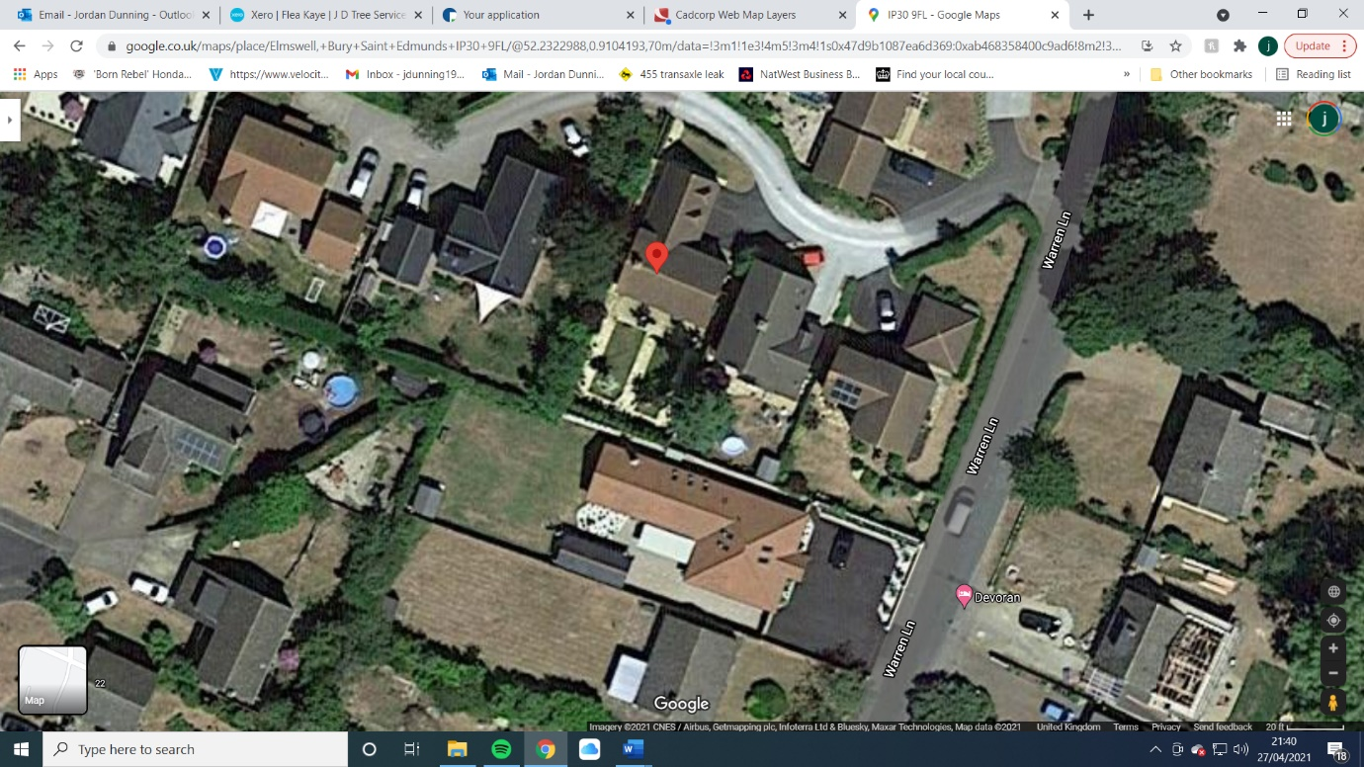

T1 – Spruce in proximity to house

Pathway with access gate

House

TPO Tree

Garden